
AGRICULTURAL LAND USE DYNAMICS AND ITS IMPLICATION ON ENSET FARMING: THE ARI HIGH LANDS OF SOUTH OMO ZONE, SOUTH WESTERN ETHIOPIA
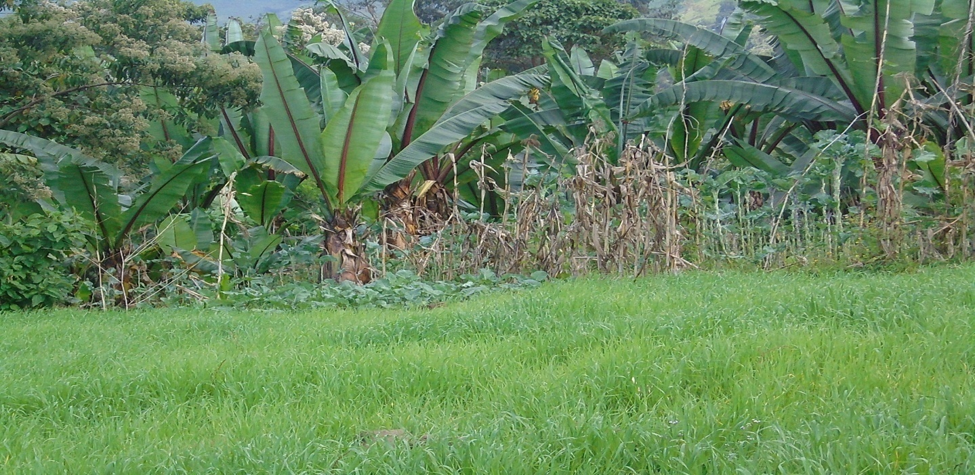
MSc Thesis

AGRICULTURAL LAND USE DYNAMICS AND ITS IMPLICATION ON ENSET FARMING: THE ARI HIGH LANDS OF SOUTH OMO ZONE, SOUTH WESTERN ETHIOPIA

MAY, 2017
ARBA MINCH, ETHIOPIA
AGRICULTURAL LAND USE DYNAMICS AND ITS IMPLICATION ON ENSET FARMING: THE ARI HIGH LANDS OF SOUTH OMO ZONE, SOUTH WESTERN ETHIOPIA

MSc THESIS SUBMITTED TO
DEPARTMENT OF GEOGRAPHY AND ENVIRONMENTAL STUDIES, COLLEGE OF SOCIAL SCIENCE AND HUMANITIES, SCHOOL OF GRADUATE STUDIES
ARBAMINCH UNIVERSITY IN PARTIAL FULFILLMENT OF THE REQUIREMENTS FOR THEDEGREE OF MASTER OF SCIENCE IN ENVIRONMENTAL CHANGE MANAGEMENT

PRINCIPAL ADVISOR: ABERA UNICHA (PhD)
CO-ADVISOR: GETU LEMA (PhD Candidate)

MAY, 2017
ARBA MINCH ETHIOPIA
DECLARATION
I hereby declare that this MSc specialty or equivalent thesis is my original work and has not been presented for a degree in any other university, and all sources of material used for this thesis have been duly acknowledged.
Name: Taye Ganmay Gele
Signature: _____________
Date:

ADVISORS’ THESIS SUBMISSION APPROVAL SHEET
SCHOOL OF GRADUATE STUDIES
ARBA MINCH UNIVERSITY
This is to certify that the thesis entitled “Agricultural Land Use Dynamics and Its Implication on Enset Farming, the Ari Highlands of South Omo Zone, South Western Ethiopia” submitted in partial fulfillment of the requirements for the degree of Master’s with specialization in Environmental Change Management, the Graduate Program of the Department/School of Geography and Environmental Studies, and has been carried out by Taye Ganmay Gele. No RMSc/059/2015 under my/our supervision. Therefore I/we recommend that the student has fulfilled the requirements and hence hereby can submit the thesis to the department for defense.
Name of Principal advisor: Abera Unicha (PhD) Signature Date
Name of co-advisor: Getu Lema (PhD Candidate) Signature Date

EXAMINER’S THESIS APPROVAL SHEET
ARBA MINCH UNIVERSITY
SCHOOL OF GRADUATE STUDIES
We, the undersigned, members of the Board of Examiners of the final open defense by Taye Ganmay Gele have read and evaluated his/her thesis entitled “Agricultural Land Use Dynamics and Its Implication on Enset Farming: Ari Highlands of South Omo Zone, South Western Ethiopia”, and examined the candidate’s oral presentation. This is, therefore, to certify that the thesis has been accepted in partial fulfillment of the requirements for the Degree of Master of Science in Environmental Change Management.
_______________________ _______________ _____________
Chairperson’s Name Signature Date
________________________ ___________ _____________
Internal Examiner’s Name Signature Date
________________________ __________ ______________
External Examiner’s Name Signature Date
Thesis approved by
________________ _____________ ___________
Department Signature and stamp Date

ACKNOWLEDGEMENTS
Above all I extend my special thanks to the Almighty God as everything was due to his goodwill. It is not possible to thank all those people and institutions that have helped me in accomplishing my Thesis research work, but the following deserve special mention. First and foremost, I thank my major advisor Dr. Abera Unicha in offering constructive comments, guiding and encouraging me in all moments from topic selection up to accomplishing Thesis write up. His critical review and readiness to help me are unforgettable. Really, I learned a lot from him. I equally thank my Co-advisors, Getu Lema for his comments, guidance and encouragement starting from proposal development to the final write up of this Thesis. My appreciations and gratitude also goes to South Omo Zone Administration office for offering me the opportunity to attend this MSc studies. I am grateful to this office for every kind of support and facilities made available for the MSc study and research work.
I also thank all staffs members of AMU, Department of Geography and Environmental Studies and my class Mets for their encouraging me in academic and idea to accomplish this MSc study and Thesis work. I wish to address my heartfelt thanks to data collectors for their support and commitment during household survey. I am grateful to my father, Mr. Ganmay Gele, and my mother Ms. Gbnako Masi who, being illiterate themselves, encouraged my schooling and still helping me and my nucleus family.
I express my sincerely gratitude to my beloved wife W/ro Dirework Saliye for her endless encouragement, moral support and true love with taking care of me in all my ways through and she care our off springs without my support . My special thanks and heartfelt appreciation is reserved to my three daughters Kenay, Mahider and Gelila who lost my love during my study.

ABRIVATIONS and ACKRONOMYS
ADLI = Agricultural Development Leading Industrialization
ANOVA = Analysis of Variance
CSA= Central Statistics Agency
DAWARDO = Debub Ari Woreda Agriculture and Rural Development Office
DA = Development Agents
EBE = Enset Bacteria Wilt
EXW = Enset Xanthomonas Wilt
ETM+ = Enhanced Thematic Mapper Plus
FDRE = Federal Democratic Republic of Ethiopia
FGD = Focus Group Discussion
GIS = Geographic Information System
GPS = Global Positioning System
HHH = Household Heads
JARC = Jinka Agriculture Research Center
LULC = Land Use Land Cover
MoARD = Ministry of Agricultural and Rural Development
MoFED = Ministry of Finance and Economic Development
MSS = Multi Spectral Scanner
NGO = None Governmental Organization
SARI = Southern Agricultural Research Institute
SNNPRS = Southern Nations Nationalities and Peoples Regional State
TM = Thematic Mapper
USGS = United States Geological Survey
UTM = Universal Transverse Mercator
WGS = World Geodetic Survey

TABLE OF CONTENTS
CONTENTS PAGE
Acknowledgment…………………………………………………………………………………….i
Abbreviations and Ackronomys…………………………………………………………………………………...ii
Table of Contents…………………………………………………………………………………………………iii
List of Tables…………………………………………………………………………………………………….vii
List of Graphs and Pi-charts………………………………………………………………………………….....viii
List of Figures………………………………………………………………………………………………….....ix
Abstract……………………………………………………………………………………………………………x
CHAPTER ONE: INTRODUCTIO……………………………………………………………………………….1
1.1. Background of the Study 1
1.2. Statement of the Problem 2
1.3.1. General Objective 4
1.4. Research Questions 4
1.5. Significances of the Study 4
1.6. Scope of the Study 5
1.7. Limitations of the study………………………………………………………………………………………5
1.8. Organization of the paper………………………………………………………………………...................5
1.9. Operational Definitions……………………………………………………………………………………..5
1.10. Ethical Considerations……………………………………………………………………………............6
CHAPTER-TWO: RELATED OF RELATED LITRATURE 7
2.1. Taxonomy and Botanical Classification of Enset 7
2.2. Origin of Enset Agriculture in Ethiopia 8
2.3. Ethiopian Agricultural Policy and other perennial crops 9
2.4. Farming System of Enset 10
2.5. Land Use/Land Cover Dynamics and Implication: the Ethiopian Experience………………………………11
2.6. Contributions of Enset Farming ……………………………………………………………………………………………………………………...........11 2.7.Major Factors Affecting Enset Farming……………………………………………………………………………………….13
2.8. Conceptual Frame Work of Factors Affecting Enset Farming……………………………….......................19
CHAPTER THREE: STUDY AREA AND RESEARCH METHODES 21
3.1. The Study Area Description 21
3.2. Research Methods 23
3.2.1. Research Design 23
3.2.2. Data Sources 23
3.2.3. Instruments of Data collection…………………………………………………………………………….23
3.2.4. Sampling Techniques and Sample Size 25
3.2.5. Methods of Data Analysis and Interpretation 27
4. CHAPTER- FOUR : RESULT AND DISSCUSSION………………………………………………………..28
4.1. Demogrphic and Socio-economic Characteristics of Households …………………………………………………………….………28
4.2. Land Use/Lnd Cover Dynamics and Pattern(Both Temporial and Spatial ………….……………………32
4.3. The Current Statutes of Enset Farm …………...………………………………………………………...37
4.4. The Major Factors for the Decline of Enset Agriculture …………………………………………………………………………………38
4.5. Effects of Current Agricultural Land Use Change on Enset Farming……... ………………………….........................47
5. CHAPTER-FIVE: CONCLUSION AND RECOMMENDATIONS………………………………..……....53
5.1. Conclusions ………………………………………………………………………………………………………………………………………………............53
5.2. Recommendations ………………………………………………………………………………..……………………………………………………………..54
6.REFRANCES…………………………………………………………………………………………………..55
7. APPENDIX…………………………………………………………………………...………………….........61

LIST OF TABLES
TABLES PAGE
3.1. Land Use/Land Cover Data Source…………………………………………………………………...25
3.2. Sample Size of Households…………………………………………………………………………...27
4.1. Land Use/Land Cover Class of 1985 to 2015…………………………………………………………32
4.2. Land Use/Land Cover Dynamics Trends from 1985 to 1995…………………………………………34
4.3. Land Use/Land Cover Dynamics Trends from 1995 to 2015…………………………………………35
4.4. Land Use/Land Cover Dynamics Trends from 1985 to 2015…………………………… ………….36
4.5. Land use conversion matrix…………………………………………………………………………...36
4.6. Effects of Agricultural Land Use Change on Enset Farming……………………………………….. 48

LIST OF GRAPHS AND PI-CHARTS
GRAPHS AND CHARTS PAGE
Chart 2.1 Land Use Change……………………………………………………………………………………...17
Chart 4.1 Sex Distribution of Households………………………………………………………………………28
Graph 4.1 Age Distribution of Households……………………………………………………………………...29
Chart 4.2 Family Size of Households……………………………………………………………………………30
Graph 4.2 Educational Characteristics of Households………………………………………………..…………31
Graph 4.3 Enset Farm Coverage………………………………………………………………………………...38

LIST OF FIGURS
FIGURES PAGE
2.1, Enset Plant…………………………………………………………………………………………………….7
2.2. Conceptual Frame Work…………………………………………………………………………………….20
3.1. Study area Location………………………………………………………………………………………….21
4.1. LULC Map of 1985……….…………………………………………………………………………………32
4.2. LULC Map of 1995………………………………………………………………………………………….33
4.3. LULC Map of 2015………………………………………………………………………………………….33
4.4. Propagated Enset Shoots Prepared for Transfer……………………………………………………………..39
4.5. Enset Varity Preservation Nursery Site……………………………………………………………………...40
4.6. Enset Plantation under Tree Shade…………………………………………………………………………..43
4.7. High Market Value Vegetables under a Good Management……………………………….........................44
4.8. Poor Farming System………………………………………………………………………………………..45
4.9. Replacement of Enset Farm with Annual Crops/ Crop Substitution/……………………………………….50

ABSTRACT
Enset is one of the staple food crops in Ethiopia cultivated for socio-economic and environmental advantage. It is mostly cultivated in southern and south western parts of the country. The main objectives of this study was to assess the current status of enset farming and effects of agricultural land use change in Ari highlands of South Omo zone, south western Ethiopia. The study kebels were selected by purposive sampling method and systematic sampling technique employed for selection of household heads. The data were collected through semi-structured questionnaire from household heads, key informant interview and focus group discussions and satellite imageries were used to evaluate land use/land cover changes. The gathered data was analyzed by using descriptive statistical analysis and Ch-square test. While the satellite imageries were processed using Arc GIS software. According to the major findings, the current status of enset farming system and productivity is decline over time. The major factors for enset cultivations are the overall poor and cultivations and land fragmentation due to population increasing puts its pressure on enset farming system. Moreover, the LULC result of Landsat image of 30 years shows that there is a remarkable decrease for enset and forest. To the opposite agricultural land shows dramatic increase to become large land use type in the study area results puts its pressure on enset farming system. Finally the enset farming system in the study area at present time need a high attention and call for all concerned bodies like farmers, government actors, NGOs, interested bodies, individuals and researchers should come together to prevent and rehabilitate this major co-staple food crop which supplies large population.
Key Words: Ari highland, Bacteria Wilt, Enset Agriculture, Ensete Ventricosume, Geographic Information system, Land Use/Land Cover.

CHAPTER ONE: INTRODUCTION

Background of the Study
Agriculture faces many challenges, making it more difficult and difficult to achieve its primary objective feeding the world each year. Population growth and challenges in diet associated with rising incomes drive greater demand for food and other agricultural products , while global food system are increasingly threatened by land degradation, climate change , and other stressors (Global Initiative for UN, 2013).
Climate change, resulting mostly from global warming, has been among the major causes of reduced agricultural production and productivity in many parts of Africa, including East Africa. Over the last three decades the frequency of droughts and floods in East Africa has increased, resulting in crop failures and loss of livestock. Ethiopia has been hit hardest by persistent drought, making food security the key issue for poverty reduction (African Development Bank, 2010).
Ethiopian agriculture is mainly subsistence type where Farmers produce for their own consumption as well as for market. As much as 85 percent of the Ethiopian population lives in rural areas and depends on rain fed agriculture. While the agriculture has low productivity where by farmers generating more than 95 percent of the country’s outputs are still using traditional farming tools and practices Tsedale (2009).Nevertheless, as reported by Awol et.al. (2014) enset crop is versatile, environmentally resilient and serves for 20 percent of Ethiopian population as staple and or co-staple food, which is belongs to the order scitanmineae family musaceae and genus Enset.
Enset is a part of a wide spread and ancient system of cultivation of vegetative crops formerly distributed much more widely through the Ethiopian highlands. As stated by Roger et al. (2003) the cultural and linguistic evidences concerning the origin and distribution of enset culture seem to point generally in the same direction. Enset is a tree like root crop that sometimes referred to as the false banana was domesticated in Ethiopia and usually forms a part of a farming system that combines the cultivation of root crops and cereal grains with animal and tree husbandry.
According to Hilscher and Schnieder, (1998) as cited in Bimerta et al, (2004) enset is presently the main crop of a sustainable indigenous African farming system, which ensures food security in a country that is severely food deficient. Besides its use as source for large quantities of carbohydrate rich food, enset is also utilized for animal forage, fiber production, construction materials as an ornamental and for its medicinal values with demonstrated antimicrobial activities against viral, bacterial, fungal and nematodal diseases of humans. Although the economic importance enset is very high its yield and quality is affected by biotic and a biotic agents such as diseases, insect pests, weeds wild animals and soil nutrient depletion (Mekuria Wolde, 2013).
Thus Enset serves a number of beneficial functions for those who manage it. In spite of these benefits enset based system experience a number of limiting factors. This limiting factor includes its production needs time and labor incentive. It requires a good deal of specialized knowledge, land owner ship in many areas is highly segmented each family owing sever problem in owing plots of land. This adds to the time and labour costs of enset production. Enset is a slow return investment; farmers may not see a reasonably sized harvest for three to six years from initial planting (Daniel M, 1999).
From this limiting factors the major one is agricultural land use report of (MoARD, 2010) as cited in Moges Gobena, (2010), indicates out of 111.5 million hectare land area of the country, 70% is estimated to be suitable for annual and perennial crop production. Cereal crop production is the most important crop accounting for 82% of the total area cultivated and 87% of the total crop produced.
According to CSA, (2010) that, Enset provides important diet in the southern and south western part of the country and covers considerable land area within the private holdings. More than 395.000 hectares of land in the country, yielding more than 8.02 million quintals of produce by the peasant holders, but the same report of CSA, (2011) shows that, the Enset covers considerable land area and a total of 312,171.98 hectares of land in the country these shows the land covered by enset and enset production is declining.
The land use is the backbone of agricultural economies and it provides substantial, necessary and essential for economic development and social progress, but often comes at a substantial cost to the environment. The agricultural land use change in enset farming region of the country SNNP particularly the study area needs land use control decision and proper management to enhance the enset cultivation. While the study was focuses on agricultural land use dynamics and its impacts on the enset farming.

Statement of the Problem
Enset produced with relatively high yield in the small area, when compared to the grain crops. While still the other crops are produced in limited amounts as supplements for the food value obtained from enset Tsedale Waiktola (2009). However In the last 20 and 30 years enset has been replaced by coffee and annual crops and as a result its production declining. When enset production declined, there has been an observed food problem in the area.
If no change is made to the enset-based agriculture in terms of research and development, the existing population growth and land degradation continues the danger of replacement may be inevitable (Tsedale Waiktola, 2009). According to Teshome Yirgu, (2016) due to land use change enset farm decrease by 15.4% which is about 40.4 hectares of enset farm was covered to other land uses mainly in to crop land.
Ari Highland is found in enset based farming system; here enset is used as staple food in the area. As other parts of the country, the common crops are cereals, root crops and cash crops, which are the dominant agricultural cultivation crops. However, enset in the area have been commonly growing and producing as a culture of drought resistance. Previously enset is a major crop produced in large quantity and quality. Now through time its management and cultivation system declining over time in the study area.
Currently enset agriculture is rapidly declining. The main influencing reasons are demographic pressure, farming (management) system, disease, crop substitution system, and land scarcity in study area. On the other hand the land use land cover dynamics is changed alarmingly. This drastically change of land use land cover of the area aggravated the climate and environmental change in the area. As the result the production and productivity of agriculture become declining now currently the study area experiences food shortage.
Due to the lack of proper enset farming system, the production status of enset in the area has been declined. Moreover the highland communities for this happening issue they are not giving attention to prevent the effect. However, in the future those peoples may be under the ultimate negative consequences. In this regard, agricultural land use dynamics is seriously increasing over time and resulted in reduction of enset land.
This implies that, the current land use change is challenging the enset cultivation and production in the study area. However, if the problem cannot be measured by the stakeholders, it will become unbreakable to prevent the effects. Therefore, to reduce these negative consequences, the enset land race varieties should be preserved, replant and distribute among the farmers to enhance the productivity in the study area.
The research conducted about enset were focuses on enset diversity and distribution among this, Melese Mariyo, et al (2014), the management of Enseteventricosum in the Gamo highlands of south western Ethiopia, Daniel, (1999). Nutritive values of the drought tolerant food and fodder crop enset. (Mohammed B, et al, (2013), Morphological and use-value related management of enset diversity and distribution in (SNNPRS). Zerihun Yemataw et al, (2012), Assessment of bacteria wilt / Xanthomonas campestrispv. Musacearum/ of enset colony and antibiotic towards its management, Mekuria Wolde (2013), Livestock feeds and feeding system in enset, and Dominated mixed farming system of southern Ethiopia Samuel (2014), Diversity and cultural use of enset in Bonga in situ conservation site, Ethiopia Yemane Tsehaye and Fassil Kebebew (2006), indigenous Knowledge use and on- farm management of enset diversity in Wolaita, southern Ethiopia Temesgen Magule, et al, (2014).
According the experiencing problem in the study area the Agricultural land use dynamics and its implication on enset farming not studied. Therefore this research aspires to investigate Land use system changes/dynamics/ of the study area, Effect of Land Use/Land Cover Dynamics on Enset Farming system, the current status of enset farming system and major causes for the enset farm decline, are the problems. This a spires the researcher to conduct this study to put his own contribution to improve the production and the productivity of enset in the area and to initiate the other interested persons to conduct further research to improve the land use system in the study area.
  - Objectives of the Study

General Objective
The main objective of this study is to investigate the agricultural land use dynamics and its implication on enset farming the Ari highlands of South Western Ethiopia.

Specific Objectives
The specific objectives of the study are:-
- To assess the demographic and land use practices
- To examine the land use dynamics of the study area
- To assess the current status of enset farming.
- To identify the major causes for the decline of enset production.
- Effect of Land Use/Land Cover Dynamics on Enset Farming.

Research Questions
- How demographic characteristics affect land use practices of the study area?
- How is the land use dynamics in the study area?
- What is the current status of enset farming?
- What are the major causes contributing for the decline of enset farming?
- Effect of Land Use/Land Cover Dynamics on Enset Farming?

Significances of the Study
Agriculture is leading economic sector for the developing countries like Ethiopia. Ethiopia promotes the agricultural sector as the center of the government development policy and strategy. Ethiopia developed the national strategy known as the “Agricultural Development Led Industrialization” (ADLI) FDRE, (1991). This will be ensured when food security is achieved. Hence research works towards agricultural may provide important solution to fill the gaps for the practical implementation of the agricultural policies. Hence particularly researches on enset are crucial to ensure food securities. Enset is known for its drought resistance and known as “a tree against hunger”. There for, this is research expected to:-
- Improves the awareness of the farmers and other concerning bodies in effective management in enset farming to improve production of enset in the study area.
- Strengthening public, government and NGOs to mitigate problems related to enset productions.
- Provide important issues for government actors and planners solutions for effective agricultural land utilization and proper management.
- Help as a reference material for who want conduct research on the same topic and indicate future areas of research.

Scope of the Study
This study was conducted in Ari highlands South Omo Zone South Western Ethiopia. The study area comprises with 37 kebeles all are found in the highland (Dega) agro ecology. The study focused on examining the land use /land cover/and its effects on enset farming (management practices) and major causes for enset farm decline. The participants of the study were including peasant household, DAs heads, Extension workers and agriculture expertise in the woreda and additionally because of time, budget constraints and topographic inaccessibility only four kebeles were sampled. This study was only focus on one crop that is enset.
  - Limitations of the Study
A limitation of the study is because of lack of officially organized data about the land holding sizes of each household. Due to this the present and previous enset farm size of each household was not compared and contrasted.
  - Organization of the Paper
The thesis is classified into five chapters. The first chapter is an introductory part which incorporated background of study, statement of the problem, objectives, research questions, significance and scope of the study. The second chapter is devoted to only literature review. Chapter three has description of the study area and research methods (research design, source of data, instruments of data collections, sampling techniques and sample size methods of data analysis and interpretation, and ethical consideration. Chapter four depicts the result and discussion and finally the last chapter is all about conclusion and recommendation.
  - Operational Definitions
Enset: “Ensete ventricosume of root crop that the study focuses about in the study”.
Farming system: “Implies the farming and management system/practices of the particular of the study area”.
GIS: “Geographic Information System that is used to examine the land use changes in the study area”.
Implications /Effects/:“the agriculture land use and its effects particularly to enset farming”.
Land shortage: “Because of other crop land expansion and the minimization of land size particular to enset crop/ farming”.
Land use dynamics: “the land change/conversion/ from one use type to another land use system both in extending /shrinking/”.
  - Ethical Consideration
A good research should be ethical in all aspects and the researcher has an obligation to respect the right, needs, values, and desires of the informants. According to this the study was kept important ethical issues, before the beginning and during each data collection of the study which was clearly described to those respondents who participated in this study in any way and step forwarded based on the permission of the respondents. This are:
- The culture, tradition and language of the respondents’ are respected starting from the guide study, and questionnaire administering to report.
- The survey data are promised to be handled carefully and used for the purpose of this research only.
- Sense of confidentiality is maintained among respondents where information might be sensitive.

CHAPTER-TWO: REVIEW OF RELATED LITRATURE

Taxonomy and Botanical Classification of Enset
Enset (Enseteventricosum (welw) cheesman) belong to the order scitamineae, the family musaceae and the genus enset. It is monocarpic hercabceous plant banana is in the same family as enset but in genus musa. Enset looks like a large thick single stemmed banana plant. Both enset banana have an underground corm, a bundle of leaf sheaths that for the pseudostem, and large leaves. Enset however is usually larger than banana. Enset has three parts; the upper most portions are the pseudostem which made of a system of tightly clasping leaf sheaths. Pseudostem may be two to three meters tall and contains an edible pulp and quality fiber. The underground corm is really an enlarged lower portion of the stem Mekuria Wolde (2013).
Edwards and Laye (1997) as cited in Adimasu Tsegaye (2002) enset (Enseteventricosum w.) is monocarp perennial herb and 4-8m tall (sometime even up to 11m). The plant consists of an adventitious root system, and underground stem structure known as corm. A pseudostem which is distinctly dilated at the base formed from leaf sheaths that extend from the base of the plant, leaf and an inflorescence. The wild enset plan seed from at 2800 m ASL in the forest of Dawo region near WakaTown. Pseudostem has a diversified grow to about 5 m tall leaves are belong to oblanceolate – oblong up to 7m x1m bright to dark green with their midribs petioles and margins sometimes pale to dark red or dark purple relay also the lower side is redish.
Enset farming communities has maintained a diversity of enset germplasms and sustainably utilize the crop over several decades. Farmers conserve and cultivate different enset clones for various purposes like kocho, bulla, and fiber yield and quality, medicinal drought and (EXW) tolerance/ resistance and ritual purposes in various levels of abundance (McKnight, 2013).
Figure: 2. 1: Enset Plant (Ayalew, 2006)

Origin of Enset Agriculture in Ethiopia
Westphal, (1975) as cited in Adimasu Tsegaye, (2002) there are four major farming systems in Ethiopia, pastoralism, shifting cultivation, seed farming and the complex. Among these the enset planting complex is the most sustainable indigenous farming system that can support the densely populated highlands of south and south western parts of Ethiopia. Enset (Enseteventricosum (welw) cheesman) is one of the oldest cultivated plants in Ethiopia.
Enset is a plant that has been in Ethiopia since pre-history. It is a plant which provides complete food security, fertility and gives other useful socio-economic products, but has still not spread beyond its traditional areas of cultivation in the south. Why? Its use is complex and in those areas where it is not grown previously its cultivation and the preparation of its products are difficult for the uninitiated. Kocho is seen as a “country food” even “backwards” or “primitive” by many Ethiopians and town people are inclined towards injera, the pancake like teff based common staple which is found across Ethiopia (Perm culture Research Institute (2010).
Enset is a perennial herbaceous and monocarp crop belonging to the family musaceae. The root is the edible portion as its fruit is not edible. Each plant takes four to five years to mature, at which time a single root will give 40 kg of food. Due to the long period of time from harvest plantings need to be staggered over time to ensure that there is enset available for harvest in every season. Enset tolerate drought better than most cereal crops. Enset provides more amount of food staff per unit area than the most cereals. It is estimated that 40-60 enset plant occupying 250-375 square meter can provide enough food for family of 5-6 people. The crop represents 65% of the total crop production in the southern region of Ethiopia. The highly carbohydrate rich crop and pseudo steam serves as staple food co-staple food for about 20% of the Ethiopian population living in the southern and southern-western parts of the country MoANR (2016).
According to CSA (2005) and Brandt et al (1997) as cited in Tariku Hunduma et al, (2015) Enset (Enseteventricosum widely grown in Ethiopia and is a traditional staple food crop for over 20 million people in the South and South West parts of the country. It is estimated that about 146 thousand hectares in Southern Nations, Nationalities and Peoples Regional State (SNNPRS) and 79 thousand hectares in Oromia are covered with Enset. Enset can grow in a wide range of altitude, however the best elevation for its cultivation is between 2000 and 2750 m. a. s. l with an average annual rainfall of 1100 to 1500 mm. The crop can withstand relatively long period of drought (about 5 months). The average temperature of Enset growing areas is between 10 and 21°C and a relative humidity of 63 to 80 percent.

  - Ethiopian Agriculture Policy and other perennial crop
The Rural Development Policy and Strategies RDPS (2003) present specific policies and strategies to guide agricultural and rural development, based on the ADLI platform. The RDPS recognizes that the development effort in rural areas cannot be limited to agriculture alone. There is a need for rural infrastructure and social development programs and for trade and industry to build on and support developments in agriculture. Key elements of the RDPS include: rural and agricultural centered development as a means of: (i) Ensuring rapid economic growth; (ii) Enhancing benefits to the people; (iii) Eliminating food aid dependency and (iv), Promotion of the development of a market-oriented economy. It also sets out five basic directions for agricultural development FDRE, MoARD (2010).
According to Nickola (2006) as cited in Tsedale Waiktola (2009) the intensification of changes from subsistence to commercial agriculture, by supplying inputs to the agricultural production system, is to achieve specialized and standardized products that are preferred by the market. Marketing is developing in Ethiopia as a result of changes of state policy with the move to open market conditions. Currently, the agricultural development is in transition, with the co-existence of production for subsistence and for the market. The idea is for the production to transfer into more market-led agriculture as economic development progresses (Federal Democratic Republic of Ethiopia (2001).
The existing subsistence agriculture is to be changed to surplus production for market, by such measures as commercialization, intensive farming, and increased marketable outputs to stimulate the growth of the economy. As a result such crop like enset has got little or no space in agricultural policy of Ethiopia. Enset crop lacks attention at various levels including the regional and national government, international donors and researchers despite its commendable role for household food security.
The budget allocated by the Government is very minimal compared to the research budget to cereals and other root and tuber crops. Further, given it is as a regionally specific crop consumed among the minority populations of SNNPR, it lacks attention and focus by the political and policymaking actors at the national level. It can be argued that there is less political will and interest to promote this crop at the national level. The current agricultural and rural development policies of Ethiopia favor cash crops and food crops. The promotion of cash crops like coffee, ginger and wheat had a negative effect on the cultural value and paradoxically affected as well its food security role. In the international research arena, enset is not widely known outside Ethiopia Mulugeta Lolamo (2014).
Growth in cereal production accelerated to 7 percent per year from 1999/2000 to 2008/09 (with teff, sorghum, and wheat having the fastest annual growth rates), reaching an average production of 10.94 million tons of cereals per year. Also yield levels of all five major cereals increased rapidly in this period. As cereal production and yield growth were particularly rapid from 2004/05 to 2008/09. The cultivated land share in total area of grains, cereal and root crop is 92.7%, 73.4% and 1.6% respectively. This indicates that the share of root crop cultivation in agriculture sector of the country is too small and become declining (Ethiopian Development Research Institute, 2012).
  - Farming System
Enset is a well-known for its tolerance to transient drought and for its high productivity. Hence it is considered as one of the prior crop for food security in the country. Owing to its morphological growth habit and cultivation practices, enset can be grown with minimum tillage helping reduce soil erosion, land degradation and loss of productivity. Unlike cereals and other root and tuber crops soil under enset production to display a positive nutrient balance making the crop suitable for sustainable agriculture. Enset is perhaps one of a few crops that is cultivated by men but harvested, processed and marketed solely by women McKnight (2013).
In the enset based cultivation enset (Enseteventricosum) also called enset in (English) traditionally ranked first in importance as cultivated food crop and it is an important staple food. The extent which the staple crop is supplemented by other crops however may vary considerably; Enset is the main source among the semetic speaking Gurage the East-Cushitic speaking Sidama and related groups. It is not the only staple food, but exists side by side as a co- staple to other crops, whether tuber crops or cereals, among the Gamo, Hadiya, Wolaita, Gedio and Ari Adimasu Tsegaye (2002).
Enset is vegetatively reproduced by a sexually processes propagate from the corm of an immature plant. In October the central part of the corm is scraped and the growing bud is removed to encourage growth of multiple shoots. The hollow planting material is filled with sand or soil and left to dry under the sun. This planted in well prepared hole and covered with soil. After about one month 50 to 60 shoots will appear and these seedlings will be planted. Growing plants are transplanted several times and the enset plant is given a new name each year during its development from sucker to mature plant Tsedale Waiktola (2009).
  - Land Use/Land Cover Dynamics and Implication: the Ethiopian Experience
In Ethiopia, the proximate causes of land cover change particularly natural forest destruction are agricultural expansion, both through shifting cultivation and the spread of sedentary agriculture; the demand for increasing amounts of construction material, fuel wood and charcoal. Charcoal production is common place in the arid, semi-arid and dry sub humid parts of the country. Using fire to fumigate bees and to facilitate hunting is also very common, which results forest fire and destructs natural forests (Kahsay Brehe, 2004).
Daniel Ayalew (2008) have reported an increase in wood lands (eucalyptus tree plantations) and cultivated land at the expense of grazing land. These reports have shown the difference in the changes in type, pattern, direction, and magnitude of LULC in the country and have revealed the difficulty of concluding the known trends to areas that have not been surveyed.
In Ethiopia the effects of changes in LULC were articulated in terms of lack of fodder, scarcity of wood for household use (women in particular emphasized that they had to walk for increasingly greater distances to collect firewood), loss of forest income, loss of biodiversity and further soil degradation.( Efrem Garedew,2010)
In Ethiopian highlands with the absence of appropriate policies and technological assistance, and increasing population, rural poor households can be caught in poverty. It was believed that land cover change can be resulted from the existing poverty. As a result of this, many people have to get income for living from other sources such as selling fire wood, cow dung and others that are obtained from exploitation of environmental resources. These activities in turn degrade the land and expand the land cover and use change (Nurelegn Mekuriaw and Amare Sewnet, 2014).

Contributions of Enset Farming

Ecological Functions
The leaf-sheathes of the pseudostem are responsible for rainy water capture and storage. The pseudostem bulges of the base and tapers towards the top, the base forms a drum like (leaf-sheaths) are serially inserted on the corm forming compartments in which the trapped rainy water is stored. The compartment also trap a leaf- liter and other through- fall substance dissolved in the rainy drops, thus the compartment are also a site for various animals such as insects and other arthropods, earthworms, frogs, rates, snakes and / or microorganisms(bacteria and fungi). Roots are responsible for holding the soil intact and improving the physical soil condition (example due to the tubular epidermis that remains intact after decompositions of the other parts and chemical condition due to position of the roots. The corm remains subterranean until late in the life of the plant. Roots from several structures holding the soil intact against rain water erosions (Tadesse Kuppie 2002).
Brandt et al., (1997) as cited in Adimasu Tsegaye (2002) Enset is also likely to affect the macro-environments of an area in a positive manner. It has been commonly observed that species like enset with deep roots and leaf canopies of long duration, improves the hydrological dynamics of an area. As the proportion of these species increases with respect to annual species water infiltration increases and surfaces run off decrease, resulting in more water in the soil and aquifers. The result is increased water availability and greater volume and duration of discharge to springs, decreasing the effective length of the dry season.
The enset cropping serves as a number of other ecological functions such as maintenance of hydrological regime (through increase water infiltration), watershed protection, amelioration of climate, carbon sequestration etc. precise quantification of such ecosystem functions of the enset-based system is interesting and necessary but not possible in these due to lack of data. The role of semi-permanent cropping with enset in avoiding the annual immediate loss entitles losses quantifying the gross agricultural output losses in single year due to erosion in non-enset field and estimating the degree to which enset cropping can avoid such losses Eyasu Ermias, (2003).

Enset as Food Security
According to Dreje Gorfu (2012) as cited in Mekuria Wolde (2013) Enset is a staple food crop for over 20 million people in the southern part of Ethiopia. The main food product obtained by fermenting the mixture is locally known as ‘kocho’ part of the starchy liquid called ‘bulla’ obtained by squeezing the mixture can also be consumed after it is allowed to settle for some days. The fresh cooked corm is locally called ‘amicho’ and can be consumed in similar way as Irish potato. The plant can be harvested at any developmental stage if there is storage of food, thus the plant is considered as field bank for food.
Nutritionally rich in carbohydrate enset products are of great nutritional significance. The nutritional value of enset is comparable to other products such as sweet potato, taro and yam. The fat and carbohydrate contents of enset products are even better compared to sweet potato and yam. But the protein content of enset is extremely low and therefore it cannot satisfy the protein requirements. The enset food contains more Ca and Fe than most cereals, tubers and root crops Adimasu Tsegaye (2002).
Livestock Fodder: There is a prudent interaction between enset and livestock in enset farming areas particularly in the highlands where enset serves as a source of fodder and livestock provide manure to fertilize enset fields. Limiting the livestock number per HH also limits the availability of manure to fertilize the enset plant, which in turn affects enset farming system Melese Mariyo et al., (2014).

Other Uses of Enset Farming
Fiber: Fiber of produced as aside- product during food processing. It is used for making ropes, strings, baskets, sacks, house floor carpets, filters, utensils, cleaners, and many traditional houses décor. Also a fiber is used for fencing and construction of houses Temesgen Magule et al., (2014).
Enset Leaves: Enset leaves are used for baking bread, for wrapping, for shade or protection for heat and rain, sheets on which to sleep and sit, and for making women’s’ skirts Almaz Negash (2001).
Medicinal: Enset is medicinal plant and its part contributed to indigenous ethno -medicinal value mostly administrated in the form of food products (i) porridge made of food from agino and Geftenuwa landraces for strengthening women after delivery and healing bone fractures in humans respectively, (ii) very high fermented uncca from maziya and Halla landraces for curing stomach cramps and (iii) boiled corn of lochingia for birth control and abortion in humans and to feed cows and to feed to feed cows to facilitate placental expulsion Temesgen Magule et al.,(2014).
Cultural Uses: According to Gebre Yintiso (1996) as cited in Almaz Negash (2001) enset is considered not only as the principal crop for subsistence, but also for various cultural and social functions. According to traditional knowledge of enset growers, some of the clones have medicinal value for humans and for animals. The water squeezed from the pseudostem is given to newborns before breast-feeding and also later to supplement the breast-feeding until the baby starts taking supplementary food. Moreover, a woman right after delivery will be given a product from enset for a period of three days to release the placenta and to further reduce delivery-associated stomachache and relieve pain from uterine contractions. Furthermore some clones are used for abortion or to reduce fertility both in humans and animals.
Among the Ari, the pseudostem of enset is used for cashi (a special blessing ceremony). The lineage leader (babitoid) must bless a newly bought or acquired animal before it is used, which involves feeding the animal with the pseudostem. Enset is also used during ritual occasions such as funeral ceremonies or weddings. During a funeral ceremony, people beat the pseudostem of enset or they often come crying from distant places with enset leaves in their hands as an expression of their sorrow and women wear the enset leaves as clothes during the ceremonies.
When a person dies, the Ari culture requires that several enset be chopped down. Then, people step on the plant while performing a funeral dance. Relatives attending the funeral from distant places carry pseudostem of enset with them in addition to other funeral gifts such as cloths and money for the household members and close relatives of the deceased. All male relatives of the deceased person tie their head with a piece of dry stem of enset for seven days. There are different types of ceremonies related to birth, marriage and death. Almost all ritual and ceremonies like within Ari enset is considered the most important root crop, required not only for substance but also for cultural, social and ritual functions.

Major Factors Affecting Enset Farming

Labour and Time Cost
According to Zipple (2002) as cited in Mekuria Wolde (2013) the agronomic practices from field preparation and propagation to harvesting and processing are laborious and time consuming. It is mainly women who carry out enset harvesting and processing local tools. Diseases insects pets, population pressures resulted land shortage, lack of improved clones (like resistance of BWE) soil degradation, drought and wild mammals are some of the constraints of enset production. Also enset is cultivated in subsistence farming system with little connection of the production with the market, low price and production mainly for personal use.
Enset production is very time and labor intensive. It requires a good deal of knowledge land ownership in many areas is highly segmented, each family owing several non-contiguous plots of the land. This adds to the time and labor costs of enset production. Enset is slow return investment. Farmers may not see a reasonable sized harvesting for three to six years from initial planting. Where land claims are tenuous or socio-political circumstance threatens the stability of local land and resource tenure, individuals may not be willing to make such an investment Daniel M., (1999).
The labor-intensive strategy is well placed to promote quality as well as quantity of agricultural production, as its reliance on labor will allow close monitoring of agricultural processes. A focus on high value crops that require close management and care is therefore possible. As in the case of the labor-intensive strategy, this approach emphasizes increasing output and productivity, and developing the land through irrigation, application of chemical inputs, diversifying production, etc. but using limited manpower and producing output that is mostly of low value MoFED (2003).

Market Access
Market access encourages farmers to focus on easily marketable, often high valued products necessary for household consumption. The species diversity agro forestry home gardens located nearby market areas was low because farmers concentrated on few commercial crops. Farmers produced the major necessary for their subsistence, but they produced significantly the share of the enset and coffee in favor of the other cash crops such as chat and pineapple whose marketing was realized due to road accesses. In order to compensate for the smaller area share of the staple annual food enset, farmers increased the share of annual food crops mainly maize and sweet potato Tesfaye Abebe (2013).
The desire of the town dwellers to shift towards cereals and the related high market demand for cereal products has been forcing farmers to allocate more land to cereals at the expense of enset and other perennial crops. On the other hand as the available and per capital becomes more limited it become a necessary to intensify the systems to produce more food per unit area Tilahun Ahmed and Mulugeta Diro (2005).

Lack of Attention
Enset crop lacks attention at various levels including the regional and national government, international donors and researchers despite its commendable role for household food security. The budget allocated by the Government is very minimal compared to the research budget to cereals and other root and tuber crops. Further, given it is as a regionally specific crop consumed among the minority populations of SNNPR, it lacks attention and focus by the political and policy making actors at the national level. It can be argued that there is less political will and interest to promote this crop at the national level. The current agricultural and rural development policies of Ethiopia favor cash crops to food crops. The promotion of cash crops like coffee, ginger and wheat had a negative effect on the cultural value and paradoxically affected as well its food security role. In the international research arena, enset is not widely known outside Ethiopia Mulugeta Lolamo (2014).
Farmers say “Enset is the enemy of hunger, and human and livestock life is impossible without it”. However, there has been little research and development work on enset production systems, despite its importance for food security and environmental sustainability. The Ethiopian government had mainly focused its agriculture research development efforts on which yielding annual crops that can be marketed. The attention of the government towards encourages has resulted in a shift from enset to cereal growing regions have experienced famine in recent years, something unknown to past government. The enset-based farming system is very poorly known, particularly details about enset production systems, cultivation methods, and genetic diversity. Average farm size has decreased with increasing population, and enset cultivation under traditional technologies and practices has failed to produce enough to feed the population Adimasu Tsegaye (2002).
Market oriented agricultural strategy of government, the desire for agricultural development that is market- driven, the ambition to penetrate the international market, and the assertion that accelerated and sustainable agricultural development cannot take place in the absence of such a development strategy are not sheer rhetoric’s but guiding principles and bases to transform the agriculture sector. They should guide the day-to-day agricultural operation. It is to mean that every agricultural production activity should aim at producing marketable output of acceptable quality and should be competitive in the international market that shows crops like enset lacks attention MoFED (2003).
The threat from government involvement is in the disincentives created by the agricultural extensions workers who promote the production government is on cash crops and even the respective regional states follows the federal trend. And hence there are some experiences in the highland where the farmers are replacing enset by plantation of annual crops instead of the by annual crops despite the push from the extension workers. In contrast the government’s focus for particular agricultural crops depends mainly on the customer demand for products. Thus lacks attentions not only policy makers but also the local level governments and extension workers to the problems Tsedale Waiktola (2009).
Policy support is needed to increase consumer demand for diverse enset resources and to improve processing, packaging, storage and marketing of enset production and also to enhance the on- farm conservation of enset in the situ conservation site requires intervention to increase benefits to farmers through processing and sensitization of entrepreneurs to use more local production Yemane Tsehaye and Fassil Kebebew (2006).

Agricultural Land Use Change
According to Tesfaye Abebe et al., (2006 as cited in Tesfaye Abebe (2013) the change in land use is sometimes associated with introduction of external inputs. This was particularly true for maize. In these systems maize was normally growth grown in available open space within the integrated agro forestry systems sharing average of 10-15% of the crop land. Over the recent years its cultivation is expanding, also due to agricultural extension endeavors that are promoting through the use of improved seeds and fertilization. The share of maize has therefore increased largely on small farms and on farms that have access to roads, and reached as high as 40% at some sites.
Ethiopia’s shift towards a market-oriented economy has brought significant changes in the agriculture of the area from subsistent crops to those that have high market values such as coffee, chat, apple, vegetables and fruits. This is bound to bring a change in the traditional way of life associated with enset cultivation. Such trends have been identified as the major threats to the continuation of traditional farming systems in Centre’s of crop diversity. Some positive measures are needed to tackle the above actual and potential threats so as to insure the continuity and long term-sustainability of this unique farming system of Ethiopia Bizuayehu Tesfaye (2008).
Enset farming in Gamo highlands under the existing condition of demographic pressure and land scarcity enset cultivation capacity to support more population as compared to the grain crops, having such significant contribution to fulfilling the house hold food demand enset agriculture was subjected to varying threatening conditions the first mentioning challenge was progressive reduction in the size of enset farming due to dramatic land use change in increase of crop land was about 46.8% and 160 hectares of additional land was encroached in to farmland from other land use/cover/ types every year Teshome Yirgu (2016).
According to CSA (2016) Food security embraces a wide range of crops such as cereals, pulses, oilseeds, etc. the fact that most of the land that within the private peasant house hold is under these food crops. The total land area reported for the private house holdings report shows that most of the agricultural land (about 72%) was under temporary/ annual crops.
Chart 2.1, Land Use Report
(Sources: CSA, 2015/16 Land Use Report)

Land Shortages
The land shortage affects not only the expansion of enset production but also maturity for harvesting so as to obtain quality yield. The other important problem is poor agronomic and traditional cultural practices such as frequency of transplanting spacing, fertilization, efficient utilization of labor and associated problems like lack of improved clones in terms yield, diseases resistance drought tolerance, labor shortage, lack of improved processing and shortage in technologies Abraham Shumbulo et al.,( 2012).
Enset planting per capital are falling from year to year. Because of population growth and the subsequent land scarcity. Fighting for their existence farmers always prioritize their immediate copping needs. This can change the whole farming land use system. Farmers tend to grow early maturing and short season crops. Land size is another key determinant the amount of enset of and other crops planted as well as available grazing land for livestock. The rich have the large amount of land enset plantation per household, followed by small amounts (often only on enset field) for the poor and very poor (Kefale Alemu n.d).
According to Tesfaye Abebe &Bongers (2012) as cited in Tesfaye Abebe (2013) farm size is a very important factor that could affect integrity of the enset-coffee agro forestry home gardens. Poor farmers with small land-holding allocated about 27% of their crop land to enset, but the dry matter yield was often insufficient to cover household consumption requirements. This was because the proportion of matured and harvestable enset plants is often small, and this situation would force farmers to harvest immature enset plants whose dry matter yield is low. Furthermore, livestock holding, which is crucial for enset cultivation due to manure production, was low which in turn negatively affected the yield of enset.

Enset Diseases
Enset diseases are the major constraints of enset production in Ethiopia. Enset is attacked by many fungal, bacterial, viral and nematodal diseases, which attack different parts of the plant. Their importance varies with the part of the plant attacked, age of the plant and ecology. Bacterial wilt of enset (BWE), which caused by Xanthomonas scampestrispv, Musacearum is the major enset production constraint. The pathogen destroys enset plants resulting in total yield loss and threatening the livelihoods of millions of people who depend on enset as a staple food source Mekuria Wolde (2013).
The principal and major constraints for distribution of enset diseases are the use of cutting knife (the materials used for harvesting and clearing of infected and health enset plants. Sharing of planting materials from one farmer to other farmers during this situation the probability of disseminate different types of diseases and pets in another area is high in major enset growing areas of the country Tewodros Mulalem and Tesfaye Walle (2014).

Poor Agronomic Practices and Lack of Improved Varieties
The Poor agronomic and traditional cultural practice such as frequency of transplanting, spacing, fertilization, pruning and so on are done blanketly that significantly affects both production and productivity of enset in the area. Once again frequent transplanting and cultivation also has direct relation to crop maturity, productivity and efficient utilization of labor, land and time as well Abraham Shumbulo et al., (2012).
The amount of organic resource on farm depended upon the resource endowment category of farmers produced organic matters. In general, the multi-story production system with coffee-Enset field around the home garden is favored to receive high amount of organic matter. Resource flow record of the respected farms showed that about 80 % of the organic resources that farmers are producing are allocated for maintaining soil fertility, the rest 20% being allocated as cooking fuel.
The organic resources allocated for soil fertility maintenance about 65% is allocated for the homestead, where the most important security crops, like Enset and Coffee, are grown the remaining amount being allocated for the nearby midfields. Because of major reasons behind to apply most of the organic waste in the homestead year after year, like (1) lack enough organic matter to apply in good amount all over the farm (2) the most important crops in the homestead field (3) Enset is traditionally grown in the homestead and the organic matter follows it, (4) there is lack of labour to carry the organic matter in the outfield and (5) soil erosion will remove the organic matter if applied in the outfield. Lacks organic matter affects enset farming Tilahun Ahmed and Mulugeta Diro (2005).

Insect Pests and Wild Animals
According to Brandt et.al, (1997) and Ferdu et al., (2009) as cited in Mekuria Wolde (2013) banana aphid, leafhopper, spider mites and mealy bug were frequently observed on both healthy and wilting enset plants and Jassid flies in virus-infected plants. Enset root mealy bug (Cataenococcusensete) is a major pest of Enset in enset growing areas of Ethiopia. Enset root mealy bugs were found exclusively on the roots and corm of Enset. Recent survey on enset root mealy bug damage has revealed that it is incurring great loss in enset production. These soft bodied insects feed on the corm and roots and the infested enset plants show stunted growth. Wild animals such as porcupine, mole rat and wild pigs have been reported and usually feed on the corm and pseudostem of enset and among them mole rat is reported to cause considerable damage.
  - Conceptual Frame Work
Enset is well known for its tolerance to transient drought and for its high productivity, hence it is considered as one of the priority crops for food security in the enset cultivating region of the country. Growth habit and cultivation practices, enset can be grown with minimum tillage helping reduce soil erosion, and loss of productivity. Unlike cereals and other root crops, soils under enset production are known to display a positive nutrient balance, making the crop suitable for sustainable agriculture.
Agro ecological conditions in Ethiopia, remains poorly understood, hindering adequate prevention and control of the agricultural land management system particularly in the study area. However, enset production and productivity are constrained by various factors of both biotic and a biotic. The factors may positively/negatively affect the enset farming system. More specifically factors influencing enset cultivation are Agricultural land use change, land and labour shortage, lack of continuous plantation, poor cultivation, are the major factors, including of climate variability. In addition to this measures socio-economic factors include, education, sex, family size, farming experience are also the major factors contributing to enset cultivation decline in the study area. Currently the socio-economic importance of enset in the study area remains poorly recognized.
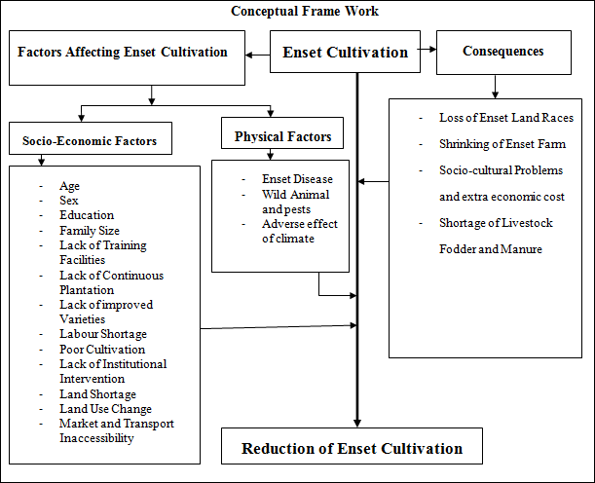
Figure 2.2: Conceptual Frame Work of Factors Affecting Enset Farming and its Consequences Source: Own Adopt Based on Survey (2017).

CHAPTER THREE: STUDY AREA AND RESEARCH METHODS

Description of the Study Area

Bio-physical Conditions of the study area.
The study area is located 6º10’.0’’ N to 6º 40’0’’ N latitude and 36º 30’.0’ E to 36º 50’0’.E longitude. (Figure: 1), and it is located at the northern tip of South Omo Zone and found South west of Uba Deberetsehay woreda, South of Oyda and Geza Gofa Woreda of Gamo Gofa Zone, North east of Basketo special woreda, North of Salamago woreda and West of Maale woreda of South Omo Zone.
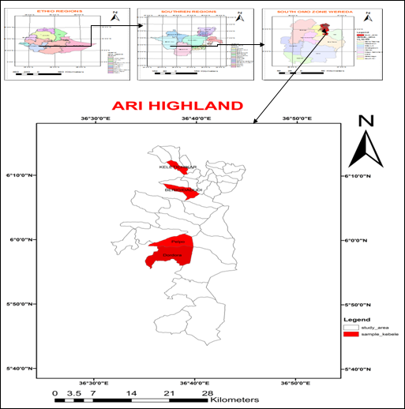
Figure: 3.1, the Study Area: Sources: Ethio-GIS

Topography Soil and the Drainage System
According to Tadesse Duressa (1994) as cited in Namsi Ardi (2016) topography of the study area is mainly hilly mountains and valleys between hills occupied by streams and rivers. The highest point in the study area are mountain Aager/ shangama/ (3418 meters), mountain Koita (3300 meters) and mountain Pelpa (3217 meters) above sea level. Regarding Soil type the major soil types are red clay loam and black grey loam the area is developed on highly weathered volcanic rocks (basalts) which are shallow to moderately deep and reddish brown in color.
Major rivers drains from the study area are Bezo watershed drains to east ward later called Woito River between the boundary of South Omo and Segen People’s Zones. Neri is watershed drains to south through Jinka town to Mago national park, Maki watersheds drains South Westward and Tembelsala watershed drains to Westward. And Ziftsala watershed drains to North West ward and when riches the boundary of South Omo Zone, Basketo special woreda, Geze Gofa Wereda (Gamo Gofa Zone) is known as Yirgino are major watersheds of the study area. All are the tributaries of Omo River.
Vegetation
The study area consists of varieties of plant species of vegetation mainly covered by highland remnant trees such as Bamboo (Aroundenaria alpine), Eucalyptus, and juniperusprocera, Haginan and Abyssinica are the dominant tree species. The grass type of the study area is temperate, mid-temperate and tropical highland grasses commonly grown in the study area.

Demographic and Socio-Economy
Population and Livelihoods
The Population of the study area is densely populated has 81,830 Male and 80,713 Female totally 162,543. Livelihood of the people in the study area is mainly mixed farming which involves in both cultivation of major crops and livestock.
Crop Production: Bimodal type of rainfall gives a wide opportunity for the study area to produce the crops and use the same land twice in a year (Belg and Mehere). However, Belg is the main growing season during which most of the total cultivable land is cultivated. The major cultivated crops in the area are vegetables like cabbages, potatoes are common. Cereal crops grown are wheat (Triticumsativum), barely (Hordeumvulgare), maize and pulses like beans, Peas pulses and oil seeds, are the most widely grown cereal crops. Enset (Enseteventricosum) is a major staple food crop for most Southern Western parts of the country and hence in the Ari highlands.
Livestock Production: Farmers in the study area pursue mixed agriculture in which livestock production is an important component. Livestock production is the major assets of the household and play an important role in crop production. Cattle, goats, sheep, horses, mules, are common live stocks in the study area.

Research Methods

Research Design
The research is a mixed approach which combines both quantitative and qualitative forms of data collection and analysis. The research design the research design is descriptive study design to provide an accurate and valid representation of the factors or variables relevant to the research question. Heavily depends on the research objective and nature of data needed. This design was selected as an appropriate method because it helps to legitimize the use of multiple approaches in answering the research questions, rather than restricting the researcher’s choice and it rejects rigidity. In this regard, the qualitative method is designed to interpret the data sources of field observation, interviews, focused group discussion/FGD/ and documents and reports, Whereas the quantitative method was mainly used for the data collected through questionnaire and to measure variable on sample of subject and to express the relationship between the variables.

Data Sources
An important primary data sources were Farmer household heads, DAs/extension workers/, key informants, woreda agriculture and natural resource development office expertise and heads. And also, secondary data sources like documents, reports, working paper, published and unpublished materials, books, web pages, journals, and magazines and satellite Imagery.
    - Instruments of Data Collection
Both Quantitative and qualitative data were collected by using the following instruments of data collection to generate valid and reliable data. These instruments of data collection includes:-
Semi-Structured Questionnaire
Based on information acquired from informal discussion with Farmers, key informants and field observation, semi-structured questionnaire was developed for household by the investigator. While the questionnaires give time, place and confidences for respondents to answer questions, and it is low cost in terms of time and money and free from bias this is why questionnaires were used.
The 8 enumerators who were the college/university / graduates who are fluently speak Ari-aff /Ari language/ were purposively selected to assist data collection. Enumerators were trained and tested for their clarity and understanding of the questions. Based on the feedback unclear and unrelated questions to local people and enumerators were modified and additional questions were also included. That was supposed to be necessary to gather relevant information on household characteristics, demographic, socio-economic, the current status of enset converge and farming systems and major causes affecting enset productivity in the study area.
Focus Group Discussions (FGD)
Focus group discussion is sometimes known as focus group interview, and it is a highly efficient technique for data collection since the amount and range of data increased by collecting from several people at the same time. It helps to gather information from people who cannot read and write. Based on this through FGD data of land use system, Farmers’ current focuses and major constraints related to enset farming was conducted by the researcher from selected participants including model farmers, farmers’ leaders, and extension workers in the study area.
Field Observation
Another tool for data collection is field observation technique which a researcher gathers first hand data on programs, processes, or behaviors being studied. This tool also makes the researcher himself is a witness and that gives more confidences. It also provides with an opportunity to openly explore the relevant topics and suggested that observation provides important information during all phases of study. However it is expensive but it is highly qualified and good enough to collect the relevant data. Therefore it was chosen as an appropriate tool for first hand data collection.
Based on this field observation was started while writing the proposal and continued into the whole process of this study. It was aimed to understand the local condition of the people of the study area in terms of their culture farm practices/land use practices and the status of the enset framing, resource utilization and others. During the walk, the researcher took notes and photo images on the land use practices and related enset farming problems, yield conditions, and topography in the study area. Side by side the different sampled peasant/household heads/ were observed purposefully.
Interview
With semi-structured questionnaire personal interview was carried out during field survey. It had an advantage like flexibility that helps to control the interview situations, results in high response rate and helps to collect supplementary information about the respondents. Using semi-structured interviews, the current land use /farming system/, enset farming practices and management, problems related to land use change to enset farming and major causes for the decline of enset quality production and coverage was evaluated. Hence, the interview was implemented with some key informants (seniors/elders household heads and rural development extension workers at field and woreda agriculture and natural resource development Office. 15 interviewee were participated that who were well aware about the land use change and enset farming system of the study area were purposely selected and interviewed.
Table 3.1 LULC Data Source
Satellite Imagery and GIS
The land use/ land cover of the study area computed based on the following table of data sources.
Sn | Satellite image | Year | Resolution | Band combination | Purpose
1 | GCP Land sat | 2017 | - | - | For accuracy assessment
2 | TM Land sat | 1985,&  1995 | 30m | 5,4,3 | To generate LULC map for 1985 & 1995
3 | Eight | 2015 | 30m | 6,5,4 | To generate LULC map for 2015
Source: Own Computed (2017)

Sampling Techniques and Sample Size
The study area has 34 rural administrative kebeles and agro ecologically all of them are in highland (Dega). From 34 kebeles 4 kebels were purposively selected because they have the same agro-ecology and dense enset cultivation is cluster of the study area. Based on this, selected sample were Berdega, Dordora, Kelet-chiqar and Pelpa kebels. To determine sample size of the studied households’ systematic sampling technique was applied. The name list of household heads was alphabetical listed and using formula /K=N/n/ = 2792/178 = 16. Accordingly every 16th interval was sampled.
Lastly, sample of household heads were determined to select 10% of the sample population. This is because; the total population of the sample site is less than 10,000 Lewis (1977). Based on this, 178 sample household heads were determined out of 2791 households. Thus, selections of sample household heads were determined by using the formula. The estimated response rate is 85.5% i.e. out of the base sample size, about 85.5% was expected to respond and 14.5% was non-respondents due to different reasons. The research was made using the following formulas often used in most social science researches for sample size determination when the target population is less than 10,000 Lewis (1997).
n = (Zα/2)2 q (1-p) /d2
Where:
n = is the desired sample size (when the population is less than 10,000
Zα/2 = is the standard normal deviate at the required (95%) confidence limit (1.96).
p = is 0.145(contingency for non-response rate or Proportion of the target population to be included in the sample).
q = is 1- p (1- 0.145=0.855)
d = is the level of statistical accuracy (margin of error) set usually at 0.05;
N = is the total number of the household heads using the above formulas, the desired sample size (n) is calculated as follows:
n= (Zα/2)2 p (1-p) /d2 Therefore n = (1.96)2 (0.145*0.855) / (0.05)2 = 190
Substituting the value of n (190) in the second formula the actual sample household number is calculated as follows:
nf= n/1+n/N = 190/1+190/2791 = 177.9 178 sample household heads.
In the study, 178 sample household heads are selected (Table -1). To generate relevant information, the sample households are proportionally selected with respect to the number of total households of each kebele through the following formula (Thomas, 1991):
n = N (S)/ΣN
Where, n= the number of required samples of each kebele;
N= Total household heads of each kebele;
S= Total sample size of the four kebeles to be treated.
ΣN= Total household head of the study area.
Total household head of the study area (ΣN) =2791, selected sample size(S) = 178, Details of sample size is presented in (Table 3.2).
Example: Bergeda kebele = 560(178)/2791 = 36

Table 3.2 Sample Size Households.
Kebele Name | Total household heads | Total sample household heads
Kebele Name | Total household heads | Male | Female | Total
Bergeda | 560 | 34 | 2 | 36
Dordora | 1120 | 65 | 6 | 71
Keletchiqar | 485 | 28 | 3 | 31
Pelpa | 626 | 35 | 5 | 40
Total | 2791 | 162 | 16 | 178
Sources: Own computed (2016).

Methods of Data Analysis and Interpretation
Both Qualitative and Quantitatively data collected by using semi –structured questionnaire and the qualitative responses were summarized, categorized and coded. The quantitative generated data by semi-structured questionnaires were organized and entered in to SPSS software version 20 for analysis of various parameters. In this case descriptive statistical analysis was carried out by frequencies, percentage and chi-square test. Information obtained from field observation, by using semi-structured interviews with key informants and focus groups discussions were written in the form of verbal/narrative.
To validate the accuracy and reliability of the findings triangulation of different data sources and examining evidences from field observation and conduct prior to the formal questionnaire survey. Semi-structured survey questionnaires were also checked by pay late questionnaires in addition to ensure the validity and reliability of the generated data. The secondary data /written documents/ were referred after conducting primary data in this study.
Land Cover Dynamics
Landsat TM 1985, 1995, and 2015) was used to generate land use/land cover dynamics of the study area. Different image rectification, enhancement and classification techniques were applied on the raw image .This has allowed the extraction of information on land use/land cover condition and quantification of changes, and its rate over the past 30 years using GIS and Remote sensing analysis. The land cover conditions of different periods have been spatially compared the rate and quantity of changes.
CHAPTER FOUR: RESULT AND DISCUSSION
In this chapter, data which were collected regarding socio-economic characteristics of the sample respondents and farm land holding, the status of the coverage in the study area. In addition, the empirical part of this study were explained about enset farming systems, land use/land cover dynamics, major causes for enset farm decline and affects productivity and effects of current agricultural land use on enset farming in the study were presented and their results were discussed.
  - Demographic and Socio-Economic Characteristics of Households
Sex and Age Distribution of Households
The distribution of sex and age characteristics and its result discussion was presented as follows (See Pi-chart 4.1).
Chart 4.1: Sex Distribution of Household Heads
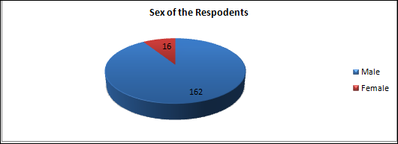
Source: Own computed (2016).
Regarding sex of the respondents where 162-male and 16-female total 178 respondents were involved as presented in Pi-chart 4.1. From this result one can conclude that, the proportionality of male is significantly dominant than female. In this particular case of enset production, female Farmers play a primary role in every aspect of the farming and production process. Therefore, it is important to support women Farmers.
While, traditionally men and women are participating differently in agriculture, in most causes women holding care for enset production processing and marketing. Similarly the finding of Almaze Negash (2001) confirmed that, women have tremendous knowledge of the diversity in enset and their preference for the different clones also varies slightly from that of the men. They have the traditional wisdom in describing many of the qualitative aspects of the crop. The females’ plays an important role in overall management, selecting and preserving selective enset varieties. And also they have better indigenous knowledge of enset disease and other pest managing to enhance enset cultivation in the study area.
In addition to this Adimasu Tsegaye and Struik (2002) study also confirmed that Women control the enset races and are also responsible for harvesting and processing. They have a well-developed knowledge of the enset crop and its biodiversity. Therefore, a gender-sensitive analysis is needed to fully understand the dynamics of enset biodiversity. However, women’s knowledge for the keeping and management of enset landraces is undoubted. In contrary, every concern of enset farming is only left for women, particularly in the study area. While, male Farmers given more attention for quality production of marketable annual crops than enset cultivation. Due to this female Farmers hold burden about every aspects of enset farming and the overall cultivation system also has contributes for the decline of both cultivations and productivity of the in the study area. This also needs another attention from male farmers.
Graph 4. 1: Age Distributions of Households
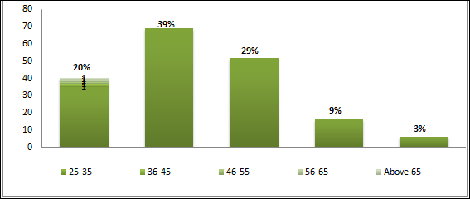
Source: Own Computed (2016).
From Graph 4.1 one can understand that, majority of the household heads are at their working age, which is nearly 88% of the studied household, are age below 55. This indicates that the study area is characterized by active and working population. The group discussion results were also confirmed that, there is high population increase in their localities. According to discussion result, the young’s were asking their parents for farmland to lead separate life.
The land fragmentation is a big problem that, it is difficult to be easily accessed to holding land for farming, grazing and settlements in the study area. Similarly the findings of Stephen (2002) indicates that, the number of active population adults (persons age 15-65) indicates household labour availability, which should, increase land use decision making attitude and subsistence demand and thereby correspond to larger production systems and cropland and pasture.
During the field observation and data collection, the researcher observed farmland was highly fragmented and the settlements are highly compacted. This indicates that how the population pressure results land fragmentation is a major challenging for sustaining the land use system in the study area. . Because of this, the Farmers’ need more farmland and also tend to produce crops with high market values of annual crops rather than producing crops like enset. Therefore it has its own contribution for the decline of the enset cultivation system.
Family Size of the Households
Pi-chart 4.2: Family Size of the Households.
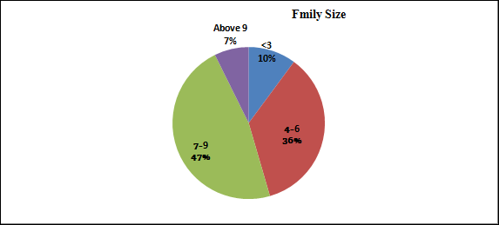
Source: Own Computed Socio-Economic Survey (2016).
The family size of the Farmers as depicted in Pi-chart 4.2, is about 90% of the studies households have more than 6 family numbers. Significant number (47%) of the studied household’s has 7-9 members in their house. To fulfill the consumption needs of the household, Farmers are expected to produce food within short time interval which contradicts with the time to be taken by enset to be harvested. Moreover, increase in the family size coupled with land shortage urges the household to feed their enset tree at its early age. So that, this problem result decline in enset coverage and diversity.
Similarly the finding of Abraham Shumbulo et al., (2012) indicates that, when the higher the family sizes the frequent will be enset feeding that, in turn results in decrease of overall enset production system. The research finding of Melese Mariyo et al.,(2014) also support this research finding, that, the focus on fast growing cash crops by young generation is also another emergent challenge. This indicates that, the youngsters gave more attention for annual crops which has attractive market values than enset cultivation. That has low demand and even lacks preference from the customers.
The land shortage as a result of high population pressure as well as the traditional rain fed agricultural farming system together makes difficult to produce more for family consumption and other socio-economic needs. The rapid population increase combined with desperate poverty and rising levels of consumption forces Farmers to search more land which, resulted in depletion of natural resources on which the livelihood of present and future generations depends on. And also, the growing trends of population and consequent demand for food, energy, and housing have considerably altered land-use practices and severely degraded the environment. However, enset is drought tolerant and important to solve food insecurity currently it is victimized by Farmers through replacing with annual crops for fast and immediate production.
Educational Characteristics of Households
Sample respondents were grouped within five levels of education categorized as not educated, read and write only, Basic education (1-8) secondary school (9-12) completed, certificate (TEVT), diploma holder and above. (See Graph 4.2) According to Meskerem Abiteka (2011) finding educational status of the household particularly determines capacity of household to enhance agricultural production and result in better household food security condition. The studied household heads educational characteristic has computed in the Graph below.
Graph 4.2: Educational Characteristics of Households.
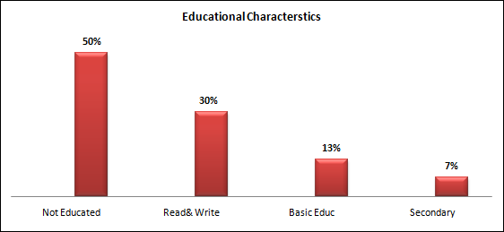
Source: Own computed socio-economic survey (2016).
About 50% of studied household heads were not educated. The management system of enset farming specially related to current environmental challenges become difficult to resist, because of lack of awareness for preventive mechanisms. Through awareness creation, improving their indigenous knowledge and the copping strategies are important to mitigate the challenges of enset farming. And also the Farmers during focus group discussion confirmed that, they tend to farm well and gives attention for annual crops better than enset farming.
According to field observation and field notes results the farming poor and needs improvement to enhance the productivity enset cultivation. While, the enset farms left without care and good management. And also, farmers tend to produce annual crops better than, other perennial crops like enset. This research finding is similar with findings of Meskerem Abiteka (2011) that, educational level of household heads has a great role for improving the agricultural production and land management system.
  - Land Use/Land Cover Dynamics and Pattern (both Temporal and Spatial from 1985-2015)
The distribution of land use/land cover units of the study area is categorized into four classes. These are forest land, farmland, enset land and grazing land. The four data of land use/land cover classification map of the study area is presented in Figure 4.1. In addition to this, the statistics of land use/land cover were computed to detect the nature of the changes based on the years 1985, 1995, and 2015 dates of imageries. The areal extent of each land use/land cover types with respective percentage is presented in Table 4.1.
Table-4.1, Land use/Land covers class of 1985-2015
Name | Area 1985 (ha) | % | Area 1995(ha) | % | Area2015(ha) | %
Farm Land | 2114 | 30.1 | 5011 | 71.3 | 5867 | 83.5
Forest | 1583 | 22.5 | 1148 | 16.3 | 336 | 4.8
Grazing land | 305 | 4.3 | 489 | 7 | 742 | 10.6
Enset | 3025 | 43.1 | 379 | 5.4 | 82 | 1.1
Total | 7027 | 100 | 7027 | 100 | 7027 | 100
Source: own computed, Arc GIS.
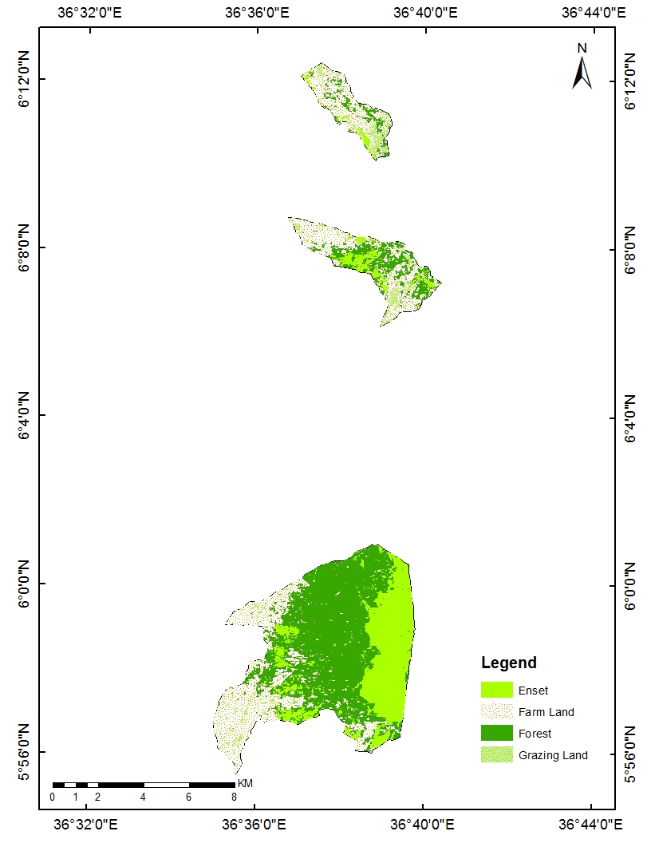
Figure:4.1: LULC map of 1985/Source: Own computed Arc GIS
According to1985 land use/land cover data dynamics of Enset land is 3025(43.1 farmland 2114 ha (30.1%), forest land 1583 ha (22.5%), and grazing land 305 ha (4.3%), respectively (Table 4.1 and Figure 4.1). Based on this result it could be concluded that, the largest area was covered by enset land or enset cultivation very large in the study area in 1985.
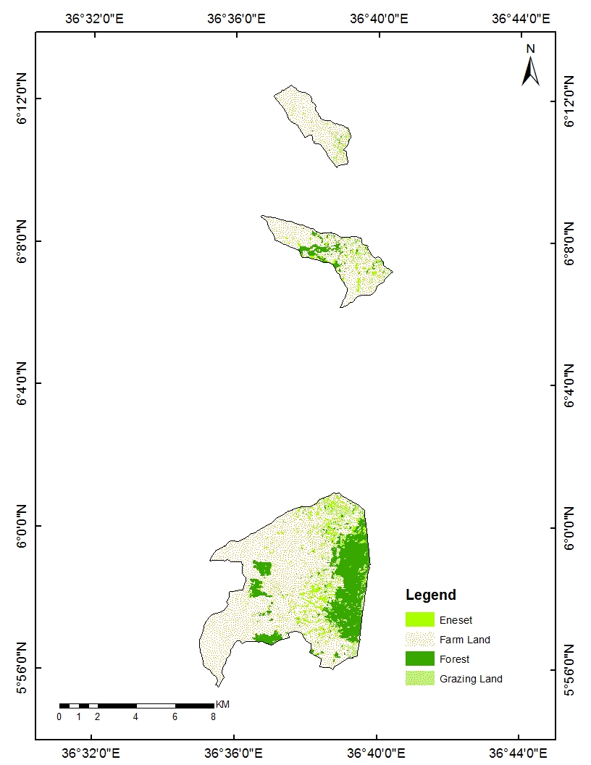
Figure: 4.2. LULC Map of 1995/ Source: Own computed Arc GIS
According to, Table 4.1 and Figure 4.2, the land use/land cover dynamic Landsat images of the land cover classes for 1995 indicates that, farmland 5011 ha (71.3%) forest land1148 ha (16.3 %), grazing land 489ha (7%) and Enset land 379 ha (5.4%). This image data indicates that, farm land radical increase within 10 years from 2112 ha (30.1%) to 5011 ha (71.3%) the rest to land use classes that, of forest and enset land covers were inversely declined.
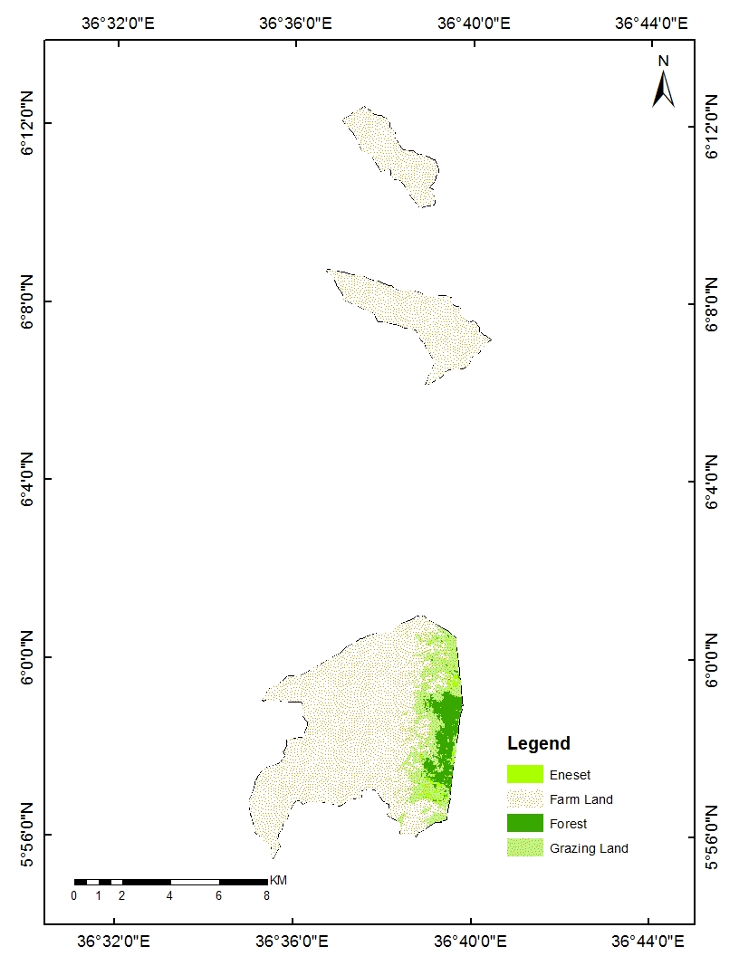
Figure:4.3. LULC Map of 2015/ Source: Own computed Arc GIS
The 2015 land use/land cover dynamics of the total study area assessed by using Landsat were enset land 82 ha(1.1%), forestland 336 ha (4.8%), grazing land 742 ha (10.6%), and farmland 5867 ha (83.5%), respectively (Table 4.1 and Figure 4.3).But the area was inversely proportional to enset land, which is the least significantly covered 81ha (1.2%). This indicates that; how the enset cultivation was declined over time comparing to the other land use/land cover of the study within 30 years.
Land Use/Land Cover Dynamics from 1985 to 1995
Table 4.2 and Figure 4.1 indicate that, the land-use/land-cover pattern and change between 1985 and 1995 indicates that enset cover in years between 1985 and 1995 dramatically decreased. As a result of this,3025 ha (43.1%) of land of area, which was covered by enset in 1985, was changed to other land use/land cover types by 1995 declined to379 ha (5.4%). This indicates that, 2646 ha (38%) of the total enset land was converted to other land use type. that refers to rapid conversion of enset farm with other land use and crop substitution.
According to the same discussions presented data, the area coverage by forest was 1583 ha (22.5%) was reduced to 1148 ha (16.3%) between the years 1985 to 1995 by 435 ha (6%). Previously land covered by forest was transformed to other land use/land cover types. On the other hand, the farm land increased from 2114 ha (30.1%) to 5011 ha (71.3%) compared to other land use/ land cover types .During the period 1985 to 1995, the total area covered by grazing land was increased from 305 ah (4.3%) to 489 ha (7%). Agricultural land was the first largest extended during this period. This Landsat image data indicates the agricultural land use the leading land use type in the study area. As a result indicates that, there was about 2897ha (41.2%) of land was added as agricultural land during this year interval. The grazing land was also extended during this period that 184 ha (2.6%) of the land previously not part of the grazing land was additional added to this land use classification. Forest and enset coverage was declined during this year intervals.
According to the central point of discussion the enset land cover is significantly declined in this period (1985-1995). As indicated Landsat image data, enset farm was reduced from 3025 ha (43.1%) to 379(5.4%) with land use difference about 2646 ha (37.7%) of enset land those year interval. From this result indicates that, the enset farm in the study area is significantly affected by the LULC of the study especially by high expansion of farm land.
Table 4.2.Land Use /Land Cover Dynamics Trend from 1985 to 1995
LULC Categories | 1985-1995
LULC Categories | ha | Percentage
Farm Land | +2897 | +41.2
Forest | -1204 | -6
Grazing land | +184 | +2.6
Enset | -2648 | -37.7
Land Use Data source: Own Computed Arc GIS

Land Use/Land Cover Dynamics from 1995 to 2015
The Table 4.3 and Figure 4.2 indicates that, the total forest cover between the years 1995 to 2015 was kept shrinking. Because of the clearance of the forest land for the expansion of grazing land, settlement and agricultural land, use of wood as fuel/energy/source, furniture and construction. This implies that 812 ha (12%) of the total land cover forest was reduced because of human intervention for different purposes. In the same year interval the area covered by enset was reduced by 297 ha, which was about 4.2% of the same land-cover was changed in 2015.
According to the result data the rapid decline in forest cover from 16.3% to 4.8% and conversion/changes/ into farmland, grazing land and settlements areas inversely to the increment in cultivated land because of the rapidly growing demand for cultivated land. On the other hand, during this period (1995 and 2015) the total area devoted for farmland was the most increasing and made it the largest land use/land cover types of the area. That indicates, it was the most leading land-use type in the year1995 and it was again extended its dominance in the year 2015 about 5874. 860ha (12.2%) of land which, was not initially part of the farm land was added to this LULC and It was estimated about 84% of land in study area.
The grazing land was the second largest extended during this period, which the total area coverage between the years was about 739 ha in 2015,as a result of this, 253 ha (3.6%) of land was added to grazing land in 2015. Besides this, the enset land cover between 1995 and 2015 was changed to either of other annual/perennial/ crops/ settlement and grazing land. The land previously covered with enset in 1995 was about 379 ha /5.4%/ now which was reduced to about the 82ha (1.2%) that was totally decreased by 297 ha (4.2%) of enset land.
Table 4.3: Land use /Land Cover Dynamics Trend from 1995 to 2015
LULC Categories | 1995-2015
LULC Categories | ha | Percentage
Farm Land | 856 | +12.2
Forest | -812 | -12
Grazing land | 253 | +3.6
Enset | -297 | -4.2
Sources: Own Computed Arc GIS
Land Use/Land Cover Dynamics from 1985 to 2015
According to the Table 4.4 and Figure 4.3 the farm land in 1985 was 2112 ha (30%) to 5867 ha (83.5%) had shown significant change. About 3753 ha (53.4%), previously a land which was not part in 1985 was converted to farmland in 2015. The second land use type shows change increment was the grazing land that, was shown change from 309 ha (4.4%) to 739 ha (10%). It had increased with 437 ha (6.2%) of land.
The land use/land cover change considering range time from 1985-2015. During this year intervals the area covered by enset land, shown a remarkable reduction from 3025 ha (43.1%) to 82 ha (1.1%). This result shows that, 2943 ha (42%) land previously covered by enset is changed to other LULC type. On the hand land covered by forest in 1985 was about 1583 ha (22.5%) and in 2015 this land covered by enset decline by 336 ha (4.8%) and the difference is about 1247 ha (17.7%). The Landsat result above implies that, the land forest land was changed/reduced/ to other use type of land. The farm land had shown inversely a significant increase.
Table 4.4: Land Use /Land Cover Change Dynamics Trend from 1985 to 2015
LULC Categories | 1985-2015
LULC Categories | ha | Percentage
Farm Land | 3762 | +53.4
Forest | -1247 | -17.7
Grazing land | 437 | +6.2
Enset | -2943 | -42
Sources: Own Computed Arc GIS
Table 4.5: 30 years land use conversion Matrix Result
1985 |  | Farm Land | Forest | Enset |  | Grazing Land |  | Total
Farm Land |  | 2101 | 0 | 0 |  | 13 |  | 2114
Forest |  | 597 | 332 | 70 |  | 584 |  | 1583
Enset |  | 2865 | 4 | 12 |  | 144 |  | 3025
Grazing Land |  | 304 | 0 | 0 |  | 1 |  | 305
Total |  | 5867 | 336 | 82 |  | 742 |  | 7027
The land use/land cover change matrix indicates that farmland shows significant increase than other land use type in the study area. Based on this Matrix result, 2865,597,304 hectares of, enset, forest and grazing land respectively were converted to farmland. This result enset farm shows a drastic conversion to farmland. On the other hand only 4 ha of enset land were converted to forest and 332ha of forest land is unchanged. As depicted table matrix result 70 ha of forest land was converted to enset farm and had only 12 ha of enset farm land are unchanged. The land use which shows increment is grazing land that 584, 144, and 13 heaters of forest, enset and farmland were converted to grazing land and only 1ha of the gazing land was unchanged. Totally from the matrix result we can understand, during those 30 years significantly converted to other land use type is enset farm land.
The overall accuracy was weighted by the number of sample/pixels in each class that is the sum of all samples on the diagonal divided by the total number of samples. Based on this, the accuracy for all land use/land cover classification of 1985, 1995 and 2015 was performed. Accordingly the analysis and change detection of forest land, enset land, farm land and grazing land are 91%, 81%, 80% and 100%, respectively. The land use/land cover map of the year1985, 1995, and 2015 has been classified with an overall accuracy of 87.5% respectively (see Appendix 2).
However, most of the empirical evidences indicated that land use and land cover change and socioeconomic dynamics have a strong relationship; as population increases the need for cultivated land, grazing land, fuel wood; settlement areas also increase to meet the growing demand for food and energy, and livestock population. Thus, population pressure and weak management are considered as the major causes for the land use and land cover dynamics and degradation of natural resources in Ethiopia.
According to recorded Landsat images enset land and the farmland has a show inversely change. The land use/land cover change analysis concluded that, how the enset farm was significantly declined. Finally this finding is supported by research studied finding of Teshome Yirgu ( 2016) the case Baso watershed in Gamo highlands, land use/ cover change detection analysis depicts that, there was a substantial dynamics all cover types; mainly woodlands, grasslands and enset lands, which was badly damaged. But agricultural land is still leading to increased runoff, erosion, flooding, and resulted in declining soil infertility. Under condition of ever increasing rural population and degraded soil, in the area enset is considered as the major food security tree crop, beyond its environmental and socio-cultural significance.
  - The Current Status of Enset Farm
The enset farm in the study area is majorly cultivated co- staple food crop. However, currently this crop is declining thorough time comparing to other annual crops.
The survey data result, 83% of the sample populations were believes that enset farm is declining (Graph 4.3). According to studied households heads population growth and the subsequent land scarcity, this again leads the people to food shortage. During the field survey, it was observed that Enset population and coverage was declined. On the other hand, the annual crop farm is increasing rapidly overtime. During the group discussions Farmers were asked and confirmed that, the enset farm is declining in coverage. However, enset is staple food for the study area community and enset similar with enset cultivating rural communities of the country. Nowadays the enset farms have been substituting by other monoculture crop types.
Graph 4.3: Enset Farmland Coverage
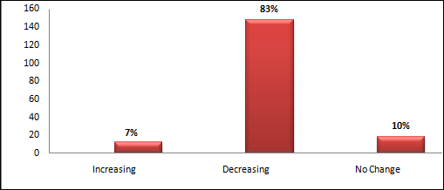
Source: Own Computed Socio-Economic Survey (2016).
They also told that “we had born with enset” why the newly born child feed squeezed enset water before breasting. The mother herself first feed prepared food made of corm with cabbage locally called (Burbur) before she had taken any other prepared food. However, at present it calls for warning that not only falling to food insecurity, and but also brought challenges socio- cultural life of the people.
From the result discussion one can conclude that, the declining of enset coverage a major problem of the enset farming region of our country and the Ari high lands has also experiences the problem of declining enset in coverage and diversity. This research finding agreed with Kedir Abdela (2016) finding confirmed that, fighting for their existence Farmers always prioritize their immediate copping needs, which can change the whole farming/land use systems.
  - The Major Causes for the decline of Enset Farm Agriculture
In the Ari highlands enset farm size and input-output (yield) is declining over time. There are major factors that affect the farming system enset in the study area. Available data and studied households identified various factors as follows.
Lack of Continuous Plantation
As to the annual planting of enset, 75.8% studied households were not continuously planting enset comparing to other crops. From this result, one can conclude that, most of the Farmers in the study area are not continuously planting enset. During FGD the Farmers’ reason out, there are different problems especially time constraints, labor shortage, and even some problems with lack of attentions. Hence, the key informant interview result also confirmed that, most of the time Farmers spend more time at annual crop field for farming and management, better than perennial crops like enset. In this regard Farmers were not planting enset consistently that resulted gap between the enset plants. If there is no constant plantation and expansion the enset farm become declining. Therefore lack of successive plantation affects the enset farming system and its maturities’ for harvesting for both home and marketing; this is why Farmers have been harvesting immature enset.
Research finding of Tesfaye Abebe (2013) similarly confirmed that, growing enset until it attains full maturity enables Farmers to benefit from its yield potentially needs time. To this effect, the principles of successive rotation cycles used in forestry can be applied to manage and sustainably harvest enset production. To get continuous and sustainable food consumption from the enset yield, there is a need for successive planting and transplantations of prepared enset shoots.
Farmers delay planting at the start of the rainy season partly due to problems of land preparation which cases decrease enset coverage and farm lands. On the other hand, if there is no successive plantation, the Farmers also using immature enset production for home consumptions and even for marketing. Therefore lack of successive enset plantation is a serious problem and as one of the main cause for the decline of the farming system in the study area. Finally the research finding alarms continuous and sustainable food production from the enset is become questionable in the study area. While during the field survey it was observation that, enset shoots which propagated to plant in a newly prepared place were left without transfer (Figure 4.4).
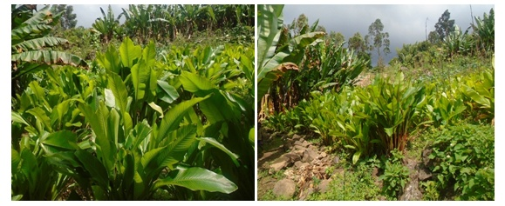
Figuer-4.4: Propagated Enset Shoots Prepared for Transfer
Lack of Improved Varieties
There is a nursery site which is owned by Jinka Agriculture research center. According to the project document, it was established to collecting, preserving and redistributing the species of the different varieties among the Farmers. In addition to this, the nursery site as a field laboratory within the study area for Farmers, government bodies’ individual’s researchers.
About 78.1% studied household heads were replied that, there is a nursery site in their locality. The studied households also confirmed that, this acquired information about the nursery site is through informal exchange of idea among them. This indicates that, established nursery sites were not formally introduced by the concerned bodies. To this end, discussion and interviews were holds with the key informants and agriculture extension workers also confirmed that, they were informed about these sites. However, the aim and functions of this established sites is not formally well known within the community.
The research sites of both Jinka agriculture research center and Mester community enset variety preservation and field laboratory for the community established were not well managed and functional (Figure 4.5). However, Enset cultivation has huge socio-economic and environmental importance and it is environmentally friendly crop. Despite such importance of the crop, enset production in the study area has little attention from Farmers, local government, research institutes, development agencies, individuals and researchers and it is left poorly by all bodies.
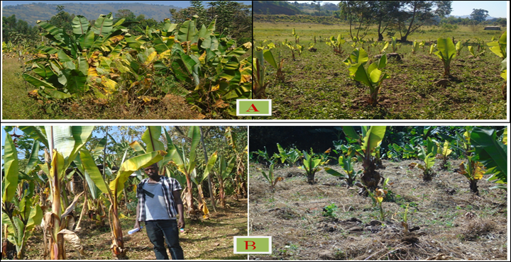Figuer-4.5: Enset Varity Preservation Nursery Site / (A: JARC nursery site and B: Metser community nursery site)
As to the introduction of new varieties, 98.9% of studied household heads replied that, improved enset varieties were not distributed in their locality by any other bodies. From the above responses it can be concluded that, the established nursery sites and any other concerned bodies were not carry out their responsibilities for the improvement of the enset productivity in the study area. Currently these sites were not well threatened by the responsible bodies (JARC and Mester Kebele Administration) (Figure 4.3).
The participants of the group discussions and key informants also ensured that, in their localities this established nursery sites were no helping them to improve their enset farming system. As mentioned by Farmers, they need introductions of improved varieties and other technical assistance to enhance their enset productions. In addition, during field survey it was observed that, the nursery sites were not fenced and are left open for destruction by grazing herbs (domestic and wild animals) (Figure 4.3).
Currently this nursery sites are not also model and used as demonstration site in the community. Because, on the ground its management and enhancement is very poor and not well treated. To improve the enset productivity, introduction of improved varieties is not only for the study area but also for enset cultivating parts of the country now a burning issue. Especially the study area is currently endangered for its declining of enset coverage and productivity. Due to this, most farmers were left farming the enset and tend to farm other cereal, vegetables, and cash crops.
Lack of Training Facilities
It is well known that, education and training are among the most important instruments that enable Farmers to improve practical and imagination of their capacity to enhance the enset cultivation. About 98.3% studied household replied that agricultural extension agents had not gave any training and advice to about enset cultivation to improve productivity and over management of enset farm. The extension workers prefer to focus for the annual/ temporal/ crops. FGD and key informant interviews result confirmed that, they didn’t get any training and advice about enset farming/proper management to improve its productivity, and preserving the varieties.
This indicates that, little attention is given to the farming system of enset in the study area. Lack of skill training about good management, and copping strategies for the current climate change to improvement of enset production is significantly affects the enset cultivation. The chi-square test results (p value.0.037) also confirmed that, at the significant level of p<0.05. (Appendix 3)
The research findings of Adimasu Tsegaye and P.C (2002) also similarly confirmed that, the Ethiopian government has focused its agricultural research and development efforts mainly on high-yielding annual crops that can be marketable. Enset has both ecological and socio-economic importance especially in enset growing region human and livestock life is impossible without it. Despite such importance of the crop, enset cultivation in our country has received little attention from research and development. The attention of the government towards encouraging the adoption of these new technologies market oriented productions like cereals, pulses, and vegetables has resulted in a shift from enset- to cereal-based agriculture.
As a result, awareness creation and trainings more focuses on this market based crops. Currently some enset growing regions have experienced famine in recent years, something unknown to past generations. This shows that, still little attention was given to enset farming comparing to that of market oriented annual crops. However, enset has the drought resistant nature and sustains the food security.
Labour Shortage
Enset farming is one of the labour intensive agriculture which demands long hour engagement and follow up starting from plantation to harvesting. Enset cultivation and its harvesting also carried out in manual labour and traditional material which made difficulties the farming systems. And this is not only challenges of the production but also, affects the Farmers attitudes and interest towards enset cultivation comparing to other annual crop production.
As the house hold labour of the studied household is concerned, most households (92.1%) have available labour sources but these available labour forces are not intensively working on enset fields. Moreover FGD and key informant interviews result also confirmed that, most of the family members were not participating in the enset farming. Labour shortages and lack of full family participation is significantly affecting the enset production. Statistical result confirmed that, the chi-square test significant (p<0.05) (See Appendix 3). The finding of this research is agreed with (Abraham Shumbulo et al., (2012) study finding confirmed that, labour shortage is a major challenge for enset production.
Land Shortage
Land is one of the most essential natural resources for the survival and prosperity of humankind, and it is important where human activities take place. It is also the source of materials needed for these activities. Agriculture is an activity which relay on land and the availability of sufficient land is very important that, majorly determine the farming system. According to FAO/UNEP (1999) as cited WGEA (2013) is a limited resource with increasing substantial demands placed on it. As a result of the increasingly heavy Pressure on land resources, agricultural production declines, the quantity and quality of land deteriorates, and there is increasing competition for access to land.
About 98.9% studied households believe land shortage could affect enset farming system. From this data one can conclude that, land shortage is a major factor for the decline of enset farm. According to FGD and key informant interview, land fragmentation due to the population pressure and expansion of the annual crops creates a pressure on enset farming system. During the field survey it was observed that, there is a high expansion of the annual crops and land was highly fragmented.
This research finding is in agreement with the same research finding of Abraham Shumbulo et al., (2012). Then the land shortage results in decline of enset coverage, cultivation and harvesting, due to this Farmers harvest immature enset plants for home consumption and marketing. This indicates that, the expansion of annual crops together with population pressure created land fragmentation is a main challenge for enset farming. The shortage of land affects not only the expansion of enset production but also, the maturity for harvesting, obtain quality yield.
Planting Enset under Tree Shade
As to the Planting enset under tree shade and its effects to productivity about 73% studied household heads replied that, planting enset under tree shades (old enset, coffee, other like, avocado tree and cardomne around the enset farms is common practices in their localities). The FGD and key informant were also confirmed that, Farmers plant the young enset plants under tree shades and even under the old enset plant. During the field survey it was also observed that, the enset plants were planted under tree shade and along the road. Therefore the enset plants cultivated along the road were also not well fenced and managed due to this it was continuously damaged by herds.
According to the key informants interviews result the major reason for planting the enset under old enset is for replacing the young at place where they harvest the matured one for its moisture. On the other hand because of the land shortage and low moisture fertility of the other crop fields the Farmer prefer to plant around and under the tree shades. Therefore farming/planting/ enset under tree shade is significantly affecting the yielding condition of enset which is related to productivity and quality of the products statistically significant at p<0.05 (Appendix 3). The cash crop like cardomne which, planted around the enset farm had extended and covers all farms of the enset land. Finally this cardomne had covered the whole enset farm because of its invading nature. Farmers’ planting this crop like cardomne and coffee around the enset farm is for its moisture under the enset and around the farms (Figure 4.6).
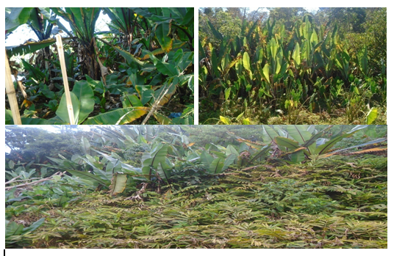
Figure, 4. 6: Enset Plantation under Tree Shade
Poor Cultivation System
Poor cultivation refers to lack agronomical good management of enset farms in terms manuring, composting, and fencing the farm to keep from animals damaging the plantation and following the yields. About 82% of the studied households replied that, enset farming system in their locality is very poor. The FGD and key informant interviews result confirmed that, the cultivation system in their locality is very poor for enset farms, comparing to the other cop farms.
Different reasons like time constraints, shortage of labour, and giving more attention to cultivation of annual crops which has high market values are major reason for poor cultivation. Some of the key informant Farmers told that, they have no extra time to manage the enset farms. From this point of view it concludes that, for some according to some Farmers managing the enset farm as extra time job. On the other hand, most of the Farmers are not fertilizing the enset land by adding home product wastes /refuses/ and manuring. Instead of fertilizing the enset farm they use these organic fertilizers for marketable vegetables like onion, cabbages to produce quality products to earn interesting income. This indicates that, Farmers giving more attention and management for the vegetables and crops with high market values instead of enset (Figure 4.7).
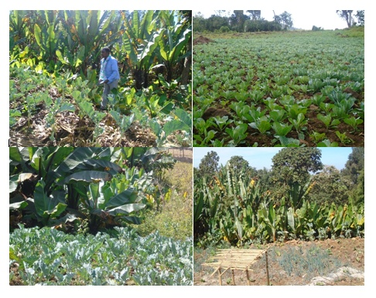
Figure: 4.7, High Market Value Vegetables under a Good Management
According, to observation and field note there is a poor farming and management system in the study area. This finding is supported by the Abraham Shumbulo et al.,(2012) confirmed that, poor agronomic and traditional cultural practice such as frequent of transplanting, spacing, fertilization, pruning and so on are done blanketly that, significantly affects both production and productivity of enset. Similarly, poor agronomic is the major problem that, contributes for the declining of the enset productivity in the study area.
During the field survey it was observed that, enset farms were left without fencing and good management as a result, the enset plants were damaged herds by grazing herds (domestic animal, and wild Animals) and some other pests and rat mole. On the other hand, the Farmers were not well managed, by digging, and adding composts to fertilize the enset farms. The farming system is poor which is currently not only difficult to get good production, but also its sustainability for further socio-economic and ecological importance of this crop in the study area is under question.( Figure 4.8).
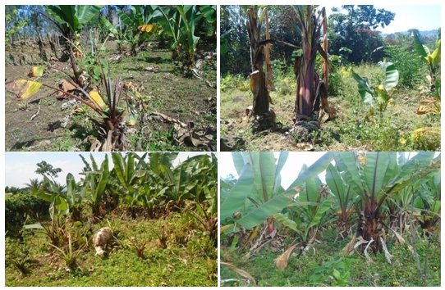
Figuer-4.8: Poor Farming System/
Lack of Institutional Support
Involvement of any Organizational institution is very important to improve the management and productivity, as well as to enhance the total faming. About 99.4% of the sample household heads replied, no institution had involved to improve the enset cultivation. This result indicates that, how enset farming lacks government, NGOs, individuals, research institutions intervention to improve the enset productivity. Lack of institutional intervention has its own contribution to change the attitudes of Farmers’ towards annual crops.
Enset has important role for environment, food security and socio-economic benefits. Besides this, still it lacks care and management to improve the productivity and preserving the diversity of this crop at country level and particularly in the study area. Similarly studied research finding of (Melese Mariyo et al., 2014), also confirmed that the government and community participation in order to implement enset disease protection at local level, development workers should have expertise on enset landrace diversity management so that, they may support Farmers.
This finding is in agreement with Abraham Shumbulo et al., (2012) the current status of enset farming area calls for the involvement of government officials, research professionals from universities and research centers. And also the development organizations (GOs and NGOs), development agents and Farmers collective actions to save gene erosion (loss of diversity), exploit the crop potential and to extend its production. Eventually, it could be concluded that, to protect and conserve enset landrace diversity, scholars in ethno botany, microbiology and genetics should work together for a realistic workable solution.
Damage of Wild Beasts and Disease
Wild Beasts and Pests
Wild animals are common in the study area, some of the most known wild animals attack enset plant are mole rat (Heterocephalus glaber) locally (Ocha), nematodes (phylum nematd) locally (Moti), porcupines (Erethizon Dorsaum) locally (Girsha) and wild pigs, locally (Gudm) are seriously damaging enset. The Farmers were described these issues as common problems that, were not a recent concern in their locality but, still they faces challenges to control it. According to survey data result, all studied households confirmed that, currently wild animals and pests are major problem that, affecting enset cultivation and productivity.
Also the FGD and key informant interviews result ensured that, wild animal and pests are one of the main causes for the decline of enset yield, because, it is very tiresome to protect those animals. Statistically significant at p<0.05 indicates that, enset attacking wild animals and pests significantly affecting the enset cultivation. The damaging wild animals and pests in the study area are one of the major factors for the decline of enset cultivation those needs attention for its preventive solution. The research finding is in agreement with studied research findings of Teshome, (2016) and Melese et al.,2014), that, wild animals and pests usually attack enset clones whose corms are sweet, which met Farmers’ immediate consumption needs.
Enset Diseases
According to survey result about 99.4% of household heads were accepted that, enset disease in the study area is a major challenging problem for the enset cultivation. FGD and key informant were agreed that, today enset disease like Bacteria Wilt locally /Durqa) and Root Mealy burg) locally called /Buqa/Moti) are highly affect the enset yields and productivity. According to FGD result, the contaminated farming tools are the most important factor that plays major role in disseminations of EBW, pathogen in their Enset fields. In addition to this during field survey it was observed that, enset disease is currently threatening Enset crop production and farming totally.
This research finding similarly confirmed with the studied finding of Awassa Agricultural Research Center (2008) research report cited in Genene Gezahign (2014) enset disease was widely distributed in many enset growing regions of the country. The disease affects the crop at all developmental stages. The results obtained from recent bacterial wilt disease assessment made in some enset fields in SNNPR showed losses of up to 100% under severe damage. Therefore Bacteria wilt causes complete death of the plant within weeks that, yellowing and drying of the emerging shoots. Finally according to result of this research finding individual plant infection and loss is common but ‘hot spot’ losses are potential for harvestable plants that damaged many yields of enset in the study area.
Market and Transportation Inaccessibility
The survey results revealed about 93% of studied household heads were confirmed that, there is a market and transportation problem in their locality. The studied households also confirmed that, in the local markets the price of enset products is low comparing to nearby town markets. According to discussion result of FGD and key informants because of lack transport access they don’t get transport services to take the enset products to the nearby town market. Only who have pack animals were accessed to the main road. And those Farmers who don’t have pack animals were forced to sell their products at local market. However the price at nearby town is good, because transportation problems they sell at local markets.
The low price at local market discourages Farmers to cultivate and improve enset productivity. Because of this the Farmers prefer to produce crops which are easily transportable crops. This research finding is confirmed with research finding of Nurile Lefebo (2016) access to market information and transport facilities were the significant factors affecting value of enset production. Based on this it can be concluded that, lack of market and transportation accessibility of the study area is major factor that discourages the Farmers to cultivate enset.
  - Effect of Land Use/Land Cover Dynamics on Enset Agriculture
In recent years, Enset farming system has been in jeopardy in southern Ethiopia partly due to the desire of town dwellers shift to the ‘prestige’ foods of cereals thereby affecting the market opportunities to Enset products. In addition, to this decreased number of animals to produce enough manure to support the enset fields has its own effect on the productivity of enset. The land use change resulted high shift from root crop farming to the annual/temporal crops.

Table-4.6: Effects of Land Use/Land Cover Dynamics on Enset Farm.
Effects | Strongly agree |  | Agree |  | Disagree |  | Strongly disagree |  | Not decide
Effects | No | % | No | % | No | % | No | % | No | %
Loss in variety of enset land races | 126 | 70.8 | 51 | 28.7 | - | - | - | - | 1 | 0.5
Decline in productivity | 125 | 70.2 | 53 | 29.8 | - | - | - | - | - | -
Shrinking of enset farm land | 127 | 71.3 | 51 | 28.7 | - | - | - | - | - | -
Increase cost of enset production | 87 | 48.9 | 91 | 51.1 | - | - | - | - | - | -
Lack of enset production for day to day none food services materials. | 75 | 42.1 | 103 | 57.9 | - | - | - | - | - | -
Socio-cultural and Extra Economic costs | - | - | 128 | 71.9 | 45 | 25.3 | - | - | 5 | 2.8
Shortage of Livestock fodder and Manure | 29 | 16.3 | 148 | 83.1 | - | - | - | - | 1 | 0.6
Source: Own Computed Field Survey (2016)
Loss of Enset Land Races
Enset landraces were losing over time in the study area due to land use/land cover change and Farmers shift attentions to monoculture. Studied households (99. 5%) confirmed that, most of the enset landraces were converted into other annual cropland (Table 4.6). Similarly FGD and key informant interviews were also confirmed that, currently different enset land races were lost. According to FGD result shortage of land/land fragmentation/ management problems and climate change together currently challenge the diversity and productivity of enset land races. During the field survey it was observed that, the enset land races in the study area is dramatically decline.
This research finding is in agreement with studied research finding report of Zerihun Yemataw et el., (2016) Farmers continue to face many risks because of enset vulnerability to biotic and a biotic problems, and global climate change. According to this research finding enset landraces declined both in abundance and in distribution. The factors purportedly responsible for this decline were both agricultural and natural (disease and pest and drought). That is could be concluded that, how this problem is serious in all enset farming region (SPNNP) of the country similar in Ari highlands.
Decline of Enset Productivity
According to Table 4.6 studied household heads agree that, Due to the land use land cover dynamics of the study area the enset yield, productivity and farming system were affected. Similarly, the FGD and key informant interviews result confirmed that, the productivity of enset is declined over time. Based on the field survey data the Farmers in the study area were not well managing and farming enset farms. According to the other research finding of Melese Mariyo et al, (2014) the enset cultivation is basically an incessant labor seeking activity and any interruption in enset growing activity may affect its diversity and production.
Similarly, the research finding, of Tesfaye Abebe et al., (2010) as cited in (2013) indicates that, currently the yield from enset is not sufficient to feed the family, due to this Farmers do not expect enset harvest in the immediate future, they bring more of the enset field into cultivation of annual food crops, like maize and sweet potato. The attention more given to annual crops rather than, cultivating perennial crops (enset and other root crops) is main cause for declining of enset productivity.
The land use change has also its effect on the enset farming and its resulting decline of enset productivity is primarily associated with decline soil fertility. As a result of decreased animal manure to support the enset fields, increasing human population, land shortages, climate change consequences are in recent years. The productivity of enset crop is declining due to various biotic and a biotic factors in the study area.
Shrinking of Enset Farm
Regarding the enset farm decline, studied households replied that, enset farm is shrinking over time. Significantly about 71.3% of respondents were strongly agreed that, enset land and farming is shrinking (Table 4.6). Farmers were giving more attention to grow crop type which currently, agricultural extension focuses on revising and amending the existing packages that are mainly for cereal, pulse, and oil crops. The newly developing packages focus on marketable products including spices, vegetables, and fruits better than the perennial crops.
Figure 4.9 indicates that, the expansion of annual crop in diversity and coverage encroached to the enset farmland. On the other hand the Key informants and group discussion members were also agreed that, the annual crops expanding instead of perennial crops like enset. While, the Farmers are converting enset farm is not only, because of land shortage and fragmentation but also, the Soil quality like total nitrogen, soil organic carbon and available phosphorus is higher status the land covered by enset.
According to Tesfaye Abebe (2013) farm size of cash crops like coffee and monoculture maize system is increasing. But the staple enset is declining and the area of the main perennial crops and their gradual replacement with monoculture fields could make the system liable to instability and collapse. The same is true in the study area that most of the land covered by enset is currently become replaced by monoculture fields .This are cash crops like coffee and cardomne as well as annual crops like maize, wheat and other vegetables (cabbage, onion, potatoes). Change in land use system especially introduction of market based extension to produce marketable crops like pulses cereals and other cash crops brought enset farmland became shrunken.
Chakoro Tamiru and Mekuria Argaw (2015) studied research finding forwarded recommendations indicate that, enset cultivation is sustainable system with regard to maintain soil fertility significantly higher in the enset field. Materials added to the soil from the plant parts and organic farming (application of manure and domestic waste) are important. Enset has highly degradable parts such as leaf midribs; pseudostem sheath, pseudostem core/ which are used to maintain soil fertility.
The land covered by enset is very fertile and has moisture which is very important for cultivation of monocultures. This is why currently replacing the enset land with annual crops which, has high market values. According, to this research findings, Farmers replacing enset farm in to monoculture crops. This makes enset farming system in the study area become threatening (Figure 4.7).
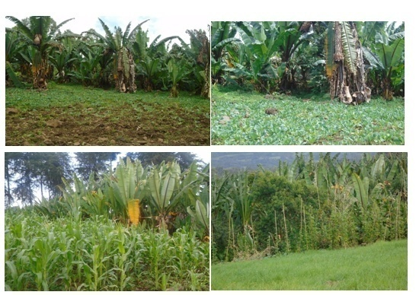
Figuer-4.9. Replacement of Enset Land in to Annual Crops (Crop Substitution)
Increasing Demand for Enset Products
Increasing trend of the demand for enset products at local markets is the implication of the decline of enset farming in the area. As indicated in Table 4.6 all surveyed households agreed that, enset products such as Kocho, Amicho, etc are getting expensive at nearby town market. Moreover FGD result also shows that, the decline in enset farm size and productivity has effect on market price of enset products. This indicates that, it is not too late for all stockholders to work together to recover enset production to ensure food security in the study area. Similarly, Farmers namely, Ato Adimasu and w/ro Deyako sound that, “in our life we grew our children with this very important crop and also we pass the challenges during drought and food shortage. Previously our locality was not known. But since decades our locality is become food insecurity area.
These two Farmers’ namely (Ato Adimasu and W/ro Deyako) alarms that, all the concerned bodies to come together to rehabilitate enset farming of the study area. This research finding is similarly, supported by the studied research finding of Adimasu Tsegaye (2002) and indicates that, the government attention towards encouraging the adaption of the new technologies has resulted in shift from enset to cereal-based agricultural. As a result, some enset growing regions experienced famine in recent years, something unknown to the past generation.
Socio-Cultural and Economic Effects
Regarding the socio-cultural effects Table 4.6 result indicates that, about 97.2% of studied households confirmed that, declining of enset cultivation has an adverse effect on economic and socio-cultural services. Cultural services like (Funeral, Weeding, Cahi/ especial blessing) ceremonies takes place in the study area become challenging, due the effect of the decline of enset cultivation. Furthermore enset has an important role in culture of the enset cultivating societies.
Regarding extra economic costs, Farmers are forced to buy other alternatives materials to replace the enset products like fiber and wrapper needs for making ropes, baskets, strings, utensils, fencing and house constructions. In addition, Farmers also bought leaves for backing breads and other uses and dried leaf-sheathes for sleep and sits. Previously selling enset leave at local market was not common in the study area. During the FGD and interview Farmers had also approved these extra economic costs.
Shortage of Livestock Fodder and Manure
Regarding shortage of livestock fodder and manure, studied households (99.4%) confirmed that, there is a shortage of fodder for livestock and resulted manure problem to fertilize the enset farmland. Similarly, the FGD result also confirmed fodder shortage is the result of decline enset cultivation and grazing land. The enset leaves (botanically the leaf blades) stalks form the pseudostem) are not used as food for humans, are not available for feeding animals. And during droughts, green enset leaves can be cut off and given to animals as fodder. Due to this, there is no enough manure to fertilize the enset farmland in the study area. According to Melese Mariyo et al., (2014) research findings there is a prudent interaction between enset and livestock in enset farming areas particularly in the highlands, where enset serves as a source of fodder, and livestock provide manure to fertilize enset fields.
Thus, enset leaves are especially important as fodder resource when grasslands and annual crops fail due to extended and unpredictable, droughts. Because of shortage of none food products of enset like pesdostemes and wasted leaves and leaf-sheathes, it is challenging to produce livestock fodder. As the result of this, manuring / fertilizing/ the enset farm is very difficult, while the enset farm management become poor.
The shortage of manure negatively affects the enset productivity whereas; availability of manure also improves the yielding condition and productivity of enset. Therefore, it has appositive relationships to the productivity of enset that, the animal manure decline because of the decline of fodder. Which the fodder shortage is also one of the result of shortage of none food enset products. In the absence of livestock, the sustainability of enset production definitely will be disadvantaged.
The land use change has also its effect on the enset farming and its resulting decline of enset productivity is primarily associated with decline soil fertility, as a result of decreased animal manure to support the enset fields. Finally it could be concluded that, population increase resulted land use pressure and decreases in animals and manure causes reduction in crop yields and soil fertility, thereby reducing the long-term sustainability of the enset system in system in the study area.
This research finding is similar with Adimasu Tsegaye (2001) research studied finding indicates that, livestock dung is mainly used for farm yard manure. Enset and livestock can be intensified so as to ensure sustainable livelihood in the farming system. However, still with the decrease in manure availability enset gets preferential treatment in manure application though the decline enset productivity and manure are highly related and they are interdependent.

CHAPTER-FIVE: CONCLUSION AND RECOMMENDATIONS
  - Conclusion
Agriculture is the main economic activities of Ari highland for the consumption as well as for market, whereas enset farming is one of the major components of agricultural practicing crop types. However, agricultural land use dynamics on enset farming has been threatened the coverage and product of the enset in the area. The main reason was agricultural land increasing, which resulted land fragmentation through productive population increasing size and family together makes enset cultivation is become challenging in the study area.
Therefore, the socio-economic characteristics of studied households indicate that, about 88% of population age group is found below 55. It indicates that, the study area characterized by large number of productive age with large family size. The major factors contribute for reduction of enset cultivation are poor cultivation and over all enset farm management problems relate to using organic fertilization, controlling enset disease and grazing herds (domestic and wild animals).
The land use/ land cover change considering range time from 1985-2015 has brought a remarkable decline for enset and forest, whereas, agricultural and grazing shows increase in the study area. The enset land in 1985 was 3025 ha (43.1%) was shrunken to 82ha (1.1%) in 2015. In contrast the farmland shows increase about 5867 ha (84%) about 3753ha (53.4%) of land was converted to farmland.
Regarding effects of agricultural land use change on enset farming, the landsat and survey result indicate that, the enset cultivation have been declined. The problems associated with enset are food insecurity during annual crop failing, increasing price of enset products and economic challenges for replacing with alternative other materials. Similarly, carrying out socio-cultural processes like funeral, weeding ceremony and cashi special blessing is become difficult. Finally in the study area relevant threaten are land use change, lack of attention from concerned bodes for better management, bacterial wilt, animal and recurrent drought. Thus the demographic pressure and associated land shortages are the factors that challenging enset farming and currently put enset cultivation threaten.

  - Recommendations
Agricultural land use dynamics has been seriously challenging the enset cultivation in the study area which needs effective management and land use decision making. The following suggestive solutions are forwarded to motivate Farmers and responsible stockholders to increase enset production and productivity in the study area.
- To produce quality as well as quantity products of enset in the study area, the extension agents should give advice and train to improve Farmers’ indigenous knowledge for better farming and overall management system.
- Government research institutes and NGOs should evaluate the performance of the established nursery sites, by means of participatory monitoring and evaluation methods, which aimed to collect; preserve verities, train and making demonstration site, and redistributing the improved varieties.
- Farmers should also be supported and empowered by modern agricultural mechanisms through providing pesticides for enset disease and wild animals especially like rat mole. Therefore all concerned bodies should work together to rehabilitate this drought tolerant crop.
- Land use change of the study area especially farming land shows, a remarkable increased in contrast potentially decline of Enset farmland needs special attentions. Thus, the concerned bodies, farmers, local government, NGOs and other interested individuals and researchers should give due attention to improve the land use management system of the study area through awareness creation to Farmer, giving short term training and capacity building for the government actors and conducting further researches.

- References
African Development Bank (2010) Smallholder agriculture in East Africa and trends, constraints and opportunities: working paper No, 105.
Abraham Shumbulo, Yishak Gecho and MeleseTora (2012), Diversity challenges and Potential of enset (Enseteventricosum (welw)) production: in case of Offa woreda Wolaita Zone Southern Ethiopia. Journal of food science and Quality management ISSN 2224- 6088 (paper) ISSN 2225-0557 (online) vol.7 pages 24.
Adimasu Tsegaye, (2002) on indigenous production genetic diversity and crop ecology enset (Enseteventricosum (Welw) Cheesman), PhD thesis presented at Wageningen Univniversity, the Netherlands page 4-8.
Almaz Negash, (2001) Diversity and conservation of enset (Enseteventricosum (welw), cheesman) and its relation to household food and livelihood in south western Ethiopia. PhD thesis presented in Wageningen University the Netherlands.
Awol Z, Zerihun Y, Woldeyesus Sinbo, Sadik M and Daniel Ambachew (2014) on farm cultivar diversity of enset (Enseteventricosum) in Southern Ethiopia, Southern agricultural research center institute Awassa, JAD4 (1) page -63.
BhawanaKc (2015), Land use and land cover change in relation to internal migration and human settlement in the middle mountains of Nepal, MSc thesis Enschede the Netherland page 13.
Bizuayehu Tesfaye (2008), the enset (Enseteventricosum) gardens of Sidama: Composition, structure and dynamics of a traditional poly-variety system, Genet Resource Crop vol. 55: 1347-1358.
Genet Bimerta, Hilde Nymbo and Endeshaw Bekele, (2004) Genetic variability and biotechnological studies for the conservation and improvement of Enseteventricosum, Doctoral thesis, presented Swedish University of Agricultural Sciences Alnarp, 91pp.
Global Initiative for the United Nation (2013) Solutions for sustainable agriculture and food system: technical report for the post 2015 development agenda.
Chakora Tamiru and Mekuria Argaw, (2015) Role of the enset (Ensete ventricosume (Welw) cheesman) in soil rehabilitation of Hadiya Zone South Western Ethiopia, retrieved from http://www.sciencepublishing groups. come/j/ajaep/dio:10-11648/j-ajep.20150406:14.
Central Statistics Agency (2010), Agricultural sample surveys, Report on area and production of major crops (Private holdings, Meher season) vol.4, retrieved from http://www.csa.gove.et newscsaweb/documents/survey/Agricultural_sample_survey.
Central statistics Agency, (2012) Agricultural sample survey, Report on area and production of major crops Private peasant holdings, Meher season) vol. (1) Retrieved from http://www.csa.gove.et newcsweb/images/documents/surveys/Agricultural_sample_survey.
Central Statistics Agency (2016) Agricultural sample survey, Report on area and production of major crops Private peasant holdings, Meher season) vol. (4) Retrieved from http://www.csa.gove.et newcsweb/images/documents/surveys/Agricultural_sample_survey.
Daniel Ayalew. (2008). Remote sensing and gis-based Land use and land cover Change Detection in the upper Dijo river catchment, Silte zone, southern Ethiopia Working papers on population and land use change in central Ethiopia, nr. 17.
Daniel M. Cartage, (1999) the management of enset (Enseteventricosum) in Gamo highlands of south western Ethiopia: Journal of culture and agriculture vol.21, No.1 (37-38).
Efrem Garedew (2010) Land-Use and Land-Cover Dynamics and Rural Livelihood Perspectives, in the Semi-Arid Areas of Central Rift Valley of Ethiopia, Doctoral Thesis presented at Swedish University of Agricultural Sciences Umea Pp 41.
Ethiopian Development Research Institute (2012) Summary of Ethiopian Strategy Support II working paper 16: crop production in Ethiopia pattern and trends.
Eyasu Ermias (2013), Genetic diversity, coffee and soil erosion in Ethiopia: paper prepared for the role of agriculture international conference, (2013), Rome Italy page-6-17.
Federal Democratic Republic of Ethiopia Ministry of Agriculture and rural development, Agricultural sector policy and investment framework, Retrieved from http:// gafund.org/ Files/Document/Ethiopia5_of_6CAADP_compact_Invetment_plan_pdf.
Gnene Gezahigh, (2014) in vitro regeneration of disease free enset (Ensete ventricosume (welw) Cheesman planting material from bacteria wilt disease plants using shoot tip culture, MSc thesis presented at Haramaya University Ethiopia.
Junjie Wu, (2008), Land use change, Economic, Social and Environmental impacts, retrieved from http:// www.choicesmagazins, org.
Kahsay Berhe. (2004). Land Use and Land Cover Changes in the Central Highlands of Ethiopia: The Case of Yerer Mountain and Its Surroundings.
Katie MaCEntee, Jennifer Thompson, Sradink Fikereyesus and kemeru Jihad, Enset is a good thing “Genderand Enset in Jimma zone Ethiopia, Journal Appl.sce.Techinol. (Special issue No 1): 103-109(2013).
Kedir Abdela, (2016), Traditional medical use of Enset ventricosume (welw) cheesman in Gedeban Gutazer welene district Gurague zone SNNPR region MSc thesis presented at Addis Ababa University Ethiopia.
Kefale Alemu (n.d), Farmers’ indigenous knowledge cultivation, utilization and classification of enset in North Omo Ethiopia.
Lewis B. (1997) Doing your Research project: A guide for first time Researchers in Education and social science, 3rd Edition Open University press maidenhead, Philadelphia.
McKnight Foundation Collaborative Crop Research Program Project (2013) Integrated management of Bacteria wilt of Enset (Enseteventricosum (welw) cheesman) caused by Xanthomonascampestricspv. Muscaearum in Ethiopia, (McKnight-CCRP 11-283: Annual report (November 2012 - October 2013).
Mekuria Wolde (2013) Assessment of the bacteria wilts (SNNPR) and evaluation of enset clones and antibiotics towards its management, MSc thesis, presented in Haramaya University Ethiopia Page 1-7.
Melese Mario, Sileshi Nemomissa and Tamirat Bekele, (2014), Diversity and distribution of enset ( Enseteventricosum ( welw) cheesman) landraces in KambataTambaro Zone south western Ethiopia, proceedings of 4th National Conference on “Environment and Development” Dilla Retrieved from http:// www.du.edu.et/rd/conference.
Meskerem Abiteka (2011). Household Food Security Situation in Girar Jarso Woreda, North Shewa Zone of Oromiya National Regional State, Addis Ababa University College of development Studies Food Security Studies, Ethiopia.
Minister of Agriculture and Natural resource (2016), plant variety release, protection and seed quality control directorate, crop variety registrar, issue No.18 page 180Addis Ababa Ethiopia.
MoFED, economic policy and planning department, rural development policy and strategies (2003), Addis Ababa Ethiopia, page 15&63.
Moges Gobena (2010). Effect of large –scale land acquisition in rural Ethiopia: case of BakoTibeworeda, MSc thesis Swedish university, page 7.
Mulugeta Lolamo (2014) Green famine in Ethiopia understanding the causes of increasing vulnerability to food insecurity and policy responses in the southern Ethiopia highlands, PhD dissertation presented at University of Sussex UK, Retrieved from http://Sro.sussex.ac.uk.
Namsi Ardi, (2016) Home garden plant species diversity in Debub Ari woreda south western Ethiopia, MSc thesis presented at Dilla University, unpublished page 16-18.
Nurile Lefebo, (2016) value chain analysis of enset (Ensete ventricosume) in Hadiya Zone Southern Ethiopia, PhD Dissertation presented at Haramaya University, Ethiopia.
Nurelegn Mekuriaw and Amare Sewnet (2014) Land Use/Cover Dynamics in Ribb Watershed, North Western
Ethiopia,pp 14.
Perma culture Research institute (2010) Enset the false banana gives food security and more, Retrieved from perm culture news.org, 2010/11/0.
Roger B. et al, 2003 Enset culture and its history in highland Ethiopia, proceedings of the Cushitic and Omotic conference lieden (2003), Cambridge University, page-3.
Stephen G.preze (2002), Household demographic and land use allocation among small farmers in the Brazilian Amazon, retrieved from http://HumanEcology Review Vol.g.No.2.2002 page-8.
Tadesse, Kippie (2002). Five thousand years of sustainability: a case study on Gedeo land Use (Southern Ethiopia): Treemail Publisher, Heelsum. (Netherlands), Retrieved From http://www.treemail.nl/books.
Tariku Hunduma, Kassahun Sadessa, Endale Hilu and Mengistu Oil, 2015 Evaluation of enset clones resistance against enset bacteria wilts disease (Xanthomonas competerispv.musacearum) journal of veterinary science technology, Retrieved from http://dx.doi.org/10.4172/2157_7579.1000232.
Temesgen Magule, Bizuayehu Tesfaye, Marcello Catallani and Mario Gnricop 2014 Indigenous knowledge use and on farm management of enset (ventricosume (welw) chessman) diversity in Wolaita southern Ethiopia, journal of ethinomedicine, retrieved from http://www.ethinobiomed.com/content/10/1/41.
Tesfaye, Abebe (2013) determinants of crop diversification and composition in enset coffee agro forestry home gardens of southern Ethiopia, Journal of agricultural and rural development in the tropic and sub tropics, vol.114 No.1 page 29-38.
Teshome, Yirgu (2016). Land use dynamics and challenges of enset (Enseteventricosum) agriculture in upper reaches of Baso-watershed, Gamo highlands south western Ethiopia. Global journal of interdisciplinary social science vol, 5(3):pp20-28 Retrieved from http://www.gifre.org.
Tewodros Mulalem and Tesfaye Walle, (2024) Farmer’s indigenous knowledge and assessment of enset for major insect pests in ojoria watershed KambataTambaro Zone South western Ethiopia. Sky journal.of.agriculture.and.research.vol.3.(6):.pp112-119.Retrivied.from http://www.skyjournals.org/SJAR
Tilahun Amede and Mulugeta Diro (2005) optimizing soil fertility gradients in the enset systems of the Ethiopian highlands, African highlands initiative, and (AHI) Working paper # 15.
Thomas Tolcha, (1991) Aspects of soil degradation and conservation measures in Agucho catchment, West Hararghe, Soil Conservation Research Project Report. University of Bern, Switzerland.
Tsedale Wakitola (2009), Globalization and neo-liberalization: challenges and opportunities to Enset crop-based agricultural communities and their farming system in Ethiopia, PhD thesis presented at University of Alberta Canada Page-5.34, 49, 56-60,105-106.
Tsegaye Yilma, (2001) Coffee –enset livestock interaction for sustainable livelihood in the Sidama area, South Western Ethiopia from, www.http://scholarworks.wmich.edu/africancenter_icad_arcive.
William G. Axinn and Dighan J.Ghimire, (2007), Research report on social organization, Population and land use, and population study center University of Michigan institute of Social research, retrieved from psc.isr.umich.edu.pubs/pdf/rro7-617.pdf.
Working Group on Environmental Auditing (WGEA), (2013), Land use and land management practices in environmental perspective Retrieved http://www.environmentalauditing.org.
Yemane Tsehaye and Fassil Kebebew (2006) Diversity and cultural use of enset (Enseteventricosum (Welw) cheesman) in Bonga in situ conservation site Ethiopia, A journal of plants people and Applied Research, Retrieved from http://hdl.handle.net 10125/246 page-156.
Zerihun Yemataw, Kassahun Tesfaye, Awel Zeberga and Guy Bulomme, (2016), exploiting indigenous Knowledge of subsistence farmers for the management and conservation of enset musacexe Family diversity on farm, Retrieved from doi: 101186/313002-016-0109-8.

- APPENDIXES
Appendix 1, (HHH) SURVEY QUESTIONAIRIES
- Semi-Structured Questionnaire Prepared for HHH Survey
Objective of the Study
The objective of the survey questionnaire is to collect the data about agricultural land use dynamics and its implication on enset farming.
- The questionnaire is only prepared for research purpose.
- Please give your genuine answer response and be confident your honest correct answer is very important for achieving the research objectives.
Thank you in advance for your willingness to participate and co-operation.
PART-ONE: - Socio-Economic Characteristics of Household.
Name of Kebele:-
1. Respondent’s sex
1). Male 2. Female
2. Age of the respondents
1). 25-35 3). 46-55
2). 36-45 4). 56-65
6). > 65
3. Marital status
1). Single 3). Divorced
2). Married 40). Widowed
4. Household member/ family size/
1). < 3 3). 7-9
2). 4-6 4). Above 9
5. Educational status /level/
1). Not educated 4). Secondary education (9-12)
2). Read and write 5). Certificate/TEVT)
3). Basic education (1-8) 6). Diploma and above
PART-TWO: - Current Status of Enset Farming.
- Do you have enset farm?
1). Yes 2). No
- What is the current status of enset farming in your locality?
1). Increasing 3). No change
2). Decreasing
8. Have you planted enset in this year?
1). Yes 2). No
9. If your answer for question number 8 is yes, how many enset you plant in your garden?
1). < 5 3). 11-15
2). 6-10 4). Above 15
10. Where did you prefer to plant enset?
1). Cropland 3). Along coffee and tree shade
2). in the garden 4). Along the road side
PART-THREE: - the Land Use Dynamics
11. Which types of crop growing more expanding in your farms?
1). Annual crops (maize, wheat, Barely, sorghum, beans and pens)
2). Perennial crops (Coffee, Cardomne, enset, banana, mango, avocado)
3). Root crops (Yam, Taro, potato and sweet potato) 4). Vegetables (Cabbage, tomato, peper, carrot, Onion)
5). Cereals, pulses and vegetables
- Others’ (please specify ).
12. Do you believe that enset farming is expanding in diversity and coverage?
1). Yes 2). No 3). Not decide
- If your answer for question number 12 is NO why?
- If you say No why?
13. Is there any improved enset varieties species introduced to your localities to enhance the productivity?
1). Yes 2). No
14. If your answer for question number 16 No, which type of crop is more introduced by extension workers?
1). Vegetables (tomato, pepper. Cabbage, salata, Onion)
2). Root crops (Yam, Taro, potato and sweet potatoes)
3). Cash crops (Coffee, Cardomne, Sugarcanes)
4). Fruits (Banana mango, avocado)
5). Cereals (maize, wheat, barly, beans, peas…) and pulses
6). Both cereals, pulses and vegetables
15. Is there any kind of skill training that is given to you about enset farming system?
1). Yes 3). No
PART-FOUR: - Effects of Current Agricultural Land Use Change on Enset Farming?
(Put a mark for the alternatives listed in the table)
PART-FOUR: - Effects of current agricultural land use change on enset farming?
(Put a mark for the alternatives listed in the table)
No | Effects/consequences/ | Strongly Agree | Agree | Disagree | Strongly disagree | Not decide
16 | Loss in Varity of enset land races
17 | Decline in productivity
18 | Poor Agronomic
19 | Shrinking of enset land
20 | Increase cost of enset productions
21 | Lack of enset production for day to day none food services material (leaf, leaf-sheathes, fiber, dried leaf-sheaths)
22 | Problem in socio-cultural services(funeral, weeding) of enset
23 | Forced to buy/use/ other alternatives instead of fiber and wrapper needs extra cost/economic impacts/
24 | Livestock fodder shortage
25 | Problems of manure to fertilize enset
Source: Own computed field survey (2016)
PART-FIVE: - The Major Factors for Enset Production.
6.1. Labor and Time cost
26. In which farm do you spend more time for cultivation?
1). Annual crop (cereals, pulses and vegetables) farm land
2). Enset 3). Fruits (Banana, Mango…)
- Others Specify ( ).
27. Most time who cultivate and give care for enset from your family?
1). Male
2). Female
28. Do you believe that most family member participate in cultivating enset?
1). Yes 2). No
- If you responded for question number 28is No, Why?

6.2. Market Access
29. What is your major source of household income?
1). Farm income
2). off- farm income
3). Both
- Others specify ).
30. The demand for enset production like kocho and Amicho in market now is?
1). Very high 3). Low
2). High 4). Very low
31. Where do you sale the products of enset?
1). Rural/local market 2).Nearby town
3). others please Specify )
32. Which type of crop do you produce more and sales at market?
1). Vegetables (tomato, cabbage, pepper)
2).Cash crops (coffee, chat, Cardomne)
3). Cereals and pulses (Maize, Wheat, Barely, Beans and Paeans)
4). Enset and other root crops (Yam, Taro, Cassava)
5). Both cereals, pulses and vegetables
- Why?
6.3. Lack Attention
33. Do agricultural extension workers and Local government (Woreda and Kebele) leaders give training and advice to improve production and management of enset farming?
1). Continuously 2). Sometimes 3). Not at all
34. Does agricultural extension workers local government actors advise you about socio-economic and environmental role enset?
1). Continuously 2). Sometimes 3). Not at all
35. For which crop types that extension workers and local governments gives you more advise you to produce for market demands?
1). Annual crops (pulse and cereals)
2). Vegetables (cabbage, tomatoes, pepper and salata)
3). Enset)
4).Cash crops (Coffee, chat, Cardomne…)
5). Cereals, pulses and vegetables
36. Compared to other annual crops the enset farming system is
1). Increasing 3). No change
2). Decreasing
- If you decreased enset coverage of your land what other crops you preferred to plant?
- Why
37. Do you believe that the land shortage can affect the enset farm size?
1). Yes 2). No
6.6. Poor Cultivation and Lack of Improved Varieties
38. How are you giving care and cultivation to enset and enset farm?
1). Always 2). Sometimes
3). Not at all
39. Have you adding manure and composts to improve enset production comparing to other crops.
1). Always 2). Some times
3). Not at all
40. Is there any other organization that involve for development and improvement of enset diversity and quality production?
1). Yes 2). No
- If yes which organization list them:
41. is there any community/government/ nursery site?
1). Yes 2). No
42. If your response is yes, Have they give training and distribute improved varieties in your localities?
1). Yes 2). No
43. Is there any wild animals /pests that eating and damaging the enset farm?
1). Yes 2). No
- If your answer is yes, List them:
- Are there any preventive mechanisms to such problems?
-(Traditional: )
-(Modern:
44. Is there any diseases that affect enset plant in your localities?
1). Yes 2). No
- If your answer is yes, List them:
- Are there any preventive mechanisms to such problems?
- (Traditional: )
- (Modern:
- Key informant Interview Guidelines
- Age:-
- Sex:-
- Position:-
- Education:-
- How do you describe the current status/ present situation of enset farming system and coverage compared to previous time:-
- How do you explain about the environmental and socio-economic importance of enset:-
Socio-cultural values
Economic values
Ecological/Environmental/ values
Other values:
- Describe about the land use changes in your locality
- What type crops more farmers cultivate in your localities? List out
- Explain the land use types
- Can you describe the effects of current agricultural land use change on enset farming and its results
Results
- What are the determining factors for the decline of enset land, enset coverage and quality production

- Is there any pests and wild animals in your locality that damages the enset farm?

- Check lists for focused group discussion.
- Discuss about the current status of enset farming.
- Land use types and changes.
- Discuss about replacement of enset farmlands with other annual crops and its challenges.
- Discuss about the determining factors for the decline of enset land coverage & quality production.
  - Labor and Time cost
  - Market accessibility
  - About policy attention
  - Land shortages
  - Agronomic practices and improved verities.
  - Pests and wild animals

Appendix 2: Classification Accuracy assessment report
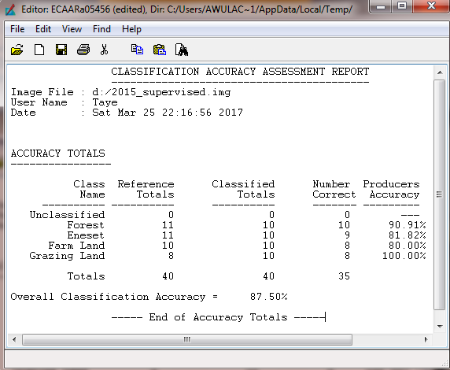
Land Cover Dynamics
Landsat TM 1985, 1995, and 2015) was used to generate land use/land cover dynamics of the study area. Different image rectification, enhancement and classification techniques were applied on the raw image .This has allowed the extraction of information on land cover condition and quantification of changes, and its rate over the past 30 years using GIS and Remote sensing analysis. The land cover conditions of different periods have been spatially compared the rate and quantity of changes.

Image Registration and Geometric Correction
Image registration is the process of transforming the different set of data into one coordinate system. All the Landsat MSS, TM and ETM+ images had been already orthorectified by the image supplier to Universal Transverse Mercator (UTM) projection on the WGS84 datum, UTM Zone 37 North.
Subsetting
Image subsetting also applied that helps to cut out the unnecessary data from the file and increase the data-processing speed. The vector file was used for defining the boundary of the study area. Imagery of the study areas were clipped out using the extract by mask operator of the Arc GIS spatial analyst tool box. To achieve this, predefined shape files of the study areas.
Image Enhancement
The Landsat image of the study area was enhanced though the process of making an image more interpretable for particular application. Common problem in remote sensing is the range of brightness collected by sensor that most of the time does not match with the capabilities of image medium. Contrast enhancement was used to compensate for this problem. Hence, linear contrast stretching was applied on the dark subtracted imageries prior to image classification.
Image Classification
Image classification is the process of sorting pixels into a finite number of individual classes, or categories of data based on their data file values. If a pixel satisfies a certain set of criteria, then the pixel was assigned to the class that corresponds to those criteria. After the necessary image preprocessing, classification was computed. The classification of image was done using both unsupervised and supervised classification.
Unsupervised and Supervised Classification
Unsupervised classification was used to get insight about the overall class and to identify the study site. The result of unsupervised classification was used as a guide for the selection of training site for supervised classification and it also gives preliminary information on the potential spectral clusters to be assigned to thematic classes. In supervised classification the image was classified at pixel level using maximum likelihood classifier approaches.
Descriptions of Land Cover Classes:
As there are some differences between the land classes in the historical land-cover maps of 1985-2015 and land-cover classes, which can be discriminated from the satellite image, recoding was needed to create a common classification for change detection purposes.

Appendix 3: Chi-Square Test Analysis Tables
Chi-Square Test Analysis Tables
 | Value | df | Asymp. Sig. (2-sided)
Pearson Chi-Square | 21.365ª | 2 | .000
Linear-by-Linear Association | 4.342 | 1 | .037
N of Valid Cases | 178
a. 4 cells (66.7%) have expected count less than 5. The minimum expected count is .04.
Chi-Square Tests
 | Value | df | Asymp. Sig. (2-sided)
Pearson Chi-Square | 6.350ª | 1 | . 012
Likelihood Ratio | 5.754 | 1 | . 016
Fisher's Exact Test
Linear-by-Linear Association | 6.315 | 1 | . 012
N of Valid Cases | 178

Chi-Square Tests
 | Value | df | Asymp. Sig. (2-sided)
Pearson Chi-Square | 8.936ª | 3 | .030
Likelihood Ratio | 8.397 | 3 | .038
N of Valid Cases | 178
a. 2 cells (25.0%) have expected count less than 5. The minimum expected count is 2.90.

Chi-Square Tests
Wild/Enset production decline | Value | df | Asymp. Sig. (2-sided)
Pearson Chi-Square | 6.453ª | 2 | .040
Linear-by-Linear Association | 5.873 | 1 | .015
N of Valid Cases | 178

