
HOUSEHOLD SOLID WASTE GENERATION DETERMINANT FACTORS AND COMPOSITION STUDY FOR SUSTAINABLE MANAGEMENT PRACTICES; THE CASE OF MOJO TOWN, ETHIOPIA.
M.SC. THESIS
BY
AREGASH KEBEDE ENDALE

ADVISOR: ALEMAYEHU HAILEMICAEL MEZGEBE (PhD)

NOVEMBER, 2019
ARBA MINCH, ETHIOPIA
HOUSEHOLD SOLID WASTE GENERATION DETERMINANT FACTORS AND
COMPOSITION STUDY FOR SUSTAINABLE MANAGEMENT PRACTICES;
THE CASE OF MOJO TOWN, ETHIOPIA
BY

AREGASH KEBEDE ENDALE

A THESIS SUBMITTED TO DEPARTMENT OF BIOLOGY, COLLEGE OF NATURAL
SCIENCES, SCHOOL OF GRADUATE STUDIES ARBA MINCH UNIVERSITY IN
PARTIAL FULFILLMENT OF THE REQUIREMENTS FOR THE DEGREE OF
MASTER OF SCIENCE IN ENVIRONMENTAL SCIENCES

ADVISOR: ALEMAYEHU HAILEMICAEL MEZGEBE (PhD)

NOVEMBER, 2019
ARBA MINCH, ETHIOPIA

DECLARATION
I declare and affirm that, this thesis is my own original work. Where work of other scholars has been duly acknowledged through citation. This thesis has been submitted to in partial fulfillment of the requirement of MSc Degree at Arbaminch University and it has neither been submitted to elsewhere for award of any academic degree or diploma.

Name: _______________________________________________
Signature: ________________________________________
Date: __________________________________________

ADVISORS APPROVAL SHEET
This is to certify that the thesis entitled “Household solid waste generation determinant factors and composition study for sustainable management practices; the case of Mojo town, Ethiopia.” submitted in partial fulfillment of the requirements for the degree of Master’s with specialization in environmental science, the Graduate Program of the Department of Biology, has been carried out by Aregash kebede Id. No PRNS/1056/10, under my supervision. Therefore I recommend that the student has fulfilled the requirements and hence hereby can submit the thesis to the department for defense
_____________________ ___________ ___________
Advisor Signature Date

EXAMINERS APPROVAL SHEET
We the examiners’ board approve that this thesis has passed through the defense and review process
Chairperson Signature Date
________________ _________ ________
Internal examiner Signature Date
________________ _________ _________
External examiner Signature Date
________________ _________ _________
Principal adviser Signature Date
________________ _________ _________
Head of department Signature Date
________________ ___________ ___________

ACKNOWLEDGMENTS
Foremost and above all I would like to thank the ALMIGHTY GOD for giving me health, strength and wisdom to successfully complete this thesis work. Next to GOD, I would like to express my sincere gratitude to my advisor Alemayehu Hailemicael Mezgebe (PhD) for His unreserved professional guidance, supervision and assistance starting from proposal writing to the end of my thesis.
I want to thank Dilla University for giving me chance for MSc education and financial helps for my work. I would like to thank Mojo town municipality for providing me with the material support and written document that is required for my study. Special thanks go to Arba minch University Department of Biology for their great support when I do the hole of my work during study time.
It is with great pleasure that I acknowledge all my families and friends who supports me in all steps and also respondents who participated in providing the necessary data for this study and particularly my heartfelt thanks to Mr. Geda Erecho for his motivation, encouragement, willingness for my success starting from lower grade up to end of my thesis work.
Finally, I would like to express my deepest gratefulness to my husband Alemu Jote for his moral, financial support and help me physically during data collection.

ABBREVIATIONS AND ACRONYMS
ANOVA Analysis Of Variance
DSWGR Daily Solid Waste Generation Rate
HHs House-holds
HIHH High Income House-hold
HHSW House Hold Solid Waste
MIHH Medium Income House-hold
MSW Municipal Solid Waste
MSWM Municipal Solid Waste Management
LIHH Low Income House-hold
OSCE Organization for Security and Co-operation in Europe
PCPDSWGR Per Capita Per Day Solid Waste Generation Rate
SDRPD Sustainable Development and Regional Planning Division
SBD Sanitation and Beatification Departments
SPSS Statistical Package for the Social Sciences
SW Solid Waste
UNEP United Nations Environment Programme

TABLE OF CONTENTS
CONTENTS page
DECLARATION ii
EXAMINERS APPROVAL SHEET iv
ACKNOWLEDGMENTS v
ABBREVIATIONS AND ACRONYMS vi
TABLE OF CONTENTS vii
LIST OF TABLES x
LIST OF FIGURES xi
ABSTRACT xii
1. INTRODUCTION 1
1.1. Background of the study 1
1.2. Statement of the Problem 2
1.3. Objectives of the study 4
1.3.1. General objective 4
1.3.2. Specific objective 4
1.4. Significance of the study 4
1.5. Delimitation of the Study 5
1.6. Limitation of the study 5
1.7. Operational definition 6
2. LITERATURE REVIEW 7
2.1. Concept of solid waste 7
2. 2. Source and types of solid waste 7
2.3. Municipal solid waste 8
2.4. Physical characterization of household solid waste 9
2.5. Solid waste generation 9
2.6. Solid waste generation rate 10
2.7. The factor influencing solid waste generation 11
2.7.1. Age 12
2.7.2. Marital status 12
2.7.3. Education 12
2.7.4. Family size 13
2.7.5. Income 14
2.8. Solid waste management system 14
2.9. Waste disposal and alternative waste management options 15
2.9.1. Source reduction 15
2.9.2. Reuse 16
2.9.3. Recycle 16
2.9.4. Composting 17
2.9.5. Incineration 18
2.9.6. Sanitary landfill 19
2.10. Impact of solid waste on environment and public health 20
3. MATERIALS AND METHOD 21
3.1. Description of study area 21
3.1.1. Location of the study area 21
3.1.2. Climate 22
3.1.3. Population 22
3.2. Sampling techniques 22
3.3. Sample size determination 22
3.4. Study design 24
3.5. Source of data 24
3.6. Data collection instrument 24
3.6.1. Questionnaires 24
3.6.2. Field observation 25
3.6.3. Interview 25
3.6.4. Sorting physical composition and quantifying of solid wastes 25
3.7. Materials 27
3.8. Data analysis 27
3.9. Ethical consideration 27
4. RESULTS AND DISCUSSION 28
4.1. Socio-economic characteristics of sampled households 28
4.2. Daily household solid waste generation rate 29
4.3. Per capita solid waste generation rate 30
4.4. The relationship between solid waste generation and relevant socioeconomic factor 31
4.4.1. Solid waste generation and family size 32
4.4.2. Solid waste generation and family income 32
4.4.3. Solid waste generation and educational level 34
4.4.4. Solid waste generation and marital status 35
4.5. Solid waste physical composition analysis 35
4.6. Solid waste management practices at household level 38
4.6.1. Awareness of HH about solid waste generation and handling practice 39
4.6.2. Solid waste collection and transportation system 41
4.6.3. Solid waste disposal practice 44
4.6.4. Municipal solid waste management 46
4.7. Street sweeping activity 47
5. CONCLUSION AND RECOMMENDATIONS 49
5.1. Conclusion 49
5.2. Recommendations 50
6. REFERENCES 51
APPENDICES 61

LIST OF TABLES
TABLE PAGE
Table 1. Socio-economic characteristics of households 29
Table 2. Generation rate of Mojo town 30
Table 3 .Correlation coefficient of socio- economic factor 31
Table 4.Monthly Income, average family size and HH solid waste generation rate 33
Table 5 . Solid waste composition result in the study area 36
Table 6. Awareness of household about solid waste generation 39
Table 7. Solid waste collection and transportation 42
Table 8. Reused solid waste 43
Table 9. Solid waste collection and disposal monitoring condition 47
Table 10. Solid waste handling practice at household level 66
Table 11. Solid waste disposal practice 67

LIST OF FIGURES
FIGURE PAGE
Figure 1. Location of the study area 21
Figure 2 . Measuring, sorting and transporting of solid waste during study time. 26
Figure 3. The average daily total weight in percentage of solid waste collected 34
Figure 4 . Percentage of solid waste composition 37
Figure 5 . Physical composition of solid waste. 39
Figure 6. Organic solid waste generation. 40
Figure 7. Some solid waste storage material at household level 42
Figure 8. Some of the reused solid waste. 44
Figure 9. Burning of solid waste at disposal site 46
Figure 10. Solid waste disposal practice 48
Figure 11. Street sweeping activity 49
Figure 12 . Collection and transportation practice in mojo town. 68
Figure 13.Solid waste disposal site in mojo town. 69
Figure 14. Illegal disposal place in mojo town 70

ABSTRACT
Solid waste management is a serious problem in many developing nations. Knowledge of the quantities, compositions and identifying the socioeconomic factor influencing household waste generation are needed to plan and implement effective waste management activity. The study was conducted to assess socioeconomic factors affecting household solid waste generation and composition in Mojo town. Purposive and systematic random sampling techniques were employed in this study. The study design combined physical observation (measurement of daily solid waste at household level) and descriptive survey method by using questionnaires. The daily solid waste generated from household was sorted to its component and their weights were recorded. The solid waste collection has been conducted for seven consecutive days. The result of this study shows that, household waste generation rate is estimated to be 0.24 kg/capita/day and the daily, weekly, monthly, annually solid waste generation were 17.13, 119.9, 514 and 6168 tons respectively. The physical composition of solid waste of the town is dominated by organic waste (84%). Multiple linear regression analysis proved socio-economic factors influencing households’ solid waste generation. Family size, family income, level of education and marital status found to have positive correlation on HH waste generation and statistically significant at (P<0.05). Questionnaire result showed inadequate solid waste collection, storage, transport and disposal practice. Therefore, the solid waste management system of mojo town is poor due to lack of awareness, facilities and absence of information on solid waste generation and composition. Thus, the study recommended, increasing awareness of the community, responsible bodies (Government, Community and Health Bureau) should pay attention to the issue, in order to improve the current poor solid waste management practices in the town.
Key words: Mojo town, Physical Composition, Solid Waste Generation Rate, Solid Waste Management. Socioeconomic Factors

1. INTRODUCTION

1.1. Background of the study
Solid waste management problem is a global issue that is experienced by all urban areas. The higher potential productions of solid waste are, due to an aggregation of human settlements in urban area (Dereje Tadesse, 2012). Waste management practice such as collection, transport and disposal of that waste has been generally assumed as the responsibility of municipal governments in the developed world (Senkoro, 2003). Even if the format varies in most urban areas, garbage is collected either by a government agency or private contractor. This constitutes a basic and expected government function in the developed world (Dereje Tadesse, 2012). Municipal solid waste management (MSWM) is usually well managed in developed countries than developing country. Frequently the highly technical and complicated methods dealing with MSW which used effectively in developed countries are brought to developing countries. But, they are not sustainable due to lack of capacity and awareness to establish the methods (Yukalang et al., 2018).
In developing countries, the management of municipal solid wastes accounts for between 20% and 50% of local government budgets (Yukalang et al., 2018). According to (UNEP, 2016; UNEP, 2009) more than 50% of population living in developing countries has lack consistent access to waste collection services and their disposal systems always include open dumping and open burning. As population continues to increase, the management of municipal solid waste has become a most important concerning issue in many developing nations (Selin, 2013). The problem is more intense as many nations continue to urbanize rapidly. In many developing countries, 30-50% of population lives in urban area. The growth rate of urban areas exceeds 4% in many African countries (Dereje Tadesse, 2012).
Solid waste streams characterization and the assessment of solid waste generation rates are basic data desired to seek alternative solutions to problems occurred by rising of solid waste disposal costs, low interest in recycling and reusing (Dereje Diriba, 2009). The quantity of waste generated often depends on the socioeconomic factor (income, age, family size, education, gender, occupation, and marital status), cultural habits of the people, density of population, and extent of commercial activity (Khan et al., 2016).
A waste management system should not only ensure human health and safety, but it also both environmentally and economically suitable (Khan et al., 2016). Source reduction, using landfills, recycling, reusing, composting, and incinerating are the generally accepted methods of waste management in many countries (Williams, 2005).
In Ethiopia, similar to other developing countries, the solid waste generation rate is increasing from time to time which is resulted from rapid urbanization and population increments (Lema Asfaw, 2007). For example, the amount of solid waste generated in Addis Ababa and other fast growing areas of the country have been increasing over time. From the total solid waste generated by the population in the in Addis Ababa, only 50-60% was collected (Dawit Walelegn and Alebel Bayrau, 2003). Solid waste disposal system is another important part of solid waste management system which requires much attention to avoid environmental pollution (Paul, 1978).
Mojo town is the town that highly running business activities. Due to these activities the number of population was rapidly increased. But the waste management system in the town is very poor when compared with extent problem. In the town there are illegal dumps on ditches, open lands, roadside, and drainage.

1.2. Statement of the Problem
The increasing of human population with rapid growth of economy, more urbanization and the rise in community living standards has greatly speeded up the municipal solid waste generation rate in developing countries (Minghua et al., 2009). As the world urbanizes, the situation is becoming more acute. As the number of population increase, the amount of solid waste generation is also increase, especially in fast-growing cities where the bulk of waste is generated, Municipalities are usually responsible for waste management in the cities by providing effective and efficient system to the inhabitants. However, they often face problems beyond the ability of the municipal authority due to lack of organization, financial resources and complexity of the management system (Burntley, 2007).

The quantity of solid waste generated as well as its ever changing characteristic is alarmingly increasing. The type of solid waste varies with respect to the consumption pattern of its generation (Tsegaye Mekuria, 2006). The household solid waste contains biodegradable solid waste (such as vegetables, food) and non-biodegradable materials such as plastic and there by indicating complicated environmental issues which need proper planning and management practice (Swapan, 2009).
In Mojo town, the proper provision of municipal solid waste management practice is still unsatisfactory and unsafe. In the town there are different industries which make people comes from different part the country such as from rural and urban area to the town for labor work. Such increase in population size has led to serious problem of Waste management system. Moreover, the amount and type of solid wastes generated is diversified from packed to road side food leftovers. This in turn creates mountains of solid waste damped on the road-side, within vacant lots, drainage, around health centers etc.
The efforts made by the municipality to change the situation are inadequate as it was compared with the extent of problem. Except sporadic reports on GIS based solid waste disposal site selection (Minalu Ambaneh, 2016), no research has been conducted to alleviate the problem of household solid waste generation rate and physical composition of the solid waste. Therefore, this study has tried to investigate the household solid waste generation factors and composition study for sustainable management practices in Mojo town.

1.3. Objectives of the study

1.3.1. General objective
- To study household solid waste generation determinant factors and composition study for sustainable management practices in Mojo town.

1.3.2. Specific objective
Specifically it is designed to:
- determine the generation rate of solid waste at household level.
- analyse the physical composition of the solid waste generated.
- examine the relationship between the amount of household solid waste (SW) generation with relevant socio-economic factors.
- assess the existing status of household solid waste management practiced in the town.

1.4. Significance of the study
The city that cannot be effectively managing its waste is rarely able to manage more complex service such as health, education and transportation. No one wants to live in a city surrounded by garbage (Moya etal., 2017). In the town intensive amount of waste is generated in every day activity. Therefore, this study would support as background information for municipality, government agency, urban community and environmental protection agency to improve their solid waste management facilities such as increasing the number of trucks for solid waste collection and transportation, distribute the container around the residential area etc. The finding of this study would be important input for other research in the future as reference. It would give basic information for all concerned body in order to make the safe, environmentally sound and cost effective waste management system and enables one to know about the types of waste generated from HH in the town. This study recommend to government and stakeholders on the need to employ the necessary manpower and strategies on waste collection, storage, treatment & disposal, which will be advantageous to the community

1.5. Delimitation of the Study
Solid waste management involves all waste streams from various sources such as households, commercials, institutional etc. It also assesses all activities including waste generation rate and composition, identification, collection, storage, transfer, processing, transportation, and disposal facilities. However, because of financial and time limitation the scope of this study focuses only on Household solid waste generation determinant factors and composition study for sustainable management practices in Mojo town.

1.6. Limitation of the study
The major limitation in this study is lack chemical analysis and Willingness of selected households to give reliable information. Even if explanation given to them about the usefulness of the study, some of the household doesn`t believe rather than they need financial support. During survey, willingness to inform the actual income was also a problem.

1.7. Operational definition
Ash: is in compostable material that remain after fuel (wood) and solid waste has been burnt.
Composting: biological decomposition of solid organic material by bacteria, fungi, and other organism into a soil like product (humus)
Household: any unit of habitual residence where some consumption and production may be taken in common
Kebele: The smallest legal administration unit
Open dump: an unplanned “land fill” that incorporate the characteristic of a controlled land fill, but there is typically no leachate control, no access control, no cover, no management and exposed to many scavengers.
Physical composition: The major components of solid waste which include food waste, glass, metals, can, debris, bricks, boards, leaves, paper, dirt and ashes.
Korales: persons who practice exchange of recycled wastes in other goods
Recycling: the process of transforming materials in to secondary resource
Resource recovery: obtaining of economic benefit from materials that are regarded as waste
Reuse: being used for some purpose again (e.g., refilling of a soft drink bottle)
Solid waste generation rate: an estimate amount of solid waste created from different source over a certain period of time.
Source reduction: any procedure to reduce solid waste at the point of generation
Sanitary land fill: an engineering method of disposing off solid waste on land, in manner of that meet most standard specification, including sand citing, extensive site preparation, proper leachate and gas management

2. LITERATURE REVIEW

2.1. Concept of solid waste
A material is considered as a waste when it can no longer be used or reused and requires treatment or disposal. Solid wastes are all the wastes arising from both human and animal activities that are normally solid and discarded as useless (Tolina Tiruneh, 2006). In the earlier Human beings and animals have used the resources of the earth for their survival and then dispose the waste, but it did not pose any significant problem. This is because of at that time the number of population was too small when compared with the todays and large land area is available for the assimilation of waste (Zerayakob Belete, 2002). But Problems with the disposal of waste can be traced from the time when humans first began live together in tribes, villages and communities, the accumulation of waste become a consequence of life (Zerayakob Belete, 2002).
Internationally, the solid waste are used to express the useless and unwanted products in the solid state arising from domestic, trade, commercial, agriculture, industrial, mining activities and from public services as well (Haider et al., 2015). According to UNEP (2005), fast expansion of urban, agricultural and industrial activities encouraged by rapid population growth has produced a massive amount of solid waste that pollutes the environment and damage resources.

2. 2. Source and types of solid waste
For effective and efficient solid waste management, having knowledge of the source and types of solid waste, along with data on the composition and generation rate, is the critical information. It helps to design and operate the functional elements associated with the management of solid waste. The solid wastes can be generated from different sources such as residential, commercial, institutional, construction and demolish municipal services, industrial, treatment plants sites and agricultural wastes. All of them are included in municipal solid waste (MSW) normally with the exception of industrial process and agricultural wastes (Dereje Tadesse, 2012).
Solid waste can be classified based on its origin, risk potential and characteristics. Based on origin, solid waste can be classified into residential waste, commercial waste, agricultural waste, institutional waste, industrial process waste, and demolition and construction wastes.
Based on its characteristics, it was classified as biodegradable and non-biodegradable, based on its risk potential, again it can be categorized in to hazardous and nonhazardous wastes (Addai and Danso, 2014). The household solid waste stream also contains different components as organic or inorganic, biodegradable or non-biodegradable. The organic matter include paper, wood, food waste, they are compostable in the aspect of waste stream. In the other hand the inorganic matter is non-compostable (rubber, leather, plastic, metal, glass, fabric and battery and others (Song et al., 2009).

2.3. Municipal solid waste
MSW is also called urban solid waste. It is normally composed of different wastes generated by households, commercial and industrial premises, institutions such as schools, hospitals, care homes and prisons, and from public spaces such as street sweeping , markets, slaughter houses, public toilets, bus stops, parks, and gardens demolition and construction wastes (Gaurav et al., 2014; Coffey and Coad, 2010). Solomon Cheru (2011) also defines municipal solid waste (MSW) as a materials discarded in urban areas for which municipalities are usually responsible for collection, transportation, and final disposal.
Municipality administration is responsible for waste collection in many cities of Ethiopia. Though, there is a wide variation in performance in relation to waste collection in cities of Ethiopia. It has become a common business practice to have household waste to be pre- collected by individuals who are organized through formal or informal association. The pre- collected waste is then transferred into containers which are collected by municipalities. Nevertheless, in many cities there are no enough containers to cover the population and vehicles are typically under maintenance or out of service for long periods of time. As there is very limited effort to recycle, reuse or recover the waste that is being generated, waste disposal has been the major problem in waste management practice. Quantity and composition of MSW vary from one municipality to others (Genemo Berisa and Yohanis Birhanu, 2015).

2.4. Physical characterization of household solid waste
Solid waste streams should be characterized from sources they emanate, by the types of wastes produce, as well as by generation rates. The exact information in these three areas is essential in order to monitor and control existing waste management systems and to make regulatory, financial, and institutional decisions (Palanivel and Sulaiman, 2014; Dereje Tadessa, 2012). One of the most significant different between the solid waste generated between developed and developing nation is in term of its composition (zhang et al., 2010). The solid waste generated in developed nation is mainly inorganic in nature whereas organic contents form a large portion solid waste in developing countries (Babayemi and Dauda, 2009). In the developing country situation, the proportion of organic contents in solid waste is almost three times higher than that in developed countries (Xue et al., 2011).
Different information related to sources, quantity and composition are very important for the design and operate of the functional elements related to waste management. Additionally characterization of the waste streams in order to monitor and determine the waste composition and generation rate per capita per day from residential households, commercial centers, public institutions and health care facilities is significant in planning, development and regulating of waste management strategies (Mesfin Assefa and Muktar Mohammed, 2017).

2.5. Solid waste generation
Waste generation refers to all activities that identify the materials as no longer being of value and thus are either thrown away or collected for disposal. It is a critical phase that determines extremely the activities of all the subsequent functional elements. Therefore, this condition states that, the presence of strong interdependence between waste generation and the other functional elements. This process is called systems continuity (Gabretsdkan Gabremichael, 2002).
This phase is very important, because all activities that lead to identification and understanding of solid waste generation rate, volume, composition, and their expected changes overtime are included to this stage of solid waste management. So, this element is essential stage for obtaining accurate information that is necessary to monitor existing management system (Solomon Cheru, 2011). In day to day activity every person has capacity to generate waste but the amount may be different and thus a contributor to this problem. To generate, waste is one thing, the type of waste generated is another and yet also the way the generated waste is managed or disposed of is quite a different issue. But the quantity of solid waste generated is far higher than the capacity to responsibly manage this waste (Kirunda, 2009).

2.6. Solid waste generation rate
The solid waste generation rate will increase from time to time as the income of individual changes and living standard is improved. That means, as the living style of individuals change the rate of waste generated per day also changes. As Fitsum Tsegaye (2007) reported that, regarding to the solid waste generation rate of Addis Ababa city, there is no up-to-date and reliable data. But few studies are undertaken since 1982 by different scholars. The first main study is carried out in 1982. The studies states that, per capital generation of solid waste were 0.15kg/day/person with a 1% annual growth rate and approximate waste density of 370 kg/m³.
Internationally in 1986 Louise Burger carried out the second study and coming with result of 0.20kg/day/person. In 1994 and 1995 Louise Burger also carried out the third study. According to the study takes place 1994 and 1995, the amount of waste generated is dependent up on economic developments. Depend on the data collected in 1994; generation/capital/day was 0.35kg, 0.28kg, and 0.17kg, for high, medium, low income groups respectively. The data collected in 1995 also shows that 0.47kg, 0.26kg, and 0.236kg for high, medium and low respectively (Zerayakob Beleta, 2002).
The studies takes place in Arada sub city on the quantity and compositional analysis also indicate that, the result of solid waste generation rate for low income, middle income and high income group are 116.9, 153 and 162.5 gm/cap/day respectively with average density of 159.8 Kg/m³ (Yitayal Beyene, 2005). The quantity of solid waste generated and its management practices may vary in country to country, state to state, city to city as well as within different areas of the same city. For example in Indian cities municipal solid waste generation ranges between 0.3 and 0.6 kg/capita/day and annual increase in municipal solid waste generation by volume is estimated as 1.33% per capita (Siddiqqui, 2018).

In sub- Saharan Africa the amount waste generation is approximately 62 million tons per year. Per capita waste generation is generally low in this region, but in spans a wide range, from 0.09 to 3.0 kg per person per day, with an average of 0.65 kg/capita/day. Islands is also the country with the highest per capita rates, this is likely due to waste generated by the tourism industry and a more complete accounting of all wastes generated (Hoornweg and Perinaz, 2012). In Ethiopia, the total generation of municipal solid waste which was estimated in Jigjiga city in 2007 to be 21.4 to 60.4 tones (Yohanis Birhanu and Genemo Berisa, 2015).
The aim for measuring solid waste generation rate is to determine the total amount of wastes to be managed. Therefore, having accurate information on the quantity of solid waste generation and composition in a given area is very important for preparation and implementation of appropriate MSWM. Because it gives critical information on human, financial and equipment resources required for collection and transportation of waste. To enact appropriate laws on waste reduction, and establish current and future needs for solid waste disposal sites (Afon, 2007).

2.7. The factor influencing solid waste generation
In the earlier economist also tried to compare the composition and quantity of waste in terms of income level, household size and age structure of the household as these affect the quantity and composition of solid waste. So much variation in results indicates waste generation being affected by a wide range of factors and the factors vary from one place to another. The amounts and composition of solid waste generated are affected by different factors, including socioeconomic development of the area, degree of industrialization and urbanization. Generally if there are more economic development and higher degree of urbanization, the more amount of solid waste produced (Hassan et al., 2001).

2.7.1. Age
Age is one of the factors that affect waste generation in many cities. The study carried out in Czech Republic, showed that the highest level of household solid waste was generated by people reaching towards the end of their working career than children and teenagers. Because of various activities such as reconstruction of home, replacement of household goods, sorting and discarding one's belongings accumulated during previous decades, which lead to generating large amounts of waste (Soukopova and Struk, 2016).
Addai and Danso (2014) also reported that middle age group in the age range of 21 to 60 were found to be more willing to pay for improved municipal solid waste than older ones (above 60) and younger ones (below 20). This was because old people (above 60) considered solid waste management as government's responsibility while young ones (below 20) just did not feel responsible for improved solid waste management. But the middle age group has better understood the implications of poor municipal solid waste management and were more familiar with cost sharing and were therefore more willing to pay for improved municipal solid waste management services. Studies that takes place in Jamaica also shown that there is a positive relationship between the working age group of a population and the volume and type of solid waste produced (SDRPD, 2007). This implies that the larger the working age population, the more they will consume different types of products providing they have access to income.

2.7.2. Marital status
The marital status of the household head is expected to have great influence on the waste management practices. This is due to the fact that married people are likely to be more responsible to keep the environment clean than the single one and hence are more likely to be willing to pay more for improved waste management (Shabani, 2015).

2.7.3. Education
There are arguing on the relationship between education status of the public and household solid wastes generation among different scholars. A study conducted in china reported that, education level of household have negative impact on household waste generation (Gu et al., 2015). Because of usually higher education is related with high level of awareness on environmental issues, But on the other hand, the study by (Kayode and Omole, 2011; Sujauddin et al., 2008) in Bangladesh showed that average level of education of family members have significant positive impact on waste generation. Because of the cumulative nature of education that increases with the new number of graduates every year, but environmental awareness (such as impact of higher waste generation) does not increase at the same time (Oribe et al., 2015).
Niringiye (2010) suggested that in higher level of education the more people would encourage the management of solid waste and the more value of the individual would give in order to avoid the risk of being a victim of unclean environment. (Afroz et al., 2009) also states that education relates to a better understanding of the problem of solid waste and hence willing to pay for improved waste management.

2.7.4. Family size
This refers to the number of household members. Studies by (Maskey et al., 2016; Sankoh et al., 2012; Afroz et al., 2011; Sujauddin et al., 2008) indicated that household size to have positive impact on more waste generation. Since a larger household size was presumed to generate higher quantity of waste because more individuals are included in the household unit. Although it is apparent for more members of a household to generate more waste, but sometimes the phenomena of ‘living in groups ‘and ‘common consumption’ can saturate the amount of waste being generated as number of generators increase (Gu et al., 2015).
Many studies also supported that household size to have opposing effect on waste generation (Miezah et al., 2015; Xu et al., 2014; Kayode and Omole, 2011) Large family are at an advantage when it comes to intensive utilization of materials such as food, paper and plastic, thus reducing per capita waste generation compared to the small family through reusing and composting of the waste. Sometimes this variable is expected to have negative influence on the willingness to pay. This is due to the reason that when there are more children in the household, the more they would prefer to use their children to clean their environment rather than paying more to the municipal authorities to clean the environment (Niringiye, 2010).

2.7.5. Income
An income refers to the income of head of the household from all sources. Studies by different scholars indicates that monthly income have positive impact on house hold waste generation, they explain that most of the time when the income is higher, it is expected to increase demand for commodity products, and the consumption of which will ultimately produce more waste (Afroz et al., 2011; Kayode and Omole, 2011; Sujauddin et al., 2008). But, Qu et al., 2009) in his study in China showed that family income to have negative impact on waste generation because of those having higher income dine outside more frequently than cooking at home, whether it be at work or for leisure; thus, generating less waste.
The other studies takes place in Thu Dau Mot also showed a negative relationship between income and household SW generation rate; this means higher income people are generating less waste than the lower income people. This is because of the city is characterized by industrial activities; most households have members working in shift, so they often have lunch and dinner at working places. So higher income household generate less waste compare to lower income families (Trang, 2017).

2.8. Solid waste management system
The management of municipal solid waste includes several distinct processes such as generation, separation, collection, transfer, transportation and disposal. It includes the way that considers public health, economics, conservation, aesthetics, environment, and is responsive to public attitude. As urbanization continues to increase, solid waste management (SWM) becomes a major problem to public health and environment in urban areas (Kobina, 2011). The appropriate solid waste management minimizes the adverse impacts on the environments, human health and supports economic development and improved quality of life (Minalu Ambaneh, 2016).
It is the responsibility of municipalities to spend 20-50% of their accessible recurrent budget on solid waste management in developing countries, it is also common that 30-60 % of all the urban solid waste is uncollected and less than 50 % of the population is served in developing country. In some cases, 80 % of the collection and transport equipment is out of service, it need of repair or maintenance. In many developing countries, open dumping and open burning is the common disposal site. In all African cities the municipal solid waste management constitutes facing the most crucial health and environmental problems. This is because even though these cities are using 20% of their budget in solid waste management, only 20-80% of the waste is collected, the uncollected or illegally dumped wastes constitute are very disaster for human health and the environment. The management of waste can involve solid, liquid or gaseous wastes, with different methods and fields of expertise for each (Lema Asfaw, 2007).

2.9. Waste disposal and alternative waste management options
The disposal of solid wastes is the ultimate fate of all waste collected from different source which include both disposal of solid and semi-solid materials that are resulting from human and animal activities that are useless, unwanted, or hazardous. Most of the time municipal solid waste (MSW) is dumped illegally on land with more or less uncontrolled manner in developing country. These situations create scarcity of the available space, allow free access to waste pickers, animals and flies and often produce unpleasant and hazardous smoke from slow burning fires. So the safe and reliable long-term disposal of solid waste is considered as an essential component of integrated waste management (Melaku Tegegn, 2008).

2.9.1. Source reduction
Source reduction means avoiding the production of waste at generation phase by decreasing its amount or toxicity of the materials that we throw away. Effective and efficient source reduction encourages the use of products that generate the smallest environmental impacts. It includes Purchasing of long lasting goods, seeking products and packaging which are as free of toxics as possible. Redesigning products to use fewer raw materials in production, have a longer life, or are used again after its original use, eliminating unnecessary packaging and Avoiding disposable products if reusable items are available (Melaku Tegegn, 2008).
Prevention is better than cure. By preventing or reducing the generation of waste, we can minimize other problems such disposal which related to waste to a great extent. Source reduction is the acceptable method of reducing waste at the time of generation. The practices such as backyard composting, two-sided copying of paper and reducing of unnecessary packaging materials by industry have produced substantial benefits through source reduction.
Source reduction also has huge benefit for the environment. It avoids emissions of many greenhouse gases, reduces pollutants, saves energy, conserves resources, and reduces the need for new landfills and combustors (Pradhan, 2008).

2.9.2. Reuse
Reusing items by repairing them, donating them to charity and community groups, or selling them also reduces waste production. Reusing of the waste materials as much as possible is better than recycling because the item does not need to be reprocessed before it can be used again (Melaku Tegeng, 2008) Reusing is also more efficient and better than both recycling and composting methods because cleaning and reusing materials in their present form avoids the cost of energy for remaking them into something else (Cunningham, 2008).
Reuse of materials and different products is considered as more socially acceptable than recycling the same materials. For example Card board boxes that are used for shipping products, can be folded and sent back to the manufacturer to be reused for shipping the same or other products. Cardboard boxes can also be recycled at paper mills, but in order to recycle the boxes water and energy are required. Not only the energy required, but also Paper recycling generates sludge in the process, which is needed to be disposed of again (Zurbrugg, 2002). Reuse can be realized through using items more than once so they stay useful for longer and giving away unwanted household items to someone who needs them and can use them rather than throwing them away (Sardinia, 2007)

2.9.3. Recycle
Recycling is an important way of collecting solid waste materials and returning them into useful products that can be sold in the market place. In this process the materials can be recycled in two ways: primary and secondary. Primary recycling is a process in which original waste material is made back in to the same material for example, newspapers recycled to make newsprint. In secondary recycling, waste materials are made into different products that may or may not be recyclable for instance, cardboard from waste newspapers (Miller, 2007). Recycling can provide benefit for social, economic, and environment. It also provides an income to the scavengers who recover recyclable materials and reduces the amount of wastes that need to be collected, transported and disposed of, and extends the life of disposal facilities, which saves money to the municipalities (Kofoworola, 2006). Recycling can be conducted differently in both developed and developing countries. In the developed world, municipalities have responsible for creating recycling programs, which usually involve separation of recyclable materials at the source of generation. In this type of programs, individuals and businesses separate their recyclable materials in a different container and before they are mixed with the rest of their garbage (Lema Asfaw, 2007). But in Africa as general, reclamation of the materials is done by the informal sector in an unorganized manner and is mainly done by very poor unemployed people who are able to improve their way of life and get a small income by scavenging firstly usable items. These are containers for storage of household items, material to construct shelters with, clothing, and secondly items that have a value and can be sold to recyclers. Because the recycling industry is still in its infancy compared to the manufacturing industry (Sardinia, 2007).

2.9.4. Composting
Composting is the process of allowing biological decomposition of solid organic materials by the action of microorganisms into a soil for transforming large quantities of organic materials to compost (humus like materials). The organic materials produced by composting can be added to soil to supply plant nutrients such as nitrogen, phosphorus, potassium, iron, sulfur, and calcium, to slow soil erosion, make clay soils more porous or increase water holding capacity of sandy soils (Enger and Smith, 2008).
Composting processes is takes place in two ways: Anaerobic composting and Aerobic composting. In aerobic composting the organic material present in MSW is converted into humus like substance by the action of bacteria in the presence of oxygen under hot and moist conditions. And the final product obtained after bacterial activity is called compost (humus). It is used as fertilizer for agricultural purpose and it is non-odorous and free of pathogens. As a result of the composting process, the waste volume can be reduced to 50-85% (Sharholy et al., 2008). But if the organic waste is buried in pits with the absence of oxygen, it will be acted up on by anaerobic microorganisms with the release of methane and carbon dioxide; the organic residue left is good manure.

Generally compost which is prepared from organic waste has too much advantage; first it would reduce amount of waste requiring ultimate disposal and extending the life of landfills. When it done correctly the end result becomes a useful product, capable of being used at household level for agriculture to enhance soil nutrient levels and increase organic matter in the soil, increasing soil stability. If the product has high enough quality and markets exist, it can be sold (Solomon Cheru, 2011). Therefore, the final product is sufficiently stable for storage and application to land without adverse environmental effect.

2.9.5. Incineration
For sustainable solid waste management, incineration method is used as one option. It is defined as the process of burning solid waste under controlled conditions to reduce weight and volume of solid waste, and often to produce energy. It is truly used for waste reduction, because no more waste is disposed, but though following incineration residue (ash) must still be disposed. This method is recognized as a practical method of disposing of certain hazardous waste materials (such as medical waste). It can be carried out both on a small scale by individuals and on a large scale by industry (Miller, 2007). The temperature in the incinerators varies between 980 and 2000ºC. The incineration process can be used to reduce the original volume of combustible solid waste by 80-90%. In some incinerators designed to operate at high temperatures enough to produce a molten material, it may be possible to reduce the volume to about 5% or even less (Sharholy et al., 2008).
It is usually carried out in an enclosed structure. It may include energy recovery. However Waste generated in developing countries usually do not allow energy recovery, due to their high moisture and high content of organic matter (Hui et al., 2006). In developing country, the experience with incineration has been mostly negative. For example incinerators built in Africa, Asia and Latin America did not function as promised. Because of the waste has high moisture content that fuel had to be added to maintain combustion, which increased costs significantly (Hui et al., 2006). But even if incineration is one option for municipal waste management it has further chances of environmental pollution increases, due to toxic emissions if proper measures are not taken.

2.9.6. Sanitary landfill
One of the accepted and recommended methods for ultimate disposal of MSWM is sanitary land fill. It is one of the essential mechanisms of MSWM. Due to all other method produce some residue that must be disposed of through land filling. Its Structural process involves placing of wastes in a large specially designed cavity, then covering them with soil each day. The daily cover prevents attraction of animals and insects. There are many specific requirements for landfills, including that the bottom of the landfill be lined with more than one layer of impermeable materials such as synthetic plastic and natural clay to prevent the contamination of ground water by liquid leaching from the landfill (Dereje Diriba, 2009).
Most of the time sanitary landfills are designed more carefully to reduce or prevent the risks that waste disposal may pose to the public health and environmental quality. They are usually placed in areas where land features act as natural buffers between the landfill and the environment. In addition to the strategic placement of the landfill, other protective measures are incorporated into its design. The bottom and sides of landfills are lined with layers of clay or plastic to keep the liquid waste, known as leachate, from escaping into the soil. The leachate is collected and pumped to the surface for treatment. Boreholes or monitoring wells are dug in the vicinity of the landfill to monitor groundwater quality (Lars, 1999; Medina, 1999).
In an urban area landfill site selection is a critical issue. Because of its huge impact on the economy and the environmental health of the region, many sitting factors and criteria should be carefully organized and analyzed. Locating of landfill sites has precise steps including site selecting and preparation of waste for landfill site. If these landfill sites are near the center community area, it may cause severe consequences to human life (Taghi et al., 2015). Landfilling is necessary for municipal solid waste disposal but every landfill has its own finite capacity. The most common approach to extending the life of landfills is recycling, composting, and incineration into the solid waste disposal system (Frantz, 2006). So to say the sanitary land fill is acceptable method of municipal solid waste it must fulfill the following three condition; Compaction of waste, Daily covering of waste with soil or other material, Control and prevention of negative impacts on public health and the environment (Kadam and Sarawade, 2016).

2.10. Impact of solid waste on environment and public health
The deterioration of ground and surface water quality, as well as air and land pollution are the result of poor solid waste management. The impact is vary depend on waste component and disposal practice. For example the traditional landfill which used in many cities release numerous land fill gases such as methane, carbon dioxide, carbon monoxide, nitrogen, hydrogen sulfide and ammonia. The greenhouse gases (methane and carbon dioxide) are dominant in percentage (40-60%). Some of these gases (ammonia and hydrogen sulfide) which are produced from this landfill have pungent in odor and also poisonous (Dereje Diriba, 2009). Therefore the health’s of the people that live near to the land fill are highly affected by different disease if proper collection is not provided for these hazardous fumes. Some of the negative impacts of improper solid waste management are: Flies bread in some constituents of solid wastes, and flies are very effective vectors that spread diseases, Mosquitoes breed in blocked drains and in rain water that is retained in discarded cans, tyres and other objects. The open burning of waste causes air pollution; the products of combustion include dioxins which are particularly hazardous, polluted water (leachate) released from waste dumps and disposal sites can cause serious pollution of water supplies, chemical wastes (especially persistent organics) may be fatal or have serious effects if ingested, inhaled or toughed and cause widespread pollution of water supplies.

3. MATERIALS AND METHOD

3.1. Description of study area

3.1.1. Location of the study area
Mojo Town is located in Eastern Shoa Zone, Oromia Regional State. The town is an administration center of Lome Woreda and industry town. It is found 70Km South East of Addis Ababa, the capital city of the country. The total area of the town is 4532 hectare. Geographically the study area lies within the coordinates between 08º39'00"-${ 08}^{0}$65'00"North and ${39}^{0 }$5'00"-39º83'00" East (figure 1). The altitude ranges from 1751 to 1805 meter amsl (above Mean Sea Level) (Minalu Ambaneh, 2016).
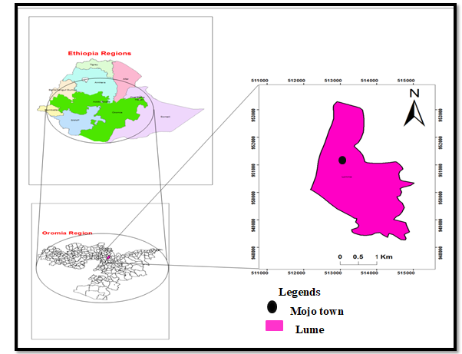
Figure 1. Location of the study area

3.1.2. Climate
The study area is mainly arid to semi-arid with hot temperature for most of the year. The climate of Mojo town is characterized by four distinct seasons. According to the traditional climate zone classification, Mojo town is grouped under Woinadega climatic zone. According to the meteorological data, the mean monthly temperature of the town was 20.2ºC. The minimum and maximum temperature was 6.8ºC and 31.8ºC respectively. The mean monthly rainfall of the town was 79 mm, the highest record of precipitation was 420 mm and the lowest was 5.9 mm. (Minalu Ambaneh, 2016).

3.1.3. Population
The total population of the town is 71392 from this 34410 are male and 36982 are females (Mojo town municipality, 2016). Economically, most of the residents in Mojo town are engage in trading activities and as employees of industries. Agriculture and handcrafting are also economical sources for some residents (Minalu Ambaneh, 2016).

3.2. Sampling techniques
Mojo town was selected Convenience because of the following reasons. Lack of background information about households’ solid waste generation and composition, current solid waste management system and its challenges, high number of people comes from different part of the country in all directions. The town as a whole has two kebeles (01 and 02). But the populations that live in those two kebeles are very large in number. Therefore, the information was gathered from representative household (sampled household) of the study areas to represent the total population. So for this research the representative sample of household from both Kebeles were picked systematically at distance of every ith household where i= N/n Where, “N” is the total number HHs in the sampling frame list adopted from municipality and “n” is the number of sample households determined by using scientific formula.

3.3. Sample size determination
Determination of sample size is the first step in any sample survey. The total number of households in the Mojo town is 15160. So to determine the sample size of household those participate in the study, the formula which was developed by Cochran (1977) has been used as follows.
n=$\frac{{NZ}^{2}PQ}{d^{2}\left(N-1\right)+Z^{2}PQ}$
Whereas: n = total sample size
P = the proportion in the targeted population estimated to have characteristic being
Measured (from Lema Asfaw, 2007, p is 0.9, i.e, 90% of this target population should addressed)
Q = 1-P which, 1- 0.9
N= Total number of housing units (total number of house hold found in Mojo town).
Z= Standardized normal variable and its value that corresponds to 95 %
Confidence interval equals 1.96
d = Allowable error (0.05)
According to the data obtained from the health office of Mojo town (2018) the total household of the town (N) is 15160. So the sample size has been determined by this formula.
n= $\frac{{NZ}^{2}PQ}{d^{2}\left(N-1\right)+Z^{2}PQ}$ =$= 1$37
Therefore n= 137 is the minimum sample of house hold of reliable data. To be safe in cases of non-cooperativeness of households, unforeseen problems during collection and other cases the sample size was increased to 160 (for contingency). For higher statistical accuracy and confidence level, the number of samples would be more (Dereje Tadesse, 2012).
To obtain (population proportion) representative sample size for each Kebele the following formula has been used.
nh = (Nh/N)n (Kothari, 2004)
nh = sample size of each Kebele
Nh = total household of each Kebele
N = total household of all Kebele
n = total sample size from all Kebele

Kebeles | Number of household | Number of household has been sampled
01 | 7050 | 74
02 | 8110 | 86

3.4. Study design
The study design was the descriptive survey method. Both quantitative and qualitative data were used. The quantitative data were obtained by measuring daily solid waste generated at the house hold level to determine the physical composition and solid waste generation rate. The qualitative data were obtained by using questionnaires on socioeconomic status and solid waste management system of the household and interview with key informants.

3.5. Source of data
All data required for this study were collected from both primary and secondary sources. The primary data were collected through questionnaires, solid waste sample, and interview with key informants and field observation. Secondary sources of data are very crucial in order to fill the information gap from primary data sources. Secondary source was gathered from published and unpublished materials such as reports, journal articles, official records, project reports, municipal report, and internet source.

3.6. Data collection instrument

3.6.1. Questionnaires
In this study, to gather necessary information from sampled households, structured questionnaire was prepared carefully in both open ended and close ended. The questionnaire was prepared in English language and translated to Afan Oromo and Amharic. All necessary information on socioeconomic status such as gender, age, family size, marital status, educational level, occupation, income level and household solid waste management practice from the sampled household was gathered. Pre-test of questionnaire was also conducted before actual data collection to check their understanding and clarity of the questions.

3.6.2. Field observation
In this study, field observation was employed to understand the status of household solid waste management practice such as solid waste handling, storage and processing, solid waste collection, transportation system and disposal site facilities of all sampled households. Checklist and Photography of solid waste management practices were taken during the time of field observation.

3.6.3. Interview
The interview is one of the data collection instruments. It was conducted with purposively selected key informants such as two Kebele leaders, one SBD heads and three employees of municipality to get detail information about a waste management system of the town which was not being covered by the questioner and to obtain some written documents through face to face interview.

3.6.4. Sorting physical composition and quantifying of solid wastes
Before starting collection all sampled households were informed and briefed as the sample was collected for scientific study. Then, the actual collection of waste from the participating households was conducted for eight consecutive days. But the waste collected on the first day of the survey was discarded assuming that it was composite of waste stored for more than one day of solid waste generated. In order to have an average result of the whole days of the week, in case of differences in waste generation between days, for each household two plastic bags labeled with its house number were given for biodegradable and non-degradable solid waste. On the first day, during the distribution of plastic bags socioeconomic information was collected and household requested to deposit the solid waste in two plastic bags. Then, the next day, during collection, another bag with the same label was given for the next day collection day. Finally, the collector collects the sample to the working area by using horse- driven carts, this process continued up to end of sample collection (8days).
The solid waste collected to working site has been sorted into major components such as food, paper, plastic, ash/dust and diaper, yard, glass, metal by using all safety measures. Then each solid waste type has been weighted using a digital balance.
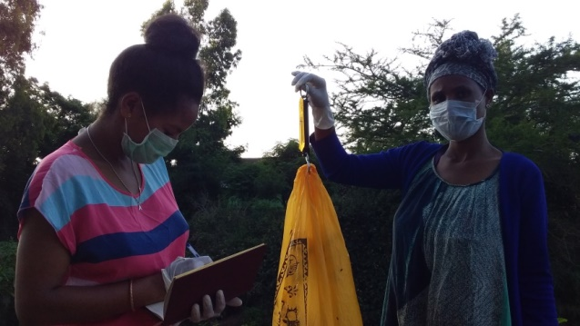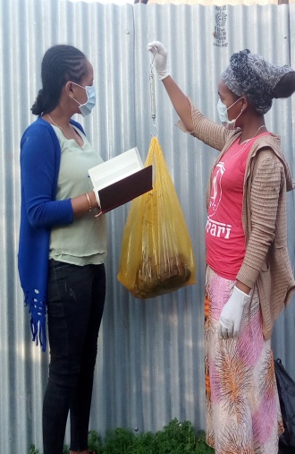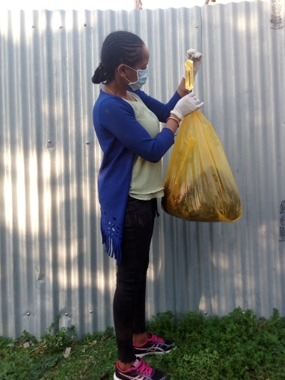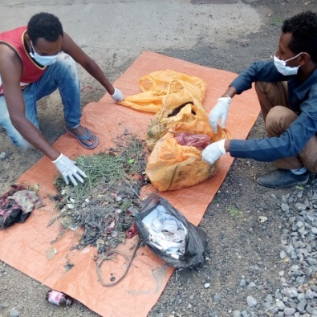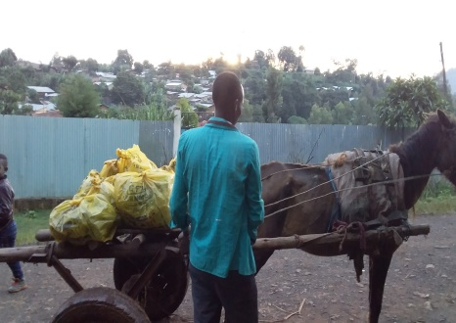
Figure 2 . Measuring, sorting and transporting of solid waste during study time.
Following Melaku Tegegn (2008) the daily solid waste generation rate (DSWGR) of the town as well as per capita per day solid waste generation rate at household level (PCPDSWGR) has been calculated as follows.
DSWGR = $\frac{total solid waste generation rate in 7 days }{7 daysx sample size}$
PCPDSWGR =$\frac{total solid waste generation rate in 7 days }{7 day x total family size in household }$

3.7. Materials
Materials used for the survey were digital balance for weighting, plastic bags (festal) are used for storing the waste generated at home, glove for our hand when sorting the waste, nose mask for our nose to avoid bad smells, clean plastic sheet for solid waste sorting, horse driven cart for solid waste transportation and camera for photo document.

3.8. Data analysis
The gathered questionnaires and the amount of solid waste generated is analyzed by using the statistical package for social science (SPSS, version 20) and MS excel 2010.The average waste generated by the different households was calculated for low, medium and high-income levels. Some data were analyzed by descriptive statics such as, mean, frequency, percentage. The relationship of socioeconomic factor and household solid waste generation has been analyzed by multiple regression models and ANOVA test was used to analyze the difference amount of waste generated among the categorical variables such as income level, marital status, and level of education.

3.9. Ethical consideration
Data collection was preceded after obtaining a written consent from Arba Minch University College of Natural Sciences, Department of Biology, Mojo town administration and kebele administrative and all concerned bodies to communicate about the research and for required data.

4. RESULTS AND DISCUSSION

4.1. Socio-economic characteristics of sampled households
As explained in Table1, about 42.5% and 57.5% of participated households were men and female respectively. In addition, about 113(70.625%) of participated household are belongs to the age group (15-45), 32(20%) and 15(9.375%) of household are belong to the age group (46-60) and (above 60) are respectively. This believed to contribute to the accuracy of information gathered from such respondents. Concerning to the marital status, household conducted in this study, 119(74.375%) were married, 11(6.875%), 20(12.5%) and 10(6.25%) were single, divorce and widowed respectively. This shows that a higher percent of households conducted in this study were married.
Based on the information obtained from the questionnaire data, the respondents are categorized into three groups depend on their monthly family income. Thus, the household who earns less than 2000 Birr per month are low income groups, whose monthly income (2000-3000) are a medium income group and (above 3001) were grouped under high income group. Based on this category, 71(44.375%) of household are a high income group, 50(31.25%) are medium income group and lastly 39(24.375%) are low income groups. Most of the randomly selected household participated in the study were from the high income group, this could be due to participation in trade activity in addition to other normal work. As per data collected from respondents, large number of households participated in this study have family size 4-8(88.75%). With respect to educational level, the majority of household has a low educational background. Table 1 indicates that, about 59.38% are less than 12 grade and 40.68% were at higher educational level. This low educational background has great influence on the full waste management system.

Table 1. Socio-economic characteristics of households
Variables | Categories | Frequency | Percentage (100%)
Gender | Female | 92 | 57.50
Gender | Male | 68 | 42.50
Age | 15-30 | 30 | 18.75
Age | 31-45 | 83 | 51.88
Age | 46-60 | 32 | 20.00
Age | Above 60 | 15 | 9.38
Family income | <600 | - | -
Family income | 600-1000 | 7 | 4.38
Family income | 1000-2000 | 32 | 20.00
Family income | 2000-3000 | 50 | 31.25
Family income | Above 3000 | 71 | 44.38
Education | Informal education | 18 | 11.25
Education | 5-8 | 30 | 18.75
Education | 9-12 | 47 | 29.38
Education | Diploma holder | 25 | 15.68
Education | Degree | 28 | 17.50
Education | Masters and above | 12 | 7.50
Marital status | Single | 11 | 6.88
Marital status | Married | 119 | 74.38
Marital status | Divorced | 20 | 12.50
Marital status | Widowed | 10 | 6.25
Family size | 1-3  4-6 | 18 | 8.13
Family size | 1-3  4-6 | 74 | 46.25
Family size | 7-10 | 68 | 42.25
Family size | >10 | - | -
Occupation | Government employed | 45 | 28.13
Occupation | Private employed | 47 | 29.38
Occupation | Self employed | 66 | 41.25
Occupation | Daily labor | 2 | 1.25
Source: Survey data

4.2. Daily household solid waste generation rate
According to the result of this study, the solid waste generation rate of Mojo town at household level was 1.4kg/HH/day. Based on the current population of the Mojo town (71392), the daily solid waste generation rate was estimated to be 17.13 tones.

4.3. Per capita solid waste generation rate
Estimating the quantity of waste generated to be handled is crucially important to design collection services and disposal facilities. Based on the result of this study, the solid waste generation rate of the town per capita per day at household level was 0.24kg/cap/day. Based on this result the Daily, Weeky, Monthly and Annually solid waste generation rate of the residential household in the town was calculated as the total population of the town (71392) times per capita household solid waste generation rate respectively.
Based on the current population of Mojo town (71392) the amount of solid waste generated was calculated as follows;
Weekly solid waste generation rate = daily generation rate*7
Monthly solid waste generation rate = daily generation rate*30
Annual solid waste generation rate = daily generation rate*365
Table 2. Generation rate of Mojo town
Time | Generation rate(kg) | Generation rate in tons
Daily | 17134.08 | 17.13
Weekly | 119,938.56 | 119.94
Monthly | 514022.40 | 514.02
Annually | 6,168,268.80 | 6168.27

The result was similar with different study such as the 0.277 kg/cap/day of Mekelle (Gabretsadkan Gabremichael, 2002); 0.229kg/cap/day of Gambella town (Afework Belay, 2015); 0.21 kg/cap/day of Gondar (Mohammed Gedefaw, 2015); 0.267 Kg of Adama (Dereje Tadesse, 2001) and 0.2kg/cp/ day/ of Hosanna town (Mekonnen Abebe, 2012). It is true that the generation rate in all case is relatively similar.
To the contrary, this result is less than 0.322kg/cap/day the study of Dire Dawa city (Zerihun Alamrew, 2018) and 0.43kg/cap/day of Laga Tafo Laga Dadi town (Mesfin Assefa and Muktar Mohammed, 2017). Amounts and characteristics of MSW differ not only from country to country, but also from region to region and neighborhood to neighborhood even within the same city. These differences depend on socioeconomic structure, income level, consumption, and usage habits of people (Kale and Anthappan, 2012; Banar and Ozkan, 2008). Comparing the SW generation rate of the study area with another area that have similar socioeconomic situation enables us to estimate the magnitude of the solid waste problems of the town.

4.4. The relationship between solid waste generation and relevant socioeconomic factor
Solid waste generation shows a great variation related to difference in socioeconomic background of households. To test the relationship between the amount of waste generated (dependent variable) and independent variable (family income, level of education, family size, age and marital status) multiple linear regression was carried out (Y= β₀₊ β₁ x₁ ₊ β₂ x₁ ₊ β₃ x₁). As indicated in the result of data analysis, the variables with the positive sign is said to be positively correlated and the ones with the negative sign is said to be negatively correlated with total waste generated.
Table 3 .Correlation coefficient of socio- economic factor
Variable | Correlation( R) | Sig.
Age | .098 | .109
Marital status | .193 | .007
Family size | .672 | .001
Family income | .312 | .000
Level of education | .163 | .020
Based on the result, R-squared value, which measures the goodness of fit for estimating regression model, of 0.609 depicts good fitting of the model. It indicates 60.9% of total variation in HH waste generation is explained by independent variables (family income, level of education, family size, age and marital status) included in the model (Appendix 3). As explained in Table 4 except age, the rest variable (marital status, family size, family income and level of education) were positively correlated with generation of household waste and statistically significant. The age of household is positively correlated, but insignificant effect on waste generation at (p<0.05). This could be because of more solid waste is generated by the working age group rather age increase or decrease. It is in line with study conducted in Jamaica, which states there is a positive relation to the working age group of the population and solid waste generation (SDRPD, 2007). Because of different activity such as reconstruction of homes, replacement of HH goods is taking place by working age group (Soukopova and Struk, 2016). The result of the study shows that, large quantity of solid waste was generated due to the presence of large family members in the household, married household, increase of family income and level of education.

4.4.1. Solid waste generation and family size
The family size of household is positively correlated with the amount of solid waste generated. That means, large family is generating more waste than the small family. Therefore, the positive coefficient on household size (r=0.672) indicates that holding all other variable constant, as the member of household increase, the total HH waste generated will be increase by 2kg, at (p< 0.05), this number (2kg) shows us, by what amount will the dependent variable increases if the independent variable increased by one unit. The positive relationship between these two variables is generally supported by the previous literature (Kassahun Tassie, 2018; Maskey et al., 2016; Afroz et al., 2011) states that, there were positive relationship between waste generation and the household size.
The more members in a HH, the more will be purchased and consumed that will ultimately result in higher waste generation. This is obviously due to the reason that an increase in household members leads to increase in resource consumption resulting increase in waste generation at their houses.

4.4.2. Solid waste generation and family income
As explained in Table 3, there is positive relationship between per monthly income of households with the amount of solid waste generated. Therefore, the positive coefficient on total monthly income (r=0.32) indicated that, holding all variable constant, when household earns more, the waste generated by households will increase by 2.6kg at (p<0.05). this number (2.6kg) shows us, by what amount will the dependent variable increases if the independent variable increased by one unit. This implies, more income means more purchasing power, which enables people to buy more, thus in the end generates more waste. Similar correlation was conducted in many studies (Maskey et al., 2016; Xu et al., 2016; Sankoh et al., 2012; Kayode and Omole, 2011). Hence the increase in family income leads to more material consumption, which increases the amount of waste.
Limbu (2013) also states that, More income means more purchasing power, which enables people to buy more, thus in the end generates more waste. The results are reasonable since increases in income are expected to increase the demand for commodity products. Therefore, income level is the most important factor influencing the type and quantity of waste generation rate at household level.
Based on the questionnaire survey also, household in the study area was categorized into three groups depending on the monthly income of the family. Thus, the respondents` whose monthly income ($<$2000) are low income groups, (2000-3000) are a medium income group and (above 3001) were grouped under high income group. Because of lack of data on the income level of the town rather than country level, the categorizations take place based on the recent study in the Dire Dawa city (Zerihun Alamrew, 2018). The solid waste generation rate directly related to the family incomes, the low income household generates a less amount of waste than high income household (Table 3), this could be because of Households that have a better life standard use more consumption materials than low income households, so they generate higher wastes. The increasing trend of waste generation rate from low to high income groups shown in this study is similar to a study reported in Ghana by (Monney et al., 2013). Per capita income level and solid waste generation rates have a direct relationship (Wells, 1996).
Table 4.Monthly Income, average family size and HH solid waste generation rate
Description | Low income | Middle income | High income
Monthly income | $<2000$ | 2000-3000 | $>3001$
Number f household | 39 | 50 | 71
Average family size | 6.7 | 5.8 | 5.0
Kg/HH/day | 1.2 | 1.4 | 1.6
Kg/cap/day | 0.1 | 0.2 | 0.3

As shown in Table 3, low income household generates 1.2 kg/HH/day for whereas middle income and high income households generate 1.4 kg/HH/day and 1.6 kg/HH/day respectively. Similarly, per capita generation rate of family members are 0.1 kg/cap/day 0.2 kg/cap/day and 0.3 kg/cap/day for low, middle and high income, respectively. The result shows that, the daily HHSW generation per person increases with the increased economic status of households and standard of living. Similar study was observed in Adama town (Lema Asfaw, 2007) and Hawasa town (Dereje Diriba, 2009).

Figure 3. The average daily total weight in percentage of solid waste collected

4.4.3. Solid waste generation and educational level
Level of education had also a positive relationship with amount of solid waste generated by HHs. The positive coefficient on level of education(r=0.163) also indicates that, holding all other variable constant, when the level of education increased, the waste generation in that household will increase by 0.02 kg at (p<0.05). this number (0.02kg) shows us, by what amount will the dependent variable increases if the independent variable increased by one unit. This might happen because when people acquire more education, they get better a job with higher income that raise the income level of the household. It is in line with the study of Sankoh et al., (2012) and Sujauddin et al., (2008) which states, higher education level directly leads to the change in consumption pattern which will in turn have an impact on waste being generated. So there are positive correlation between the education level and solid waste generation.
The result also supported by the study conducted by Maskey and Singh (2017) which states, the content of education does not specifically educate or make people aware enough about the impact of waste on the environment.

4.4.4. Solid waste generation and marital status
Marital status is also another variable which has a positive influence on the amount of waste generated at household level. It also indicates that holding other variable constant, when the married family increase, or one individual perform a marriage ceremony, waste generation in that household will be increased by 0.03kg at (p<0.05). this number (0.03kg) shows us, by what amount will the dependent variable increases if the independent variable increased by one unit. This is may be due to the reason that, the person who lives alone generates a small amount of waste than the person who lives with coupled in the household. It is similar with the previous study, living as a couple had a positive impact on the waste generation (OECD, 2011)

4.5. Solid waste physical composition analysis
Solid waste streams should be characterized by their sources, by the types of wastes produced, as well as by composition. Accurate information in these three areas is necessary in order to monitor and control existing waste management systems (Dereje Tadesse, 2012). The physical composition of household solid waste generated from Mojo town which was expressed as the percentage of different components from 160 sampled household is summarized as follows.
Table 5 . Solid waste composition result in the study area
Waste types | SWGR/cap/day | Percent
Food left over | 0.13 | 51.71
Paper | 0.01 | 3.23
plastic | 0.01 | 3.77
Textile | 0.00 | 1.15
Glass | 0.01 | 3.12
Metal | 0.00 | 2.42
Ash/dust | 0.05 | 22.18
Diaper | 0.01 | 5.57
Yard/wood | 0.02 | 6.80
Total | 0.24 | 100
As indicated in Table 5, food waste took the larger figure (52%) among the waste types followed by ash (22%) and yard waste was the third (7%) whereas the textile waste generation was the lowest one (1%). Knowing the household solid waste quantity and analysis of its component is fundamental for planning of municipal solid waste management service.
Based on these results, every household generates 0.7kg/HH/day and 0.13kg/cap/day of food waste. Food waste constitutes 52% of the total solid waste generated in the study area. Food wastes also generated from house cooking, food slip and vegetables and fruits. The physical composition of solid waste analyzed in this study was described in pie chart as follows.

Figure 4 . Percentage of solid waste composition
According to this study, about 84% of waste generated is food, ash, yard, and paper. The composition of organic solid waste constitutes the highest fraction of the total household solid waste generated from the study area. Organic solid waste is mainly composed of kitchen waste such as food remains, vegetables, fruits and garden wastes, ash, dust, leaves, scarp of chat and papers, etc. In this study, the inorganic waste is metal, plastic, Glass and textile and diaper waste accounts 16%. There are different types of plastic such as festal, broken piece of plastic material, highlands, and plastic packing materials. All types of inorganic waste do not decompose easily which is significantly affecting the landfill life of disposal area.
The organic waste generated in the study area cover 84% of total solid waste generated (52% of food, ash 22%, yard 7% and Paper 3%,) and the inorganic waste is only 16% (metal 2%, glass3% plastic 4%, textile1% and diaper 6%) (Figure 4). From organic waste food wastes where the maximum organic fraction (52%). This is due to the reason that, the eating habits of the population, high moisture contents of food waste. These compositions are agreed with several studies in many areas of the countries such as 37% of food waste in Jigjiga town (Genemo Berisa and Yohanis Birhanu, 2015); 59.7% of food waste and 31.3% of ash/sand/fine waste in Hawasa (Dereje Diriba, 2009); 59.17% of food waste of Addis Ababa city (Yitayal Beyene, 2005); 59.5% food waste and 25.1 of ash/dust waste in Walaita Sodo town (Endrias Gao and Solomon Sorsa, 2017). The result is also similar with other developing country for example, 40.7% food waste in Guadalajara, Mexico (Perez et al., 2001). Generally, the larger portion of SWs in developing countries is food waste (Tchobanoglous et al., 1993).
Therefore, at it is expected in many developing country towns about 84% of household solid waste composition of Mojo town is predominantly made up of biodegradable solid waste such as food, ash, Yard and paper. Ash waste contains (22%) of biodegradable waste, this was due to all fine waste, including fire residue are taken as an ash component during study time. And the source of energy for some household is wood, charcoal, paper and yard. The main causes for the proportion of ash to be high, is the life style of the population and physical environment of this area. Especially from households that made injera for selling purposes, higher amount of ash waste is disposed every day. About 40% (Table 8) of household use some kinds waste such as paper, plastic and yard and wood for fuel, this activity also contributor for the presence huge amount of ash at household level.
From the result, the composition of metal accounts 2% of the inorganic waste. This could be because of most households does not dispose the metal as waste. They store at in their home rather than disposing them for sale to informal buyers. It is composed of a piece of metal, old can, bottle corks etc. Plastic and paper content also accounts 4% and 3% by weight respectively. The proportion could be considered less because of these materials are used as catch fire agent for firewood by the household and have low weight. Besides, plastic waste was used as reusable materials. Glass waste was reused by many households and recycled by buyer through house to house waste collectors.
It accounts only 3%. From the sampled household more than twenty household dispose diaper waste, so it accounts 6%. The proportion of textile waste was the last which is 1%. Generally, metal, plastic, glass and old shoes were observed to be as reusable resource by many households. The study showed less proportion of inorganic waste compared to organic waste.Such high proportion of organic waste has been reported by studies conducted in many different cities of the developing countries. For example, in Nepal organic waste share 47.25% (Maskey and Singh, 2017). Similarly, in a study conducted in Ghana the proportion of organic waste accounts 48% (Monney et al., 2013). A study conducted in Palestine also indicated that the bulk of solid waste was organic 65.1% (Alkhatib et al., 2010).
In fact that there are several studies indicating that, the amount of organic waste of developing countries in general consists of more than 50% of total waste composition (Aleluia and Ferrao, 2016; Al-Khatib, 2010). A complete picture about the composition of household solid waste is an essential part in order to select the appropriate types of waste management system. The composition of the solid waste stream may be influenced by changes in consumption pattern and solid waste reusing or recycling practice of the town.
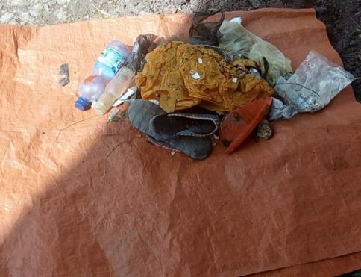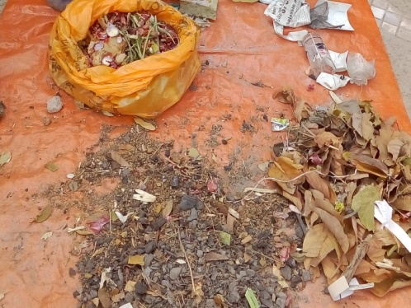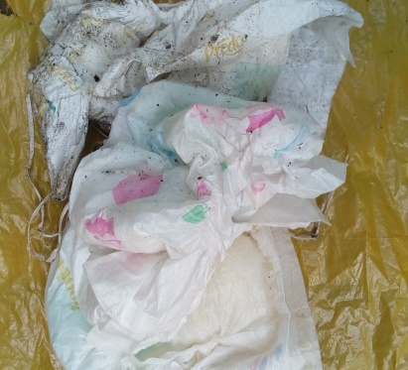
Figure 5 . Physical composition of solid waste.

4.6. Solid waste management practices at household level
Solid waste management is in crisis in many of the world’s largest urban areas. Population attracted to cities continues to grow and this has led to ever increasing quantity of domestic solid waste while space for disposal decreases (Yitayal Beyene, 2005).

4.6.1. Awareness of HH about solid waste generation and handling practice
Table 6. Awareness of household about solid waste generation
Variables | Frequency | Percentage
Awareness of HHs on solid waste generation
Yes | 101 | 63.13
No | 59 | 36.88
Most abundant solid waste generating at HHs level
Organic  Inorganic  Both | 106  19  35 | 66.25  11.88  21.88

According to table 6, 101(63.13%) of household have a general awareness about the types and amount solid waste generation. Some of the households 59(36.88%) are not aware about solid waste generated from their house. About 106(66.25%) of household perceive that, the solid waste generated is dominated by organic waste, such as ash, food, yard and paper. and 19(11.8%) of households said that, the proportion was found to be dominated by inorganic waste and the remaining 35(21.88%) of HHs perceive as it has both. Any activity which helps in reducing waste, focusing on reuse and recycling at the source is termed as source reduction. Source reduction is the basic and most important step in order to improve appropriate solid waste management practice. But due to lack of awareness, reducing the solid waste at the time of generation not practicing in the study area.
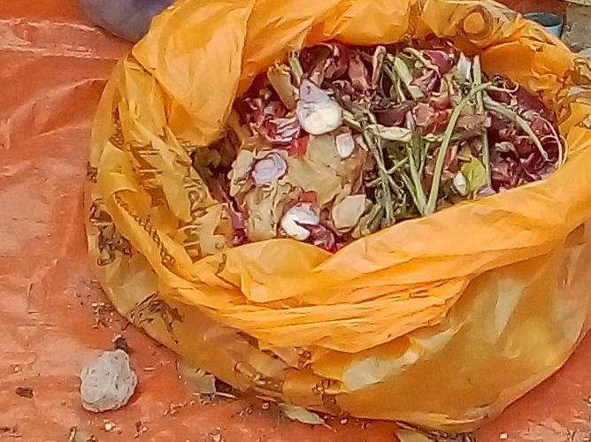
Figure 6. Organic solid waste generation.
As explained in appendix 2, of the total household, 142(88.75%) of respondents have solid waste storage material in their home. However, they did not sort and store. For example, storing activity took place by household who use plastic bags and plastic container as temporary storage. This could be because of the low holding capacity of thin plastic bags, plastic container and practice of disposal as it gets full to an open space near to their home. While the rest 18(11.25%) of household have no solid waste storage materials at their home. They threw waste on the street, open space near to their home and in drainage channels. About 104(65%) of respondents use trash bag as temporary solid waste storage materials while, 25(15.62%) and 6(3.75%) use plastic bags and basket respectively. The rest 25(15.63%) use other materials such as plastic container and open areas at their home side (appendix 2).
Many households use trash bags as temporary storage materials. This could be because of its durability than plastic bags. Its size also has contributed to its preference and for most families it accommodates a week round wastes. Moreover, it is convenient to handle when wastes are transported from houses to disposal site. In the study area, no communal bin or container used for solid waste temporary storage before it is transported to the disposal area in everywhere. Concerning to house cleaning condition, about 53(33.13%) of respondents clean their house once a day and about 73(45.63%) and 34(21.25%) of respondents clean their house twice a day and three times a day respectively (Table 10). Because it may be depends on their family size, the household who has high family size may be clean their house two or three times and it also depends on lifestyle of respondents or quality of their house.
Regarding to the contribution of solid waste handling responsibility, about 115(71.87%) respondents believed that female is responsible; while male accounts only 7(4.37%) and about 38(27.75%) of HH respondents believed as both of them have responsible for solid waste handling at their home. But 71.87% of respondents answered as female`s responsibility. This was because most of time they stay at home and more frequently handle home cleanliness and also household waste management was generally regarded as the duty of women. This could be attributed to cultural influence. About 118 (73.75%) indicated that, household waste is produced by female rather than male or both.
This could be due to the fact that, household solid waste management was taken as the responsibility of females in everywhere in Ethiopia. In many countries the role of women to clean the house and dispose of the solid waste is common traditional (Addai and Danso, 2014).
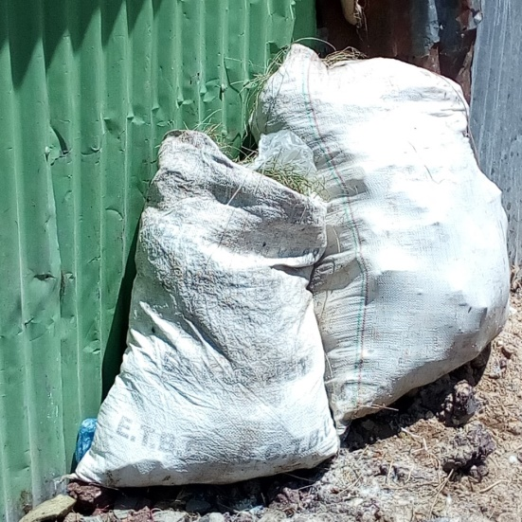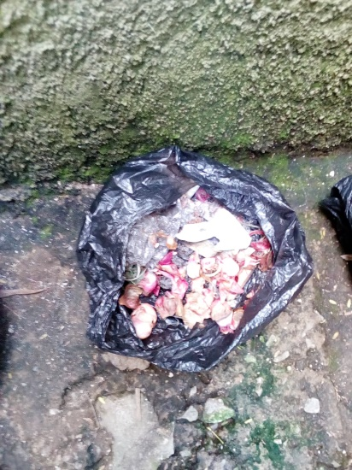
Figure 7. Some solid waste storage material at household level

4.6.2. Solid waste collection and transportation system
Table 7. Solid waste collection and transportation
Variables | Frequency | Percentage
Problem of proper collection of solid waste at HH level
Yes | 99 | 61.88
No | 61 | 38.13
Means of solid waste transportation system at HH level
By hands | 65 | 40.63
By hand push carts | 17 | 10.63
Horse driven cart | 53 | 33.13
By vehicle | 25 | 15.63
Of the 160 participated households in study, about 61(38%) of households have access door to door solid waste collection and transportation service and about 99(67%) of household did not have proper collection and transportation service for solid waste. This implies that, door to door solid waste collection system of the town is insufficient. Because of much amount of solid waste remain uncollected, it will be disposed on street and open space near to their homes. Regarding means of transportation of solid waste, about 78(48.75%) of households use vehicle and horse driven cart as transportation service while the rest 82(51.25%) of household uses their hand and hand push carts as transportation service. This result indicates that most of the solid waste of the town was transported improperly. Waste collection service in the study area is carried out in two ways, formally and informally. Formally, there are macro small scale enterprises which collect solid waste door to door and transport in the provided disposal area of the town. While the others collect informally and disposed to elsewhere. In the study area about 82(51.25%) of household dispose their waste informally by their hand and by hand push cart. However, hand and hand push cart transportation service does not reach the proper disposal place selected by the municipality of the town. Hence, they dispose the waste in open space found in anywhere else. This could be because of no container for temporary waste storage in the town. According to the residents, the general quality of the service regarding waste collection by the municipality was unsatisfactory. The poor quality of collection service could force the residents to revert to other illegal dumping methods if drastic measures are not put in place to improve current conditions (Monney et al., 2013).
Table 8. Reused solid waste
Variable | Frequency | Percentage
Reusing of solid waste
Yes | 66 | 41.25
No | 94 | 58.75
Solid waste used as fuel
Yes | 64 | 40.00
No | 96 | 60.00
Solid wastes commonly sold at HH level
Metals | 20 | 12.5
Plastic and old shoes | 71 | 44.38
None | 45 | 28.13
Glass( especially bottle) | 24 | 15.00
Commonly celling body of solid waste
Korales | 148 | 92.50
Others | 12 | 7.50
Of the total respondents 94(58.75%) of households do not reuse solid wastes. They dispose all the waste generated at home. This could be because of many households did not sort the solid waste at the site of production. Concerning awareness on reusability of solid waste only 66(41.25%) of household have information on reusability resources. So they reuse some kinds of wastes such as plastic and paper for fuel, food for compost and for the purpose of feeding their own animals. As explained above, about 64(40%) of households use some types of waste such as paper/carton, plastic, yard for fuel. While about 96(60%) didn`t use any types of waste for fuel.
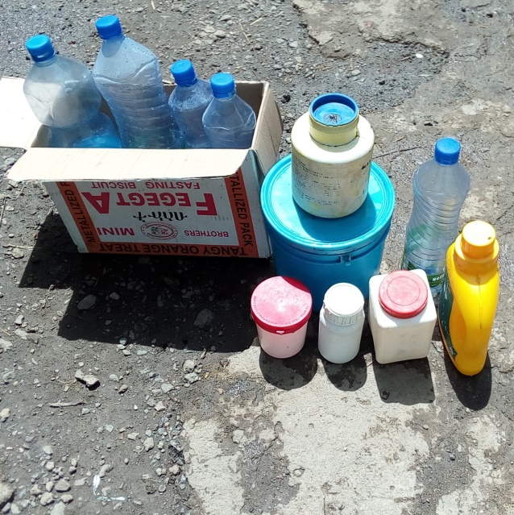
Figure 8. Some of the reused solid waste.
In many studied households the dominant types of solid wastes that are sold were plastic and old shoes, which account 71(44.375%) and about 20(12.5%), 24(15) metal and glass respectively (Table 8). And about 45(28.13%) of household never sold any types. According to this study, the solid wastes that are sellable are only put alone. Because of many households do not consider these materials as waste and not mix with other types waste. The selling area of this material is mostly dominated by korales 148(92.5%). This shows that, there was no formal recycling center in the town. Collecting all types of waste at the same place was found to be common practice in the study area. It was observed that no system for separating solid waste at the source of generation has yet been introduced in Mojo town. Once mixed, it is difficult to any recovery companies to separate the solid waste into different usable materials for further treatment or recycling. It is one method of reducing the problem of landfill site expenses and makes waste management easy and simple. However, it should not be a one time activity, rather should be a habit for proper and sustainable solid waste management. Many studies indicate that, separation at source was totally absent in the waste management practice of most developing countries; practically it was true in the study area. Source reduction in addition to central sorting techniques has been the bedrock of successful solid waste material recovery and recycling programs in developing countries (Oduro and Aggrey, 2013).

This result explained that, the awareness of household about usefulness of discarded solid waste is relatively very low and the activity of resource recovering such as reusing, recycling and composting was found to be very poor in management practice of study area. Similar result was observed in Ghana (Nyankson et al., 2015).

4.6.3. Solid waste disposal practice
As explained in Table 11or appendix 2, about 97(59.38%) households used open dump as solid waste disposal practice at their home. While 63(40.63%) households are not used open dump as solid waste disposal methods. This was occurred due to lack of efficient collection and transportation system. Solid wastes of the town are usually dumped in open spaces around health centers, on roads and ditches. Concerning the selected time of solid waste dumping, 64(40) household using night time and 63(39.38%) legal disposers responded that, they disposed their solid wastes at the time when the waste collectors come and the rest 33(20.63%) of respondents using morning time for solid waste dumping. This implies that, the study area is dominated by illegal method of dumping practice.
Regarding to solid waste dumping areas, about 30(18.75%) of households dumping the solid waste inside the compound. Out of this, about 26 household uses burning practice commonly to minimize the size of waste collected for saving space. While 67(41.88%), 63(39.38%) are dispose the solid waste outside the compounds and at disposal area provided by municipality respectively. This shows about 97 of household dispose their waste in illegal way, it may be in open space, in the compound, home side, bridges etc. As explained in Table11, concerning to solid waste burning condition, 72(45%) are using burning practice as solid waste disposal system sometimes, depending on types of waste generated. while 88(55%) of households are not use burning as solid waste disposal system. Many households use open dumping and burning system as solid waste disposal practice, which account 68(42.5%) and 26(16.20%) respectively. As the respondent answer, burning is used to minimize the amount of collected waste (figure 10). 3(1.88%) and 63(39.38%) use composting and landfill practice as solid waste disposal respectively.

Sanitary land fill is the most common technology around the world. However, unconventional and environmentally unfriend methods including open-burning and open-dumping were the common solid waste management practice in the study area.
In the study area about 58.7% of house hold use the open burning and open dumping, this shows that, large number of household use illegal disposal method which is not supported by anybody. One of the amazing actions observed in the dumpsite during data collection were, there was continuous burning of the dumped waste, due to waste is coming from different source especially chemical waste from industry made reaction and there is internal ignition by waste itself (figure 9). This result was in line with other study where , Open air burning and spontaneous combustion in dumping site, are among the causes of air pollution and unpleasant odour (Nigatu Regasa et al., 2011). It was documented that, solid waste burning activities is contribute to global greenhouse gas emission by approximately 4%. In particular, the disposal in land fill generates methane that has high global warming potential (Papageorgiou et al., 2009).
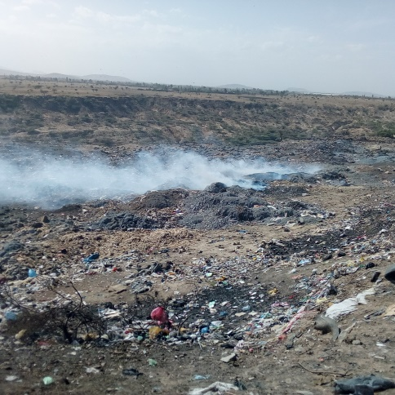
Figure 9. Burning of solid waste at disposal site

4.6.4. Municipal solid waste management
Table 9. Solid waste collection and disposal monitoring condition
Variable | Frequency | Percentage
Solid waste management condition in municipality
Satisfactory | 41 | 25.63
No satisfactory | 119 | 74.30
Collection and disposal service condition by municipality
Poor | 99 | 61.88
Satisfactory | 41 | 25.63
Good | 20 | 12.50
Very good | - | -
As shown in Table 9, about 119(74.3%) of household responds that, the solid waste management system of municipality was not satisfactory. While only 41(25.625%) household responds as solid waste management system of municipality was satisfactory. Regarding collection and disposal service condition, 99(61.88%) of household answered the solid waste collection and disposal service of municipality is poor. While the rest answered that, satisfactory and good, which accounts 41(25.62%) and 20(12.50) respectively.
According to this result, the management system of municipality is very weak. It was observed that, the municipality of Mojo town select disposal site which is very close to Mojo River. It doesn’t consider distance from water bodies, agricultural fields and settlement. The existing site didn`t consider major environmental and health factors. The residents live near to the dump site are suffering from air pollution comes from the dumped waste and due to pollution of the river they cannot use for animal feeding and irrigation. The animal eat the grass that grow around dump site were also exposed to different disease.
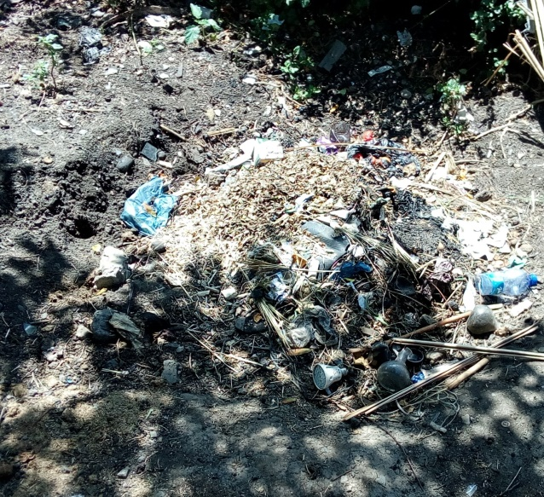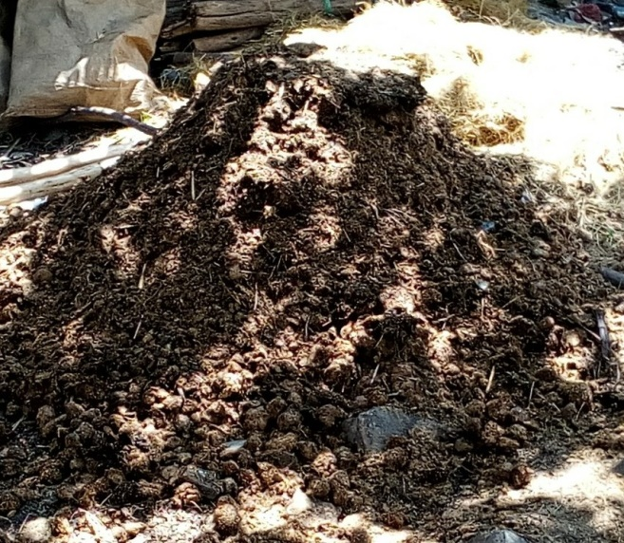
A, Open dump in the compound B, Solid waste collected for compost preparation 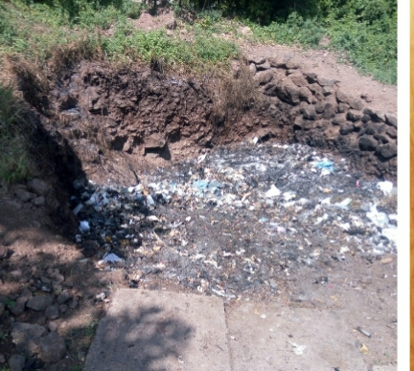 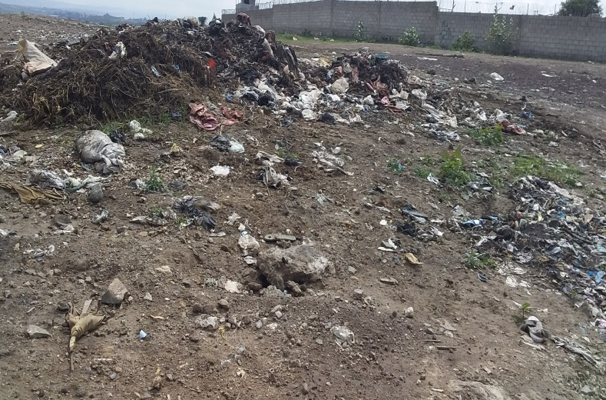
C. Burning in the pit in the compound D. Dumping on open space around residents area
Figure 10. Solid waste disposal practice

4.7. Street sweeping activity
Street sweeping is one of the waste management practices under the responsibility of municipality in Mojo town. For cleaning of these roads, about 26 women sanitation workers were employed with contract by SBD. Street sweeping takes place for three days within a week. This indicates that, poor waste management practice. Because of no street dust bins for generation of solid wastes such as pieces of paper, residual vegetables and fruit, it needs to be done every day. This could be because of high number of population, amount of waste damped and absence of waste management facility in the town.
The street sweepers were separated to different place around the streets, and clean roads using brooms and sickle that are provided by the department. After cleaning they burn the burnable waste and store the rest on some transfer place until the municipality truck comes. Based on observation and interview with SBD heads there was shortage of tracks to collect and transport waste in the town. And also shortage of man powers for street sweeping. Due to this, the existing employees do not able to cover all street of the town, most of the times they clean around the center of town where street are busy with different activity. The residents are very carless to clean front of their compound rather than cleaning their house and they see as the responsibility of municipality. This shows that, how communities give little attention to clean their surroundings. Therefore, the condition is becoming common problem for both local community and municipality.
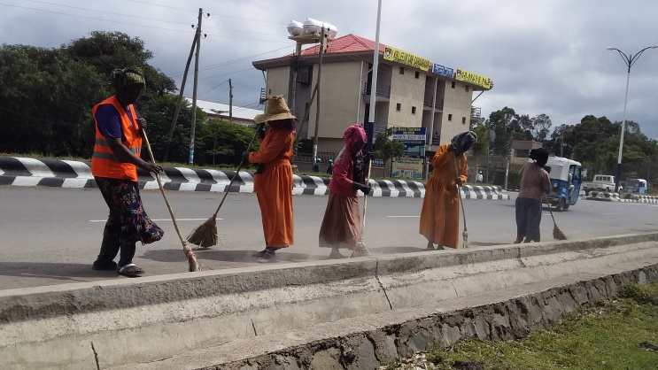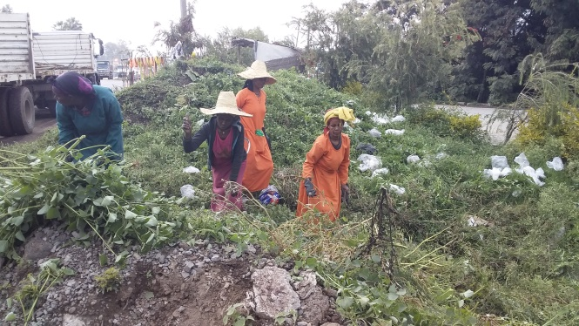
Figure 11. Street sweeping activity

5. CONCLUSION AND RECOMMENDATIONS

5.1. Conclusion
The majority of solid waste generated by the town is organic. This composition is very suitable to make compost, which is the best ways of sustainable solid waste management. Thus, a waste management strategy for the town should focus on managing biodegradable organic waste. In the study area, the existing solid waste management systems are inadequate both in terms of coverage and treatment of solid waste. The solid waste collection service is also very low in terms of coverage that means the large proportion of solid waste generated in the town was uncontrolled and improperly disposed. It was estimated that, the average daily solid waste generation rate is 0.24kg per capita per day whereas the average daily solid waste generation per household is 1.4kg/HH/day. In the current situation of the study area, source separation at household level is totally absence, therefore the activity of reusing and recycling of solid waste, which has great role in source reduction at the point of generation was not practical. The amounts of solid waste generated were highly affected by dominant socioeconomic factors such as Household income, family size, level of education and marital status. The factories are positively correlated with household waste generation and statistically significance at (p<0.05). This shows that, household solid waste generation increase with the increase of income level of households, number of individual in the house, increase level of education and marriage people increases, thus can be important indicators to forecast solid waste generation trend.

5.2. Recommendations
The following recommendation were made based on the current research findings
- In spite of the numerous items which could be potentially recovered for, reusing recycling, none of the residents during survey is not sorted out any item therefore, giving training to the residents on source separation is important to made appropriate waste management system
- Since the composition of household waste present a good opportunity for waste recycling through composting, intensive education on the ways of compost preparation is highly recommended. Because of it is used to prolong the lifespan of landfills as well as replenishing soil nutrients
- Since, this study is the first study for the town on the household solid waste generation factor and composition study, it is necessary to conduct further studies and implement long range managerial organization for solid waste generation.
- Most socioeconomic included in this study have positive impact on waste generation so, all concerned body should educate people on waste issues, especially on source reduction
- Based on generation rate and physical composition of solid waste in the town, integrated solid waste management system which combines the range of solid waste treatment option such as source reduction, composting, recycling, and solid waste to energy transformation is recommended.
- Educating the community about the impact of dumping solid waste on elsewhere and monitoring mechanism should be placed on the dumping site to avoid illegal dumping.
- Municipality should provide awareness about the importance of solid waste management in the town.
- Further study should be done on chemical analysis of solid waste.
- The municipality should distribute the number of container in the town, order to minimize illegal dumping b/c of absence of container in elsewhere.
- New land fill is urgently needed with proper selection (environmental impact assessment) b/c the existing land fill environmentally unsound and socially unacceptable.
- There is shortage of trucks for waste collection in the town, therefore increasing the number of truck is very important in order to improve waste collection and transportation service.

6. REFERENCES
Addai, K. N., and Danso-Abbeam, G. (2014). Determinants of Willingness to Pay for Improved Solid Waste Management in Dunkwa-on-Offin, Ghana : Journal of Agriculture and Environmental Sciences. 3(1), 189-199.
Afewark Belay, (2015). Household solid waste generation rate and composition, and people attitude towards its management in Gambella Town. MSc thesis, Haramaya university. Ethiopia.
Afon , (2007). An Analysis of Solid Waste Generation in a Traditional African city: the Example of Ogbomoso, Nigeria: International Institute for Environment and Development: Journal of the Nigerian Institute of Town Planners. 19(4), 33–41.
Afroz, R., Hanaki, K .,and Hasegawa-Kurisu, K. ,(2009). Willingness to pay for waste management improvement in Dhaka city, Bangladesh: Journal of environmental management. 90(1), 492-503.
Afroz .,R, Hanaki.,K, Tudin, R.(2011). Factors affecting waste generation: a study in a waste management program in Dhaka City, Bangladesh. Environ Monit Assess (179) 509–519
Aleluia, J., and Ferrão, P. (2016). Characterization of urban waste management practices in developing Asian countries: A new analytical framework based on waste characteristics and urban dimension. Waste Management, 58, 415–429
Al-khatib,A.;Arafat,A ; Basheer,T.; Shawahneh,H .; Salahat,A.;Eid,J. and Ali,w., (2010).Trends and problems of solid waste management in developing countries: A case of a study in seven Palestinian districts. Journal of waste management, 27, 1910-1919
Babayemi, J . A. and Dauda , K ., (2009). Evaluation of solid waste generation , categories and disposal option in developing countries: A case study of Nigerai: Journal of applied science and environmental management .13(3), 83 – 88
Banar, M. Ozkan, A.( 2008) Characterization of the Municipal Solid Waste in Eskisehir City, Turkey. Journal of environmental engineering science 25(8), 1213–1220.
Beigl, P., Wassermann, G., Schneider F., Salhofer S., (2004). Fore casting municipal solid waste generation in major European cities. International Congress on Environmental Modelling and Software 83.https://scholarsarchive.byu.edu/iemss conference/2004/all/83
Bukar A. G., Bogoro A. G., Samson M. N., and Rasheed.O .,( 2014). Economic factors that determine the quantity and Characteristics of Solid Waste in Bauchi Metropolis, Nigeria: IOSR Journal of Environmental Science, Toxicology and Food Technology (IOSR-JESTFT). 8(6), 01-07.
Burntley, S.J. ,(2007). A Review of Municipal Solid Waste Composition in the United Kingdom: Journal of Waste Management. 27(5), 1274-1285.
Cochran, G., (1977). Sampling Techniques, 3rd edition, Wiley Series in Productivity and Applied Mathematical Statistics. New York, USA
Coffey . M and. Coad .A, (2010). Collection of Municipal Solid Waste in Developing Countries , United Nations Human Settlements Programme (UN-HABITAT). Nairobi, Kenya.
Cunningham, (2008). Principles of Environmental Science Inquiry and Applications.4th edition, McGraw Hill International Edition, USA.
Dawit Walelegn and Alebel Bayrau , (2003) . Improvement of solid waste Management in Addis Ababa, A participatory Approach (Draft). Addis Ababa university. Ethiopia.
Dereje, Diriba, (2009). Household solid waste generation rate, composition and content analysis for disposal and resource recovery in two selected kebeles of Hawassa town. MSc thesis, Addis Ababa university. Ethiopia
Dereje Tadesse ,(2001). Financing urban infrastructures and services in Ethiopia: The case of Solid waste Management in Adama. MSc thesis, Addis Ababa University, Ethiopia
Dereje Tadesse Mekonnen, (2012). Study of domestic solid waste management in Jimma town, MSc thesis, Addis Ababa university. Ethiopia
Endrias Goa and Solomon Sorsa , (2017). Generation rate and physical composition of solid waste in Wolaita Sodo town, Southern Ethiopia: Ethiopian Journal of Environmental studies and Management. 10 (3), 415- 42.
Enger and Smith, (2008) .Environmental Science a Study of Interrelationship.11th edition, McGraw Hill International Edition. USA
Fitsum Tsegaye, (2008). Assessment of management option for Domestic Solid waste in Addis Ababa. MSc thesis, Addis Ababa University. Ethiopia
Frantz, A, (2006). A comparative study of municipal waste disposal practices and management in the Breede River District Council and the Cape Metropolitan Area. MSc thesis, University of the Western Cape
Gabretsadkan Gabremichael, (2002). Domestic Solid Waste Management in Mekelle City: Tigray Region, MSc thesis, Addis Ababa University. Ethiopia
Gaurav K. Singh, K.G, and Shashank. Ch , ( 2014). Solid Waste Management: Its Sources, Collection, Transportation and Recycling: International Journal of Environmental Science and Development. 5(4), 347-351.
Gu, B., Wang, H., Chen, Z., Jiang, S., Zhu, W., Liu, M., Bi, J. (2015). Characterization, quantification and management of household solid waste: A case study in China. Resources, Conservation and Recycling, 98, 67–75. https://doi.org/10.1016/j.resconrec.2015.03.001
Haider .A , Aleem .A, Shahid , Khan .S ,Mahrukh and Butt. A , (2015 ). Knowledge, Perception and Attitude of common People towards Solid Waste Management- A case study of Lahore, Pakistan: International Research Journal of Environment Sciences. 4(3), 100-107.
Hassan., M. N, Chong, T. L, Rahman., M. Salleh., M. N, Zakaria.,Z, Awang., M. (2001). Solid waste management in southeast Asian countries with special attention to Malaysia: International Waste Management and Landfill Symposium.
Hoornweg .D and Perinaz . B .T, (2012 ). A Global Review of Solid Waste Management. WHAT A WASTE.
Hui Y., Li’ao W., Fenwei S., and Gang H. (2006). Urban solid waste management in Chongqing: challenges and opportunities waste management, 26(9), 1052-1062.
Kadam M.S ,and Sarawade S. S. , (2016) . Study and Analysis of Solid Waste Management Challenges and Options for Treatment (Indian Villages): IOSR Journal of Mechanical and Civil Engineering e-ISSN: 2278-1684,p-ISSN: 2320-334X PP 15-22.
Kale, D. K., Anthappan P.D., (2012). Solid waste management by use of EM technology, Asian Journal of. Expremental. Science.26 (1), 5-16.
Kassahun Tassie Wegedie, (2018). Households solid waste generation and management behavior in case of Bahir Dar City, Amhara National Regional State, Ethiopia: Research article.
Kayode, A. M., and Omole, F. K. , (2011). Some socio-economic factors affecting solid wastes generation and disposal in Ibadan Metropolis, Nigeria: Journal of Environmental Issues and Agriculture in Developing Countries. 3(1), 55–64.
Kirunda . M. P., (2009) . Public Participation in Solid Waste Management: Challenges and Prospects. A case of Kira Town Council, MSc thesis, University of Agder. Uganda.
Khan, D., Kumar, A., & Samadder, S. R. (2016). Impact of socioeconomic status on municipal solid waste generation rate: Waste Management, 49, 15–25
Kobina S. O. (2011). Composting as a tool for solid waste management and for promotion of organic farming. MSc thesis, Kwame nkrumah University of science and technology. Ghana
Kofoworola .O.K . , (2006). Recovery and recycling practices in Municipal solid waste management in Lagos. Journal of Waste Management. 27 (3), 1139–1143
Kothari, C.R.(2004).Research Methodology; Method and techniques. NewAge International Publishers, New Delhi, India.
Lars .M .J and Gabriela .B,(1999). Observations of Solid Waste Landfills in Developing Countries: Africa, Asia, and Latin America, Washington, D.C., U.S.A.
Lema Asfaw, (2007). Household generation rate and composition analyses in Adama town. MSc thesis, Addis Ababa university. Ethiopia.
Limbu. J ,(2013). Analyzing socio-economic and cultural factors affecting waste generation in guma gewog, punakha: Royal institute of management.
Maskey, B., Maharjan, K. L., and Singh, M. , (2016). Ecological solid waste management act and factors influencing solid waste management in barangay Pansol of Quezon City, the Philippines: Journal of International Development and Cooperation. 22, 37–45.
Maskey and Singh, (2017). Household Waste Generating Factors and Composition Study for Effective Management in Gorkha Municipality of Nepal: Journal of Sustainable Development 10(6), 1913-9071.
Medina,. M (1999). Globalization, Development, and Municipal solid waste Management in third world cities; Tijuana , Mexico.
Mekonnen Abebe, (2012). Development of solid waste management strategy in Hossana town, Southern Ethiopia. MSc thesis, Addis Ababa university. Ethiopia.
Melaku Tegegn , (2008). Household Solid Waste Generation Rate and Physical Composition Analysis, in Jimma Town, MSc thesis, Addis Ababa university. Ethiopia
Mesfin Assefa and Muktar Mohammed , (2017). Solid Waste Generation Rate and Characterization Study for LagaTafo Laga Dadi Town, Oromia region, Ethiopia: International Journal of Environmental Protection and Policy. 5(6), 84-93.
Miezah, K., Obiri-Danso, K., Kádár, Z., Fei-Baffoe, B., and Mensah, M. Y. , (2015). Municipal solid waste characterization and quantification as a measure towards effective waste management in Ghana. Waste Management, 46, 15–27. https://doi.org/10.1016/j.wasman.2015.09.009
Miller. G., (2007). Living in the Environment. 5th Edition, International Student Edition, USA
Minalu Ambaneh, (2016). Solid waste disposal site selection using GIS and Remote sensing: for Mojo Town, MSc thesis, Addis Ababa University. Ethiopia.
Minghua, Z. F. Xiumin, A. Rovetta, H. Qichang, F. Vicentini, L. Bingkai, A. Giusti, L. Yi.,(2009) .Municipal solid waste management in pudong new area, China: Journal of Waste Management. 29(3), 1227–1233.
Mohammed Gedefaw,(2015). Assessing the Current Status Of Solid Waste Management Of Gondar Town, Ethiopia: International journal of scientific and technology research.4(9), 2277-8616
Mojo Town Municipality, (2016). Lume Woreda 2011 Annual Report. Mojo, East Shewa, Ethiopia
Monney, I., Makimula, B.T., Chendire,.H.G,.(2013). Characteristics and management of household solid waste in urban areas in Ghana: the case of WA: Journal of civil and Environmental Research. 3(9), 2225-0514
Moya .D , Clay. A ,Germánico. L and Prasad.K , ( 2017). Municipal solid waste as a valuable renewable energy resource: a worldwide opportunity of energy recovery by using Waste-To Energy Technologies: 9th International Conference on Sustainability in Energy and Buildings,
Nigatu Regasa,. Sundaraa Rajan., and Bizunesh Bogale. (2011). Challenges and Opportunities in Municipal Solid Waste Management: The Case of Addis Ababa City, Central Ethiopia. Journal of human ecology 33(3),179-190.
Niringiye, A , (2010). Determinants of willingness to pay for solid waste management in Kampala city. Current Research: Journal of Economic Theory. 2(3), 119-122.
Nyankson,A.E., Fei-Baffoe.B., Gorkeh-Miah.J.(2015). Household solid waste generation rate and physical composition analysis: case of Sekondi-takoradi Metropolis in the western region, Ghana: International journal of environment. 4(2), 2091-2854
Oduro,K and Aggrey,B,.(2013). Determinants of source separation of municipal solid waste in developing countries: the case of Ghana. Journal of sustainable development in Africa,
Organisation for Economic Co-operation and Development( OECD). (2011). Greening Household Behaviour: The Role of Public Policy. Viewed on 21st October, 2013 from http://www.oecd.org/env/consumption- innovation/47234481.pdf
Organization for Security and Co-operation in Europe [OSCE]. (2009). Gender and environment: A guide to the integration of gender aspects in the OSCE’s environmental projects. Vienna.
Oribe-Garcia, I., Kamara-Esteban, O., Martin, C., Macarulla-Arenaza, A. M., and Alonso-Vicario, A. , (2015). Identification of influencing municipal characteristics regarding household waste generation and their forecasting ability in Biscay. Waste Management, 39, 26–34. https://doi.org/10.1016/j.wasman.2015.02.017
Palanivel. M .T and Sulaiman. H ,(2014). Generation and Composition of Municipal Solid Waste (MSW) in Muscat, Sultanate of Oman. APCBEE Procedia 10, 96 – 102
Papageorgiou, A., Barton, J. and karagiannidis, A., (2009). Assessment of the greenhouse effect impact of technologies used for energy recovery from municipal waste. Journal of environmental management 90, 2999-3012
Perez G.B, Colon S.S, Garmendia M.A. Villareal A.D, and Elena M.S.S., (2001). Solid waste characterization study in the Guadalajara Metropolitan Zone, Mexico. Waste Management Research 19: 413-424.
Pradhan.U. M, (2008). Sustainable solid waste management in a mountain ecosystem: Darjeeling, West Bengal, India. MSc thesis, University of Manitoba. India
Qu, X., Li, Z., Xie, X., Sui, Y., Yang, L., and Chen, Y. (2009). Survey of composition and generation rate of household wastes in Beijing, China. Waste Management, 29(10), 2618–2624.
Sankoh, F. P., Yan, X. and Conteh, A. M. H. , (2012). A situational assessment of socioeconomic factors affecting solid waste generation and composition in Freetown, Sierra Leone: Journal of Environmental Protection. 3, 563–568.
Sardinia, (2007). Waste recycling in developing countries in Africa: Barriers to improving reclamation rates, Eleventh International Waste Management and Landfill Symposium
Shabani . R . A, (2015). Factors affecting community participation in solid waste management in lindi municipal council Tanzania,
Sharholy. M., Ahmad, K., Mahmood, G. and Trivedi, P.C. (2008).Municipal solid waste management in Indian cities- A review, waste management 28, 459-467.
Siddiqqui .M .A , (2018). Municipal solid waste management in India-Status and Challenges: An overview: International Journal of Biology Research. 3(1), 126-133.
Soloman Cheru, ( 2011). Assessment of Municipal solid waste management service in Dessie Town. MSc thesis , Addis Ababa University. Ethiopia
Song, J.; Murphy,R.; Narayan, R. and Davies, G. , (2009). Biodegradable and compostable alternatives to conventional plastics, philosophical transactions of the Royal society B: biological science , 364,2127-2139.
Soukopova, J., Struk, M., (2016). Age Structure and Municipal Waste Generation and Recycling – New Challenge for the Circular Economy.4th International Conference on Sustainable Solid Waste Management 23rd - 25th June 2016 Limassol, Cyprus - Preliminary version.
Sujauddin, M., Huda, S. M. S., and Hoque, A. T. M. R. , (2008). Household solid waste characteristics and management in Chittagong, Bangladesh.: Journal of Waste Management. 28(9), 1688–1695.
Sustainable Development and Regional Planning Division (SDRP), (2007). Management of hazardous and solid wastes in jamaica, Planning Institute of Jamaica.
Swapan .M , (2009). Socioeconomic aspect of solid waste recovery and recycling in Bangladesh: A case study of Khulna city. In: proc. The annual conference of Australian sociological Association, 1-4.
Taghi .S,.Seiied.S ,Ebrahim. F, Taghi .E, and Ali .M. (2015). Site Selection of Sarein's Municipal Solid Waste Landfill Using the GIS Technique and SAW Method: International Journal of Environmental Science and Development. 6(12), 934-937.
Tchonobanglous G., Theisen., and Samuel N., (1993). Integrated Solid Waste Management
Engineering principles and management Issues McGraw – Hill. Singapore
Tolina Tiruneh , (2006) . Households Willingness to Pay for Improved Solid Waste Management: The Case of Adama. MSc thesis, Addis Ababa University. Ethiopia
Trang, P. T. T., Dong, H. Q., Toan, D. Q., Hanh, N. T. X., and Thu, N. T, (2017). The effects of socio-economic factors on household solid waste generation and composition: A case study in Thu Dau Mot, Vietnam. 3rd International Conference on Energy and Environment Research 107, 253–258.
Tsagaye Mekuria, (2006). A multi- criteria analysis for solid waste disposal site selection using remote sensing and GIS. MSc thesis, Addis Ababa university. Ethiopia
United nation environmental programme (UNEP), (2005). Integrated Waste Management Score board. A Tool to Measure Performance in Municipal Solid Waste Management. Retrieved from: http://www.unep.or.jp/ietc/ Publications/spc/IWM_scoreboard-binder.pdf
United Nations Environment Programme (UNEP) ,(2009). Developing Integrated Solid Waste Management Plan, Training Manual, 3: Targets and Issues of Concern for ISWM; United Nations Environment Programme : Osaka/Shiga, Japan, p. 48
United Nations Environment Programme (UNEP) , (2016). Integrated Solid Waste Management. Available online: http: //www.unep.org/gpwm/what-we-do/integrated-solid-waste-management.
Wells, D. (1996). Environmental Policy: Abnormal Perspective to the Twenty-First Century.
Prentice-Hall, New Jersey, USA
Williams .P.T, (2005) .Waste Treatment and Disposal. Second Edition USA. John Wiley and Sons,
Xu., L, Lin., T, Xu.,Y, Xiao.,L, Ye., Z, Cui., Sh,(2014). Path analysis of factors influencing household solid waste generation: a case study of Xiamen Island, China: Journal of Material Cycles and Waste Management. 18(2), 377–384 .
Xue. B , Yong. Ge ,Wan-xia .R , Zi-long .Z , Wei-wei .Z , Chen-yu .L , Xing-peng .C,(2011). An overview of municipal solid waste management in Inner Mongolia Autonomous Region, China: Journal of Material Cycles and Waste Management . 30 ,716-724
Yitayal Beyene, (2005). Domestic solid waste quantity and composition Analysis in Arada Sub-City, Addis Ababa. MSc thesis, Addis Ababa University. Ethiopia
Yohanis Birhanu and Genemo Berisa, (2015 ). Assessment of Solid Waste Management Practices and the Role of Public Participation in Jigjiga Town, Somali Regional State, Ethiopia: International Journal of Environmental Protection and Policy. 3(5) ,153-168.
Yukalang .N ,Beverley. C and Kirstin .R, (2018). Solid Waste Management Solutions for a Rapidly Urbanizing Area in Thailand: Recommendations Based on Stakeholder Input: International journal of Environmental Research and Public Health. 15(7), 1302.
Zerayakob Belete ,(2002). Analysis and Development of Solid Waste Management system of Addis Ababa, MSc thesis, Addis Ababa University. Ethiopia
Zerihun Alamrew, (2018). Determination of household solid waste generation rate and characterization of its composition in Dire dawa city administration, MSc thesis, Haramaya University, Ethiopia.
Zhang ,D.;Tan ,S. and Gers berg, R ,(2010). Municipal solid waste management in China. Status, problems and challenges: Journal of Environmental manage. 9(8),1623-1633.
Zurbrügg , (2002). Urban Solid Waste Management in Low-Income Countries of Asia How to Cope with the Garbage Crisis; Review Session, Durban, South Africa,

APPENDICES
Appendix 1. Questionnaires
ARBA MINCH UNIVERSITY POST GRADUATE SCHOOL COLLEGE OF NATURAL SCIENCES DEPARTMENT OF BIOLOGY ENVIROMNETAL SCIENCE STREAM.
Questionnaire developed for sample household data collection in mojo town
This questionnaire prepared for an academic purpose for fulfillment MSc degree in environmental science. The objective of the study is assessing the household solid waste generation factors and composition study for sustainable management practices in Mojo town. Therefore your response is very important for success of my study because all information that you determines the analysis and conclusion of the research. Hence you are kindly requested your response by circling your answer from the given alternatives or describing your opinion. Please be informed that your response is kept in confidential and you are not required to write your name. I would like to thank you for your cooperation.
Questionnaires for socioeconomic data collection
1. Residential area A, kebele one (01) B, kebele two (02)
2. Sex A, Male B, Female
3. Age A, 15-30 B, 31-45 C, 46-60 D, Above 60
4. Marital status A. married B, not married C, divorce D, widowed
5. Education level A, informal education B, 1-4 grade complete C, 5-8 complete D, high school complete. E diploma holder F, BSc holder G, MSc holder and above
6. Family size A, 1-3 people B, 4-6 people D, 7-10 people E, above 10
Male ……………………… female…………………..
7. Occupation A, government employed B, private employed C, self-employed D, student E,daily labor F, unemployed G, farmers

8. Family income : A, less than 600 B, 601- 1000 D, 1001-2000 D, 2001 -300
E, above 3001
Part II, questionnaires for waste management practice.
1. Do you know about solid waste generation? A, Yes B, No
2. Which is the most abundant solid waste generated in your home? A, Organic B, Inorganic
3. Do you have solid waste storage at your house? A, Yes B, No
4. Which materials is used for solid waste temporary storage at your house?
A, Trash bag B, Plastic bag C, Basket D, Others
5. How often do you clean your house? A, Once a day B, Twice a day C, Three times a day
6.Who is responsible for solid waste handling at home? A, Male B, Female
Why? -------------------------------
7.Who produce much solid waste at home? A, Male b, Female
Why-----------------------------------------------
8. Which solid waste disposal system is commonly practiced at your home?
A, Composting B, Open burning C, Open dumping D, land fill
9. Do you reuse waste? A, Yes B, No
10.If yes, Reused wastes ------------------------------------------------------------------------
11, Do you use waste for fuel? A, Yes B, No
12. If yes what type of wastes .…………………………………………………
13. Do you burn solid waste? A, Yes B. No
14. Do you use open dump as disposal method? A, Yes B, No
15.Where do you dump? A, Inside the compound B, Outside the compound C, At disposal area D, Others
16.At what time do you dump? A, Night time B, Early in morning D, day time C, At the time of waste collector is came back
Why you prefer the above time?-------------------------------------
17. By what means do you use to transport solid wastes?
A, By hands B, Hand push carts c, Horse driven carts
Others specify-------------------------
19. Do you sell solid wastes? A, Yes B, No
20. What types of solid wastes do you commonly sell?
A, Plastics B, Metals C, Papers d, Leaves or grasses e, Old shoes
Others specify -------------------------------
21. For whom do you sell solid wastes? A. Korale B, Formal recycling centers C, others
Specify -----------------------------
22. Is there anybody who monitors that solid waste is properly collected and transported to the disposal site A, Yes B, No
If yes who? ---------------------
23. Is the existing solid waste management of the municipality satisfactory? A, Yes B, No
24.If no, what measures do you think should be taken to improve? -----------------------------
25.What action do you take on persons who improperly dispose solid wastes? ----------------------
26. What kind of household waste collection and disposal systems do you recommended and why? ------------------------------------------------------------------------------------------
27. The collection and disposal services provided by the municipality or private agency
A, Poor
B, Satisfactory
C, Good
D, Very good
28. If your answer is poor, what is your suggestion to improve these services
………………………………………………………….

Appendix 2. Solid Waste Handling and Disposal Practice
Table 10. Solid waste handling practice at household level
Variable |  | Frequency | Percentage
Presence of solid waste storage at HH levels
Yes |  | 142 | 88.75
No |  | 18 | 11.25
Solid waste storage material at HH levels
Plastic bag  Trash bag  Basket  Other |  | 25  104  6  25 | 15.62  65.00  3.75  15.63
House cleaning condition at household level  Once a day  Twice a day  Three times a day |  | 53  73  34 | 33.13  45.63  21.25
Who is responsible for SW handling at HH level
Male  Female  Both  Who produce much solid waste at HH level  Male  Female  Both |  | 7  115  38  12  118  30 | 4.38  71.87  23.75  7.50  73.75  18.75

Table 11. Solid waste disposal practice
Variables | Frequency | Percentage
Use of open dump as solid waste disposal method at HH level
Yes | 97 | 60.63
No | 63 | 39.38
Common solid waste dumping time at HH level
Night time | 64 | 40
Early morning | 33 | 20.63
At the time of waste collector is came back | 63 | 39.38
Commonly Dumping place at HH level
Inside the compound | 30 | 18.75
Outside the compound | 67 | 41.88
(disposal area) | 63 | 39.38
Solid waste burning condition at HH level
Yes | 72 | 45.00
No | 88 | 55.00
Commonly solid waste disposal method practiced at HH level
Open burning | 26 | 16.20
Open dumping | 68 | 42.5
Composting  Land fill(disposal area) | 3  63 | 1.88  39.38

Appendix 3. Solid Waste Transportation and Disposal site
I, collection and transportation system in mojo town
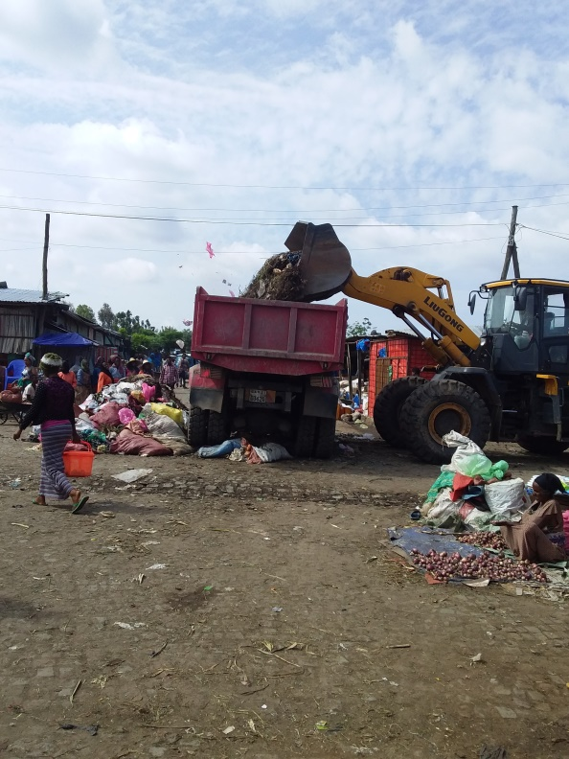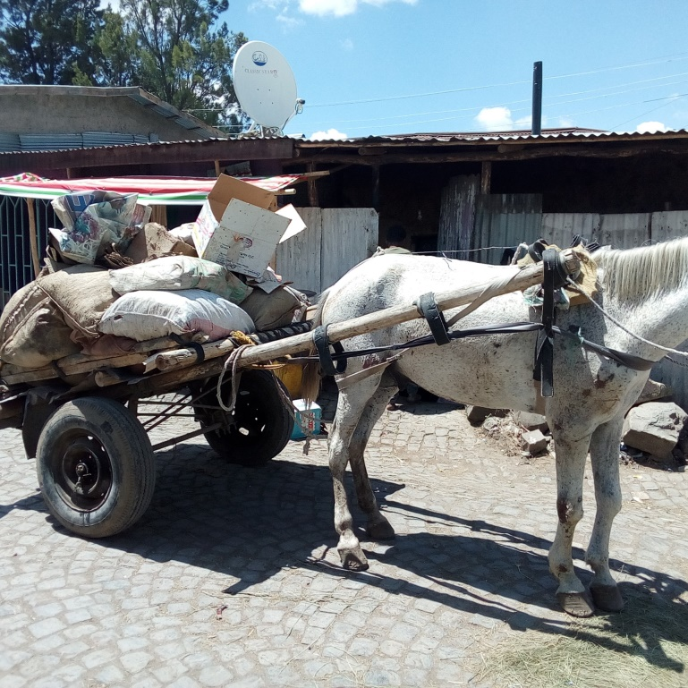

A, collection of waste around gebaya B, door to door waste collection by horse driven carts
Figure 12 . Collection and transportation practice in mojo town.

II. Disposal Site of Mojo Town
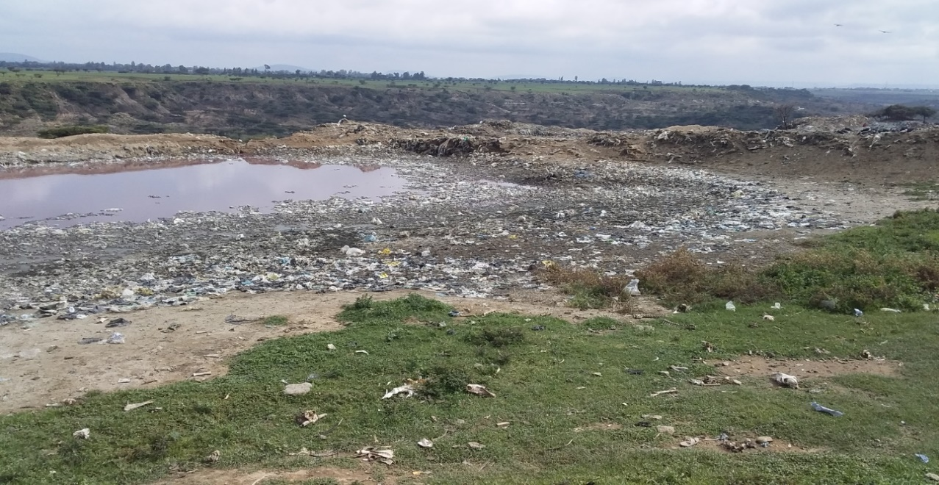
Solid and liquid waste damped in disposal site.
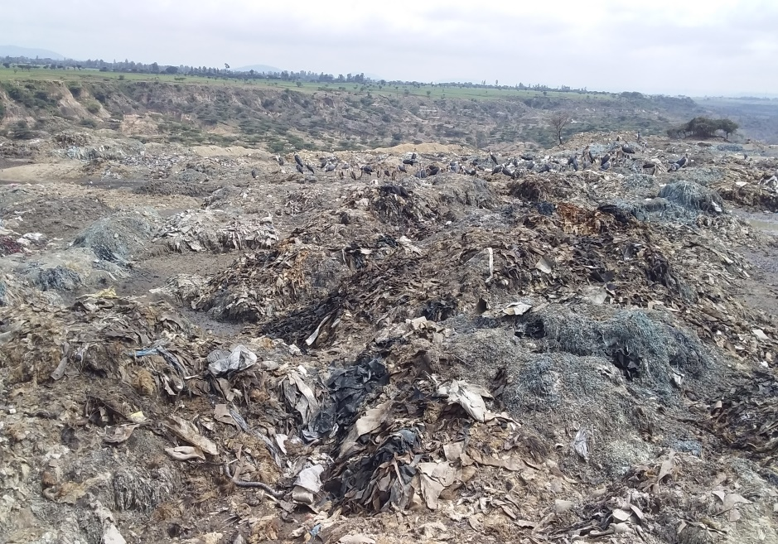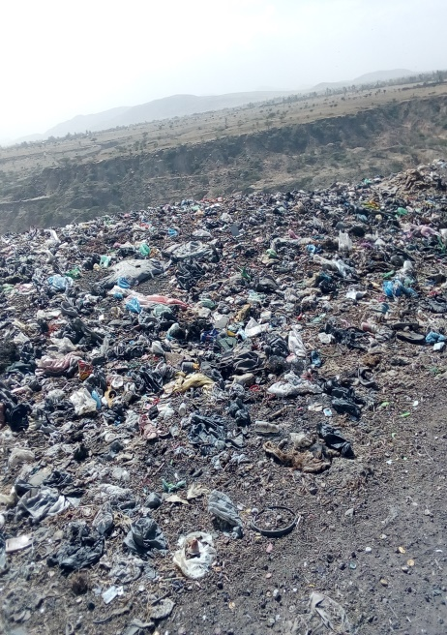
Mojo town disposal site
Figure 13.Solid waste disposal site in mojo town.
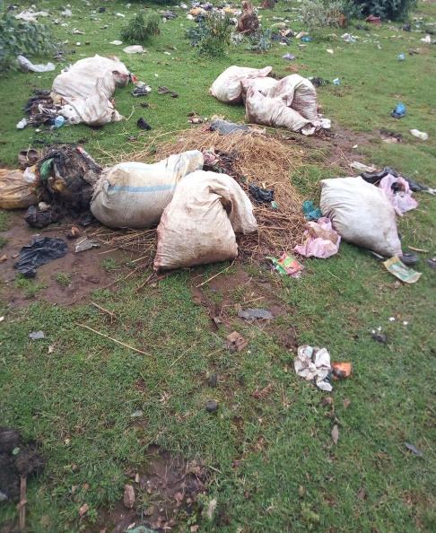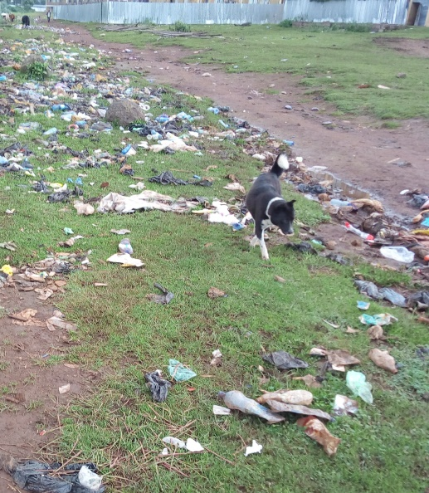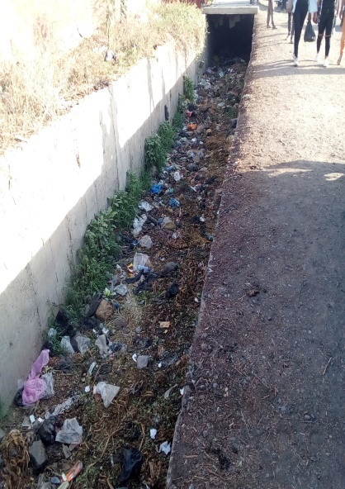
Figure 14. Illegal disposal place in mojo town
Appendix 4. Model summary and ANOVA
Model summary
Model | R | R Square | Adjusted R Square
1 | .753ª | .621 | .609

Coefficients of Regression
Variables |  |  |  | T | Sig. | 95% Confidence Interval for B
Variables | B | Std. Error |  | T | Sig. | Lower Bound | Upper Bound
Constant | 3.900 | 1.109 |  | 3.517 | .001 | 6.090 | 1.709
Age | -.747 | .306 |  | -1.698 | .016 | -1.352 | -.142
marital status | .034 | .020 |  | 2.441 | .001 | .073 | .005
family size | 2.037 | .124 |  | 16.367 | .000 | 1.791 | 2.283
family income | 2.639 | .286 |  | 9.220 | .000 | 2.074 | 3.205
level of education | .015 | .160 |  | .096 | .024 | .331 | .300

ANOVA
ANOVAª
Model |  | Sum of Squares | df | Mean Square | F | Sig.
1 | Regression | 1793.239 | 6 | 298.873 | 62.599 | .000^{b}
1 | Residual | 730.481 | 153 | 4.774
1 | Total | 2523.720 | 159

Test interpretation for ANOVA
Ho=there is no significant difference between the mean of waste generated amount category of independent variable
H₁ = there a significant difference between the mean of waste generated amount category of independent variable.
As the computed p-value is lower than the significant level alpha= <0.05, the null hypothesis Ho is rejected and alternative hypothesis is accepted
Therefore there is a significant difference between mean of waste amount within category of independent variable

Appendix 5. Amount of solid waste generation
Household | Family size |  | Family income | Solid waste in kg/7days
HH1 | 5 |  | < 2000 | 6.95
HH2 | 8 |  | < 2000 | 16.5
HH3 | 3 |  | 2000-3000 | 6.1
HH4 | 4 |  | <2000 | 6.3
HH5 | 3 |  | 2000-3000 | 3.1
HH6 | 3 |  | 2000-3000 | 4.9
HH7 | 7 |  | 2000-3000 | 12.2
HH8 | 7 |  | 2000-3000 | 14.25
HH9 | 6 |  | >3001 | 11.3
HH10 | 6 |  | >3001 | 10.3
HH11 | 7 |  | < 2000 | 8.3
HH12 | 6 |  | < 2000 | 4.9
HH13 | 8 |  | < 2000 | 12.8
HH14 | 7 |  | <2000 | 3.68
HH15 | 5 |  | <2000 | 5.8
HH16 | 5 |  | <2000 | 5.9
HH17 | 5 |  | 2000-3000 | 10.7
HH18 | 3 |  | >3001 | 6.6
HH19 | 7 |  | 2000-3000 | 10.5
HH20 | 7 |  | >3001 | 16
HH21 | 8 |  | 2000-3000 | 10.5
HH22 | 8 |  | < 2000 | 11.6
HH23 | 8 |  | < 2000 | 8.6
HH24 | 5 |  | 2000-3000 | 8.6
HH25 | 5 |  | 2000-3000 | 9.6
HH26 | 7 |  | 2000-3000 | 11.85
HH27 | 5 |  | 2000-3000 | 6.7
HH28 | 8 |  | 2000-3000 | 10.83
HH29 | 5 |  | 2000-3000 | 10.5
HH30 | 3 |  | >3001 | 5.7
HH31 | 6 |  | >3001 | 8.6
HH32 | 3 |  | >3001 | 7
HH33 | 3 |  | >3001 | 9.5
HH34 | 6 |  | >3001 | 11
HH35 | 7 |  | 2000-3000 | 10.4
HH36 | 8 |  | >3001 | 22
HH37 | 7 |  | < 2000 | 3.5
HH38 | 7 |  | < 2000 | 3.3
HH39 | 8 |  | 2000-3000 | 11.3
HH40 | 3 |  | >3001 | 8
HH41 | 3 |  | >3001 | 7.4
HH42 | 7 |  | 2000-3000 | 13.7
HH43 | 4 |  | >3001 | 8.4
HH44 | 7 |  | < 2000 | 3.5
HH45 | 7 |  | < 2000 | 4
HH46 | 3 |  | 2000-3000 | 4.9
HH47 | 5 |  | < 2000 | 5.1
HH48 | 8 |  | < 2000 | 11.7
HH49 | 8 |  | < 2000 | 12.5
HH50 | 6 |  | 2000-3000 | 9.8
HH51 | 7 |  | 2000-3000 | 11.8
HH52 | 6 |  | >3001 | 10.9
HH53 | 4 |  | >3001 | 14
HH54 | 7 |  | 2000-3000 | 13.5
HH55 | 6 |  | >3001 | 9.6
HH56 | 7 |  | 2000-3000 | 10.35
HH57 | 7 |  | >3001 | 10.6
HH58 | 3 |  | 2000-3000 | 9
HH59 | 6 |  | >3001 | 12.3
HH60 | 6 |  | >3001 | 12.4
HH61 | 6 |  | >3001 | 13.5
HH62 | 7 |  | 2000-3000 | 12.2
HH63 | 7 |  | 2000-3000 | 9.6
HH64 | 7 |  | 2000-3000 | 10.26
HH65 | 3 |  | 2000-3000 | 8.72
HH66 | 3 |  | 2000-3000 | 9.5
HH67 | 5 |  | 2000-3000 | 7.1
HH68 | 5 |  | 2000-3000 | 9.3
HH69 | 5 |  | < 2000 | 4.3
HH70 | 8 |  | < 2000 | 11.1
HH71 | 7 |  | < 2000 | 10.6
HH72 | 7 |  | < 2000 | 11
HH73 | 6 |  | < 2000 | 7.5
HH74 | 7 |  | < 2000 | 8.86
HH75 | 6 |  | >3001 | 9.7
HH76 | 6 |  | >3001 | 12.3
HH77 | 6 |  | >3001 | 10.5
HH78 | 6 |  | >3001 | 12.1
HH79 | 6 |  | >3001 | 12.6
HH80 | 6 |  | >3001 | 11.65
HH81 | 6 |  | >3001 | 12.3
HH82 | 3 |  | 2000-3000 | 7.18
HH83 | 7 |  | 2000-3000 | 10.13
HH84 | 6 |  | >3001 | 10.3
HH85 | 3 |  | >3001 | 7.6
HH86 | 6 |  | >3001 | 14.2
HH87 | 4 |  | >3001 | 8.2
HH88 | 5 |  | < 2000 | 4.2
HH89 | 7 |  | < 2000 | 4.8
HH90 | 7 |  | < 2000 | 10.5
HH91 | 6 |  | 2000-3000 | 5
HH92 | 6 |  | < 2000 | 5.8
HH93 | 7 |  | < 2000 | 3.4
HH94 | 7 |  | 2000-3000 | 11.1
HH95 | 5 |  | 2000-3000 | 8.8
HH96 | 4 |  | >3001 | 6.3
HH97 | 4 |  | >3001 | 8
HH98 | 4 |  | >3001 | 9.6
HH99 | 7 |  | 2000-3000 | 13.7
HH100 | 7 |  | < 2000 | 12.75
HH101 | 6 |  | < 2000 | 10.9
HH102 | 6 |  | < 2000 | 7.4
HH103 | 8 |  | < 2000 | 11.6
HH104 | 7 |  | 2000-3000 | 8.98
HH105 | 6 |  | 2000-3000 | 8.7
HH106 | 7 |  | 2000-3000 | 8
HH107 | 8 |  | 2000-3000 | 11.15
HH108 | 4 |  | >3001 | 9.4
HH109 | 4 |  | >3001 | 8.7
HH110 | 4 |  | >3001 | 9.1
HH111 | 8 |  | >3001 | 23.2
HH112 | 6 |  | >3001 | 12.9
HH113 | 6 |  | < 2000 | 8.3
HH114 | 8 |  | < 2000 | 11.5
HH115 | 7 |  | < 2000 | 9
HH116 | 8 |  | < 2000 | 21.2
HH117 | 6 |  | < 2000 | 8.9
HH118 | 8 |  | < 2000 | 11.5
HH119 | 5 |  | 2000-3000 | 8.7
HH120 | 5 |  | 2000-3000 | 7.4
HH121 | 8 |  | 2000-3000 | 16.52
HH122 | 5 |  | 2000-3000 | 6.85
HH123 | 4 |  | >3001 | 9.6
HH124 | 4 |  | >3001 | 7.9
HH125 | 8 |  | 2000-3000 | 13.9
HH126 | 5 |  | 2000-3000 | 7.2
HH127 | 8 |  | >3001 | 17.9
HH128 | 8 |  | >3001 | 18
HH129 | 4 |  | >3001 | 9.4
HH130 | 7 |  | 2000-3000 | 9.7
HH131 | 6 |  | 2000-3000 | 9.6
HH132 | 7 |  | 2000-3000 | 7.9
HH133 | 4 |  | 2000-3000 | 5.4
HH134 | 4 |  | >3001 | 9.5
HH135 | 8 |  | >3001 | 16.5
HH136 | 4 |  | >3001 | 10.2
HH137 | 4 |  | >3001 | 6.3
HH138 | 6 |  | >3001 | 15.2
HH139 | 8 |  | >3001 | 18
HH140 | 6 |  | >3001 | 13.8
HH141 | 7 |  | >3001 | 18.9
HH142 | 4 |  | >3001 | 7.4
HH143 | 4 |  | >3001 | 9.4
HH144 | 6 |  | >3001 | 13.8
HH145 | 6 |  | >3001 | 16.2
HH146 | 3 |  | >3001 | 13.1
HH147 | 4 |  | >3001 | 7.8
HH148 | 5 |  | >3001 | 9.2
HH149 | 7 |  | >3001 | 13.8
HH150 | 3 |  | >3001 | 6.4
HH151 | 4 |  | >3001 | 7
HH152 | 7 |  | >3001 | 13
HH153 | 7 |  | >3001 | 10.5
HH154 | 5 |  | >3001 | 9.3
HH155 | 3 |  | >3001 | 8
HH156 | 5 |  | >3001 | 12.7
HH157 | 8 |  | >3001 | 20
HH158 | 7 |  | >3001 | 15.4
HH159 | 7 |  | >3100 | 14
HH160 | 4 |  | >3100 | 12.6
Total | 930 |  |  | 1622.36

