

ARBA MINCH UNIVERSITY
COLLEGE OF NATURAL SCIENCE
SCHOOL OF POST GRAGUATE STUDIES
DEPARTMENT OF CHEMISTRY

RECOVERY OF CHITIN AND CHITOSAN FROM NILE TILAPIA FISH SCALE WASTE: CHARACTERIZATION AND EVALUATION OF CHITOSAN EFFICIENCY AS CLARIFYING AGENT FOR APPLE JUIC CLARIFICATION
M.Sc.THESIS
BY
TADEWOS LARE

AUGUST, 2019
ARBAMINCH, ETHIOPIA

RECOVERY OF CHITIN AND CHITOSAN FROM NILE TILAPIA FISH SCALE WASTE: CHARACTERIZATION AND EVALUATION OF CHITOSAN EFFICIENCY AS CLARIFYING AGENT FOR APPLE JUICE CLARIFICTION

M.Sc. THESIS
BY
TADEWOS LARE
PRNS/1279/09

A THESIS SUBMITTED TO DEPARTMENT OF CHEMISTRY, COLLEGE OF NATURAL SCIENCE, AND SCHOOL OF GRADUATE STUDIES ARBA MINCH UNIVERSITY IN PARTIAL FULFILLMENT OF THE REQUIREMENTS FOR THE DEGREE OF MASTER OF SCIENCE IN INDUSTRIAL CHEMISTRY (FOOD AND SUGAR TECHNOLOGY)

AUGUST, 2019
ARBA MINCH, ETHIOPIA

DECLARATION
I hereby declare that this master of science thesis entitled ‘’RECOVERY OF CHITIN AND CHITOSAN FROM NILE TILAPIA FISH SCALE WASTE: CHARACTERIZATION AND EVALUATION OF CHITOSAN EFFICIENCY AS CLARIFYING AGENT FOR APPLE JUICE CLARIFICATION’’ is my original work and has not been presented for a degree in any other University, and that all sources of materials used for this thesis have been properly acknowledged.

Name: TADEWOS LARE
Signature: ------------------
Date: -------------------------

ADVISORS’APPROVAL SHEET

ARBA MINCH UNIVERSITY
SCHOOL OF GRADUATE STUDIES DEPARTMENT OF CHEMISTRY
ADVISORS’THESIS SUBMISSION APPROVAL SHEET
This is to certify that the thesis entitled ‘’Recovery of Chitin and Chitosan from Nile Tilapia Fish Scale Waste: Characterization and Evaluation of Chitosan Efficiency as Clarifying Agent for Apple Juice Clarification’’ and submitted in partial fulfillment of the requirement for the degree of the master of science in Industrial Chemistry (Food and Sugar Technology), the graduate program of Industrial Chemistry/School of Graduate Studies has been carried out by Tadewos Lare under our supervision. Therefore, we confirm that the student has fulfilled the requirements and hence hereby can submit the thesis to the department for defense.

Dr. Belete Yilma | ----------------- | ----------------------
Name of Principal Advisor | Signature | Date
------------------------------------------ | ----------------- | ---------------------
Name of Co-advisor | Signature | Date

EXAMINORS’ APPROVAL SHEET

ARBA MINCH UNIVERSITY
SCHOOL OF GRADUATE STUDIES DEPARTMENT OF CHEMISTRY
EXAMINORS’ THESIS SUBMISSION APPROVAL SHEET
This is to certify that the thesis entitled and submitted in partial fulfillment of the requirement for the degree of the master of science ‘’Recovery of Chitin and Chitosan from Nile Tilapia Fish Scale Waste: Characterization and Evaluation of Chitosan Efficiency as Clarifying Agent for Apple Juice Clarification’’ with specialization in Food and Sugar Technology incorporate the rule and regulation of Arba Minch university and meets the accepted standard with respect to originality and quality.
Approved by, we examiners’ board approved that this thesis has passed through the defense and review process.

---------------------------------------------- | ---------------------------- | --------------------
External Examiner | Signature | Date
---------------------------------------------- | ------------------------------ | -----------------------
Internal Examiner | Signature | Date
--------------------------------------------- | ------------------------------ | ----------------------
Chair Person | Signature | Date
-------------------------------------------- | ------------------------------ | -----------------------
Department Head | Signature | Date

ACKNOWLEDGEMENTS
Above all, I thanks to ALMIGHTY GOD for helping, giving me this opportunity and for being with me from the beginning to the end of this work by encouraging and keeping me safe in realizing my study to the completion.
I would never have been able to finish my thesis without the guidance of my advisors, and wonderful support that I acknowledged from my family and friends. I would like to express my genuine thankfulness to my principal advisor, Dr. Belete Yilma and Co-advisor Dr. Bambuskin for their encouragement, guidance, valuable and concrete professional suggestions in every step during my thesis. I would like to acknowledge to the staffs of chemistry department in Arba Minch University.
I would like to express my deepest appreciation to my beloved wife Genet Tadele for her invaluable continuous support, carrying our babies, suggestion and encouragement in each step from early beginning up to the end of my study. It also my pleasure to thank and words are not enough to express my gratitude to whole lovely family, my mother Mama, my beloved brother Mr. Ayele Lare and Mrs. Ayelech Lare for their support, love, kindness and everything that they sacrificed in my entire life, career development, constructive suggestion and informative guidance for which I have been winning to complete my study successfully.
I am also very happy and appreciated Arba Minch University chemistry laboratory technicians specially, Mr. Ambaye Alemayehu, Mr. Enesermo Daba, Mr. Habtamu Birhanu, Mr. Fitum H/Micael, Mr. Gemechu Leta (from Biology laboratory) for their technical support, collaboration and willingness until the completion of experimental works and provide me with guide and keep me on the correct path during laboratory works.
Finally, I would like to apologize to all those I did not mention their name here and they have helped me fruitfully in various ways to undergo a successful study.

ACRONYMS
ANOVA  AOAC  DA  Da  DD  DMA  FAO  FBC  FTIR  HFA  HFIP  KDa  MC  NTUS  SD  SNNPR  TSS  UV-VIS  WAPI  WBC  XRD | Analysis of Variance  Association of Official Analytical Chemist  Deacetylation  Dalton  Degree of Deacetylation  Dimethyl Acetamide  Food and Agricultural Organization  Fat Binding Capacity  Fourier Transform Infrared  Hexa Fluoro Acetone  Hexa Fluoro Isopropanol  Kilo Dalton  Moisture Content  Nephelometric Turbidity Units  Significance Difference  Southern Nations, Nationalities and Peoples Region  Total Soluble Solid  Ultra Violet-Visible  World Aquaculture Performance Indicator  Water Binding Capacity  X-Ray Diffraction

TABLE OF CONTENTS
Content Page
DECLARATION i
ADVISORS’APPROVAL SHEET ii
EXAMINORS’ APPROVAL SHEET iii
ACKNOWLEDGEMENTS iv
ACRONYMS v
TABLE OF CONTENTS vi
LIST OF TABLES ix
LIST OF FIGURES x
ABSTRACT xi
CHAPTER ONE 1
INTRODUCTION 1
1.1 Background of the Study 1
1.2 Statement of the Problem 3
1.3 Objectives of the Study 4
1.3.1 General Objective 4
1.3.2 Specific Objectives 4
1.4 Significance of the Study 5
1.5 Scope of the Study 6
LITERATURE REVIEW 7
2.1 Chitin 7
2.2 Chitosan 8
2.3 Chitin and Chitosan Structure 8
2.4 Chitin and Chitosan Sources 11
2.5 Fish Waste as Source of Chitin and Chitosan 12
2.6 Chitin and Chitosan Extraction Processes 15
2.7 Physico-chemical Properties of Chitin and Chitosan 16
2.7.1 Degree of Deacetylation 17
2.7.2 Solubility 18
2.7.3 Molecular Weight 18
2.7.4 Viscosity 19
2.8 Application of Chitin and Chitosan 19
CHAPTER THREE 23
MATERIALS AND METHODS 23
3.1 Study Area Description 23
3.2 Chemicals and Reagents 23
3.3 Apparatus and Instruments 24
3.4 Sample Collection and Preparation 25
3.4.1 Acid Treatment Process 27
3.4.2 Deproteinization Process 27
3.4.3 Depigmentation and Deodorizing Process 28
3.4.4 Deacetylation Process 28
3.5 Determination of Chitin and Chitosan Yield 30
3.6 Determination of Moisture and Ash Contents of Scale, Chitin and Chitosan 30
3.6.1 Determination of Moisture Content 30
3.6.2 Determination of Ash Content 31
3.7 Chitin and Chitosan Characterization 32
3.7.1 Fourier Transforms Infrared Spectroscopy (FTIR) 32
3.7.2 X-ray Diffraction (XRD) 32
3.7.3 Determination of Degree of Deacetylation (%DD) 32
3.7.4 Determination of Intrinsic Viscosity 33
3.7.5 Determination of Molecular Weight 34
3.7.6 Determination of Solubility 35
3.7.7 Determination of Water Binding Capacity and Fat Binding Capacity 36
3.8 Determination of physicochemical properties of clarified apple juice with chitosan and without chitosan 37
3.8.1 Clarity Analysis of Apple Juice 37
3.8.2 Determination of Total Soluble Solids in Apple Juice 37
3.8.3 Determination of Titratable Acidity (TA) of Apple Juice 37
3.8.4 Determination of pH of Apple Juice 38
3.8.5 Determination of Turbidity 38
3.9 Sensory Evaluation of Prepared Apple Juice 38
3.10 Method of Statistical Analysis 39
CHAPTER FOUR 40
RESULTS AND DISCUSSIONS 40
4.1 Extraction of chitin and preparation of chitosan 40
4.2 The Physicochemical Properties of Prepared Chitin and Chitosan 41
4.3 Instrumental Characterization of Chitin and Chitosan 45
4.3.1 Fourier Transform Infrared (FTIR) Spectroscopy Study 45
4.3.2 X-Ray Diffraction of Chitin and Chitosan Analysis 48
4.4 Viscosity and Average Molecular Weight of the Produced Chitosan 49
4.5 Water Binding Capacity (WBC) and Fat Binding Capacity (FBC) 52
4.6 Effects of Chitosan on the Clarification of Apple Juice 53
4.6.1 Titratable Acidity of Apple Juice before and after Clarification by Chitosan Prepared from Fish Waste 55
4.6.2 The Effects of Prepared Chitosan on the Turbidity of the Apple Juice 56
4.6.3 Total Soluble Solids (TSS) 57
4.6.4 pH Measurement 59
4.7 Sensory Quality Analysis Results for the Treated Apple Juices 60
CHAPTER FIVE 64
CONCLUSION AND RECOMMENDATION 64
5.1 CONCLUSIONS 64
5.2 RECOMMENDATIONS 66
REFERANCES 67
APPENDICES 75

LIST OF TABLES
Content Page
Table 2.1 World Fisheries and Aquaculture Production and Utilization 14
Table 2.2 Capture and Aquaculture Production of Fish in the EA Sub Region in 2016…………………………………………………………………………………..15
Table 2.3 Potential Uses of Chitin and Its Derivatives at Different Application Field 21
Table 4.1 Comparison of the Yield and Physical Appearance of Chitin and Chitosan with Reported Studies 40
Table 4.2 Physiochemical Parameters of Chitin and Chitosan 41
Table 4.3 Comparison of Solubility of Produced Chitosan Value with Reported Values 44
Table 4.4 Dilute Chitosan Solution Viscosity Designation 50
Table 4.5 Different Chitosan Concentration Versus Calculated Parameters 50
Table 4.6 Comparison of Water and Fat Binding Capacity of Crepared Chitosan with Reported Values .52
Table 4.7 Results of TA% of Apple Juice before and after Clarification 55
Table 4.8 The Effects of Chitosan Treatments on Turbidity of Apple Juice 56
Table 4.9 The Effect of Chitosan on the TSS of Apple Juice 58
Table 4.10 Effect of Chitosan on pH of Apple Juice in Different Time 59
Table 4.11 Sensory Quality Analysis Results for the Treated Apple Juices 61

LIST OF FIGURES
Content Page
Figure 2.1 The Polymer Chain of Chitin and Chitosan where n Stands for the Degree Polymerization.. 9
Figure 2.2 Schematic Representations for the Conversion of Chitin into Chitosan 10
Figure 2.3 Schematic Representation of Three Different Colymeric configuration of Chitin 11
Figure 2.4 World Fisheries and Aquaculture Capture Production 13
Figure 2.5 World Utilization and Supply of Fish 13
Figure 3.1 Geographical Location Map of the Study Area 23
Figure 3.2 Pretreatment of Fish Scales 26
Figure 3.3 Production of Clear Apple Juice 27
Figure 3.4 Fish Scale Demineralization Process 28
Figure 3.5 Alkaline Treatment Processes 28
Figure 3.6 Depigmentation and Deodorizing Process 29
Figure 3.7 Deacetylation Process 30
Figure 3.8 Flow Chart Depicting in Extraction of Chitin and Chitosan from Fish Scale Wastes.. 30
Figure 3.9 Determination of Chitosan WBC and FBC 37
Figure 4.1 Relationship between Solubility and DD of Chitosan 43
Figure 4.2 Fourier Transform Infrared (FTIR) Spectrum of Chitin from Nile Tilapia Fish Waste 46
Figure 4.3 Fourier Transform Infrared (FTIR) Spectrum of Chitosan from Nile Tilapia Fish Waste 47
Figure 4.4 Chitin and Chitosan XRD 48
Figure 4.5 Reduced and Inherent Viscosity Versus Different Chitosan Concentration 51
Figure 4.6 Effects of Chitosan on Clarity of Apple Juice 54

ABSTRACT
Fish and seafood processing large and small scale industries generate large quantities of waste, which are at the origin of several environmental, economic and social problems. However, fish waste contains high value-added substances such as chitin and chitosan. In Ethiopia, Arba Minch is one of the leading areas of fish production zone and hence everyday lot of fish wastes has been generated due to this. This work has focused on the extraction and characterization of chitin and chitosan from fish wastes generated in Lake Chamo, Arba Minch and evaluation of chitosan efficiency as clarifying agent for apple juice clarification. The obtained chitin and chitosan have been characterized by using techniques like spectral analysis and parameters including yield, moisture and ash content, solubility, degree of deacetylation (DDA), WBC, FBC, viscosity and M_{w} of the recovered chitosan and its application as clarifying agent on the apple juice clarification have been carried out. The results obtained from this study show that the yield of chitin and chitosan were 29.88 ± 0.01 and 15.87 ± 0.14, respectively. The moisture and ash content, DD, solubility, FBC, WBC, intrinsic viscosity and M_{w} of the extracted chitosan were found to be 6.79 ± 0.40, 1.22 ± 0.16, 85.25 ± 0.28, 94.3 ± 0.99, 391.17 ± 0.13, 461.34 ± 0.42, 4.4215 ± 0.0101 and 155,730.4870 ± 1.1, respectively. Based on these characteristics, chitosan, extracted from Nile tilapia fish scale waste, was of standard quality for industrial application. The extracted chitosan at different concentrations were used for apple juice clarification. The reduction in TSS value from (12.67 to 9.20), titratable acidity (2.38 to 1.61) and turbidity (320.2 to 86.6) after treatments have confirmed the effectiveness of chitosan on apple juice clarification. The reduction in titratable acidity has been supported by increase in pH value (3.19 to 4.29). The sensory evaluation of control juice and chitosan added juice samples were performed and it has been observed that chitosan concentration of up to 0.25 g/l was accepted by the consumers.
Keywords: Extraction, Chitin, Chitosan, Clarification, Deacetylation,.

CHAPTER ONE

INTRODUCTION

1.1 Background of the Study
Ethiopia is a surrounded by land and it depends only on inland water sources for the contribution of fish as a low cost protein source. Its economy is mainly dependent on agriculture which accounts for forty-nine percent of the gross domestic product (GDP) and more than eighty percent of whole employment. It has an approximated fish production potential of 51, 481 tonnes in each year for utilization. Fish is one of the most essential sources of human protein and its utilization has a long history in Ethiopia. We know that People consume large amount of fish in fasting days in big cities, in well known production areas and towns, particularly in Arba Minch, Hawassa, Zeway and Bahir Dar due to the presence of large amount of water bodies [1].
Fish processing pass on to the method related with fish products between the time fish are caught or collected and the time the last product is distributed to the customers. Its activities produce potentially huge quantities of organic waste and by-products from non edible fish parts and endoskeleton shell parts from the crustacean and other fish peeling process. The actual proportion depends on the edible fraction of each species being processed. Fish waste is a wealthy resource of important amino acids and all non edible fish waste should be transformed into valuable by-products (e.g. fishmeal or silage).
Currently discarding of fish processing waste or fishery waste is causing serious environmental problems that have become an issue of public concern. Fish waste could be utilized for production of animal feed, biodiesel, natural pigments, food products and pharmaceuticals. Major attention was also directed towards the recovery of valuable bimolecular such as chitin, chitosan, collagen, ω-3 polyunsaturated fatty acid, trypsin, chymotrypsin and elastase. Among these molecules, chitin and chitosan are the most useful and abundant polysaccharides that can be extracted from fish wastes. They have wide range of biological activities including antioxidant and antimicrobial effects and many other properties that could be used in the food industry to improve food safety, quality, and shelf-life and as clarification and deacidification agent in fruit, beverages and waste water processing industry [2]. In Ethiopia, Arba Minch is one of the leading areas of fish production zone and hence everyday lot of fish wastes has been generated and damped simply in some corners of the town and raises the issues of pollution.
Globally, 18–30 million tons of fish waste is being deposited every year. Fishery wastes are very hazardous because of their high biological oxygen demand (BOD), chemical oxygen demand (COD), total suspended solids (TSS), fat–oil–grease (FOG), pathogens, organic matters, other nutrients [3].
Fish scale is one of the most important fisheries products around the world including Ethiopia. They are disposed of daily as waste materials from fish markets and fish processing industries or kitchens. This abundant waste may cause environmental hazard due to the easy deterioration. The basic content of fish scale is 30-40% protein, 30-50% calcium carbonate or 30-50% calcium phosphate and 20-30% chitin [4, 5].
Chitin is a nitrogenous polysaccharide originate in the exoskeleton as well as in the internal structure of invertebrates and it is the second most plentiful renewable polysaccharide after cellulose and it is a natural biopolymer, first recognized in 1811 [5]. Shrimp, crab, squid, lobster, insect cuticle, fish scales, fungi and yeast are the best naturally occurring sources of chitin. Chitin and its derivatives are bimolecular of immense importance, having adaptable biological actions, and they exhibit biocompatibility and biodegradability. Accordingly, chitin and its derivatives are broadly used in pharmaceutical, cosmetics; feed additives, agriculture, semi permeable membranes, food and textile industries and waste water treatment [3].
Chitosan is a modified natural organic polymer derived from chitin which is formed from N-deacetylation of chitin and has a chemical structure of linear chain consisting β-(1, 4)-linked 2-acetamino-2-deoxy-β-D-glucopyranose with 2-amino-2 deoxy-β-D-glucopyranose. It is well known for having universal properties of polysaccharides such as biocompatibility, biodegradability, non toxicity while possessing some unique properties like film forming ability, acid binding capacity, chelation and absorption properties as well as antimicrobial characteristic. It has been manufactured from waste fish scale by chemical technique involving demineralization, deproteinization and deacetylation. Its quality depends on the conditions of the chemical, temperature and extraction process. Beginning from short period of time chitosan has been involved practically in dietary supplements, beverage and fruit processing industry and water treatment, food preservation from microbial deterioration, agriculture, cosmetics, pulp, paper and medical applications [5].
The fish manufacture potential of the Chamo Lake is estimated approximately 4,500 tonnes per year [1]. Around 20% of it has been generated as the waste, that means about 900 tonnes per year of waste is generated. This causes serious environmental problems with offensive odour if it is not properly managed [5]. Therefore, the fish waste that is generated from Chamo Lake offer great potential for extraction of chitin, chitosan, collagen and other there derivatives.
Clarification is an essential step in the processing of fruit juice mainly in order to eliminate pectin, particulates, dissolved contaminants and other carbohydrates which are present in the juice. Generally, clarifying procedures can be achieved by centrifugation, enzymatic treatment or applying clarifying agents such as bentonite, silica sol, and polyvinyl pyrrolidone. However, use of such clarifying agents can be labor-intensive, less effective in the clarification, contain chemicals, time-consuming and discontinuously operated. Besides, the use of additives (fining agents and filter aids) may leave a slight after taste in the juice [6]. Apple juice (AJ) is one of the most well-liked juices consumed all over the world. Raw apple juice obtained after the pressing of apples is very viscous, turbid or cloudy, brown colored and presence of particulate and dissolved contaminants. Chitosan can be used as an effective coagulating / or flocculating agent by causing the separation of suspended particles from the juices [7].

1.2 Statement of the Problem
Larger and small scale fish processing industries dispose off enormous amounts of fish waste. Annually, around 20 % of the total production from fish processing industry has been discarded as waste approximately. Majority of waste from large and small fish processing industries are bones, skin, scales, head, stomach and fins, which constitute over 70 % of fish. This large amount of waste is discarded to the environment as trash without attempt to decrease the harmful effects and which does make disposal problems. These wastes have almost the same amount of protein content as in fish flesh; from those waste the basic content of fish scale is 30-40% protein, 30-50% calcium carbonate and calcium phosphate and 20-30% chitin and therefore, part of them are utilized as feedstuff. The major parts of these wastes are not fully utilized and most of them are discarded. This waste load is a problem on the living environment and makes globalised issue. The use of this waste, if it is properly managed to manufacture valuable and biologically sustainable materials, is a challenge for current research and development.
Apple juice that is produced from raw apple is clarified using traditional clarificants such as bentonite, silica sol and polyvinyl pyrrolidonine all are obtained from commercial companies to which improve the color, remove colloidal, extend the shelf life of the juice and keep the quality of the juice during storage time. The juice is clarified because unclarified juice can easily undergo enzymatic changes and affects the quality, appearance, flavor, economic losses and color of juice during storage. The process is also done because color of juice is one of the most important parameters for deciding the apple juice quality.
Moreover, clarification of apple juice by traditional clarificants for effective removal of impurities in processing of raw juice is enforcing additional cost on producers. They are labor-intensive, time consuming, intermittently operated and less effective clarificants than chitosan [7] then chitosan is natural biopolymer, non-toxic, safe, biocompatible, biodegradable and more effective clarificant in its nature. A major weak side facing on fruit juice producers is that, most of the processes are not effective in removing certain types of soluble contaminants by traditional clarificants. Therefore, the aim of this study is to assess production of value added products such as chitin and chitosan from fish wastes as well as evaluating the clarifying capacity of chitosan as alternative clarifier of apple juice to reduce the cost of processing than the existing bentonite and others.

1.3 Objectives of the Study

1.3.1 General Objective
- The general objective of the study is to extract and characterize chitin and chitosan present in fish wastes (Nile Tilapia Fish Waste) available at Chamo Lake and to evaluate chitosan efficiency as a clarifying agent in apple juice.

1.3.2 Specific Objectives
- To extract chitin and chitosan from fish waste (Nile tilapia scale).
- To analyze the physicochemical parameters of the extracted valuable products.
- To characterize the extracted product using spectroscopic techniques, like FTIR and XRD.
- To evaluate the efficiency of chitosan in apple juice clarification and the quality of the juice.

1.4 Significance of the Study
Ethiopia is one of the centers of uprising that is changing the concept of food and increasing research funding for different sources of food product. Food industry and food research in general reacted to this effectively by improving traditional process or by providing new emerging non-thermal technology solutions to create efficient and effective valuable products that help consumers’ requirement and nutritional value. Developments of valuable products from fishery waste are highly required in order to utilize the product competently at the time of its production, which is avoiding environmental pollution. In these sense, the extracted chitin can be used to produce chitin-derived products, such as chitosan and glucosamine.
Nowadays there is an increasing demand for chitosan for their use in various applications like cosmetics, food and textile industries, feed additives, agriculture, waste water treatment, fruit juice and beverage clarification, pharmaceutical and biomedical applications. One of the most important sources for the extraction of chitin and chitosan are from marine and fresh water organisms (fish scales, shrimp, crab, squid, lobster, insect, cuticle, fungi and yeast). Chitosan can be characterized based on their properties; one of them is degree of deacetylation (DD). The degree of deacetylation of chitosan determines the sort of applications it can be used for. In Ethiopia, southern region, Arba Minch is one of the main city of Gamo zone which is well known for its production and exporting of fish meat for Ethiopian market and exports to other countries. Every day, lots of fish wastes are generated due to processing of fishes. In this aspect, this study focuses on potential utilization of fish waste generated to produce value added products like chitin and chitosan. Chitosan applications as juice clarifying agent would be analyzed and revealed. Chitosan is used for removal because of their safe and non-toxic nature. This study would also help in understanding the importance of extracted chitosan, application as clarifying agent in the apple juice and it paves the way for more focus on extraction and commercial production of chitosan in Ethiopia in the future for different fruit juice and other processing industries as clarification agents and for extending the shelf-life of fruit and vegetables. It would also create awareness among local fisher men and thereby generates job opportunity of extracting chitin and chitosan from fish wastes and it is most important for stakeholders, policy makers, academicians and researchers in order to focus and give the attention for the fish and its products in the future in Ethiopia. The environmental pollution with offensive odours caused due to fish wastes can also be prevented.

1.5 Scope of the Study
The study generally covers investigation of processing method for production of
chitin and chitosan from fish waste and characterization of extracted chitin and chitosan with different physicochemical parameters (moisture, ash, DD, solubility, WBC, FBC, Mw and viscosity), XRD and IR spectroscopy. The examination of prepared chitosan as clarificant agent for the apple juice has been done by performing TSS, PH, turbidity and sensory evaluation of clarified apple juice with chitosan. One of the limitations of this study is only the fish waste produced in Arba Minch has been studied. The ultimate goal of the whole thesis is to develop good value added product (chitosan) from fishery waste and efficient use of the product for the clarification of apple juice. The outcome of this study helps recovery of valuable products for different applications especially in food, fruit and beverage industries, in reducing the environmental pollution caused due to fish wastes and it also generates additional income for the country and local fishermen. This may also serve as a reference for other researchers in the future.

CHAPTER TWO

LITERATURE REVIEW

2.1 Chitin
Chitin is a naturally abundant long un-branched polysaccharide consisting of a repeating disaccharide unit and the supporting material of crustaceans, insects and fish scales etc. From economic and technological points of view, the fish wastes represent abundant, cheap, ecologically-friendly, renewable resources for the extraction of chitin and its derivatives where several million tons of chitin are harvested annually in the world [8]. In spite of its huge availability, the utilization of chitin has been restricted by its intractability and insolubility. The fact that chitin is as an effective material for stitches essentially because of its biocompatibility, biodegradability and non-toxicity together with its antimicrobial activity and low immunogenicity points to huge potential for future development. It is well known to consist of 2-acetamido-2-deoxy -D-glucose through a (1$→$ 4) linkage and depending on the source, chitin can occur in the forms of α-, β- and γ-. The differences among them depend on the arrangement of chains of the crystalline regions [9]. Because of these differences each chitin polymorph has different properties. In most cases, crystallinity index provides information about the crystal state, and it is also very useful for distinguishing α-chitin from β chitin. It is a highly insoluble material resembling cellulose in its solubility and low chemical reactivity. It may be regarded as cellulose with hydroxyl at position C-2 replaced by an acetamido group. Like cellulose, it functions naturally as a structural polysaccharide. Chitin is a white, hard, inelastic, nitrogenous polysaccharide. Chitin is highly hydrophobic and is insoluble in water and organic solvents. Solubilization of chitin has been also reported using highly polar solvents such as HFIP (C₃H₂F₆O), HFA (C₃F₆O), and chloroalcohols in conjugation with aqueous solutions of mineral acids and DMA (C₄H₉NO) containing 5% lithium chloride [10]. Chitin is the exoskeletons of marine animals along with calcium carbonate, proteins, lipids and pigments [11]. It is a linear polysaccharide considered the second most abundant substance on the biomass with the advantage of presenting a replacement rate twice that of the cellulose.

2.2 Chitosan
Chitosan is the most abundant basic biopolymer and is structurally similar to cellulose, which is composed of only one monomer of glucose. Chitosan solubility, biodegradability, reactivity, and adsorption of many substrates depend on the amount of protonated amino groups in the polymeric chain, therefore on the proportion of acetylated and non-acetylated D-glucosamine units. It is insoluble in water, organic solvents and aqueous bases and is soluble after stirring in acids such as acetic, nitric, hydrochloric, perchloric and phosphoric acids [12].
Chitosan is a natural product resulting from the polysaccharide comprising copolymers of glucosamine and N-acetylglycosamine. It can be obtained by partial or full deacetylation of chitin. A study reported by Muzzarelli et al., [13] indicated that chitosan was reportedly first discovered by Rouget in 1859, when he boiled chitin in concentrated potassium hydroxide solution which gave rise to de-acetylated chitin. Commercially, chitosan is obtained from waste crab, shrimp shells and fish scales etc. It is first treated with acids to remove calcium carbonate and then treated with alkaline solutions to deacetylate the polymer as well as remove any minerals that are associated with it [11]. The study carried out by Acheampong and Benavente [14, 15] briefly explained that chitosan has been shown to have excellent metal coordination properties due to the availability of free amines and hydroxyl groups present on the polymeric chain. Chitosan is usually further processed into flakes and ultimately into fine powders. Chitosan has been widely used very much in diverse fields, ranging from waste management’s to food processing, medicine and biotechnology. It has the unique ability to attach itself to lipid and fat.

2.3 Chitin and Chitosan Structure
The chemical structure of chitin (C₈ H₁₅ O₅ N) _{n} is like cellulose, having one hydroxyl group on each monomer substituted with an acetyl amine groups. Chitin is a linear chain made of (1 $→$4) linked 2-acetamido-2-deoxy-D-glucosamine while chitosan (the main derivative of chitin) is obtained by removing enough acetyl groups from chitin, the actual difference between chitin and chitosan is the acetyl content of the polymer. Both chitin and chitosan have high nitrogen content varies from 2% to 8% that make them more attractive to several industrial applications. Chitin is insoluble in water and most organic solvents, this due to its rigid structure and strong intra and inters molecular hydrogen bonds. In contrast, chitosan is readily soluble in diluted acids (as hydrochloric acid, citric acid and acetic acid) with pH below 6 [16]. Chitin is a copolymer of N-acetyl-D-glucosamine units which is linked with β - (1-4) glycosidic bond, where N-acetyl-D glucosamine units are predominant in the polymeric chain. Chitosan is the deacetylated derivative of chitin which is chemically defined as a copolymer of β- (1, 4) glucosamine (C₆H₁₃O₅ N) _{m}, having different number of N-acetyl groups. Where m stands for the degree of polymerization.
The physico-chemical behaviors of chitin and chitosan are quite different even if they demonstrate many similarities in the structures. Due to the presence of acetamide group, chitin mostly shows an inert behavior, while chitosan is highly reactive for free active amine groups. Also, the behavior attributes to the degree of crystallinity because chitin is more crystalline compared to chitosan. Moreover, there are very few solvents allowing the dissolution of chitin, whereas the chitosan dissolve in almost all aqueous acid solvents. The chitosan carries positive charges after interacting with acid for the presence of free amino groups and dissolves at pH ≤ 6.0. Over the pH 6.0, more than 50% of dissolved chitosan molecules lose its positive charges and become insoluble [17]. The chemical structures of chitin, chitosan and the conversion of chitin into chitosan have been shown in Figure 2.1 and 2.2, respectively [18].
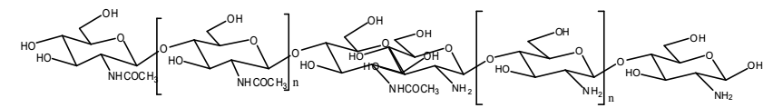Chitin Chitosan
Figure 2.1 The Polymer Chain of Chitin and Chitosan where n Stands for the Degree Polymerization

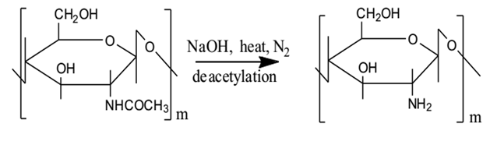
Chitin Chitosan
Figure 2.2 Schematic Representations for the Conversion of Chitin into Chitosan
A study by Usman et al., [19] briefly indicated that a structure is well known that the solubility problem of chitin results mostly from the highly extended hydrogen bonded semi crystalline structure of chitin. Chitin is a unique structural biopolymer which has a role similar to that of cellulose in terrestrial plants and collagens in higher animal. Animals such as insects, fish and crustaceans produce chitin in their scale and shells respectively, while plants produce cellulose in their cell walls. Chitin and cellulose are two main and structurally associated polysaccharides that provide protection to animals and plants respectively and their structural integrity.
The study by Rameshthangam et al., [20] reported that chitin mostly occurs in three different polymeric forms ($α,β, and γ$). Generally the structure of $α$-chitin has been investigated more extensively than that of either the $β$- or $γ$- form because it is the most universal polymorphic form. Very few studies have been carried out on $γ$- chitin. It has been suggested that $γ$- chitin may be a distorted version of either $α$- or $β$-chitin rather than a true third polymorphic form. The three different forms of chitin differ in their arrangement of the polymeric chain (Figure. 2.3). In$α$ –chitin the chains are arranged in the anti-parallel to each other, the chains in any one sheet having the opposite direction. In $β$-chitin they are arranged parallel to each other having the same direction and in $γ$- chitin the polymeric chains are arranged randomly in which two parallel chains and one anti-parallel chain forms the polymeric structure that is represented below. The most plentiful form of chitin on earth is α-chitin; it is found in the exoskeletons of lobster, crab and shrimp, as well as fungal cell walls and fish scales. Chitin in the β configuration can be found in squid pens, associated with proteins. In both α- and β-chitin, groups of chains are organized in sheets, which are held together by intra-sheet hydrogen bonds [21].

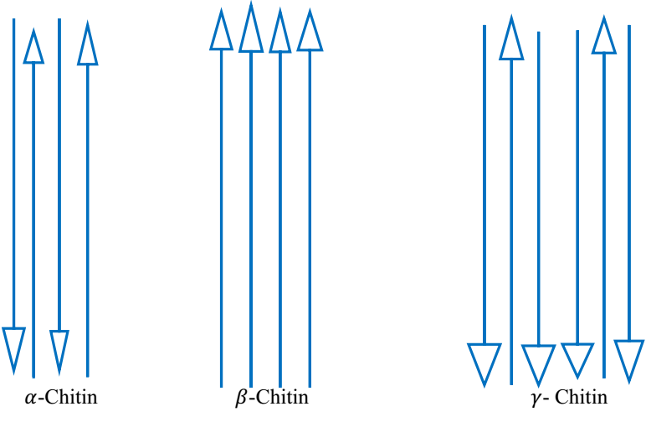
Figure 2.3 Schematic Representation of Three Different Polymeric Configuration of Chitin

2.4 Chitin and Chitosan Sources
The main sources of raw material for the production of chitin and chitosan are terrestrial organisms like insects, microorganism, marine organisms including fish wastes, and cuticles of various crustaceans, principally crabs, lobsters, krill and shrimps. In crustaceans or more specifically shellfish, chitin is found as a constituent of a complex network with proteins onto which calcium carbonate deposits to form the rigid shell. The interaction between chitin and protein is very close and there is also a small fraction of protein involved in a polysaccharide-protein complex [22].
The study by New and his coworker [23] extremely explained the sources of chitin and chitosan are present in the exoskeleton of arthropods, also in eukaryotic cells, such as those of fungi and mushrooms. It is also found in the iridophores in the epidermis and the eyes of certain arthropods and cephalopods. As chitin is present in so many diﬀerent species, it would be, certainly very attractive to use chitin for evolution and classification of these diﬀerent species, though to the best of our knowledge those studies have still to be done. Also, a comparison between diﬀerent properties, contents, etc. of chitin and chitosan from diﬀerent sources would be of great interest [24].
The chitin content is usually in the range of the following consequents whereby the organic matrices of honeybees are composed of 23 –32% of chitin, 5 to 40% of dry mass of cuticle, shellfish 5–40%, silkworms are composed of about 20% of chitin, the mushrooms 10–20% [23] and fish scale 20 -30% of chitin [11, 4] and even up to 49% were reported in squid pens [24]. The fish chitosan were suggested as potential ingredients in the manufacturing of functional food, cosmetics, biomedical and pharmaceutical applications were obtained from fish scales.

2.5 Fish Waste as Source of Chitin and Chitosan
Every year over 101 million tonnes of fish are being harvested globally from which 29.5% is transformed into fishmeal [25]. About 70 -85 % of a capture becomes fishery processing waste and 30 % of these wastes are bones, fins, scales, skin, head, stomach which contain high levels of collagen, chitin, chitosan, gelatin and other valuable products, depending on the process used and the types of products [25, 26]. Conversion of these wastes into value-added products to yield additional income has both economic and waste management benefits for the fish processing large and small scale industry [26].
In 2016, fishery captures and aquacultures supplied the world with 171 million tonnes of fish, with aquaculture representing 47 percent of the total and 53 percent if non-food uses (including reduction to fishmeal and fish oil) are excluded. With capture fishery production relatively static since the late 1980s, aquaculture has been responsible for the continuing impressive growth in the supply of fish for human consumption (Figure 2.4). Between 1961 and 2016, the average annual increase in global food fish consumption (3.2 percent) outpaced population growth (1.6 percent) (Figure 2.5) and exceeded that of meat from all terrestrial animals combined (2.8 percent). In per capita terms, food fish consumption grew from 9.0 kg in 1961 to 20.2 kg in 2015, at an average rate of about 1.5 percent per year. Preliminary data revealed that in 2016 and 2017 the consumption has been increased to 20.3 and 20.5 kg, respectively [27].
The study by FAO [28] reported that out of the 126 million tonnes for human consumption, Africa had the lowest fish consumption (9.1 million tonnes), at the same time as Asia covered two-thirds of the total consumption with 85.4 million tones.

. 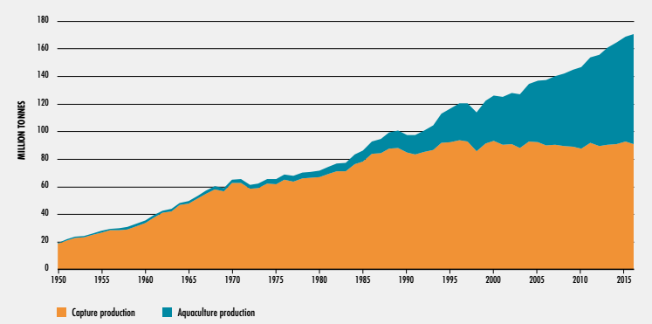
Figure 2.4 World Fisheries and Aquaculture Capture Production (FAO, 2018)
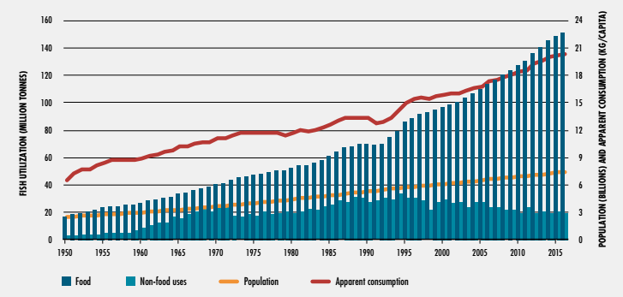
Figure 2.5 World Utilization and Supply of Fish (FAO, 2018)

Table 2.1 World Fisheries and Aquaculture Production and Utilization (FAO, 2018)
Category | 2011 | 2012 | 2013 | 2014 | 2015 | 2016
Production capture
Inland | 10.7 | 11.2 | 11.2 | 11.3 | 11.4 | 11.6
Marine | 81.5 | 78.4 | 79.4 | 79.9 | 81.2 | 79.3
Total capture | 92.2 | 89.5 | 90.6 | 91.2 | 92.7 | 90.9
Aquaculture
Inland | 38.6 | 42 | 44.8 | 46.9 | 48.6 | 51.4
Marine | 23.2 | 24.4 | 25.4 | 26.8 | 27.5 | 28.7
Total aquaculture | 61.8 | 66.4 | 70.2 | 73.7 | 76.1 | 80
Total world fisheries and aquaculture | 154 | 156 | 10.7 | 164.9 | 168.7 | 170.9
Utilization
Human consumption | 130 | 136.4 | 140.1 | 144.8 | 148.4 | 151.2
Non-food uses | 24 | 19.6 | 20.6 | 20 | 20.3 | 19.7
Population (billions) | 7 | 7.1 | 7.2 | 7.3 | 7.3 | 7.4
Per capita apparent consumption( (kg) | 18.5 | 19.2 | 19.5 | 19.9 | 20.2 | 20.3

The study by Obiero et al., [29] briefly explained that the capture fisheries and aquaculture historically, Africa’s fisheries output is dominated by capture fisheries, but the contribution of aquaculture to the total amount of fish produced in the region has grown at a steady pace over the past decade. In the Eastern Africa region countries including Burundi, Ethiopia, Kenya, Rwanda, Uganda, and Tanzania, fish is produced from freshwater inland and marine capture fisheries and aquaculture. Altogether, aquaculture production in the EA sub region is relatively small, compared to the top producers in Africa—Egypt (1.37 million tonnes) and Nigeria (306,727 tonnes) (Table 2.1). Aquaculture production is dominated by tilapia farming, which is also the most popular fish from a consumer perspective. Uganda has the highest aquaculture production of 118,000 tonnes harvested from 25,000 ponds covering 10,000 hectares in 2016. Kenya is also a regional player in the growth of aquaculture, as the fourth largest producer of farmed fish in Africa, having experienced a significant growth from 4,452 tonnes in 2008 to a peak at 24,096 tonnes in 2014, spurred by a large-scale aquaculture financial support programme under the Economic Stimulus Programme (ESP) from 2009–2013. In Burundi, Ethiopia and Tanzania, aquaculture contributes <10% to the total fish production; thus, more attention is needed to prioritize the development of the sector in these countries, taking advantage of the diverse aquatic resources that support fish production. In year 2018, Ethiopia’s aquaculture and capture production hit 45,610
tonnes which compared to other African countries is very less as shown in (Table 2.2) [29].
Table 2.2 Capture and Aquaculture Production of Fish in the EA Sub Region in 2016
Country | Capture Fisheries production (Tonnes) | Aquaculture production (Tonnes) | Total Domestic Fish Supply  (Tonnes) | Aquaculture as a Share of Fish production (%)
Sub-Saharan Africa | 7,254,848 | 592,540 | 7,847,388 | 7.8
Egypt | 335,613 | 1,370,660 | 1,706,273 | 81.73
Nigeria | 734,731 | 306,727 | 1,041,458 | 30.62
Burundi | 20,120 | 1,326 | 21,446 | 6.2
Ethiopia | 45,519 | 91 | 45,610 | 0.2
Kenya | 165,135 | 18,658 | 183,793 | 11.3
Rwanda | 29,334 | 4,847 | 34,181 | 14.2
Tanzania | 371,228 | 10,742 | 381,970 | 2.8
Uganda | 396,205 | 117,590 | 513,795 | 22.9
Data Source: WAPI-AQPRN v.2018.1 [29]

2.6 Chitin and Chitosan Extraction Processes
The studies conducted by Boarin-Alcade and his workmate [11] have explained that the process of chitin and chitosan extraction from shrimp, crab shells and fish scales. It comprises of four main sequential chemical treatment steps, in order to remove associated substances, which are demineralization, deproteinization and depigmentation or deodorization and deacetylation processes.
Study had reported that characterization of chitin and its derivates from the red snapper scale wastes [30]. They are natural biopolymers which are useful for industrial, agricultural, medical and environmental field. Study about using fish scale sources especially saltwater and lake fish are still limited. Red snapper (Lutjanus sp) is common tropical saltwater fish that known as important source of marine products, particularly in Indonesia. Likewise, the consumption of this species has generated significant amount of discarded scale wastes recently and hence can cause adverse impact on the environment. Utilizing the fish scale as alternative sources of chitin and chitosan can be one solution dealing with environmental problem. Chitin were extracted by deproteination, deodorization and demineralization while chitosan using deacetylation. The degree of deacetylation (DD) was characterized using Fourier transform infrared spectroscopy (FTIR). Proximate analysis showed that the content of moisture, ash, and nitrogen in chitin were 3.20 %, 2.40 %, and 0.04 %, respectively while in chitosan were 6.14 %, 1.18 %, 0.03 % respectively. In addition, amount of C, O, Na, Al, P and Ca elements were obtained from chitin and chitosan samples by energy dispersed spectroscopy respectively. The degree of deacetylation for both chitin and chitosan showed that high value more than 75 %. Therefore, the chemical properties of red snapper scales, it confirms that this species is a promising alternative source for both chitin and chitosan.

2.7 Physico-chemical Properties of Chitin and Chitosan
Almost all of the naturally occurring polysaccharides such as cellulose, dextrin, pectin, alginic acid, agar, agarose, and carrageen’s are natural and acidic in nature, whereas chitin and chitosan are examples of highly basic polysaccharides. The properties of chitin and chitosan includes solubility in various media, solution, high viscosity, polyelectrolyte behavior, polyatomic charge, polyoxysalt formation, ability to form films, metal chelations, optical and structural characteristics. The chitosan which has lower crystallinity that increases the accessibility to the adsorption sites of the biopolymer. The surface of chitosan contains several positively charged amino groups as a result it can easily react with negatively charged biomolecules like DNA, proteins and phospholipids which makes chitosan as bioactive in nature [31].
The study by Pillai et al., [32] reported that the physico-chemical character of chitin and chitosan influences the biomedical activity of these compounds is strongly related to the source of chitin and the situations of the chitin or chitosan production process. Separately from widely explained key points such as weight-averaged molecular weight (MW), degree of N-acetylation (DA) and other physicochemical parameters like polydispersity (MW/MN), crystallinity or the pattern of acetylation (PA) have taken into consideration. On the biological point of view, these parameters affect a very important factor—the solubility, fat binding capacity (FBC),water binding capacity (WBC) and viscosity of chitin and chitosan in water and organic solvents. The physicochemical properties of chitosan solutions can be controlled by manipulating solution conditions (temperature, pH, ionic strength, concentration, extraction time and solvent).
Some researchers deals with the chitin and chitosan by their very own way of analyzing biological and chemical properties such as non-toxicity, biodegradability, biocompatibility, cytocompatibility, anti-microbial activity, anti-oxidant activity, anti-inflammatory action, adsorption enhancer, haemostatic action, mucoadhesion, gel forming properties, heavy metal ions chelation, hydrophilicity and other properties [22, 33, 34]. The biological properties of chitin and chitosan depend strongly on their solubility in water and other commonly used solvents. In its crystalline form, chitosan is normally insoluble in aqueous solutions at above pH 7; however, in dilute acids, the protonated free amino groups facilitate the solubility of the molecule. The pKa of primary amino groups depends closely on DA, so the solubility of chitosan is also dependent on DA.

2.7.1 Degree of Deacetylation
Degree of deacetylation is a quality parameter that indicates an acetyl group which can be removed from the chitosan. Degree of deacetylation is also determined as a percentage that indicates an acetyl missing or replaced with amines. The higher the degree of deacetylation of chitosan, the lower the acetyl group contained in the chitosan [35].
The work done by Hussain et al., and Hajji et al., [36, 37] degree of deacetlyation has been reported from a chemical point of view, either acids or alkalis can be used to deacetylate chitin. Though glycosidic bonds are very susceptible to acid; therefore, alkali deacetylation is used more frequently. The N-deacetylation of chitin can either be performed heterogeneously [38], or homogeneously [38]. Commonly, in the heterogeneous method, chitin was treated with a hot concentrated solution of NaOH during few hours and chitosan was produced as an insoluble residue of deacetylated approximately 85–99%.
The degree of deacetylation of chitosan ranges from 56% to 99% with an average of 80%, depending on the chitosan sources and the preparation methods [39, 37]. Further, the degree of deacetylation can be employed to differentiate between chitin and chitosan because it determines the content of free amino groups in the polysaccharides. There are different methods which have been reported for the determination of the degree of deacetylation of chitosan. These include linear potentiometric titration, near-infrared spectroscopy, nuclear magnetic resonance spectroscopy, hydrogen bromide titrimetry, infrared spectroscopy, and first derivative UV-spectrophotometry reported in literature [40].

2.7.2 Solubility
A study reported by Mohamed his colleague that solubility was mainly controlled by the degree of deacetylation [41]. It was estimated that deacetylation must be at least 85% complete in order to achieve the desired solubility. The solubility was linked with ionic concentration, pH, and strength of the acid used for protonation, distribution of acetyl groups along the chain, in addition to the conditions of polysaccharide isolation and drying. It was also significant to consider the intra-chain hydrogen bonds involving the hydroxyl groups. Therefore, the research can be stated that the solubility of chitosan was relatively difficult to control as it depends on many parameters. According to Abouzeed et al., [42] reported that solubility decreases with increase in the molecular weight.

2.7.3 Molecular Weight
Similar to its composition, the molecular weight of chitosan varies with the source of raw material and the method of preparation. Molecular weight of native chitin is usually larger than 1,000 kilo Daltons while commercial chitosan products have the molecular weight range of 100,000 – 1,200,000 Daltons, that depending on the process and scores of the product [43]. Due to this range of molecular weights, chitosan can be categorized into low molecular weight chitosans (LMWC, 5-20kDa) [44, 37], medium molecular weights chitosan (MMWC, ~100kDa) and high molecular weight chitosan (HMWC > 300 KDa) [44]. Like most polysaccharides, concerning to molecular weight, chitosan is polydisperse.
The molecular weight (Mw) of chitosan depends on the degree of deacetylation (DD). A
higher DD would therefore imply a smaller Mw as the acetamido groups are replaced by
amino groups of lower molecular weight. The molecular weight of chitosan can be determined by different methods such as chromatography [45], light scattering and viscometer. According to Moura et al., [45] reported that viscosity average molar weight of linear polymers, such as chitosan, is determined based on the empiric Mark–Houwink–Sakurada equation, which relates intrinsic viscosity to the polymer’s molar weight.

2.7.4 Viscosity
Viscosity is an important factor in the conservative determination of molecular weight of chitosan and in determining its commercial applications in complex biological environments (e.g. food industry). Higher molecular weight chitosan polymers often cause to be highly viscous solutions, which may be unpleasant for industrial handling and lower viscosity chitosan facilitates easy handling. A few factors during the chitin manufacturing which affect the production of chitosan and its properties such as the DD, MW, concentration of solution, ionic strength, pH, and temperature. For example, chitosan viscosity decreases with an increased time of demineralization [46]. Viscosity of chitosan in acetic acid tends to increase with decreasing pH but it decrease with decreasing pH in HCl, giving rise to the definition of ‘Intrinsic viscosity’ of chitosan which is a function of the degree of ionization in addition to ion strength. A study reported by Kassai and Charlet [46] stated that it is not desirable to bleach the material (i.e., bleaching with acetone or sodium hypochlorite) at any stage since bleaching considerably reduces the viscosity of the final chitosan product. Likewise, the study reported by Hussain et al., [36], demonstrated that chitosan viscosity is significantly affected by physical (grinding, heating, autoclaving, ultrasonication) and chemical (ozone) treatments, except for freezing and decreases with an increase in treatment time and temperature.

2.8 Application of Chitin and Chitosan
Chitin and chitosan are biopolymers that show a wide range of unique applications including formation of biodegradable films, immobilization of enzymes, preservation of foods from microbial deterioration as the food additives (clarification and deacidification of fruits and beverages, emulsifier agents, thickening and stabilizing agents, color stabilization) and dietary supplements [47].
The study by Blanco et al., [48] studied and reported that chitosan is considered to be an excellent emulsifier among food grade hydrocolloids and can be used to stabilize oil in water (O/W) without the addition of any other surfactant. This is because; under acidic conditions the amino groups are protonated giving chitosan a positive surface charge. This converts it into an amphiphilic substance that can absorb bioactive substances at oil/water interfaces and thus facilitating the formation of an emulsion by lowering interfacial tension. The emulsifying capacity of chitosan however, is highly dependent on its MW and DD. Low MW chitosan was reported to exhibit better emulsifying properties than high MW chitosan, while chitosan with either a low (60%) or a high DD (86%) showed better emulsifying properties and produced a unimodal oil droplet size compared to chitosan with intermediate DD (65–77%) [49].
Chitin and its derivatives can be used in the food industry as food preservatives [50, 20]. They have an antimicrobial activity which allows them to protect foodstuff from microbial deterioration. The antibacterial activity of chitinous materials has been linked to their positive charges which interact with the negative charges of bacterial cell walls leading to leakage of the intracellular molecules of the microorganisms. The addition of chitosan to food inhibits microorganisms’ growth and avoids poor appearance, off flavors, and economic losses. The study by El-Diasty et al., [51] noticed that by adding chitosan to cheese it improved its mycological quality. Mould and yeast growth were inhibited and shelf-life was extended.
A study of Tastan et al., [7] was reported that clarification is an important step in the processing of fruit juice mainly in order to remove pectin and other carbohydrates which are present in the juice. Generally, conventional clarifying procedures can be achieved by centrifugation, enzymatic treatment, applying clarifying agents such as gelatin, bentonite, silica sol, polyvinyl pyrrolidone or a combination of these compounds. Clarity and homogeneity are the two important characteristics of clarified products, and are ensured by the complete removal of all suspended solids. Chitosan (deacetylated chitin) is a nontoxic and biodegradable compound and due to its polycationic in nature, has been found to be an effective coagulating agent. Chitosan coagulates the suspended particles and thus helps their separation from beverages. Successful application of chitosan as clarification agent for apple, grape, lemon, and passion fruit juices have been reported in literature [6]. The application of chitin and its derivatives are very wide for instance; a few studies reported that the application fields and potential uses in the following table shown below.

Table 2.3 Potential Uses of Chitin and Its Derivatives at Different Application Field
Fields | Examples of application | References
Foods | - Protective barrier against food spoilage  - Food preservative additives, biofilm formation (edible packaging) , gelling agent and flavor extender  - Stabilizers, thickeners, antioxidant and emulsifier, compounds  - Prebiotics (dietary fibers) ingredients | [13, 51, 22]
Water engineering | - chitosan molecules agglomerate largely anionic wastes in solution to form for recycling precipitates and floe  - it act as a flocculent of food processing waste capture of heavy metals from processing water, remove arsenic from contaminated drinking water  - effective in the removal of petroleum and petroleum products from waste water, deacidifying ability of chitin is utilized in coffee industry  - As clarifying agent to clarify the beverages such as wine and fruit juice, used for purification of potable water. | [52, 53]
Agriculture | - Seeds-coating agents  - Chemical pesticides replacement  - Seeds germination acceleration  - Growth accelerating and growth enhancing effects. | [4, 54]
Cosmetic and dermatologic | Active cosmetic product transporters  - Skin, hair and oral care products  - Hydrating agent, moisturizer and anti-aging agents | [55]
Biomedical | - Scaffolds fabrication for tissue regeneration  - Barrier of chitin-based dressing to microbial infections  - Surgical stitches development | [6, 32]
Pharmaceuticals | - Pharmaceutical ingredients’ carriers  - Non-viral vectors for gene delivery  - Gradual release of drugs  - Improve the arrival of nucleic acids to the therapeutic targets | [13, 20]
 | - Antimicrobial and non-allergenic fibers  - Coagulant and flocculant agents for dyes and chemicals removal from textile wastewaters  - Chelating agent that scavenges heavy metals from polluted water | [22, 7]
Enzymes immobilization | - Enzymes immobilization support on chitin-and chitosan-based materials (wine, sugar and waste water treatment for pollutant removal)  - Biosensors manufacturing for in situ measurements of environmental contaminants and metabolite control in artificial organs | [53, 54, 56]
Environment  pollution control | - Eco-friendly, treatment of industrial, nuclear and food processing wastes, flocculation, precipitation and capturing of pollutants from sewage, decontamination and removal of hazardous pollutant from marine environment. | [56]

CHAPTER THREE

MATERIALS AND METHODS

3.1 Study Area Description
This study is conducted in Arba Minch city Gamo Zone which is one of the Rift Valley city found in the Southern Nations, Nationalities and Peoples Region (SNNPR). Arba Minch city is located at 505 km south of Addis Ababa and 275 km southwest of Hawassa. It is geographically located in southern part of East African rift valley at the absolute location between 5°42’0’’N to 5º 58’30’’N latitude and 37°26‘0’’E to 37°37‘ 0’’E longitude. It is bordered by Arba Minch Zuria woreda in the north, west and south and Nech-Sar National park in the east and some part of northeast. It lies at an altitude of 1285 m above sea level. The average annual temperature and rain fall of are 29ºC and 900 mm, respectively shown Figure 3.1 below [57].
Figure 3.1 Geographical Location Map of the Study Area

3.2 Chemicals and Reagents
Throughout this study, all reagents and chemicals used were of analytical grade with high purity. Typically, hydrochloric acid (HCl), sodium hydroxide (NaOH), ethanol (C₂H₅OH), sodium hypo chloride (NaClO), acetic acid (CH₃COOH), methyl orange indicator, ammonium acetate (CH₃COONH₄), sunflower oil, deionized water, potassium bromide (KBr), distilled water, methanol (CH3OH) and ascorbic acid were used.

3.3 Apparatus and Instruments
Apparatus and equipments used for sample collection, sample preparation and analysis: Fourier Transform Infrared Spectrometer (FTIR) (Model-Shimadzu IRAffinity-1S, Germany) was used to functional group, identifies chemical bonds that presented in extracted chitin and chitosan. X-ray Diffraction (XRD) (Model- Miniflex600), in Germany: is a powerful and well-established technique which was used to analyze crystalline and amorphous regions in the structure of the extracted chitin and chitosan. An Ubbelohde type viscometer or suspended-level viscometer (Model-ASTH D₄₄₅, ISO 3014, Japan) is a measuring instrument which uses a capillary based method of measurement of viscosity. In current work, it is used to determine molecular weight of extracted chitosan. UV-visible spectrophotometer (Model- SPECORD/50 plus, Germany) was an instrument that is used in this work to determine the clarity of the chitosan treated apple juice. Drying (Electronic ) oven (Mommert model-30-1060, Japan) was used to dry samples, crucibles for heating chemical compounds, Water bath (Model-HH-4, China), is used for maintaining the homogeneity of the solution and the mixture samples present in glass tubes, glass bottles, beakers, flasks and incubate samples in water at constant temperature during the experiments, Muffle furnace (Nabertherm GmbH) (model- 336598, Germany) it is used as furnace in which a necessary high heat treatment is applied to sample to determine ash contents, Electronic balance (model-WB16ARO145, Germany), which was used to measure mass of the fish waste, chitin and chitosan and different solid chemical samples in the current work; Hand held digital refractmeter (model number TD-45, Germany), was used to measure total soluble solid in the apple juice; Centrifuge tube was used to increase the rate of sedimentation of suspensions and to spin samples in order to separate solids out of liquid chemical solution, Filter paper was used to filter impurities in a solution, Thermometer was used to measure temperature, magnetic stirrer, used for provides mixing and keeping the chemical solutions and mixtures at a certain time and temperature by the help of a magnetic bar, High speed disintegrator (grinder) (model-FW-100, Germany) is used to crush the sample, Mesh with 500 micrometer to separate fine size portion of sample, refrigerator to kept sample till analysis, measuring cylinders, micro liter pipettes and pipettes were employed for measuring the volume of sample solution; hot plate used as sources of heat, desiccators used for keeping solids sample free from moisture,
Beakers of different sizes, Burettes, Erlenmeyer volumetric flasks, Test tubes; Hi.8314 membrane digital pH-meter (model- 15711, Portugal) is used to measure pH of extracted products; Tong, Spatula, Fume hood, Desiccator,Titrette were used in the whole experimental works during this study period.

3.4 Sample Collection and Preparation
Freshly removed Nile tilapia fish scales were obtained from fish slaughtering zone of Arba Minch City that is from Lake Chamo. The collected samples were packed in clean and dried polyethylene bags immediately after slaughtering the fish and then it was brought to the laboratory within 2 hours. Raw fish scale sample was washed in tape and distilled water at 28°C in order to remove skin, tail, sand, fins, and viscera residues, then the scales were oven dried for 18 hours at 45°C and left for autolysis for 12 hours at room temperature which improve the quality of the scales. The whole process is presented in Figure 3.2. The scales of fishes were used as raw material for chitin and chitosan extraction. For valuable product to be extracted from fish scales it is essential to convert scale first to chitin. The dried fish scale is kept for further analysis in desiccators.

Figure 3.2 Pretreatment of Fish Scales
Fresh apple fruit was purchased from Arba Minch city local market. It was washed in tap water to remove any sticking substances. Different size juice container glass bottles were washed with distilled water and the juice was extracted from the apple fruit by juice extractor for 20 minutes followed by filtration through cheese cloth. During extraction of juice to avoid undesirable enzymatic browning small amount of ascorbic acid was added to the mash, then in each apple juice containing glass bottles, the different concentrations of prepared chitosan solutions were added. The range of chitosan concentration 0.05 to 1g/L and process time used in experiments was chosen according to literature [6, 7] and preliminary tests. One control glass bottle with only apple juice (without chitosan solution) was taken as the reference. Bottles were then flocculated at room temperature for 1,800 seconds, 3,600 seconds and 5,400 seconds [6, 7]. A flow diagram of apple juice extraction and clarification process is shown in Figure 3.3.

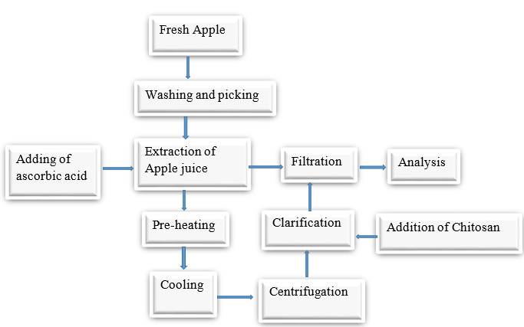
Figure 3.3 Production of Clear Apple Juice [6, 7]

3.4.1 Acid Treatment Process
Demineralization test was carried out by adding 2% HCl aqueous solution into 50 g of the dried scales sample at room temperature with a solid to solvent ratio of 1: 10 (w/v). The mixture then kept under shaking at 250 RPM for 3 hours at room temperature. The scales were filtered, washed with distilled water until neutrality and dried in oven for 18 hours at 45°C. The process is shown below in Figure 3.4.
Figure 3.4 Fish Scale Demineralization Process

3.4.2 Deproteinization Process
Samples from demineralization process were added into 4% NaOH aqueous solution at solid to solvent ratio of 1:10 (w/v) under constant shaking and were allowed to stand for 3 hours at ambient temperature. After that the solution was filtered and the samples were washed in distilled water until neutral pH obtained. The samples were then dried in oven for 18 hours at 45°C. The deproteinized residue solid products were achieved after modifying the previously reported procedure [5] is done. Proper process conditions were maintained in each step Figure 3.5.
Figure 3.5 Alkaline Treatment Processes

3.4.3 Depigmentation and Deodorizing Process
The deproteinized sample is transferred into a two litre beaker and it is treated in 100mL of 1% NaClO aqueous solution, then the mixture is stirred for two and half hours at ambient temperature. Subsequently, the samples were filtered and washed in distilled water until the sample solution maintained neutrality. Finally, it was dried in oven dryer for 18 hours at 45°C. After this processes, the dried samples were considered as natural organic polymer known as chitin [11]. The whole depigimentation and deodorizing processes are shown below, Figure 3.6.
Figure 3.6 Depigmentation and Deodorizing Frocess

3.4.4 Deacetylation Process
The deacetylation of chitin was carried out by adding 4% NaOH at sample to solvent ratio 1:5 (w/v) at 40°C for 2 hours on a hot plate by constant stirring for obtaining the chitosan. The samples were then placed under the hood and cooled for 40 minutes at room temperature. The obtained sample was hen washed with methanol for further purification of product. The samples were then left uncovered and oven dried at 45°C for 18 hours. The recovered products obtained in a creamy white form then grinded by high speed grinder and sieved with mesh of 500 µm, which is the chitosan. This process involved the removal of acetyl groups from chitin structure to convert chitin to form chitosan. The photographs of stepwise procedures and flow chart revealed in Figure 3.7 and Figure 3.8 the chitin and chitosan from fish scale waste, respectively [5].

Figure 3.7 Deacetylation Process
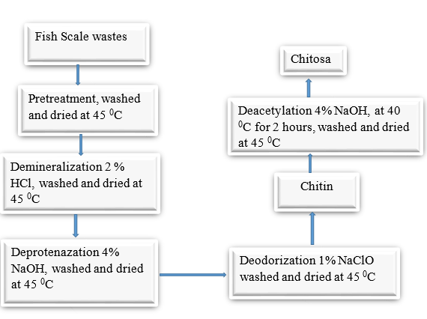
Figure 3.8 Flow Chart Depicting in Extraction of Chitin and Chitosan from Fish Scale Wastes

3.5 Determination of Chitin and Chitosan Yield
The percentage yield of chitin and chitosan were calculated by dividing the weight of extracted chitin to initial dry scale weight and weight of extracted chitosan dividing to the weight dry fish scale weight after deacetylation respectively. Yields would be
$$Yield of Chitin \left(\%\right)= \frac{Extracted Chitin (g)}{Fish Scale Waste (g)} ×100 (1)$$
$$Yield of Chitosan \left(\%\right)= \frac{Extracted Chitosan (g)}{Fish Scale Waste (g)} ×100 (2)$$

3.6 Determination of Moisture and Ash Contents of Scale, Chitin and Chitosan

3.6.1 Determination of Moisture Content
The moisture content of fish scale, chitosan and chitin samples in dry weight base was determined according to official method of analysis [58]. Cleaned and dried crucibles were prepared and the masses were weighed as W₁, exactly 3 g of fish scale, chitin and chitosan samples were weighed and transferred to in previously dried and weighed crucibles, respectively then the masses were weighed as W₂. The crucibles with fish scale, chitin and chitosan samples were placed in a thermostatically controlled oven drier, heated at 105⁰C for 12 hours and then the samples were removed and cooled to room temperature in desiccators and reweighed. The mass after cooling measured as W_{3.} Finally the following expression was used to calculate the moisture content.
$Moisture content \left(\%\right) = M_{c}= \frac{W_{2} - W_{3}}{W_{2} - W_{1}}×100 (3)$
Where: W₁ = weight of container or empty crucible (g)
W₂ = weight of container (crucible) + sample before drying (g)
W₃ = weight of container (crucible) + sample after drying (g)

3.6.2 Determination of Ash Content
Ash is an inorganic residue remaining after the material has been completely burnt at a temperature of 550ºC in a muffle furnace. In this study, the ash contents of fish scale, chitin and chitosan were determined by using the official methods of analysis [58].
The porcelain crucible used for the analysis was washed by HCl acid on boiling and it was washed with distilled water; then the crucibles were dried at 120ºC in oven drier and weighed using analytical balance (M₁). According to this method exactly 3 g of fish scale, chitin and chitosan samples were transferred in to a porcelain crucible which had previously ignited, cooled and weighed (M₂) respectively. The samples were placed in a muffle furnace at 550ºC. The temperature was maintained for 12 hours or until white ashes were obtained. The ashes samples were cooled in desiccators and the residues were weighed as M₃.
The following expression was used to calculate the % total ash content in each sample on dry basis:
$$Total ash \left(\%\right)= \frac{M_{3} - M_{1}}{M_{2} - M_{1}} ×100 (4)$$
Where: - M₃ = weight of crucible + ash (g)
M₁ = weight of empty crucible (g)
M₂ = weight of sample (g) + weight of crucible (g)

3.7 Chitin and Chitosan Characterization

3.7.1 Fourier Transforms Infrared Spectroscopy (FTIR)
In this study, infrared spectra measurements were conducted for characterization of the functional group of the chitin and chitosan formed. The experiment for the characterization of samples was conducted at Ethiopian Leather Industry Development Institute (LIDI), Addis Ababa. Pellets were scanned at room temperature (25°C) in the spectral range of 4000 – 400 cm⁻¹. FTIR was used to confirm the formation of chitin and chitosan (recovered from the fish scales). The KBr pellets were prepared by thoroughly mixing KBr (0.1 g) and sample (0.02 g) and made into pellets by pressing in the pelletizer [3]. Finally, the readout data is recorded.

3.7.2 X-ray Diffraction (XRD)
The crystallinity and amorphous structure of prepared chitin and chitosan were characterized by X-ray diffraction (XRD) technique using an X-ray diffractometer. The X-ray diffraction (XRD) powder patterns were recorded in transmission geometry with CuKα radiation source in the 2θ range of 5⁰ to 40⁰ at 40 kV, 15 mA [4].

3.7.3 Determination of Degree of Deacetylation (%DD)
According to procedure of the Hossain and Iqba., [59] the degree of deacetylation (DD) of chitosan was determined by acid-base titration method with little modifications: that 0.1 g of chitosan was dissolved in 30 mL of 0.1 M HCl and 25 mL of distilled water and stirred continuously for 3 hours, then the solution was titrated against with 0.1 M NaOH, during the process 3-4 drops of methyl orange indicator is used. The titrant was added until the red coloured reaction mixture turned to orange color, then volume of standardized NaOH recorded as initial (V_{i)} and final ( V_{f}), respectively. This process is carried out in triplicates and the average volume is recorded. The DD was obtained by the following equation:

$$DD\%= \frac{C_{1}V_{1}-C_{2}V_{2}}{W ×0.0994} ×100 (5)$$

Where, C₁ = (mol/L) concentration of standard HCl acid solution,
C₂ = (mol/L) concentration of standard NaOH solution
V₁= (mL) volume of the standard aqueous HCl solution used to dissolve chitosan,
ΔV= V_{f} – V_{i} = V₂ (mL) volume of the standard NaOH solution consumed during titration
W= (g) weight of chitosan and 0.0994 = the proportion of amino (NH₂) group by weight in chitosan. The Degree of acetylation (DA) was calculated by subtracting the value of degree of deacetylation from 100%.

3.7.4 Determination of Intrinsic Viscosity
The intrinsic viscosity was determined using different concentrations of chitosan solution prepared in solvent adding. Acetate buffer (0.2 M AcOH – 0.15 M NH₄OAc) is used to maintain pH of 4.8, solvent to solvent ratio of 10: 15 (v/v). A calibrated, standard size, borosilicate glass Ostwald U-tube viscometer clamped into a leveled water bath was used to determine the reduced viscosity (ɳ_{red}) of the solutions from the mean flow time of the solutions and the solvent at 28 ± 0.5°C. The mean flow times of the polymer solutions and the reference solvent was used to determine the relative viscosity according to Kumari et al., (2016) [4, 41] procedure.
$$V = \frac{ɳ}{ρ} (6)$$
Where η is dynamic viscosity and ρ is density of fluid. Since the polymer solutions were adequately dilute, the dynamic viscosity was supposed to be equal to the kinematic viscosity, which is equivalent to relative viscosity of chitosan solution. The viscosities of the solvent and the polymer solutions were used to find the relative viscosity (ɳ_{rel}), specific viscosity (ɳ_{sp}), reduced viscosity (ɳ_{red}), Inherent viscosity (ɳ_{inh}) and Intrinsic viscosity [η] using the following relationships:
Relative Viscosity (η_{rel}) is the ratio of the viscosities of the polymer solution (of stated concentration) to the pure solvent at the same temperature. It is also known as the ratio of solution to the solvent viscosity.
${ ɳ}_{rel}= \frac{t_{CH}}{t_{s}} ( 7)$
Specific Viscosity (η_{sp}) is the relative viscosity of a polymer solution of known concentration minus one; usually determined at low concentration of the polymer.
$$ɳ_{sp= }\frac{t_{CH}}{t_{s}} -1 = \frac{t_{CH}- t_{s}}{t_{s}} =ɳ_{rel -1} (8)$$
Reduced Viscosity (η_{red}) is defined as the specific viscosity (η_{sp}) divided by the concentration, expressed in g/ml. also known as viscosity number and is expressed using in the following equation.
$$ɳ_{red} = \frac{ɳ_{sp}}{c} (9)$$
Inherent viscosity (ɳ_{inh}) is the quotient of the natural logarithm of relative viscosity and the concentration [46].
$$ηinh=\frac{ln ɳ_{rel}}{C} (10)$$
$$\left[ɳ\right]=(\frac{ɳ_{red} +ɳ_{inh}}{2})c→0 (11)$$
Where t_{CH} is the mean flow time of chitosan solution, t_{s} is mean flow time of solvent, and c is chitosan concentration in (g/L). A plot of reduced and inherent viscosity against polymer concentration (Huggins’s plot) on extrapolation to infinite dilution gave the intrinsic viscosity of the chitosan [41, 60]. The average of the two obtained intercept values was calculated.

3.7.5 Determination of Molecular Weight
Molecular weight of chitosan can be determined by different techniques such as Gel Permeation Chromatography (GPC), Static Light Scattering (SLS) and intrinsic viscosity measurement. Determination of molecular weight by intrinsic viscosity measurement is a simple and available method for characterization of chitosan [46]. In this study, the molecular weight of chitosan was determined by using the viscometric method for each biopolymer solutions at concentrations ranging from 0.008 to 0.300 g/l (w/v). The intrinsic viscosity of chitosan (0.2 M AcOH – 0.15 M NH₄OAc) solution was measured using an Ubbelohde capillary viscometer in a water bath to maintain room temperature. In this experiment triplicate measurements were recorded. The flow time data was used to calculate the intrinsic viscosity by extrapolating the reduced and inherent viscosity to zero concentration. The value of intrinsic viscosity was then recalculated into the viscosity-average molecular weight using Mark–Houwink–Sakurada equation. The Mark-Houwink equation related to intrinsic viscosity with empirical viscometric constants (viscometeric parameters). For chitosan and the solvent (0.2 M AcOH – 0.15 M NH₄OAc), these constants were 3.64 × 10⁻⁴ and 0.780, respectively [45], finally molecular weight of chitosan is calculated using below equation.
$\left[η\right]= k \left(Mw\right)α (12)$
Where M_{w} is viscosity average molecular weight of polymer; ‘’k’’ and’’ α’’ are empirical viscometric constants, whose values where depended on the polymer type, temperature and the chosen solvent [41, 61].

3.7.6 Determination of Solubility
It was carried out according to study conducted by Kumari et al., [4] with small modifications in procedure. Chitosan was dissolved completely or partially in 1% acetic acid. 0.1 g of chitosan powder (sample was taken in triplicate) and 35 mL of 1% acetic acid was weighed. The solution was kept in a magnetic stirrer for 30 minutes. The sample was taken out and the insoluble was removed by filtration through whatman filter paper, the residue was dried in oven dryer at 50 ⁰C for 2 hours and weighed.
$$Insoluble \left(g\right)= W_{F} - W_{I} (13)$$
Where, W_{f} = final weight of filter paper with reside after drying (g) and
W_{i} = initial weight of empty filter paper (g)
$$Insolubility \left(\%\right)= \frac{insoluble \left(g\right)}{sample weight \left(g\right)} ×100 (14)$$

$$Solubility \left(\%\right)= 100 -\% insoluble (15)$$

3.7.7 Determination of Water Binding Capacity and Fat Binding Capacity
A) Water Binding Capacity
Water binding capacity (WBC) of chitosan was measured using a slightly modified method of [59]. It was initially carried out by weighing a cleaned centrifuge tube containing 0.5 g of sample, adding 10 mL of distilled water, and mixing on a vortex mixer for 1 minute to disperse the sample. The contents were left at ambient temperature for 30 minutes with irregular shaking for 5 seconds every 10 minutes and centrifuged at 3,000 RPM for 25 minutes. After the supernatant was decanted, the sample containing centrifuge tube was weighed again. WBC (WHC) was calculated as follows:
$$WBC \left(\%\right)= \frac{W_{2} - W_{1}}{W_{0}}×100 (16)$$
Where W₀ = weight of the sample (g)
W₁ = weight of the centrifuge tube plus sample (g)
W₂ = weight of the centrifuge tube plus sediments (g)

B) Fat Binding Capacity
Fat binding capacity (FBC) or OHC of chitosan was measured using the modified method [59]. It was initially carried out by weighing a cleaned centrifuge tube containing 0.5 g of sample, adding 10 mL of sunflower oil and mixing on a vortex mixer for 1 minute to disperse the sample. The contents were left at ambient temperature for 30 minutes at shaking for 5seconds for every 10 minutes and then centrifuged at 3,000 RPM for 25 minutes. After the supernatant was decanted, the sample containing centrifuge tube was weighed again. FBC was calculated using the below equation:
$$FBC \left(\%\right) = \frac{W_{2} - W_{1}}{W_{0}}×100 (17)$$
Where W₀ = weight of the sample (g)
W₁ = weight of the centrifuge tube plus sample (g)
W₂ = weight of the centrifuge tube plus sediments (g)

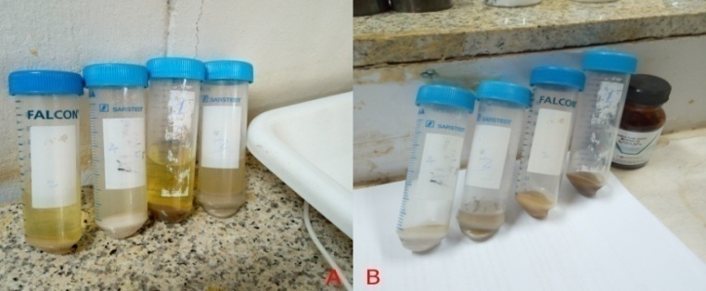
Figure 3.9 Determination of Chitosan WBC and FBC

3.8 Determination of physicochemical properties of clarified apple juice with chitosan and without chitosan

3.8.1 Clarity Analysis of Apple Juice
Clarity of apple juice was determined using (AOAC, 1990) [62] standard methods by measuring the absorbance at 660 nm using a UV-visible spectrophotometer and distilled water was used as a reference.

3.8.2 Determination of Total Soluble Solids in Apple Juice
Brix % is generally used as indicator for soluble solid content percentage in fruit juices. The total soluble solids of clarified apple juice samples was determined according to [61] method by using hand held digital refractometer (precision and specific instrument), at ambient temperature (26-28ºC) for different chitosan concentrations ranging from 0.05 to 0.25 g/L juice.

3.8.3 Determination of Titratable Acidity (TA) of Apple Juice
The extracted apple juice contains a number of major organic acids such as malic acid and citric acid, which are willingly neutralized by strong bases and can be titrated against standard bases such as sodium hydroxide. A washed and cleaned flask, burette and other necessary equipments were prepared and a 10 mL of apple juice sample was measured. Then, the sample was transferred to a 100 mL Erlenmeyer flask. The sample was diluted by adding 25 mL of distilled water. Using a standard solution of 0.1 N sodium hydroxide, the sample was titrated until detection of end point. The end point was determined using phenolphthalein indicator three to four drops. The volume of 0.1 N sodium hydroxide used was recorded at the end point. The total acidity can be calculated using equation (17) and expressed as concentration of malic acid (g/L) [63]. The measurement was repeated in triplicates and the mean value of the volume is recorded.
$$\% TA= \frac{0.1 M NaOH ×V_{NaOH(L)} ×M_{w}}{weight of the sample} ×100 (18)$$
Where, TA = titratable acidity
V_{NaOH} = volume of 0.1N of sodium hydroxide consumed during titration
M_{w} = molecular mass of malic acid

3.8.4 Determination of pH of Apple Juice
The pH values of chitosan treated and untreated apple juice were determined according to AOAC [62] using official method and the treated and untreated apple juice were measured in two day intervals for consecutive ten days at different chitosan concentration ranging from 0.05 to 0.25 g/L. The pH measurements were recorded as triplicates every day with a digital pH meter.

3.8.5 Determination of Turbidity
The turbidity of each sample of apple juice was measured using a direct reading with a portable turbid meter. The measurements of the samples of apple juice were done in triplicates with a solution of 1:10 (juice/water) to work within the detectable range. The measured results were given in NTUs of suspended solids per liter of solution [7].

3.9 Sensory Evaluation of Prepared Apple Juice
Sensory evaluation of chitosan treated apple juice and untreated apple juice was conducted in this study. The sensory evaluation was performed immediately after preparation and following 10 days. The prepared juice was kept in refrigerated for 10 days at 4°C before sensory evaluation was carried out. The sensory evaluation was carried out using untrained sensory panelists consisting of M.Sc. students our industrial chemistry stream and staff from the department of chemistry natural science collage, of Arba Minch University. The numbers of panelists were 10 (4 females and 6 males). Water, for rinsing between the samples and scroll sheet were provided for each of them. In this evaluation, the sensory attributes to assess overall appearance, color (purity, typicality and overall sensation), taste (acidity, sweetness, bitter-sweet taste and mouth- feel) and aroma (fruity and apple aroma) and overall acceptability of apple juice with and without extracted chitosan from fish waste was evaluated using a five- point hedonic scale grading from (1-5, where as 1 is minimal or very least and 5 is maximal or highest was carried out), 5 for like extremely, 4 for like moderately, 3 for neither like nor dislike, 2 for dislike moderately and 1 for dislike extremely. The prepared samples were arranged in random order on glass bottles and served to sensory panelists. Immediately before each test, brief orientation was given to the participants on the process of sensory evaluation [61]. No discussion during evaluation among participants.

3.10 Method of Statistical Analysis
All the measurements were carried out in triplicates and the data‘s were presented as mean
plus standard deviation. The statistical analysis used in the study varied depending on the type of variables and information obtained from the experimental data. Analysis of variance (ANOVA) was used to compare the measured parameter in the samples of chitosan and apple juice. The level of significance was calculated for P < 0.05. These analyses were performed using origin software version 8.0 and SPSS version 20. Excel package was used to arrange the data obtained, and the association between chitosan concentration and flocculation time during apple juice clarification was analyzed using ANOVA.

CHAPTER FOUR

RESULTS AND DISCUSSIONS

4.1 Extraction of chitin and preparation of chitosan
The present data represents the first kind of attempt to study different physicochemical properties of chitin and chitosan from Nile Tilapia fish scale wastes in Lake Chamo, Arba Minch and to examine the applications of extracted chitosan on apple juice as clarifying agent. The fish scales were collected from Lake Chamo, Arba Minch city and it was washed with tape water and distilled water then dried in oven at 45 ⁰C for 18 hours. Subsequently, the scales of fishes were used as raw material for chitin and chitosan production. For valuable product to be extracted from fish scales, it is essential to convert scale first to chitin. Usually, extraction of chitin from raw fish scale waste consists of five general steps including pre-treatment for removal of unnecessary wastes from scales, demineralization for removal of calcium carbonate/phosphate, deproteinization for removal of protein, deodorization for removal of pigments such as melanin and carotenoids, bad odour and color and then, conversion of chitin into chitosan by N-deacetylation which partially or fully removes the acetyl group from the natural organic polymers chain composition. The processes were performed to extract chitosan from fish scale. Percentage yield and physical appearance of chitin and chitosan is tabulated in Table 4.1 for comparison purpose.
Table 4.1 Comparison of the Yield and Physical Appearance of Chitin and Chitosan with Reported Studies
Sample Name | Current study value | Reported value | References
Yield of chitin (%) | 29.88 | 18.2 - 30.6 and 52 | [64, 65]
Yield of chitosan (%) | 15.87 | 21 and 5.6 - 13.5 | [65, 66]
Color of chitin and chitosan | White | White | [ 65, 66]

In present work, the total yield of chitin and chitosan obtained from Nile tilapia scale is showed in (Table 4.1). Results of the present study clearly confirmed that most favorable yield of chitin and chitosan obtained from tilapia scale waste were recorded as 29.88 % and 15.87%, respectively and it is quite high considering the conversion of waste raw material into a value added products. Previous study done by Nouri et al., [66] showed the percentage yield of extracted chitosan from fish waste ranged from 5.6-13.5 % using chemical method of analysis that was lower as compared with the current study. In another study done by Pandharipande et al., [65], the yield of chitin and chitosan from fish scales reported were about 52 % and 21%, respectively which higher as it is compared with the current study. This discrepancy in percentage yield might be attributed due to the nature of environment, method of extraction such as extraction time, temperature, solid to solvent ratio of both acid and bases, degree of deacetylation process and difference in fish species. The physical appearance of the chitin and chitosan obtained was white in color. It was also odorless and in a form of crystalline and amorphous fine powder, respectively. The characteristic of the chitosan extracted in this study was similar to the chitosan obtained from preceding studies [4, 64, 65, 66]. The white color of end product affirms the quality of chitosan product.

4.2 The Physicochemical Properties of Prepared Chitin and Chitosan
The prepared chitin and chitosan were evaluated for various physicochemical properties and the results are given in Table 4.2.
Table 4.2 Physiochemical Parameters of Chitin and Chitosan
S.No | sample name | Parameter used | Currently study values
1 | Chitin | Yield % | 29.88 ± 0.01
2 | Chitosan | Yield % | 15.87 ± 0.14
3 | Scale | Moisture % | 15.02 ± 0.44
4 | Chitin | Moisture % | 4.44 ± 0.20
5 | Chitosan | Moisture % | 6.79 ± 0.40
6 | Scale | Ash % | 37.37 ± 0.35
7 | Chitin | Ash % | 4.22 ± 0.23
8 | Chitosan | Ash % | 1.22 ± 0.16
9 | Chitosan | DD% | 85.25 ± 0.28
10 | Chitosan | Solubility% | 94.30 ± 0.99
11 | Chitosan | FBC% | 391.17 ± 0.13
12 | Chitosan | WBC% | 461.34 ± 0.42
13 | Chitosan | [ɳ] | 4.4215 ± 0.0101
14 | Chitosan | Mw | 155,730.4870 ± 1.1
Values are expressed as mean ± SD.
The fish scale, extracted chitin and chitosan were tested for different physicochemical characteristics such as yield, DD%, solubility, FBC%, WBC%, intrinsic viscosity, molecular weight, and moisture and ash contents. All chemical constituents were expressed as dry mass basis except moisture content which was in wet mass basis for fish scale. From the data presented in Table 4.2, fish scale had moisture content of 15.02 % and ash content of 37.37 % which was higher when compared with chitin and chitosan in the current study. Moisture is one of the factors which can affect the quality of chitosan produced. The higher the moisture content, then higher the chance of getting it spoiled quickly. In general, a good quality of chitin that is produced after demineralization, deproteination and deodorization processes should have moisture content of less than 10%. Result in Table 4.2, shows that the average moisture content of chitin obtained was 4.44 % (±0.20) which indicates that the standard quality of moisture content was achieved for chitin and it was suitable to be continued for the deacetylation process. Chitosan was found to have the average percentage of moisture content 6.79 (±0.40) which is somewhat higher than as to compared with the study conducted by Ait Boulash et al., [2]. The same trend in moisture contents of chitin in the current work observed. This might be due to the hygroscopic nature of chitosan compound which having a great capacity to form hydrogen bonding (formed with both hydroxyl and amino groups) with water as compared to chitin. Research conducted by Isa et al., [67], revealed that moisture content of chitin and chitosan were 12.90% and 1.4%, respectively using different sodium hydroxide concentration for its deacetylation process [37].
Further study done by Islam et al., [68] revealed that moisture content of chitin and chitosan were 10.9% and 8.2%, respectively. The reported moisture content values varied compared with current study. This might be due to difference in drying method depending upon the intensity of heat and environmental condition during the study period [68].
The study performed by Naznin., [64] revealed that moisture content of chitosan ranged from 6.62- 8.01%. The result indicates that it has a greater capability to form hydrogen bonding and the values reported is in one word line with the obtained results of the present study. The study carried out by Islam et al., [68] also showed that the moisture content of chitosan in ranges from 6-10%, that after chitosan has a greater ability to form hydrogen bonding. Additionally, the higher the water content in the chitosan structure, the faster the damage nature of the polymer via hydrolysis reactions [69].
Ash is inorganic residue remaining after water and organic residue removed from a sample. As indicated in Table 4.2, the ash content in scale, chitin and chitosan were recorded. The ash content of chitosan was lower than the corresponding scale and chitin contents that confirm the effectiveness of the demineralization process for the removal of calcium carbonate and calcium phosphate. The ash content of chitin and chitosan obtained in this work were 4.22% and 1.22%, respectively with significant difference (P<0.05). The lowest ash content was achieved chitosan due to deacetylation process by NaOH (4%) boiled at temperature 40 ⁰C for 2 hours. The ash content of chitosan from Nile tilapia scales has fulfilled the ash content maximum quality standard of commercial chitosan, which is equal to 10 %. This is an indication of the effectiveness of the method worked for removing inorganic materials. The current study result disagreed to some reported research work which showed higher in ash content in chitosan. Content of ash on chitosan extracted from Nigerian shrimp was 6.41% while in mussel shell it was 36.87% [69, 70] which was higher than from the current study, which indicates the little effectiveness of their methods compared with our study. From the experimental data it can be inferred that 2% HCI and 4% NaOH can effectively reduce the ash content of chitin and chitosan to 4.22 % and 1.22%, respectively.

Figure 4.1 Relationship between Solubility and DD of Chitosan
From the present study (Figure 4.1), is revealed that the degree of deacetylation (DD) of the chitosan obtained from fish scale is 85.25%, that shows how chitosan can play an important application role in different industrial sectors such as food, pharmaceuticals, agricultural, cosmetics, fruit juice and beverage clarification, fruit and vegetable preservation from microbial deterioration and waste water purification [13, 22, 51]. The percentage DD value indicates the effective removal of acetyl group from the long chain of chitin and it also plays a crucial role in deciding the precise application of chitosan. It is one of the most essential physicochemical and valuable parameter that may influence the physical and chemical properties of chitosan including solubility, adsorption, chemical reactivity, covalent linking, biocompability, encapsulation and biodegradability [35]. DD of chitosan may range from 56% to 95% with average of 80% depending on the available resource and procedure [40]. According to the report Hajji et al., [37], the degree of deacetylation depends on the source of chitin, concentration of acid and alkaline used, time and temperature. The value of DD % and solubility % obtained from fish scale in the current work is closely related with the values obtained from shrimp shell chitosan [71].
Table 4.3 Comparison of Solubility of Produced Chitosan Value with Reported Values
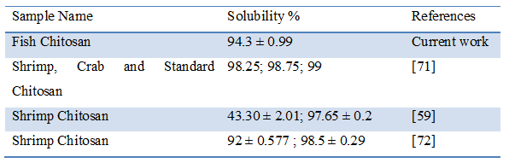
Solubility is one of the most significant physicochemical characteristics that determine the quality of chitosan, where higher solubility means better quality of the chitosan [41]. In the present work higher solubility value was achieved which indicates the quality good chitosan. This is because an increase in solubility means proportionally there is increase in the degree of deacetylation. Hence the increased degree of deacetylation confirms the high quality of the recovered chitosan. In the current work, the measured average solubility was 94.3% (Table 4.3) which is in accordance with values reported in the previous study by Hossain and Iqbal [59], where the solubility of chitosan obtained ranged from 48.30 to 97.65%. From data recorded in Table 4.3, it is in a good agreement to the current solubility value that obtained from fish scale to that of the reported commercial and shrimp chitosan with a minor difference. This might be due to the extraction methods as well as the sources of chitosan. Some of the common factors that affect chitosan solubility are temperature, duration of deacetylation, alkali concentration and chitin isolation condition [67]. Chitosan is a compound which is very hard to dissolve in water, alkaline solutions or most common organic solvents but it is soluble to some extent in dilute aqueous organic acid solutions [71]. Chitosan would get protonated in the aqueous acid solution which leads to its solubility because of the presence of amino group in its molecular structure [22].
An increase in degree of deacetylation is proportionally observed with increasing in solubility [41, 71] that is due to the removal of acetyl group from chitin during deacetylation process, leaving only amine group. Hydrogen (H⁺) ion on the amine group creates chitosan to easily interact with water through hydrogen bonding. Properties of chitosan is only soluble in dilute acid, such as acetic acid, formic acid, citric acid has been substituted except that chitosan is water soluble. Presence of carboxyl group in acetic acid would facilitate the dissolution of chitosan due to the hydrogen interaction between the carboxyl and the amine group of chitosan.

4.3 Instrumental Characterization of Chitin and Chitosan

4.3.1 Fourier Transform Infrared (FTIR) Spectroscopy Study
Fourier transform infrared (FTIR) spectroscopic study is one of the common and powerful analytical techniques used in sciences for determination of functional groups present in the samples. FTIR spectroscopic study of chitin and chitosan polymers from Nile tilapia scale waste was achieved at range (4000-400cm⁻¹) and corresponding FTIR spectrum was presented in Figure.4.2 and 4.3), respectively.

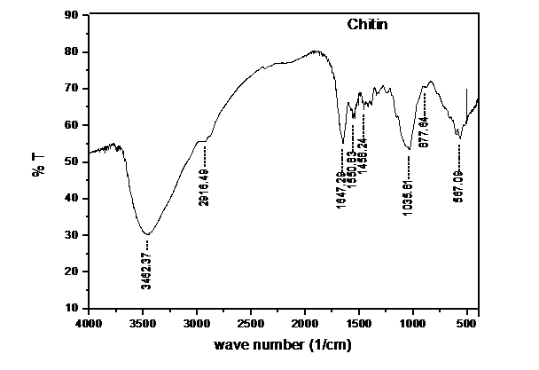
Figure 4.2 Fourier Transform Infrared (FTIR) Spectrum of Chitin from Nile Tilapia Fish Scale Waste

IR characterization of the chitin and chitosan was performed with spectrometer instrument at a frequency range of 4000–400 cm⁻¹. It was evidently observed from Figure 4.2 that the absorption patterns of the spectrum were comparable to those of the reviewed literature. The spectrum of the current study suggests the presence of high-quality chitin and chitosan biopolymers in Nile tilapia scale samples. Detailed assessment of the spectrum revealed that the spectra had characteristic bands for chitin and chitosan. From the Figure 4.3, the spectra were observed to have a band located at 3462.37 cm⁻¹, which indicates the stretching and vibrating of aliphatic O–H, which is more evident in the chitin spectrum. Absorption peak at 2916.49 cm⁻¹ is from C–H vibration of symmetrical –CH₃. Absorption band at 1647.29 cm⁻¹ represents the stretching and vibration of the carbonyl group, C=O from acetamide (-NHCOOCH₃); other characteristic absorptions band for chitin are at 1550.83 and 1458.4 cm⁻¹ confirm the bending vibration of secondary amide II band of –NH and stretching vibration of –CN from acetamide group, respectively. Absorption peak at 1035.81 cm⁻¹ was the stretching vibration for –C–O–C of the glucosamine ring or glycosidic linkage, while peaks at 877.64 cm⁻¹ is due to ring stretching a characterization band for β-1, 4 glycosidic bonds. This current study was supported by works of research scholars [3, 4, 9, 70, 71]. Due to the different arrangement between α-chitin and β-chitin, primary amide band in α-chitin spectrum splits at 1647 cm⁻¹ which is attributed to the occurrence of intermolecular hydrogen bond CO --HN and further split at 1625 cm⁻¹ due to the intermolecular hydrogen bond CO—HOCH₂. Similar results were reported by S. Kumari et al.,[3].
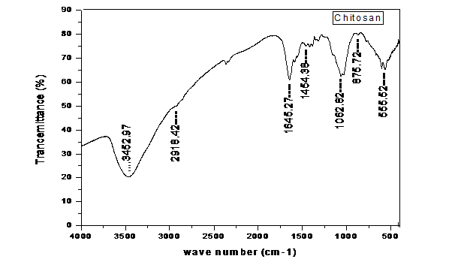
Figure 4.3 Fourier Transform Infrared (FTIR) Spectrum of Chitosan from Nile Tilapia Fish Scale Waste
The most important aspects of FTIR spectra for prepared chitosan (Figure. 4.3) are as follows: 3,452.97 cm⁻¹ (O–H stretching vibration of water and hydroxyl overlapped with N–H stretching vibration of free amino groups and inter-hydrogen bonds of the polysaccharide). The band observed at 2,918.42 and 2,878 cm⁻¹ corresponds to asymmetric stretching of CH₃ and CH₂ (C–H stretch) in the prepared chitosan, the intensive peaks around 1,645.27 cm⁻¹ corresponds to bending vibration of (amide I band, C=O stretch), 1,454.38 cm⁻¹ (NH₂ bending), 1,383 cm⁻¹ (amide III band, C–N stretch), 1,420 cm⁻¹ and 1,323 cm⁻¹ (C–H bending), 1,259 cm⁻¹ (C–N stretch), 1,062.82 cm⁻¹ (bridge C–O–C stretch) or glycosidic linkage and 875.72 cm⁻¹ pyranose ring which is a characteristic future of chitosan polysaccharide and also indicates the occurrence of deacetylation [3, 9, 67]. The current FTIR analysis study reaffirmed the successful conversion of chitin to chitosan sample, obtained from Nile tilapia scale wastes.

4.3.2 X-Ray Diffraction of Chitin and Chitosan Analysis
X-ray diffraction (XRD) of prepared chitosan and chitin from Nile tilapia scale waste showed diffraction angle ranging from 5 to 40⁰ in the Figure 4.4 (A and B), respectively. From the figures presents examples of the results revealed all the diffractograms present an amorphous-crystalline structure and two sharp crystalline reflections at 2-theta around 11.44 and 21.9 in their XRD spectrum.
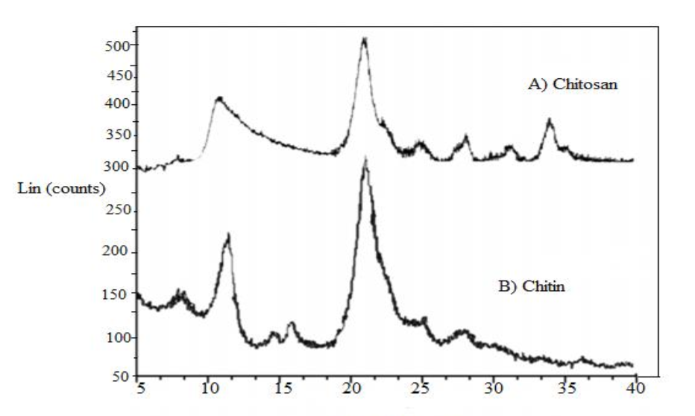
Figure 4.4 Chitin and Chitosan XRD
It is observed that, the sharpness of the bands was higher in the chitin sample (Figure 4.4, B) than in their chitosan samples and telling that the chitosan samples had lower crystallinity. The diffraction pattern of chitosan samples showed the characteristic peaks 2- theta around 11.4⁰, 21.9⁰ and 34.5⁰. Though, the intensity of crystal peak around 10⁰ was less than the crystal peak around 20⁰. These results had radically decreased because of the intramolecular hydrogen bonds after the deacetylation, and in the end product molecular structure was in an amorphous state more than after deacetylation reaction. These result also confirmed that the presence of nearly identical peaks approximately at 10⁰ and 20⁰ for chitin and chitosan at different degree of deacetylation [4]. Furthermore, from current study results strong reflection was observed at these angels belong to chitosan and peaks were almost similar to the peaks available in the commercial chitosan [3, 40]. Based on the results of the present study, clearly affirmed that the conversion of the chitin material from Nile tilapia scale waste to chitosan and it is more amorphous structure, abundantly might be used for apple juice clarification and other industrial application.

4.4 Viscosity and Average Molecular Weight of the Produced Chitosan
Viscosity is an important factor to conventional determination of average molecular weight from recovered chitosan. Consecutively to measure intrinsic viscosity, viscosities of the solvent and the produced chitosan solutions were measured [41, 46]. In this work, viscosity of seven different chitosan concentration solutions were measured and summarized along with calculated parameters in the Table 4.4 and 4.5 below. The data used for the determination of average molecular weight of the prepared chitosan according to the Mark-Houwink-Sakurada (MHS) equation that presented in Equation (12) in chapter three.
The viscometric study was carried out at an ambient temperature in order to evaluated, relative, specific, inherent and reduced viscosity of chitosan polymer in which dilute polymer solution at different concentration rate is an indication of intrinsic viscosity as well as molecular weight of the extracted polymer. Viscosity of polymer was affected by many factors such as concentration of the polymer, type of solvent, temperature, shear rate and etc. From Table 4.4, this study revealed that all viscosity linearly increased when the concentration of the chitosan was gradually increased. Consequently, at lower polymer concentration all the mentioned viscosity slightly decreased. This study confirms the average molecular weight was closely interconnected with the viscosity measurements.

Table 4.4 Dilute Chitosan Solution Viscosity Designation
Flow time (sec) of chitosan | Conc. (g/l) | ɳ_rel | ɳ_{sp} | ɳ_{inh} | ɳ red
800.613 ± 0.001 | 0.008 ± 0.08 | 1.053 ± 0.50 | 0.053 ± 0.09 | 1.953 ± 0.01 | 7.050 ± 0.90
848.300 ± 0.100 | 0.016 ± 0.50 | 1.116 ± 0.01 | 0.116 ± 0.01 | 2.010 ± 0.60 | 7.469 ± 0.47
938.571 ± 0.010 | 0.031 ± 0.30 | 1.235 ± 0.00 | 0.235 ± 0.40 | 2.020 ± 0.30 | 7.540 ± 0.24
1,134.510 ± 0.110 | 0.063 ± 0.01 | 1.493 ± 0.00 | 0.493 ± 0.70 | 2.070 ± 0.00 | 7.888 ± 0.13
1,718.530 ± 1.010 | 0.125 ± 0.01 | 2.261 ± 0.00 | 1.261 ± 0.60 | 2.320 ± 0.08 | 10.130 ± 0.81
3,223.060 ± 1.010 | 0.250 ± 0.01 | 4.241 ± 0.33 | 3.241 ± 0.13 | 2.560 ± 0.04 | 12.977 ± 0.50
3,867.670 ± 0.100 | 0.300 ± 0.01 | 5.090 ± 0.00 | 4.090 ± 0.50 | 2.610 ± 0.03 | 13.640 ± 0.45
Note: Flow time (second) for Solvent system = 760 ± 1.00
Table 4.5 Different Chitosan Concentration versus Calculated Parameters
Conc. (g/l) | ɳ_{inh} | ɳ red
0.008 | 1.953 | 7.050
0.016 | 2.010 | 7.469
0.031 | 2.020 | 7.540
0.063 | 2.070 | 7.888
0.125 | 2.320 | 10.130
0.250 | 2.560 | 12.977
0.300 | 2.610 | 13.640

Intrinsic Viscosity ([η]) is the ratio of a solution of specific viscosity to the concentration of the solute, extrapolated to zero concentration or the reduced viscosity and inherent viscosity were plotted against chitosan concentration [41, 60]. It reflects the capacity of a polymer in solution to enhance the viscosity of the solution. The viscosity behavior of macromolecular substances in solution is one of the most frequently used approaches for characterization. It is determined by measuring the relative viscosity at different chitosan concentrations and then extrapolating the specific viscosity to zero concentration. The variation of the viscosity number with concentration depends on the type of molecule as well as the solvent used. In general, the intrinsic viscosity of linear macromolecular substances is interconnected to the molecular weight or degree of polymerization. With linear macromolecules, viscosity number measurements can provide a method for the rapid determination of molecular weight when the relationship between viscosity and molecular weight has been established. Over all intrinsic viscosity is obtained by determining the reduced and inherent viscosity by extrapolating to infinite dilution of the polymers [41, 46].
Also it is an important rheological parameter which is used to characterize the hydrodynamic properties of produced chitosan and also to determine the average molecular weight of polymers by use of the Mark-Houwink Sakurada (MHS) equation [61].

Figure 4.5 Reduced and Inherent Viscosity versus Different Chitosan Concentration
The reduced and inherent viscosity of each concentration was used for the determination of intrinsic viscosity by plotting different chitosan concentrations (0.008, 0.016, 0.031, 0.063, 0.125, 0.250, and 0.300 g/mL) in the experiment, the equations fitted as y = 23.36x + 6.884; R² = 0.989 for reduced viscosity and y = 2.308x + 1.959; R² = 0.979 for inherent viscosity, respectively. From Table 4.5 and Figure 4.5, intrinsic viscosity and average molecular weight of the produced polymer obtained was 4.4215mL/g and 155,730.487g/mol, respectively. The higher molecular weight chitosan often provide highly viscous solutions which may not be attractive for industrial handling. Several factors that influence the average molecular weight during production of chitosan are high temperature, concentration of alkali, reaction time, preceding treatment of the chitin, chitin concentration and dissolved oxygen concentration [73].
In the current work, the average molecular weight obtained was found to be higher when compared to previous study report [4], where they have observed molecular weights of 5,200.96g/mol for fish scale, 1,263.11g/mol for shrimp shell and 170,046.39g/mol for commercial chitosan, respectively. When compared to commercial chitosan, the molecular weight of the present study is lower than the reported value. This is probably due to the influence of extraction methods and environmental changes [73]. These works have reported that intrinsic viscosity of chitosan molecular weight-dependent and decreased with a decrease in molecular weight in solutions of the polymer concentration.

4.5 Water Binding Capacity (WBC) and Fat Binding Capacity (FBC)
Water binding capacity (WBC) and fat binding capacity (FBC) of chitosan was measured and compared with other studies presented in Table 4.6.
Table 4.6 Comparison of Water and Fat Binding Capacity of Prepared Chitosan with Reported Values
S.No. | Sample Name | WBC (%) | FBC (%) | Reference
1 | Fish Chitosan | 461.34 ± 0.42 | 391.17 ± 0.13 | Current study
2 | Fish Chitosan | 492 | 226 | [4]
3 | Crab Chitosan | 355 to 611 | 217 to 403 | [74]
4 | Commercial Chitosan | 492.67 | 383.04 | [75]
WBC is an essential measurement in food processing applications. It refers to the quantity of water that can be absorbed per gram of sample material and the words water-binding capacity, water-absorption capacity and water-holding ability are frequently used interchangeably although the measurement method may differ. Fat-holding capacity (FHC) is a measure of the quantity of oil absorbed. Also the terms fat-absorption capacity (FAC) (or) fat-holding capacity and fat binding capacity are normally used interchangeably although the measurement process used may be differ. From Table 4.6, the present data shows that water binding capacity of 461.34% was observed in the current study; whereas the WBC of six crab shell chitosan ranged of 355% to 611% with the average values of 483% [74] which was lower as compared with the current study. The WBC values of commercial chitosan reported by Kucukgulmez et al., [75] were found to be slightly higher. This might be due to extraction method and fish species. According to Kucukgulmez et al., [75], possible explanations for the differences in water absorption between chitosan polymers include differences in the crystallinity of the products, differences in the amount of salt-forming groups and differences in the protein content of the materials. The FBC value of chitosans reported in the present study was found to be higher when compared with others [4, 74, 75]. Here, from the given data reported for WBC and FBC of fish chitosan it resembles to commercial chitosan.

4.6 Effects of Chitosan on the Clarification of Apple Juice
Chitosan possesses several inherent characteristics that make it an effectual coagulant or flocculants for the removal of contaminants from fruit juice, waste water, and beverage. It has characteristics of both coagulants and flocculants, i.e., high cationic charge density, long polymer chains, bridging of aggregates and precipitation. Chitosan is used in the production of fruit juices for clarification and precipitation of substances removing turbidity, increasing clarity, reducing the concentration of sugar, enhancing pH values and storage stability as well as extends the shelf life of vegetable, fruit and fruit juice. Also it can be combined with the negatively charged pectin, soluble starch, and protein and micro particles through positive and negative charge attraction to form floc precipitation [76].
Clarity is an important catalogue of treated fruit juices. The effect of prepared chitosan treatments on clarity of apple juice is presented on Figure 4.6.

Figure 4.6 Effects of Chitosan on Clarity of Apple Juice
From Figure 4.6, it has been observed that with increase in flocculation time (from 1,800 to 5,400seconds) and concentration of chitosan (T₁ to T₅), the reduction in absorbance values were achieved. This indicates that increase in time and concentration, the clarification effect of chitosan increases [77]. Thus, increase in chitosan concentration and flocculation time might decrease the turbidity and increase the clarity of the juice. Clarified juice is natural juices that is pulp less and clear in appearance. The clarity of the apple juice increases considerably when chitosan concentration increases. These results strongly agree with those reported value [61, 76, 77]. As the chitosan-treatment in apple juice took place, the amount of pectin in the apple juice decreased and thereby, improving the clarity of the juice. Similar trends were observed by Tastan and his workmate [7] as clarity increases with an increase in chitosan concentration. High absorbance values indicate more turbid juice where as low absorbance values indicate a clearer juice is being produced. It was also observed that the absorbance values for the treated juices were decreased with increased the flocculation time. The current result showed that the average absorbance clarity values of treated juices were ranged from 2.989 ± 0.096 to 0.18 ± 0.06 and the minimum absorbance which means the maximum clarity of juice was obtained in the flocculation time 5,400 sec and chitosan concentration of 0.25g/L at ambient temperature. When compared with the control sample, the absorbance of the chitosan treated juices was low. So, this investigation showed that he chitosan treatment process improves the clarity of the apple juices.

4.6.1 Titratable Acidity of Apple Juice before and after Clarification by Chitosan Prepared from Fish Waste
Acidity is an essential property of apple juices. If the acidity is too low, the juice will lack freshness. Conversely, too much acidity may cause to be the juice too sharp and unpleasant to drink. The form of acidity responsible for the tasting sensation is called total acidity or titrtable acidity and it is easily measured by titration technique.
Table 4.7 Results of TA% of Apple Juice before and after Clarification
 |  | Titratable Acidity (%)
Treatment time | BC |  |  | AC
(seconds) | T₀ | T₁ | T₂ | T₃ | T₄ | T₅
1,800 | 2.36 ± 0.01 | 2.31 ± 0.01 | 2.27 ± 0.03 | 2.21 ± 0.02 | 2.15 ± 0.03 | 2.10 ± 0.01
3,600 | 2.34 ± 0.04 | 2.28 ± 0.03 | 2.23 ± 0.02 | 2.21 ± 0.04 | 2.15 ± 0.03 | 2.10 ± 0.01
5,400 | 2.38 ± 0.02 | 2.18 ± 0.03 | 2.12 ± 0.02 | 2.07 ± 0.03 | 2.11 ± 0.90 | 1.61 ± 0.21
Values represent averages ± standard deviations for triplicate experiments
Note: BC = is before clarification and AC = after clarification
In this study, untreated and chitosan treated juices, the titratable acidity values were observed to be decreasing after chitosan treatment. This is due to increase in chitosan concentration and flocculation time. The increase in chitosan concentration may be contributing for reduction in acidity of fruit juice. This is good agreement with the finding of Abdelmalek et al., [76] in which the ability of chitosan to reduce various acids from coffee extracts. The effect of chitosan treatment on the decrease of titratable acidity provides a potential for acidity management in other food systems.
In this study, significant differences were found regarding the titratable acidity between treated juices produced at higher values of independent factors (chitosan concentration and flocculation time). However no statically significant differences in titratable acidity were observed between chitosan concentrations treated at lower value of independent factors (chitosan concentration between 0.05 g/L and 0.1 at 1,800 seconds flocculation time).

4.6.2 The Effects of Prepared Chitosan on the Turbidity of the Apple Juice
Turbidity is the cloudiness or haziness of a fluid caused by suspended solids that are generally not visible to our naked eye. The turbidity can be different depending on the shape, color, and reflectivity of the suspended material meaning that two solutions could have a different NTU measurement at the same percentage of suspended material [63]. The effects of chitosan treatments on turbidity of apple juice are presented in Table 4.8 below. The current study relates the reduction in turbidity values with clarity of the juice.
Table 4.8 The Effects of Chitosan Treatments on Turbidity of Apple Juice
 |  | Turbidity (NTU)
 | BC |  |  | AC
Treatment | To | T1 | T2 | T3 | T4 | T5
Time (sec)
1,800 | 320.2 ± 0.20 | 314.1 ± 0.10 | 300.60 ± 0.53 | 295.43 ± 0.53 | 288.24 ± 0.25 | 271.43 ± 0.42
3,600 | 320.1 ± 0.26 | 235.37 ± 0.42 | 225.4 ± 1.14 | 220.5 ± 0.79 | 201.83 ± 1.14 | 188.10 ± 0.46
5,400 | 319.23 ± 0.90 | 186.37 ± 0.57 | 172.2 ± 0.66 | 143.63 ± 0.45 | 106.30 ± 0.44 | 86.60 ± 0.70
Values represent averages ± standard deviations for triplicate experiments
Note: T₀ = Control (Apple juice without incorporated chitosan)
T₁ = Apple juice with 0.05 g/L chitosan
T₂ = Apple juice with 0.1 g/L chitosan
T₃ = Apple juice with 0.15 g/L chitosan
T₄ = Apple juice with 0.2 g/L chitosan
T₅ = Apple juice with 0.25 g/L chitosan
BC = before clarification
AC = after clarification
From Table 4.8, present the incorporation of prepared chitosan from 0.05g /L to 0.25g/L (T₁ to T₅) in to apple juice at different coagulation time intervals. From the table it is evident that that a significantly reduction (p < 0.05) on the turbidity of the juice. The results showed that there exists a great difference in turbidity (NTU) values between apple juices without chitosan and with incorporation of prepared chitosan as well as coagulation time. The lowest value of 86.60 ± 0.70 was obtained for T₅ followed by T_{4,} T_{3,} T₂ and T₁ having turbidity values of 106.30 ± 0.44, 143.63 ± 0.45, 172.20 ± 0.66 and 186.37 ± 0.57, respectively at coagulation time of 5,400 seconds and the coagulation interval time was moderately significant in the turbidity of the juice. Also, the T₅, T₄, T₃, T2 and T₁ samples had turbidity values of 188.10 ± 0.46, 201.83 ± 0.14, 220.50 ± 0.79, 225.40 ± 0.14 and 235.37 ± 0.42, respectively at the flocculation time interval of 3,600 seconds which depending on the various chitosan concentration. Similarly, the T₁, T₂, T₃, T₄, and T₅ samples had turbidity values of 314.10 ± 0.10, 300.60 ± 0.53, 295.43 ± 0.59, 288.24 ± 0.25 and 271.43 ± 0.42 at the coagulation time of interval at 1,800 seconds which shows great difference in results with each other in decreasing order but very less turbidity reduction effects related to other coagulation time. The coagulation time and increasing of chitosan concentration during clarification of fruit juice have inverse proportionality of turbidity that implies the reduction of juice turbidity creates the highest clarity of the apple juice. Concentration of chitosan controlled the turbidity of the apple juice. The current results are in good agreement with previously reported results values [61] who reported a decrease in turbidity due to chitosan addition with coagulation time. The lowest turbidity content, 86.60 NTU was observed in the case of apple juice enriched with highest chitosan concentration at high coagulation time which compared with others. The highest turbidity value (319.23 NTU) in apple juice without addition of chitosan and the results in all incorporating ratios showed significant different (p < 0.05). This may occur due to the presence of positive charges in the molecule amine present in chitosan.
Chitosan is able to control turbidity if binding to small sugars, pectin, coagulating them [76]. Similarly, this work closely related to the work of Abd et al., [77] who reported that chitosan was far better than conventional bentonite or gelatin flocculation since it provides turbidity reduction with much lesser dosage as well as bentonite or gelatin commonly used as coagulant were found to be much less effective in this respect than chitosan during clarification [78, 79]. This phenomenon could be explained based on charge density of the chitosan. Therefore, the turbidity reduction in this work was shown that the clarity of the juice with incorporation of chitosan in increasing order in the experiments.

4.6.3 Total Soluble Solids (TSS)
Total soluble solid is quantity of solids that are dissolved within a given solution. It is normally used to determine sugar content in drinks, medicines and fruits [78]. TSS is broadly used during fruit and vegetable processing to determine the concentration of sugar in the products. Sugar concentration is expressed in degrees Brix. Degrees Brix (symbol °B) is the sugar content of an aqueous solution. One degree Brix is 1 gram of sucrose in 100 grams of solution and represents the strength of the solution as percentage by mass. If the solution holds dissolved solids other than pure sucrose then the °B only approximates the dissolved solid content. The contents of total soluble solids of apple juice vary from varieties of apple to apple and it is affected also by the organic acid composition of apple juice [80]. Apple juices are rich in pectin, dietary fibers, organic acids, mineral substances and vitamins. The sugar content in apple depends up on apple variety and it changes during maturation, as well as on relative sugar accumulation [81, 82]. The effect of chitosan on the TSS of apple juice presented in Table 4.9
Table 4.9 The Effect of Chitosan on the TSS of Apple Juice
 |  |  | Concentration(g/l)
Day | T0 | T1 | T2 | T3 | T4 | T5
0 | 12.67 ± 0.56 | 11.83 ± 0.05 | 11.55 ± 0.16 | 10.88 ± 0.06 | 10.45 ± 0.10 | 9.48 ± 0.10
2 | 12.71 ± 0.36 | 11.79 ± 0.00 | 11.42 ± 0.96 | 10.87 ± 0.60 | 10.50 ± 0.04 | 9.50 ± 0.30
4 | 12.85 ± 0.80 | 11.64 ± 0.70 | 11.36 ± 0.42 | 10.83 ± 0.40 | 10.40 ± 0.10 | 9.35 ± 0.23
6 | 13.00 ± 0.00 | 11.63 ± 0.20 | 11.23 ± 0.10 | 10.79 ± 0.53 | 10.41 ± 0.10 | 9.34 ± 0.06
8 | 13.50 ± 0.06 | 11.62 ± 0.92 | 11.22 ± 0.80 | 10.77 ± 0.07 | 10.35 ± 0.09 | 9.32 ± 0.10
10 | 13.50 ± 0.03 | 11.58 ± 0.10 | 11.20 ± 1.01 | 10.73 ± 0.56 | 10.33 ± 0.48 | 9.20 ± 0.26
Values are expressed as mean ± SD
From Table 4.9, the present study revealed that the treatments with chitosan T₄ and T₅ mostly decreased Total Soluble Solids (ºB) with statically significantly (p < 0.05) when compared to control sample (T₀) and with chitosan low concentration (T₁). The reduction of TSS with the addition of chitosan can be explained by the capability of positively charged biopolymer coagulate at suspend solids through binding to the negatively charged sugars or pectins [78, 82]. The Brix values in fresh apple juice were higher in the present study than those found in previous studies. These differences in the fresh juice without chitosan might be due to different factors, i.e. genetic, growing environment, management practices and maturity time of the fruit [77, 83, 84].
In this current work the apple juice treated with chitosan solution (T₁ to T₅) and storage time (0 to 10 days) for the TSS values decreased from 13.50 ± 0.03 ºB for fresh apple juice to 9.20 ± 0.26 ºB for clarified juices, that indicates the significant (p<0.05) difference between each treatment process.
As can be seen in Table 4.9, there was a decrease trend in TSS content of juice that might be due to the effects of increasing the concentration of chitosan and further no more significant effects observed due to storage time. According to Barbosa et al., [80], the concentration of chitosan is an essential variable which has an impact on the TSS values for the coagulation process using chitosan. A similar behavior was observed in this current study.

4.6.4 pH Measurement
The pH value of a food is a directly interconnected to the free hydrogen ions. The pH of juice is an essential factor to check the quality of juice. The values of pH observed
in different concentrations of chitosan enriched apple juice at different storage time were given in Table 4.10.
Table 4.10 Effect of Chitosan on pH of Apple Juice in Different Time
 |  |  | Storage time (days)
Treatment | 0 | 2 | 4 | 6 | 8 | 10
T₀ | 3.19 ± 0.01 | 3.14 ± 0.02 | 3.08 ± 0.08 | 3.07 ± 0.11 | 2.95 ± 0.4 | 2.82 ± 0.3
T₁ | 3.24 ± 0.01 | 3.31 ± 0.07 | 3.34 ± 0.04 | 3.92 ± 0.11 | 3.94 ± 0.1 | 3.98 ± 0.5
T₂ | 3.54 ± 0.04 | 3.82 ± 0.02 | 3.86 ± 0.06 | 3.95 ± 0.03 | 3.99 ± 0.5 | 4.10 ± 0.1
T₃ | 3.54 ± 0.04 | 3.82 ± 0.02 | 3.86 ± 0.06 | 3.95 ± 0.03 | 3.99 ± 0.2 | 4.10 ± 0.1
T₄ | 3.18 ± 0.05 | 3.88 ± 0.03 | 4.06 ± 0.06 | 4.18 ± 0.03 | 4.19 ± 0.3 | 4.20 ± 0.3
T₅ | 4.2 ± 0.05 | 4.21 ± 0.05 | 4.23 ± 0.02 | 4.24 ± 0.01 | 4.24 ± 0.1 | 4.29 ± 0.4
Values are expressed as mean ± SD
The effect of chitosan on the pH of apple juice presented in Table 4.10 was significantly (0.05) affected by chitosan concentration and storage time. In this study the pH value increased significantly (p<0.05) with increasing in chitosan concentration, this resulted in relatively high pH range values (3.19-4.29) observed and presented in Table 4.10 when compared with preceding studies [77] in orange juice pH values varied between 3.2 and 4.2 when different concentrations of chitosan were added, while other authors also observed similar pH value trend in acerola juices enriched with chitosan concentrations ranged between 3.18 and 4.0, this effect could be due to the capacity of chitosan to reduce fruit juice acidity [79] based on its acid-binding properties.
From current study, the researcher understand that the sample in T₅ after 10 days of storage time (Table 4.9) showed a significant reduction (p<0.05) in acidity compared to controls apple juice without chitosan (T₀₎ during the storage time interval of 0 to 10 days. Although the current result was closely related to the work of Tastan et al., [7] that show a similar results in apple juice. The pH of T₄ also increased significantly with the concentration of chitosan compared to T₀, T₁, T₂, and T₃ in each storage time. The increase of pH and stability of juice can be due the ability of chitosan to reduce acidity [80], which confirms the reduction of acidity evidenced in this current work.

4.7 Sensory Quality Analysis Results for the Treated Apple Juices
The most importance factor determining the commercial feasibility of any product is its sensory (organoleptic) quality in terms of appearance, taste, aroma (flavor), color and overall acceptability of the food final product. Data relating to all sensory parameters of control (without chitosan) and chitosan clarified apple juice has been presented in (Table 4.11) which reflects the sensory scores of control and chitosan clarified apple juice flakes on five point hedonic scale for various characteristics during storage at 4 ⁰C temperature.
Results of sensory evaluation in terms of sensory characteristics such as appearance, color, taste, aroma and overall acceptability of the chitosan treated and untreated juices were presented in Table 4.11. As can be seen from the results there are significant differences (P < 0.05) in treated juice produced an independent variable (chitosan concentration) [80].

Table 4.11 Sensory Quality Analysis Results for the Treated Apple Juices
 |  | Sensory Evaluation Analysis
Conc. (g/L) | Color | Aroma | Taste | Appearance | Overall Acceptability
T₀ | 2.75 ± 0.26 | 4.70 ± 0.35 | 4.51 ± 0.35 | 4.05 ± 0.42 | 4.07 ± 0.19
T₁ | 2.75 ± 0.26 | 4.70 ± 0.35 | 4.46 ± 0.35 | 4.33 ± 0.36 | 4.09 ± 0.19
T₂ | 3.50 ± 0.41 | 4.69 ± 0.35 | 4.44 ± 0.34 | 4.43 ± 0.13 | 4.27 ± 0.16
T₃ | 4.50 ± 0.41 | 4.65 ± 0.26 | 4.45 ± 0.26 | 4.85 ± 0.35 | 4.61 ± 0.17
T₄ | 4.93 ± 0.16 | 4.66 ± 0.26 | 4.54 ± 0.20 | 4.89 ± 0.55 | 4.49 ± 0.14
T₅ | 4.97 ± 0.60 | 4.67 ± 0.54 | 4.47 ± 0.38 | 4.92 ± 0.35 | 4.59 ± 0.9
Values are expressed as mean ± SD
Appearance
Appearance is one of the most important sensory parameter in apple juice preparation, the appearance profile of individual apple juice was evaluated using hedonic scale, the highest score for this sensory profile were observed on samples T₃, T₄ and T₅ with the values of 4.85 ± 0.35, 4.89 ± 0.55 and 4.92 ± 0.35, respectively, these results were higher compared with the other remaining samples including the control sample apple juice without chitosan. As can be seen from the results of appearance values in Table 4.11, there were slightly significance differences (p < 0.05) in values for treated juice at different chitosan concentration, therefore these values indicates the apple juice treated by chitosan was highly acceptable by panelist by their appearance profile [61].
Color
From the sensory analysis result, it was observed that the color of the chitosan treated apple juice was significantly affected (P < 0.05) by independent variable (chitosan concentrations). The best acceptability scores of color were achieved for the treated juice with chitosan concentration T₅ (0.25 g/L). The minimum and maximum color score varied from 2.75 ± 0.26 to 4.97 ± 0.60 for chitosan treated and un-treated juice samples on a 5 point hedonic scale represented in Table 4.11. The effect of chitosan concentration was shown a positive effect on the apple juice, i.e. when the level of chitosan concentration increases then the color score increased significantly. When compared with the control sample, the color values of the chitosan treated juices increased significantly. Therefore, color is one of the important sensory attribute and a dark product is usually less appealing to the consumers. As observed from Table 4.11, the current result of color values strongly related with previously reported studies by [79, 80, 81].
Aroma
Aroma is another important sensory and quality determination parameter in fruit juice preparation. From the sensory evaluation result, it was observed that the aroma of the chitosan treated apple juice was not significantly affected (P < 0.05) by different chitosan concentrations. The effects of chitosan concentration during treatment on the aroma score of chitosan treated apple juice are present in (Table 4.11). As observed in the table the aroma was not influenced significantly (p ≤ 0.05) by treatment with chitosan. Also, the sensory analysis data shows that, the maximum aroma score of 4.70 ± 0.35 was recorded in sample treated with T₁ followed by the control (T₀) with aroma of 4.70 ± 0.35 which is similar score of chitosan treated with T₁. From the sensory evaluation data, it was observed that, the chitosan concentration increases, indicate that the similarity of the aroma score values with 4.70 ± 0.35 in the chitosan increasing order up to T5 that affirms the chitosan is natural aroma extender biopolymer.
Taste
The overall sensory scores of taste for chitosan-treated juice ranged between 4.51 ± 0.35 and 4.54 ± 0.20 on a 5-point hedonic scale. As shown in Table 4.11, the average overall favorite score for the taste of chitosan-treated juice was observed for T₄ concentration and it had higher acceptable score value of 4.54 ± 0.20 compared with control juice where as there was no significant difference [77]. The taste of treated juice got affected when concentration of chitosan increased above 0.25 g/l (T₅) that is significantly (p<0.05) affected with compared to the other chitosan concentration values [61].
Overall Acceptability
An effect on the overall acceptability result for chitosan treated apple juice was presented in Table 4.11. The sensory analysis results showed that the good overall acceptability scores were observed for T₃, T₄ and T₅ concentrations whereas lower scores were reported for T₀ and T₁. From this point the results of sensory analysis shows that, the maximum acceptability score of 4.19 ± 0.19, 4.29 ± 0.14 and 4.61 ± 0.17 in increasing order respectively, were recorded for sample treated with T₃, T₄ and T₅ followed by the control (T₀) with overall acceptability score 4.09 ± 0.19. It can be inferred that addition of chitosan plays a significant role in improvement of appearance, color and overall acceptability of the sample. Finally, the sensory study in this current work indicates that the chitosan treated apple juice has met the panelist expectations and all the sensory evaluation parameters values mentioned in this research was strongly related with other reported values [61, 77]. During sensory evaluation there was slight decrease in overall acceptability of the chitosan treated apple juice and which might be due to combination effects of taste and aroma of the samples [78, 80].

CHAPTER FIVE

CONCLUSION AND RECOMMENDATION

5.1 CONCLUSIONS
In this study an attempt was made to extract the chitosan using conventional method at low alkaline concentration from the Nile tilapia fishery scale waste that collected Lake Chamo, Arba Minch and the extracted chitosan was evaluated as clarifying agent on apple juice.
The conventional technique of extracting chitin and chitosan from Nile tilapia fish scale waste produced a white chitosan powder. The characterization of obtained chitin and chitosan were performed by analyzing degree of deacetylation, solubility, yield, WBC, FBC, average molecular weight, XRD and FTIR analysis. The FTIR patterns displayed the bands corresponding to vibration and stretching of O-H, N-H and CO bonds and from the absorption bands observed, the formation of α-chitin as well the conversion of chitin to chitosan have been confirmed and from XRD-patterns showed that chitosan was more amorphous as compared to chitin which affirmed the prepared chitosan might be used commercially in different fields such as food supplement, food additive, fruit juice clarification as well as drug preparation . The yield of chitin and chitosan obtained from tilapia scale waste in this study were recorded as 29.88 % and 15.87%, respectively. The moisture and ash content of fish scales were observed to be 15.02 % and 37.37 %. The moisture content of chitin obtained was 4.44 % (±0.20) which indicated its quality and suitability for deacetylation process. The moisture content of chitosan (6.79 ±0.40) was found to be higher when compared to chitin due to their hygroscopic nature. The ash content of chitin and chitosan obtained in this study were 4.22% and 1.22%, the reduction in ash content was due to the successful minimization of calcium carbonate and calcium phosphate during extraction process.
The degree of deacetylation (DD) of the chitosan was 85.25%, which indicates the effective removal of acetyl group from the long chain of chitin. The solubility of chitosan achieved was 94.3 %, which indicates that good quality chitosan was obtained. The increase in solubility means proportionally there is increase in the degree of deacetylation. The FBC, WBC, viscosity and MW of the extracted chitosan were found to be 391.17±0.13, 461.34±0.42, 4.4215 ± 0.0101 and 155,730.4870 ± 1.1 respectively.
The chitosan at varying concentrations (T₀ to T₅) has been employed for apple juice clarification. It has been observed that with increase in flocculation time (from 1,800 to 5,400 seconds) and concentration of chitosan (T₁ to T₅), the reduction in absorbance values were achieved, similar trends were observed in the case of titratable acidity values (2.38 to 1.61), TSS value (12.67 to` 9.20) and turbidity (320.2 to 86.6). The decrease in titratable acidity, TSS value and turbidity has indicated the clarification potential of chitosan addition in apple juice. The reduction in titratable acidity has been supported by increase in pH values from (3.19 to 4.29). It has been observed that T₄ & T₅ concentrations were found to be most effective among others.
The sensory evaluation of control juice and chitosan added juice samples were performed. The results showed that the good overall acceptability scores were observed for T₃, T₄ and T₅ concentrations whereas lower scores were reported for T₀ and T₁. It can be inferred that the addition of chitosan plays a significant role in improvement of appearance, color and overall acceptability of the sample. This can be confirmed by the sensory study of chitosan treated apple juice which has met the panelist expectations and chitosan concentration of up to 0.25 g/L was accepted by the consumers.
The findings of this research have proved the presence of valuable biopolymer in the Nile tilapia fish scale waste and its effective usage as clarifying agent. From this result, it can be concluded that the fishery waste in Lake Chamo Arba Minch, has the potential for the production of valuable products like chitosan that has numerous application such as food industry, fruit and vegetable, water and wastewater treatment, beverage industry, pharmaceutical, biotechnology industry, agriculture and other industrial uses. The other outcome is the extraction of chitosan from fishery waste also minimizes the environmental pollution.

RECOMMENDATIONS
The finding of this study has indicated that the chitosan has been successfully produced from fish wastes generated from Lake Chamo, Arba Minch, Ethiopia and it has better clarification efficiency in apple fruit juice. Based on the result finding the following recommendations are forwarded;
- The extracted chitosan apart from their potential as clarifying agent, it can be explored for other applications such as food packaging, fruit and vegetable preservative, bio-medical, wastewater treatment, pharmaceutical and others.
- In future; more attention has been needed to be paid all round Ethiopia to effectively convert fish wastes into value added products which may help generate additional income for local community.
- The extraction of chitosan through other extraction techniques like enzymatic extraction and supercritical fluid extraction are needed to be investigated.
- More detailed investigations on the characterization of chitosan through techniques like TGA, NMR and SEM can be carried out in future.
- The obtained chitosan from this study can be converted into nanoparticles for various industrial applications.
- I would like to recommend AMU extremely to conduct further research in fish waste to convert value added product. For example, chitosan production.

REFERANCES
- Janko, A. M. (2014), Fish Production, Consumption and Management in Ethiopia. Int. J. Econs. Mgmt., 3 (3), 2-6.
- Boulahsen, A. M.; Chairi, H.; Laglaoui, A.; Arakrak, A.; Zantar, S.; Bakkali, M. and Hassani, M. (2018). Optimization and Characterization of Gelatin and Chitosan Extracted from Fish and Shrimp Waste. E3S Web of Conferences., 37, 1 – 8.
- Kumari, P. S.; Rath, A.; Kumar, S. H. and Tiwari, T.N. (2015). Extraction and Characterization of Chitin and Chitosan from Fishery Waste by Chemical Method. J. emerg. technol. Innov., 3, 77–85.
- Kumari, S.; Rath P. and Kumar. S. H. A. (2016). Chitosan from Shrimp Shell (Crangon-Crangon) and Fish Scales (Labeorohita): Extraction and Characterization. Afr. J. Biotechnol., 12 (24), 1258-1268.
- Srivastav, A.; Swarupa, S.; Sukanya, M.; Debnath, and Datta, D. (2018). Extraction and Characterization of Chitosan from Waste Scales of Labeo Rohita. J. emerg. technol. innov., 5 (6), 540-544.
- Domingues, R. C. C.; Junior, S.B.F.; Silva, R.B.; Cardoso, V.L. and Reis, M. H. M. (2012). Clarification of Passion Fruit Juice with Chitosan: Effects of Coagulation Process Variables and Comparison with Centrifugation and Enzymatic Treatments. Int. J. Process Biochem., 47, 467–471.
- Tastan, O. and Baysal, T. (2017). Chitosan as a Novel Clarifying Agent on Clear Apple juice production: Optimization of process conditions and changes on quality Characteristics. Int. J. Food Chemistry., 237, 818–824.
- Alsharabasy, A.M. (2016). Semi-synthesis of Chitosan with High Molecular Weight and Enhanced Deacetylation Degree. Int. J. Appl. Polym. Sci., 2 (2), 1-8.
- Jang, M.K.; Kong, B.G.; Jeong, Y.I.; Lee, C.H. and Nah, J.W. (2004). Physicochemical Characterization of α-Chitin, β-Chitin and γ-Chitin Separated from Natural Resources. Int. J. Appl. Polym. Sci. , 42 (1), 3423–3432.
- Madhavan, P. (1992). Ch itin, Chitosan and Their Novel Applications Lecture Series. IJCIFT., 2 (1), 1-24.
- Boarin-Alcalde, L. and Graciano-Fonseca, G. (2016). Alkali Process for Chitin Extraction and Chitosan Production from Nile Tilapia (Oreochromis niloticus) Scales. Lat. Am. J. Aquat. Res., 44 (4), 683-688.
- Alvarenga, E. S.de. (2014). Characterization and Properties of Chitosan. IJBFS., 81(13), 5-108.
- Muzzarelli, R.A.A.; Boudrant, J.; Meyer, D.; Manno, N.; DeMarchis, M. and Paoletti, M .G. (2012). Current Views on Fungal Chitin/Chitosan, Human Chitinases, Food Preservation Glucans, Pectins and Inulin: A tribute to Henri Braconnot, Precursor of the Carbohydrate Polymers Science, on the Chitin Bicentennial. Int. J. Carbohydr. Polym., 87, 995–1012.
- Acheampong, M.A.; Meulepas, R. J. W. and Lens, P. N. L. (2010). Removal of Heavy Metals and Cyanide from Gold Mine Wastewater. Int. J. Chem. Technol. Biot., 85 (5), 590-613.
- Benavente, M. (2008). Adsorption of Metallic Ions onto Chitosan: Equilibrium and Kinetic Studies. KTH Publishers, Stockholm, 55.
- Rasha, A.R.M.; Hrdina, R.; Abdel-Mohsen, A.M.; Moustafa, M.G.; Fouda, Soliman, A.Y.; Mohamed, F.K.; Kazi, Mohsin, Tiago, Dinis and Pinto. (2015). Chitin and Chitosan from Brazilian Atlantic Coast: Isolation, Characterization and Antibacterial Activity. Int. J. Biol. Macromol., 80, 107–120.
- Roy, J.; Salaün, F.; Giraud, S.; Ferri, A. and Guan, J. (2017). Chitosan-Based Sustainable Textile Technology: Process, Mechanism, Innovation, and Safety. Int. J. Biol. Macromol, 252-278.
- Pokhrel, S.; Nath, P.; Yadav and Adhikari, R. (2015). Applications of Chitin and Chitosan in Industry and Medical Science: A Review. NJST., 16 (1), 99-104.
- Usman, A.; Mahmood, Zia. K. Zuber, M.; Tabasum, S.; Rehman, S. and Fatima, Zia. (2016). Chitin and Chitosan Based Polyurethanes: A Review of Recent Advances and Prospective Biomedical Applications. Int. J. Biol. Macromol., 86 (1), 630-645.
- Rameshthangam, P.; Solairaj, D.; Arunachalam, G.; Ramasamy, P. (2018). Chitin and Chitinases: Biomedical and Environmental Applications of Chitin and its Derivatives. Int. J. Enzyme., 1(1), 20.
- Christopher, J. and Brigham. (2017). Chitin and Chitosan: Sustainable, Medically Relevant Biomaterials. IJBWI., 6 (2), 41-47.
- Younes, I. and Rinaudo, M. (2015). Chitin and Chitosan Preparation from Marine Sources Structure, Properties and Applications. Int. J. Marine Drugs., 13, 1133-1174.
- New, N.; Furuike, T. and Tamura, H. (2010). Chitin and chitosan from terrestrial organisms, in Chitin, chitosan, oligosaccharides and their derivatives. Chemical Rubber Company (CRC) press 3-10.
- Abdou, E.S.; Nagy, K.S.A.; Elsabee, M.Z. (2008). Extraction and characterization of chitin and chitosan from local sources. Int. J. Bioresour. Technol., 99: 1359–1367.
- Kristinsson, H.G. and Rasco, B.A. (2000). Fish protein hydrolysate: production, biochemical, and functional properties. Crit. Rev. Food Sci. Nutr., 40(1), 43–81.
- See, S.F.; Hong, P.K.; Ng, K.L.; Wan Aida, W.M. and Babji, A.S. (2010). Physiochemical properties of gelatins extracted from skins of different freshwater fish species. Int. J. Food Sci. Technol., 17, 809-816.
- Food and Agriculture Organization of the United Nations (FAO), 2018, World Review of Fisheries and Agriculture. [Online]. Available at: http://www.fao.org/docrep/016/i2727e/i2727e01.pdf [Accessed: 10 March 2019].
- Food and Agriculture Organization of the United Nations (FAO), 2012,
World Review of Fisheries and Agriculture. [Online]. Available at:
http://www.fao.org/docrep/016/i2727e/i2727e01.pdf [Accessed: 19 May 2018].
- Obiero, K.; Meulenbroek, P.; Drexler, S.; Dagne, A.; Akoll, P.; Odong, R..; Boaz Kaunda-Arara, B. and Waidbacher, H. (2019). The Contribution of Fish to Food and Nutrition Security in Eastern Africa: Emerging Trends and Future Outlooks. J. Sustainability, 11: 1636.
- Takarina, N.D. and Fanani, A.A. (2016). Characterization of Chitin and Chitosan Synthesized from Red Snapper (Lutjanus sp.) Scale's Waste. ISCPMS., 1-5.
- Rajkumari, T. and Kori, M. L. (2017). A Comprehensive Review on Chitosan and Its Biomedical Applications. EJBPS., 4 (9), 277 – 280.
- Pillai, C.K.S.; Paul W. and Sharma, C.P. (2009). Chitin and Chitosan Polymers: Chemistry, Solubility and Fiber Formation. Int. J. Polym. Sci., 34 (2), 641–678.
- Soares, N.; Silva, P.; Barbosa, C.; Pinheiro, R. and Vicente, A.A. (2017). Comparing the Effects of Glazing and Chitosan-Based Coating Applied on Frozen Salmon on Its Organoleptic and Physicochemical Characteristics Over Six-month Storage. Int. J. Food Eng., 194, 79-86.
- Majekodunmi, S.O. (2016). Current Development of Extraction, Characterization and Evaluation of Properties of Chitosan and Its Use in Medicine and Pharmaceutical Industry. Am. J. Polym. Sci., 6 (3), 86-91.
- Puvvada, Y.S.; Vankayalapati, S. and Sukhavasi, S. (2012). Extraction of Chitin from Chitosan from Exoskeleton of Shrimp for Application in the Pharmaceutical Industry. Int. Curr. Pharm. J., 1 (9), 258-263.
- Hussain, M.D.R.; Iman, M. and Maji, T.K. (2014). Determination of Degree of Deacetylation of Chitosan and Their effect on the Release Behavior of Essential Oil from Chitosan and Gelatin Complex Microcapsules. Rev. Tec. Ing. Univ. Zulia., 37 (2), 69-77.
- Hajji, S.; Younes, I.; Ghorbel-Bellaaj, O.; Hajji, R.; Rinaudo, M.; Nasri, M. and Jellouli, K. (2014). Structural Differences between Chitin and Chitosan Extracted from Three Different Marine Sources. Int. J. Biol. Macromol., 65, 298–306.
- Methacanona, P.; Prasitsilp, M.; Pothsreea, Th. and Pattaraarchachai, J. (2003). Heterogeneous N-deacetylation of squid chitin in alkaline solution. Int. J. Carbohydr. Polym., 52, 119–123.
- No, H.K. and Meyers, S.P. (2000). Application of Chitosan for Treatment of Wastewaters. Int. J. Rev. Environ. Contam. T., 163, 1-28.
- Yuan, Y.; Chesnutt, B.M.; Haggard, W.O. and Bumgardne, R J.D. (2011). Deacetylation of Chitosan: Material Characterization and in vitro Evaluation via Albumin Adsorption and Preosteoblastic Cell Cultures. Int. J. Materials., 4, 1399-1416.
- Mohamed, E. I.; Badawy and Rabea, E.I. (2011). A Biopolymer Chitosan and Its Derivatives as Promising Antimicrobial Agents against Plant Pathogens and Their Applications in Crop Protection. Int. J. Carbohydr. Chem., 2011, 2-29.
- Abouzeed, A. S.; Shaltout, O.E.; Ibrahim, S. M.; Attia, R. S. and Aboul-yazeed, A. M. (2015). Production and Evaluation of Some Bioactive Compounds Extracted from Squilla (Oratosquilla massavensis) Shells. AJ.LS., 3 (6-1), 38-44.
- Lin, S.; Lin, Y. and Chen, H. (2009). Low Molecular Weight Chitosan Prepared with the Aid of Cellulase, Lysozyme and Chitinase: Characterization and Antibacterial Activity. Int. J. Food Chem., 116 (1), 47-53.
- Tsaih, M.Ts. and Chen, R.H. (1999). Molecular Weight Determination of 83% Degree of Decetylation Chitosan with Non-Gaussian and Wide Range Distribution by High Performance Size Exclusion Chromatography and Capillary Viscometry. Int. J. Appl. Polym. Sci., 71, 1905–1913.
- Moura, C.M.d.; Moura, J.M.d.; Soares, N.M. and Pinto, L.A.d. (2011). Evaluation of molar weight and deacetylation degree of chitosan during chitin deacetylation reaction: Used to produce biofilm. Int. J. Chem. Eng. Process., Process Intensification, 50, 351–355.
- Kasaai, M.R.; Arul, J. and Charlet, Ge.R. (2000). Intrinsic Viscosity–Molecular Weight Relationship for Chitosan. Int. J. Polym. Sci., 38, 2591–2598.
- Agullo, E.; Rodriguez, M.S.; Ramos, V. and Albertengo, L. (2003). Present and Future Role of Chitin and Chitosan in Food. Int. J. macromol. Biosci., 3 (10), 521-530.
- Blanco, Del.; Rodriguez, L.F.; Schulz, M.S. and Agullo, P.C. (1999). Inﬂuence of the Deacetylation Degree on Chitosan Emulsification Properties. Int. J. Colloid. Polym. Sci., 277-1087.
- Li X. and Xia W. (2011). Eﬀects of Concentration, Degree of Deacetylation and Molecular Weight on Emulsifying Properties of Chitosan. Int. J. Biol. Macromol., 48- 768.
- Sethulekshmi, C. (2014). Chitin and Its Benefits. Int. J. Adv. Res. Biol. Sci., 1, 171 - 175.
- El-Diasty, E. M.; Nesreen, Z. & Hoda, A. M. (2012). Using of Chitosan as Antifungal Agent in Kariesh Cheese. Journal of New York Science, 5, 5 – 10.
- Sami, A.J.; Khalid, M.; Iqbal, S.; Afzal, M. and Shakoor,I.A.R. (2017). Synthesis and Application of Chitosan Starch Based Nanocomposite in Wastewater Treatment for the Removal of Anionic Commercial Dyes. Pakistan J. Zool., 49 (1), 21-26.
- Eldaly, E.A.; Mahmoud, A.F.A. & Abu-Bakr, H.M. (2018). Preservative Effect of Chitosan Coating on Shelf Life and Sensory Properties of Chicken Fillets during Chilled Storage. Int. J. nutr. Food sci., 3(3), 139-148.
- Zeng, D.; Luo, X. & Tu, R. (2012). Application of bioactive coatings based on chitosan for soybean seed protection. Int. J. Carbohydr. Chem., 1-5.
- Morganti, P.; Fabrizi, G.; Palombo, P.; Palombo, M.; Ruocco, E. and Cardillo, A. (2008). Chitin-nanofibrils: a new active cosmetic carrier. Int. J. Appl. Cosmetol., 26, 113-128.
- Cheba, B. A. (2011). Chitin and chitosan: Marine biopolymers with unique properties and versatile applications. GJBBR., 6 (3), 149-153.
- Tonji, T. (2015). Mapping Urban Morphology Type (UMTs) of Arba Minch Town and Assessment of Recreational Ecosystem Services, M.SC.Thesis. Addis Ababa University, Ethiopia.
- AOAC, (2000). Association of Official Analytical Chemists. Official methods of Analysis (Vol.II 17th edition) of AOAC. International, Washington, DC, USA.
- Hossain, M.S. and Iqba, A. (2014). Production and characterization of chitosan from shrimp waste. JBAU., 12(1), 153–160.
- Minagawa, T.; Okamura, Y.; Shigemasa, Y.; Minami, S. and Okamoto, Y. (2007). Effects of molecular weight and deacetylation degree of chitin/chitosan on wound healing. Int. J. Carbohydr. Polym. Sci., 67, 640–644.
- Chatterjee, S.; Chatterjee, S.; Chatterjee, B.P. and Guha, A.K. (2004). Clarification of fruit juice with chitosan. Int. J. Process Biochem., 39, 2229–2232.
- AOAC (1990). Official Methods of Analysis 15th Edition. Association of Official Analytical Chemist Washington. D.C. P1204-1207. AOAC (2000).
- Islam, Md. K.; Khan, M.Z.H.; Sarkar, M.A.R.; Absa, R.N. and Sarkar, S.K. (2013). Changes in Acidity, TSS, and Sugar Content at Different Storage Periods of the Postharvest Mango (Mangifera indica L.) Influenced by Bavistin DF. Int. J. Food Sci., 2013, 1-8.
- Naznin, R. (2005). Extraction of Chitin and Chitosan from Shrimp (Metapenaeus monoceros) Shell by Chemical Method. Pak. J. Biol. Sci., 8(7), 1051-1054.
- Pandharipande, S.H; Jana, R. and Ramteke, A. (2018). Synthesis and Characterization of Chitosan from Fish Scales. IJSETR., 7 (4), 2278-7798.
- Nouri, M.; Khodaiyan, F.; Razavi, S. H. & Mousavi, M. (2015). Improvement of Chitosan Production from Persian Gulf Shrimp Waste by Response Surface Technology. Int. J. Food Hydrocoll., 30, 1-9.
- Abdulkarim, A.; Isa, M.T.; Abdulsalam, S.; Muhammad, A.J. and Ameh, A.O. (2013). Extraction and Characterization of Chitin and Chitosan from Mussel Shell. IJCEE., 3(2), 2222-2883.
- Islam, S.Z.; Khan, M. and Nowsad Alam, A.K.M. (2016). Production of chitin and chitosan from shrimp shell wastes. JBAU., 14(2), 253–259.
- Szymanska, E. & Winnicka, K. (2015). Stability of Chitosan – A Challenge for Pharmaceutical and Biomedical Application. Int. J. Marine Drugs., 13(4), 1819-1864.
- Isa, M.T.; Ameh, A.O.; Tijjani, M. and Adama, K.K. (2012). Extraction and characterization of chitin and chitosan from Nigerian shrimps. IJBCS., 6(1), 446-453.
- Premasudha, P.; Vanathi, P. and Abirami, M. (2017). Extraction and Characterization of Chitosan from Crustacean Waste: A Constructive Waste Management Approach. IJSR., 6 (7), 2319-7064.
- Alsharabasy, A.M. (2016). Semi-synthesis of Chitosan with High Molecular Weight and Enhanced Deacetylation Degree. Int. J. Polym. Sci., 2 (2), 11.
- Paul, S.; Jayan, A.; Sasikumar, Ch.S. and Cherian, M.S. (2014). Extraction and Purification of Chitosan from Chitin Isolated from Sea Prawn (fenneropenaeus Indicusȏ). AJPCR., 7 (4), 201-204.
- No, H.K.; Lee, K.S. and Meyers, S.P. (2000). Correlation between Physicochemical Characteristics and Binding Capacities of Chitosan Products. Int. J. Food Chem. Toxicol., 65 (7), 1134-1137.
- Kucukgulmez, A.; Celik, M.; Yanar, Y.; Sen, D.; Polat, H. and Kadak, A.E. (2011). Physicochemical characterization of chitosan extracted from Metapenaeus stebbingi shells. Int. J. Food Chem., 126, 1144-1148.
- Abdelmalek, B.E.; Sila, A.; Haddar, A.; Bougatef, A. and Ayad, I.M.A. (2017). β - Chitin and chitosan from squid gladius: Biological activities of chitosan and its application as clarifying agent for apple juice. Int. J. Biol. Macromol., 104, 953–962.
- Abd, A.J. and Niamah, A.K. (2012). Effect of chitosan on apple juice quality. Int. J. Res. Agric. Food Sci., 2(4), 153-157.
- Martin-Diana, A. B.; Barry-Ryan, C.; Rico, D. and Barat, J. (2009). Orange Juices Enriched with Chitosan: Optimization for Extending the Shelf-life. Innov. Food Sci. Emerg. Technol., 10: 590–600.
- Tastan, O. and Baysal, T. (2015). Clarification of pomegranate juice with chitosan: Changes on quality characteristics during storage. Int. J. Food Chem., 180, 211–218.
- Barbosa, I.C.; Stamford, Th. Ch. M.; Berger, L. R. R.; Melo, N. F.C.B.; Pintado, M. and Stamford, T.L.M. (2015). Potential of chitosan as an Acerola (Malphighia glabra L.) juice natural preservative. IJCMAS., 4(8), 929-942.
- Imeri, A. G. and Knorr, D. (1988). Effects of Chitosan on Yield and Compositional Data of Carrot and Apple Juice. Int. J. Food Sci., 53 (6), 1707- 1709.
- Gassara, F.; Antzak, C.; Ajila, CH. M..; Sarma, S.J.; Brar, S.K. and Verma, M. (2015). Chitin and chitosan as natural flocculants for beer clarification. Int. J. Food Eng., 166, 80–85.
- Riekstina-Dolge, R.; Kruma, Z.; Karklina, D. and Dimins, F. (2014). Physical-Chemical Parameters of Latvian Apple Juices and Their Suitability for Cider Production. Int. J. Nutr. Food Eng., 8 (3), 263-267.
- Sin, H. N.; Yusof, S.; Sheikh Abdul Hamid, N. and Rahman, R. A. (2006). Optimization of enzymatic clarification of sapodilla juice using response surface methodology. Int. J. Food Eng., 73, 313–319.

APPENDICES
Appendix A: One-way ANOVA analysis of variance at 95% confidence level multiple comparisons and independent variables for Absorbance, Turbidity and Titrtable acidity
Table A_{a.} Multiple comparisons for Clarity, Turbidity and Titrtable acidity
Tukey HSD
Dependent Variable |  |  | Mean Difference (I-J) | Std. Error | Sig. | 95% Confidence Interval
 |  |  |  |  |  | Lower Bound | Upper Bound
Absorbance | T0 | T1 | 1.48767* | .04251 | .000 | 1.3449 | 1.6305
Absorbance | T0 | T2 | 1.75000* | .04251 | .000 | 1.6072 | 1.8928
Absorbance | T0 | T3 | 2.38867* | .04251 | .000 | 2.2459 | 2.5315
Absorbance | T0 | T4 | 2.79567* | .04251 | .000 | 2.6529 | 2.9385
Absorbance | T0 | T5 | 2.79800* | .04251 | .000 | 2.6552 | 2.9408
Absorbance | T1 | T0 | -1.48767* | .04251 | .000 | -1.6305 | -1.3449
Absorbance | T1 | T2 | .26233* | .04251 | .001 | .1195 | .4051
Absorbance | T1 | T3 | .90100* | .04251 | .000 | .7582 | 1.0438
Absorbance | T1 | T4 | 1.30800* | .04251 | .000 | 1.1652 | 1.4508
Absorbance | T1 | T5 | 1.31033* | .04251 | .000 | 1.1675 | 1.4531
Absorbance | T2 | T0 | -1.75000* | .04251 | .000 | -1.8928 | -1.6072
Absorbance | T2 | T1 | -.26233* | .04251 | .001 | -.4051 | -.1195
Absorbance | T2 | T3 | .63867* | .04251 | .000 | .4959 | .7815
Absorbance | T2 | T4 | 1.04567* | .04251 | .000 | .9029 | 1.1885
Absorbance | T2 | T5 | 1.04800* | .04251 | .000 | .9052 | 1.1908
Absorbance | T3 | T0 | -2.38867* | .04251 | .000 | -2.5315 | -2.2459
Absorbance | T3 | T1 | -.90100* | .04251 | .000 | -1.0438 | -.7582
Absorbance | T3 | T2 | -.63867* | .04251 | .000 | -.7815 | -.4959
Absorbance | T3 | T4 | .40700* | .04251 | .000 | .2642 | .5498
Absorbance | T3 | T5 | .40933* | .04251 | .000 | .2665 | .5521
Absorbance | T4 | T0 | -2.79567* | .04251 | .000 | -2.9385 | -2.6529
Absorbance | T4 | T1 | -1.30800* | .04251 | .000 | -1.4508 | -1.1652
Absorbance | T4 | T2 | -1.04567* | .04251 | .000 | -1.1885 | -.9029
Absorbance | T4 | T3 | -.40700* | .04251 | .000 | -.5498 | -.2642
Absorbance | T4 | T5 | .00233 | .04251 | 1.000 | -.1405 | .1451
Absorbance | T5 | T0 | -2.79800* | .04251 | .000 | -2.9408 | -2.6552
Absorbance | T5 | T1 | -1.31033* | .04251 | .000 | -1.4531 | -1.1675
Absorbance | T5 | T2 | -1.04800* | .04251 | .000 | -1.1908 | -.9052
Absorbance | T5 | T3 | -.40933* | .04251 | .000 | -.5521 | -.2665
Absorbance | T5 | T4 | -.00233 | .04251 | 1.000 | -.1451 | .1405
Turbidity (NTU) | T0 | T1 | 133.00000* | .53886 | .000 | 131.1900 | 134.8100
Turbidity (NTU) | T0 | T2 | 147.03333* | .53886 | .000 | 145.2233 | 148.8433
Turbidity (NTU) | T0 | T3 | 175.60000* | .53886 | .000 | 173.7900 | 177.4100
Turbidity (NTU) | T0 | T4 | 206.36667* | .53886 | .000 | 204.5567 | 208.1767
Turbidity (NTU) | T0 | T5 | 233.13333* | .53886 | .000 | 231.3233 | 234.9433
Turbidity (NTU) | T1 | T0 | -133.00000* | .53886 | .000 | -134.8100 | -131.1900
Turbidity (NTU) | T1 | T2 | 14.03333* | .53886 | .000 | 12.2233 | 15.8433
Turbidity (NTU) | T1 | T3 | 42.60000* | .53886 | .000 | 40.7900 | 44.4100
Turbidity (NTU) | T1 | T4 | 73.36667* | .53886 | .000 | 71.5567 | 75.1767
Turbidity (NTU) | T1 | T5 | 100.13333* | .53886 | .000 | 98.3233 | 101.9433
Turbidity (NTU) | T2 | T0 | -147.03333* | .53886 | .000 | -148.8433 | -145.2233
Turbidity (NTU) | T2 | T1 | -14.03333* | .53886 | .000 | -15.8433 | -12.2233
Turbidity (NTU) | T2 | T3 | 28.56667* | .53886 | .000 | 26.7567 | 30.3767
Turbidity (NTU) | T2 | T4 | 59.33333* | .53886 | .000 | 57.5233 | 61.1433
Turbidity (NTU) | T2 | T5 | 86.10000* | .53886 | .000 | 84.2900 | 87.9100
Turbidity (NTU) | T3 | T0 | -175.60000* | .53886 | .000 | -177.4100 | -173.7900
Turbidity (NTU) | T3 | T1 | -42.60000* | .53886 | .000 | -44.4100 | -40.7900
Turbidity (NTU) | T3 | T2 | -28.56667* | .53886 | .000 | -30.3767 | -26.7567
Turbidity (NTU) | T3 | T4 | 30.76667* | .53886 | .000 | 28.9567 | 32.5767
Turbidity (NTU) | T3 | T5 | 57.53333* | .53886 | .000 | 55.7233 | 59.3433
Turbidity (NTU) | T4 | T0 | -206.36667* | .53886 | .000 | -208.1767 | -204.5567
Turbidity (NTU) | T4 | T1 | -73.36667* | .53886 | .000 | -75.1767 | -71.5567
Turbidity (NTU) | T4 | T2 | -59.33333* | .53886 | .000 | -61.1433 | -57.5233
Turbidity (NTU) | T4 | T3 | -30.76667* | .53886 | .000 | -32.5767 | -28.9567
Turbidity (NTU) | T4 | T5 | 26.76667* | .53886 | .000 | 24.9567 | 28.5767
Turbidity (NTU) | T5 | T0 | -233.13333* | .53886 | .000 | -234.9433 | -231.3233
Turbidity (NTU) | T5 | T1 | -100.13333* | .53886 | .000 | -101.9433 | -98.3233
Turbidity (NTU) | T5 | T2 | -86.10000* | .53886 | .000 | -87.9100 | -84.2900
Turbidity (NTU) | T5 | T3 | -57.53333* | .53886 | .000 | -59.3433 | -55.7233
Turbidity (NTU) | T5 | T4 | -26.76667* | .53886 | .000 | -28.5767 | -24.9567
Titrtable acidity (%) | T0 | T1 | .19667 | .07686 | .182 | -.0615 | .4548
Titrtable acidity (%) | T0 | T2 | .25667 | .07686 | .052 | -.0015 | .5148
Titrtable acidity (%) | T0 | T3 | .27333* | .07686 | .036 | .0152 | .5315
Titrtable acidity (%) | T0 | T4 | .26667* | .07686 | .042 | .0085 | .5248
Titrtable acidity (%) | T0 | T5 | .76667* | .07686 | .000 | .5085 | 1.0248
Titrtable acidity (%) | T1 | T0 | -.19667 | .07686 | .182 | -.4548 | .0615
Titrtable acidity (%) | T1 | T2 | .06000 | .07686 | .966 | -.1982 | .3182
Titrtable acidity (%) | T1 | T3 | .07667 | .07686 | .910 | -.1815 | .3348
Titrtable acidity (%) | T1 | T4 | .07000 | .07686 | .936 | -.1882 | .3282
Titrtable acidity (%) | T1 | T5 | .57000* | .07686 | .000 | .3118 | .8282
Titrtable acidity (%) | T2 | T0 | -.25667 | .07686 | .052 | -.5148 | .0015
Titrtable acidity (%) | T2 | T1 | -.06000 | .07686 | .966 | -.3182 | .1982
Titrtable acidity (%) | T2 | T3 | .01667 | .07686 | 1.000 | -.2415 | .2748
Titrtable acidity (%) | T2 | T4 | .01000 | .07686 | 1.000 | -.2482 | .2682
Titrtable acidity (%) | T2 | T5 | .51000* | .07686 | .000 | .2518 | .7682
Titrtable acidity (%) | T3 | T0 | -.27333* | .07686 | .036 | -.5315 | -.0152
Titrtable acidity (%) | T3 | T1 | -.07667 | .07686 | .910 | -.3348 | .1815
Titrtable acidity (%) | T3 | T2 | -.01667 | .07686 | 1.000 | -.2748 | .2415
Titrtable acidity (%) | T3 | T4 | -.00667 | .07686 | 1.000 | -.2648 | .2515
Titrtable acidity (%) | T3 | T5 | .49333* | .07686 | .000 | .2352 | .7515
Titrtable acidity (%) | T4 | T0 | -.26667* | .07686 | .042 | -.5248 | -.0085
Titrtable acidity (%) | T4 | T1 | -.07000 | .07686 | .936 | -.3282 | .1882
Titrtable acidity (%) | T4 | T2 | -.01000 | .07686 | 1.000 | -.2682 | .2482
Titrtable acidity (%) | T4 | T3 | .00667 | .07686 | 1.000 | -.2515 | .2648
Titrtable acidity (%) | T4 | T5 | .50000* | .07686 | .000 | .2418 | .7582
Titrtable acidity (%) | T5 | T0 | -.76667* | .07686 | .000 | -1.0248 | -.5085
Titrtable acidity (%) | T5 | T1 | -.57000* | .07686 | .000 | -.8282 | -.3118
Titrtable acidity (%) | T5 | T2 | -.51000* | .07686 | .000 | -.7682 | -.2518
Titrtable acidity (%) | T5 | T3 | -.49333* | .07686 | .000 | -.7515 | -.2352
Titrtable acidity (%) | T5 | T4 | -.50000* | .07686 | .000 | -.7582 | -.2418

Appendix A_{b}: One-way ANOVA analysis of variance at 95% confidence level multiple comparisons and independent variables for pH of chitosan treated and untreated apple juice.

Table A_{b} Multiple comparisons and independent variables for pH of chitosan treated and untreated apple juice.
Tukey HSD
(I) Name of sample |  | Mean Difference (I-J) | Std. Error | Sig. | 95% Confidence Interval
 |  |  |  |  | Lower Bound | Upper Bound
T01 | T11 | -.07000* | .01139 | .001 | -.1082 | -.0318
T01 | T21 | -.13667* | .01139 | .000 | -.1749 | -.0984
T01 | T31 | -.27000* | .01139 | .000 | -.3082 | -.2318
T01 | T41 | -.70333* | .01139 | .000 | -.7416 | -.6651
T01 | T51 | -.94000* | .01139 | .000 | -.9782 | -.9018
T11 | T01 | .07000* | .01139 | .001 | .0318 | .1082
T11 | T21 | -.06667* | .01139 | .001 | -.1049 | -.0284
T11 | T31 | -.20000* | .01139 | .000 | -.2382 | -.1618
T11 | T41 | -.63333* | .01139 | .000 | -.6716 | -.5951
T11 | T51 | -.87000* | .01139 | .000 | -.9082 | -.8318
T21 | T01 | .13667* | .01139 | .000 | .0984 | .1749
T21 | T11 | .06667* | .01139 | .001 | .0284 | .1049
T21 | T31 | -.13333* | .01139 | .000 | -.1716 | -.0951
T21 | T41 | -.56667* | .01139 | .000 | -.6049 | -.5284
T21 | T51 | -.80333* | .01139 | .000 | -.8416 | -.7651
T31 | T01 | .27000* | .01139 | .000 | .2318 | .3082
T31 | T11 | .20000* | .01139 | .000 | .1618 | .2382
T31 | T21 | .13333* | .01139 | .000 | .0951 | .1716
T31 | T41 | -.43333* | .01139 | .000 | -.4716 | -.3951
T31 | T51 | -.67000* | .01139 | .000 | -.7082 | -.6318
T41 | T01 | .70333* | .01139 | .000 | .6651 | .7416
T41 | T11 | .63333* | .01139 | .000 | .5951 | .6716
T41 | T21 | .56667* | .01139 | .000 | .5284 | .6049
T41 | T31 | .43333* | .01139 | .000 | .3951 | .4716
T41 | T51 | -.23667* | .01139 | .000 | -.2749 | -.1984
T51 | T01 | .94000* | .01139 | .000 | .9018 | .9782
T51 | T11 | .87000* | .01139 | .000 | .8318 | .9082
T51 | T21 | .80333* | .01139 | .000 | .7651 | .8416
T51 | T31 | .67000* | .01139 | .000 | .6318 | .7082
T51 | T41 | .23667* | .01139 | .000 | .1984 | .2749
*. The mean difference is significant at the 0.05 level.
Appendix A_{c}: One-way ANOVA analysis of variance at 95% confidence level multiple comparisons and independent variables for Appearance, Taste, Color, Aroma and Overall acceptability
Table A_{c.} Multiple comparisons for organoleptic quality of chitosan treated and untreated apple juice
Tukey HSD
Dependent Variable |  |  | Mean Difference (I-J) | Std. Error | Sig. | 95% Confidence Interval
 |  |  |  |  |  | Lower Bound | Upper Bound
Appearance | T0 | T1 | -1.02000* | .06683 | .000 | -1.2445 | -.7955
Appearance | T0 | T2 | -1.42000* | .06683 | .000 | -1.6445 | -1.1955
Appearance | T0 | T3 | -1.62000* | .06683 | .000 | -1.8445 | -1.3955
Appearance | T0 | T4 | -1.82000* | .06683 | .000 | -2.0445 | -1.5955
Appearance | T0 | T5 | -2.74000* | .06683 | .000 | -2.9645 | -2.5155
Appearance | T1 | T0 | 1.02000* | .06683 | .000 | .7955 | 1.2445
Appearance | T1 | T2 | -.40000* | .06683 | .001 | -.6245 | -.1755
Appearance | T1 | T3 | -.60000* | .06683 | .000 | -.8245 | -.3755
Appearance | T1 | T4 | -.80000* | .06683 | .000 | -1.0245 | -.5755
Appearance | T1 | T5 | -1.72000* | .06683 | .000 | -1.9445 | -1.4955
Appearance | T2 | T0 | 1.42000* | .06683 | .000 | 1.1955 | 1.6445
Appearance | T2 | T1 | .40000* | .06683 | .001 | .1755 | .6245
Appearance | T2 | T3 | -.20000 | .06683 | .092 | -.4245 | .0245
Appearance | T2 | T4 | -.40000* | .06683 | .001 | -.6245 | -.1755
Appearance | T2 | T5 | -1.32000* | .06683 | .000 | -1.5445 | -1.0955
Appearance | T3 | T0 | 1.62000* | .06683 | .000 | 1.3955 | 1.8445
Appearance | T3 | T1 | .60000* | .06683 | .000 | .3755 | .8245
Appearance | T3 | T2 | .20000 | .06683 | .092 | -.0245 | .4245
Appearance | T3 | T4 | -.20000 | .06683 | .092 | -.4245 | .0245
Appearance | T3 | T5 | -1.12000* | .06683 | .000 | -1.3445 | -.8955
Appearance | T4 | T0 | 1.82000* | .06683 | .000 | 1.5955 | 2.0445
Appearance | T4 | T1 | .80000* | .06683 | .000 | .5755 | 1.0245
Appearance | T4 | T2 | .40000* | .06683 | .001 | .1755 | .6245
Appearance | T4 | T3 | .20000 | .06683 | .092 | -.0245 | .4245
Appearance | T4 | T5 | -.92000* | .06683 | .000 | -1.1445 | -.6955
Appearance | T5 | T0 | 2.74000* | .06683 | .000 | 2.5155 | 2.9645
Appearance | T5 | T1 | 1.72000* | .06683 | .000 | 1.4955 | 1.9445
Appearance | T5 | T2 | 1.32000* | .06683 | .000 | 1.0955 | 1.5445
Appearance | T5 | T3 | 1.12000* | .06683 | .000 | .8955 | 1.3445
Appearance | T5 | T4 | .92000* | .06683 | .000 | .6955 | 1.1445
Color | T0 | T1 | -1.05000* | .07461 | .000 | -1.3006 | -.7994
Color | T0 | T2 | -1.26000* | .07461 | .000 | -1.5106 | -1.0094
Color | T0 | T3 | -1.80000* | .07461 | .000 | -2.0506 | -1.5494
Color | T0 | T4 | -2.25000* | .07461 | .000 | -2.5006 | -1.9994
Color | T0 | T5 | -3.13000* | .07461 | .000 | -3.3806 | -2.8794
Color | T1 | T0 | 1.05000* | .07461 | .000 | .7994 | 1.3006
Color | T1 | T2 | -.21000 | .07461 | .122 | -.4606 | .0406
Color | T1 | T3 | -.75000* | .07461 | .000 | -1.0006 | -.4994
Color | T1 | T4 | -1.20000* | .07461 | .000 | -1.4506 | -.9494
Color | T1 | T5 | -2.08000* | .07461 | .000 | -2.3306 | -1.8294
Color | T2 | T0 | 1.26000* | .07461 | .000 | 1.0094 | 1.5106
Color | T2 | T1 | .21000 | .07461 | .122 | -.0406 | .4606
Color | T2 | T3 | -.54000* | .07461 | .000 | -.7906 | -.2894
Color | T2 | T4 | -.99000* | .07461 | .000 | -1.2406 | -.7394
Color | T2 | T5 | -1.87000* | .07461 | .000 | -2.1206 | -1.6194
Color | T3 | T0 | 1.80000* | .07461 | .000 | 1.5494 | 2.0506
Color | T3 | T1 | .75000* | .07461 | .000 | .4994 | 1.0006
Color | T3 | T2 | .54000* | .07461 | .000 | .2894 | .7906
Color | T3 | T4 | -.45000* | .07461 | .001 | -.7006 | -.1994
Color | T3 | T5 | -1.33000* | .07461 | .000 | -1.5806 | -1.0794
Color | T4 | T0 | 2.25000* | .07461 | .000 | 1.9994 | 2.5006
Color | T4 | T1 | 1.20000* | .07461 | .000 | .9494 | 1.4506
Color | T4 | T2 | .99000* | .07461 | .000 | .7394 | 1.2406
Color | T4 | T3 | .45000* | .07461 | .001 | .1994 | .7006
Color | T4 | T5 | -.88000* | .07461 | .000 | -1.1306 | -.6294
Color | T5 | T0 | 3.13000* | .07461 | .000 | 2.8794 | 3.3806
Color | T5 | T1 | 2.08000* | .07461 | .000 | 1.8294 | 2.3306
Color | T5 | T2 | 1.87000* | .07461 | .000 | 1.6194 | 2.1206
Color | T5 | T3 | 1.33000* | .07461 | .000 | 1.0794 | 1.5806
Color | T5 | T4 | .88000* | .07461 | .000 | .6294 | 1.1306
Aroma | T0 | T1 | -.85000* | .11039 | .000 | -1.2208 | -.4792
Aroma | T0 | T2 | -1.48000* | .11039 | .000 | -1.8508 | -1.1092
Aroma | T0 | T3 | -2.10000* | .11039 | .000 | -2.4708 | -1.7292
Aroma | T0 | T4 | -2.37667* | .11039 | .000 | -2.7474 | -2.0059
Aroma | T0 | T5 | -3.39333* | .11039 | .000 | -3.7641 | -3.0226
Aroma | T1 | T0 | .85000* | .11039 | .000 | .4792 | 1.2208
Aroma | T1 | T2 | -.63000* | .11039 | .001 | -1.0008 | -.2592
Aroma | T1 | T3 | -1.25000* | .11039 | .000 | -1.6208 | -.8792
Aroma | T1 | T4 | -1.52667* | .11039 | .000 | -1.8974 | -1.1559
Aroma | T1 | T5 | -2.54333* | .11039 | .000 | -2.9141 | -2.1726
Aroma | T2 | T0 | 1.48000* | .11039 | .000 | 1.1092 | 1.8508
Aroma | T2 | T1 | .63000* | .11039 | .001 | .2592 | 1.0008
Aroma | T2 | T3 | -.62000* | .11039 | .001 | -.9908 | -.2492
Aroma | T2 | T4 | -.89667* | .11039 | .000 | -1.2674 | -.5259
Aroma | T2 | T5 | -1.91333* | .11039 | .000 | -2.2841 | -1.5426
Aroma | T3 | T0 | 2.10000* | .11039 | .000 | 1.7292 | 2.4708
Aroma | T3 | T1 | 1.25000* | .11039 | .000 | .8792 | 1.6208
Aroma | T3 | T2 | .62000* | .11039 | .001 | .2492 | .9908
Aroma | T3 | T4 | -.27667 | .11039 | .197 | -.6474 | .0941
Aroma | T3 | T5 | -1.29333* | .11039 | .000 | -1.6641 | -.9226
Aroma | T4 | T0 | 2.37667* | .11039 | .000 | 2.0059 | 2.7474
Aroma | T4 | T1 | 1.52667* | .11039 | .000 | 1.1559 | 1.8974
Aroma | T4 | T2 | .89667* | .11039 | .000 | .5259 | 1.2674
Aroma | T4 | T3 | .27667 | .11039 | .197 | -.0941 | .6474
Aroma | T4 | T5 | -1.01667* | .11039 | .000 | -1.3874 | -.6459
Aroma | T5 | T0 | 3.39333* | .11039 | .000 | 3.0226 | 3.7641
Aroma | T5 | T1 | 2.54333* | .11039 | .000 | 2.1726 | 2.9141
Aroma | T5 | T2 | 1.91333* | .11039 | .000 | 1.5426 | 2.2841
Aroma | T5 | T3 | 1.29333* | .11039 | .000 | .9226 | 1.6641
Aroma | T5 | T4 | 1.01667* | .11039 | .000 | .6459 | 1.3874
Taste | T0 | T1 | -.35000* | .09027 | .021 | -.6532 | -.0468
Taste | T0 | T2 | -.47000* | .09027 | .002 | -.7732 | -.1668
Taste | T0 | T3 | -.93333* | .09027 | .000 | -1.2365 | -.6301
Taste | T0 | T4 | -1.45000* | .09027 | .000 | -1.7532 | -1.1468
Taste | T0 | T5 | -2.21000* | .09027 | .000 | -2.5132 | -1.9068
Taste | T1 | T0 | .35000* | .09027 | .021 | .0468 | .6532
Taste | T1 | T2 | -.12000 | .09027 | .765 | -.4232 | .1832
Taste | T1 | T3 | -.58333* | .09027 | .000 | -.8865 | -.2801
Taste | T1 | T4 | -1.10000* | .09027 | .000 | -1.4032 | -.7968
Taste | T1 | T5 | -1.86000* | .09027 | .000 | -2.1632 | -1.5568
Taste | T2 | T0 | .47000* | .09027 | .002 | .1668 | .7732
Taste | T2 | T1 | .12000 | .09027 | .765 | -.1832 | .4232
Taste | T2 | T3 | -.46333* | .09027 | .003 | -.7665 | -.1601
Taste | T2 | T4 | -.98000* | .09027 | .000 | -1.2832 | -.6768
Taste | T2 | T5 | -1.74000* | .09027 | .000 | -2.0432 | -1.4368
Taste | T3 | T0 | .93333* | .09027 | .000 | .6301 | 1.2365
Taste | T3 | T1 | .58333* | .09027 | .000 | .2801 | .8865
Taste | T3 | T2 | .46333* | .09027 | .003 | .1601 | .7665
Taste | T3 | T4 | -.51667* | .09027 | .001 | -.8199 | -.2135
Taste | T3 | T5 | -1.27667* | .09027 | .000 | -1.5799 | -.9735
Taste | T4 | T0 | 1.45000* | .09027 | .000 | 1.1468 | 1.7532
Taste | T4 | T1 | 1.10000* | .09027 | .000 | .7968 | 1.4032
Taste | T4 | T2 | .98000* | .09027 | .000 | .6768 | 1.2832
Taste | T4 | T3 | .51667* | .09027 | .001 | .2135 | .8199
Taste | T4 | T5 | -.76000* | .09027 | .000 | -1.0632 | -.4568
Taste | T5 | T0 | 2.21000* | .09027 | .000 | 1.9068 | 2.5132
Taste | T5 | T1 | 1.86000* | .09027 | .000 | 1.5568 | 2.1632
Taste | T5 | T2 | 1.74000* | .09027 | .000 | 1.4368 | 2.0432
Taste | T5 | T3 | 1.27667* | .09027 | .000 | .9735 | 1.5799
Taste | T5 | T4 | .76000* | .09027 | .000 | .4568 | 1.0632
Overall acceptability | T0 | T1 | -.91333* | .09027 | .000 | -1.2165 | -.6101
Overall acceptability | T0 | T2 | -1.53000* | .09027 | .000 | -1.8332 | -1.2268
Overall acceptability | T0 | T3 | -1.93000* | .09027 | .000 | -2.2332 | -1.6268
Overall acceptability | T0 | T4 | -1.99000* | .09027 | .000 | -2.2932 | -1.6868
Overall acceptability | T0 | T5 | -2.89000* | .09027 | .000 | -3.1932 | -2.5868
Overall acceptability | T1 | T0 | .91333* | .09027 | .000 | .6101 | 1.2165
Overall acceptability | T1 | T2 | -.61667* | .09027 | .000 | -.9199 | -.3135
Overall acceptability | T1 | T3 | -1.01667* | .09027 | .000 | -1.3199 | -.7135
Overall acceptability | T1 | T4 | -1.07667* | .09027 | .000 | -1.3799 | -.7735
Overall acceptability | T1 | T5 | -1.97667* | .09027 | .000 | -2.2799 | -1.6735
Overall acceptability | T2 | T0 | 1.53000* | .09027 | .000 | 1.2268 | 1.8332
Overall acceptability | T2 | T1 | .61667* | .09027 | .000 | .3135 | .9199
Overall acceptability | T2 | T3 | -.40000* | .09027 | .008 | -.7032 | -.0968
Overall acceptability | T2 | T4 | -.46000* | .09027 | .003 | -.7632 | -.1568
Overall acceptability | T2 | T5 | -1.36000* | .09027 | .000 | -1.6632 | -1.0568
Overall acceptability | T3 | T0 | 1.93000* | .09027 | .000 | 1.6268 | 2.2332
Overall acceptability | T3 | T1 | 1.01667* | .09027 | .000 | .7135 | 1.3199
Overall acceptability | T3 | T2 | .40000* | .09027 | .008 | .0968 | .7032
Overall acceptability | T3 | T4 | -.06000 | .09027 | .983 | -.3632 | .2432
Overall acceptability | T3 | T5 | -.96000* | .09027 | .000 | -1.2632 | -.6568
Overall acceptability | T4 | T0 | 1.99000* | .09027 | .000 | 1.6868 | 2.2932
Overall acceptability | T4 | T1 | 1.07667* | .09027 | .000 | .7735 | 1.3799
Overall acceptability | T4 | T2 | .46000* | .09027 | .003 | .1568 | .7632
Overall acceptability | T4 | T3 | .06000 | .09027 | .983 | -.2432 | .3632
Overall acceptability | T4 | T5 | -.90000* | .09027 | .000 | -1.2032 | -.5968
Overall acceptability | T5 | T0 | 2.89000* | .09027 | .000 | 2.5868 | 3.1932
Overall acceptability | T5 | T1 | 1.97667* | .09027 | .000 | 1.6735 | 2.2799
Overall acceptability | T5 | T2 | 1.36000* | .09027 | .000 | 1.0568 | 1.6632
Overall acceptability | T5 | T3 | .96000* | .09027 | .000 | .6568 | 1.2632
Overall acceptability | T5 | T4 | .90000* | .09027 | .000 | .5968 | 1.2032

Appendix E: Some Pictures during Experimental Analysis
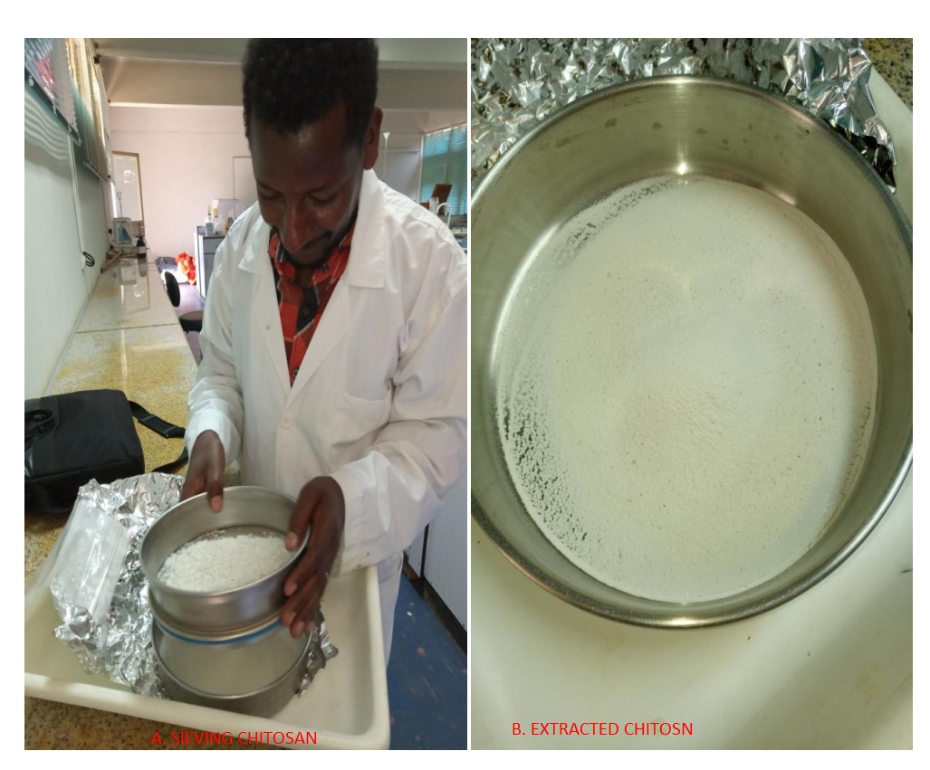
Figure A_{e}. Sieving of extracted chitosan after grinding

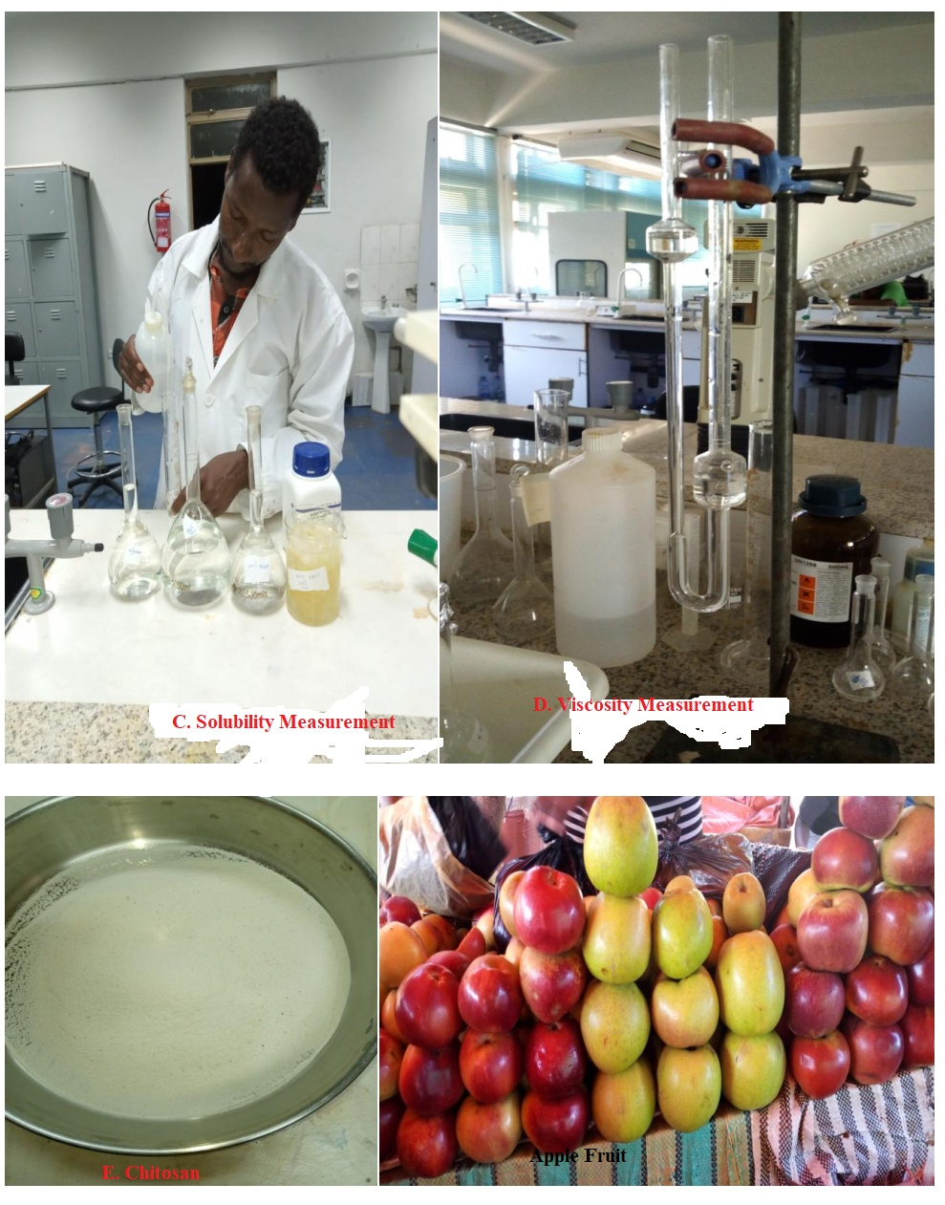
Figure A_{f}. and A_{g} representing chitosan solubility and viscosity testing
Figure A_{h} representing prepared chitosan and apple fruit for evaluation chitosan ability
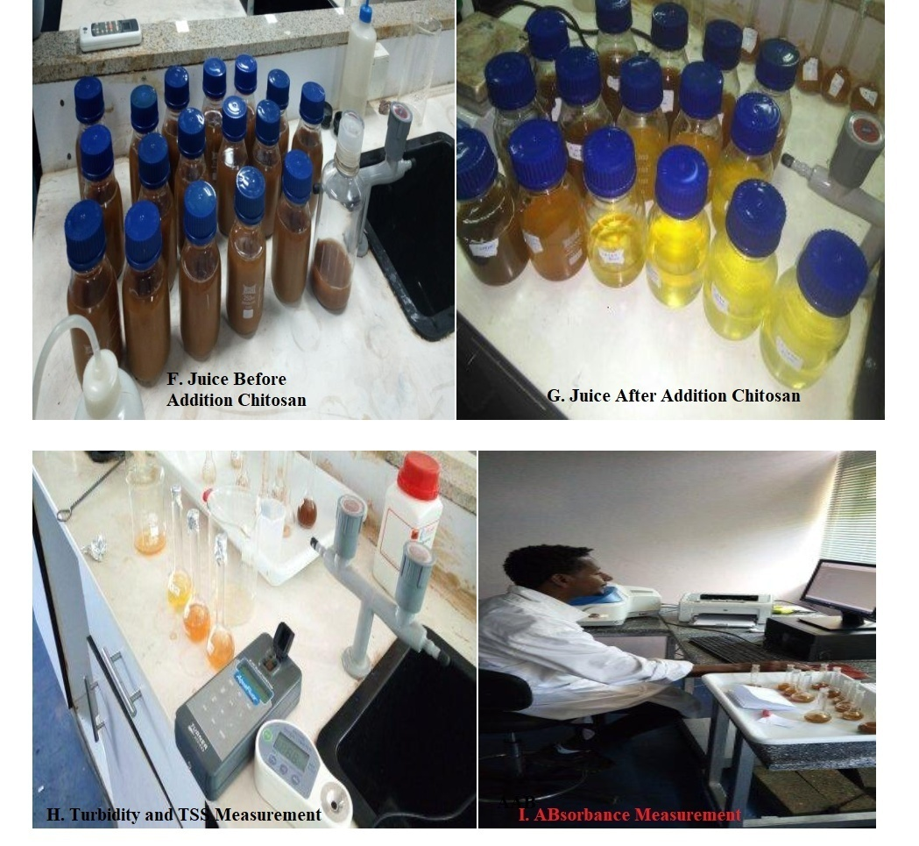
Figure A_{i} – A_{j} representing the evaluation of chitosan capacity during apple juice clarification
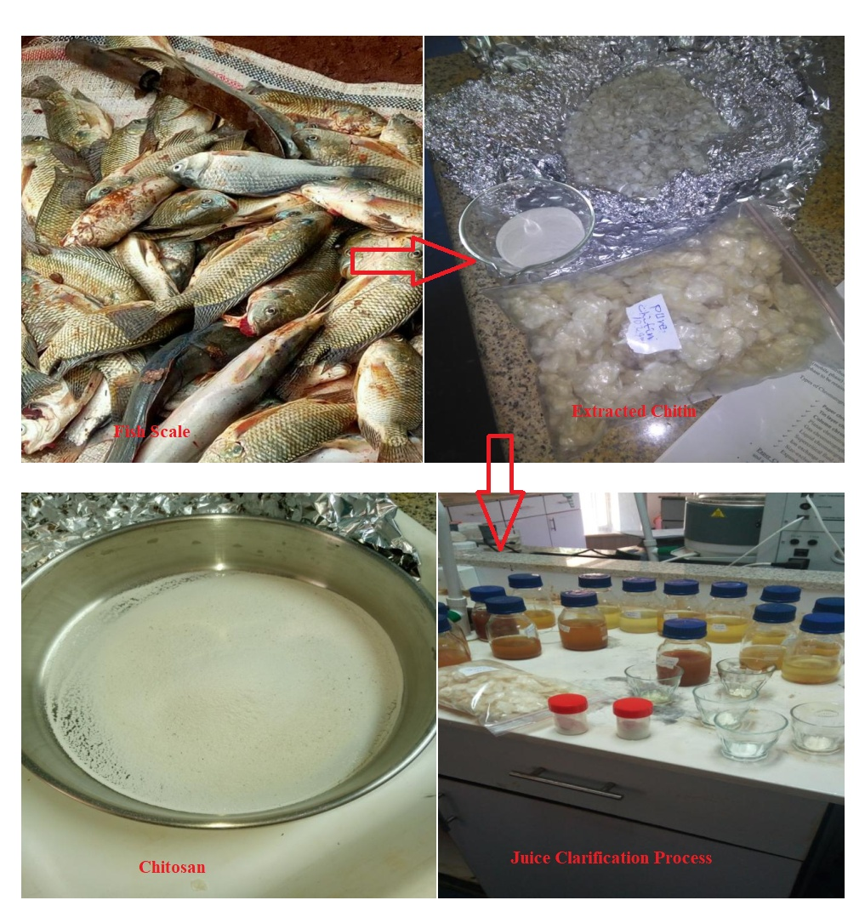Figure A_{k} Samples for testing extraction of chitosan from fish scale waste to juice clarification process
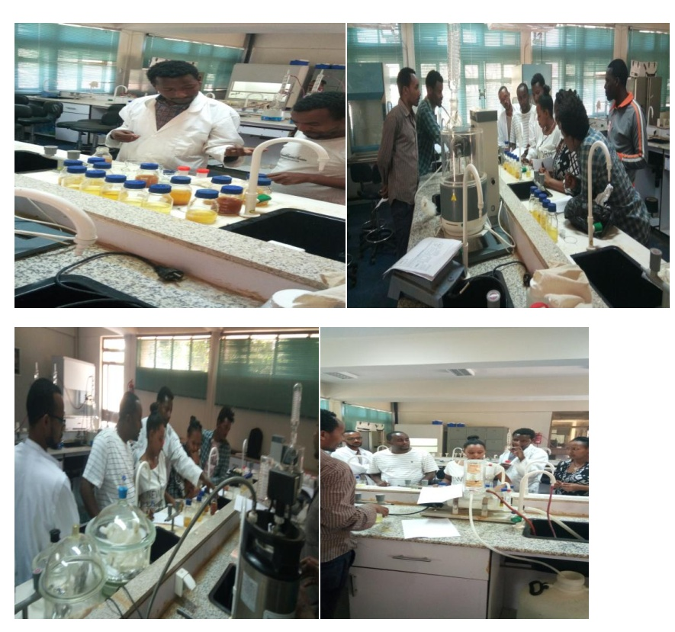Figure A_{l.} Explaining about sensory evaluation for participants before sensory quality evaluation of juice

APPENDIX M: HEDONIC RATING TEST
EVALUATION FOR SENSORY QUALITY OF CHITOSAN CLARIFIED APPLE JUICE

You are provided with the coded sample of chitosan clarified apple juice; kindly record your sensory perception on 5-point scale given below on the basis of colour, taste, aroma, appearance and overall acceptability.
Name of the Panelist -------------------------------------------- Date ---------------------------------
Product Name -------------------------------------------
Sample Code -------------------------------------

5 = Like extremely
4 = Like moderately
3 = Neither like nor dislike
2 = Dislike moderately
1 = Dislike extremely
Please evaluate the following samples as per the standard scale given
Table A_{m}: Hedonic Rating Test Parameters
Appearance | Taste | Colour | Aroma | Overall acceptability

Appendix N: Values of K and α found in the literature for the different concentration and solvent systems during determination of molecular weight of the chitosan.
Table A_{n} Values of K and α found in the literature for the different concentration and solvent systems.
Solvent system with different concentration (M) | K (ml/g) | α | References
0.3M CH₃COOH/ 0.1M CH₃COONa | 1.81 × 10⁻³ | 0.93 | [4]
0.2M CH₃COOH/ 0.15M CH₃COONH₄ | 3.64 × 10⁻⁴ | 0.78 | [45]
0.1M CH₃COOH/ 0.2M NaCl | 1.81 × 10⁻³ | 0.93 | [46]
0.25M CH₃COOH/ 0.25M CH₃COONa | 1.57 × 10⁻⁴ | 0.79 | [47]
0.2M CH₃COOH/ 0.1M CH₃COONa | 9.66 × 10⁻⁵ | 0.74 | [61]
At temperature 25 ⁰C.

