ARBA MINCH UNIVERSITY
SCHOOL OF POST GRADUATE STUDIES
COLLEGE OF NATURAL SCIENCES
DEPARTMENT OF BIOLOGY

ASSESSING AWERENESS OF THE COMMUNITY ABOUT THE MOST COMMONLY USED MUSHROOM IN SOUTH OMO ZONE, ETHIOPIA

M.SC THESIS
BY
ENDRIS MENAN

ARBA MINCH, ETHIOPIA
FEBRUARY, 2019

Assessing Awareness of the Community about the Most Commonly Used Mushroom in South Omo Zone, Ethiopia
By
Endris Menan

Advisor
Awoke Guadie (PhD)
A Thesis Submitted to Arba Minch University, School of Post Graduate Studies, College of Natural Sciences, Department of Biology, in Partial Fulfillments of the Requirements for Degree of Master of Science in Biology

February, 2019
Arba Minch, Ethiopia

DECLARATION
I hear by declare that this M.Sc. thesis is my original work and has not beenpresented to award a degree in Arab Minch University or any other University. All sources of material used for this thesis also have been duly acknowledged.
Name: Endris Menan
Signature______________
Date__________________

THESIS SUBMISSION APPROVAL SHEET
SCHOOL OF POST GRADUATE STUDIES
ARBA MINCH UNIVERSITY
ADVISORS’ THESIS SUBMISSION APPROVAL SHEET
This is to certify that the thesis entitled “Assessing Awareness of the Community aboutthe Most Commonly Used Mushroom in South Omo Zone, Ethiopia” submitted in partial fulfillments of the requirements for the degree of Master’s with specialization in Biology to the Post Graduate program of the Department of Biology by Endris Menan Id. No SMSc/029/05undermysupervision. Therefore, I recommended that the student has fulfilled the requirements and hence here by can submit the thesis to the department for defense.

Awoke Guadie (PhD) ________________ _____________
Name of principal Advisor Signature Date

EXAMINERS’ THESIS APPROVAL SHEET
We, the undersigned, members of the Board of Examiners of the final open defense by Endris Menan have read and evaluated his thesis entitled with “Assessing Awareness of the Community about the Most Commonly Used Mushroom in South Omo Zone, Ethiopia” and examined the candidate’s oral presentation. This is, therefore, to certify that the thesis has been accepted in partial fulfillment of the requirements for master’s degree in Biology. Thesis assessment Board
1. Chairperson Signature Date
__________________________ ______________ _______________
2. Internal examiner Signature Date
_________________________ ______________ _______________
3. External examiner Signature Date
_________________________ _______________ _______________
4. Advisor Signature Date
_________________________ ________________ ____________

ACKNOWLEDGEMENT
First and foremost, I would like to express my deepest gratitude to my advisor Dr. Awoke Guadie for his technical support, professional guidance and counseling, useful advice, constructive comments and encouragement from title selection up to detailed analysis and completion of my research paper.
I would also like to acknowledge Arba Minch University for giving the opportunity to study this Master Program and providing financial support to conduct this research. My thanks also goes to all teachers in Biology Department sharing their knowledge and showing love during offering courses.
I would like to give special thanks to my colleagues Mr. Shamena Kansa and Mr. Temesgen Gello who have helped and given material, technical and moral support throughout this research.
Thanks to my sister Mrs. Masresha Setegen and to my family who have given me a lot of support, encouragement and moral support throughout whenever faces failure in this research.
Lastly, my great gratitude also goes to AtoShawki Maki and all the respondents actively participated by giving relevant and sufficient information during mushroom assessment, identification and sharing their experience and knowledge in conducting my research work.

ABBREVIATIONS
AIDS Acquired Immune Deficiency Syndrome
DVDaily Value
FAO Food and Agricultural Organization
HIV Human Immunodeficiency Virus
UV Ultraviolet
WEM Wild Edible Mushroom

ABSTRACT
Wild mushroom are known to have essential compounds and functional substances and have been used that have as food and medicinal value. However, advancement in research on mushroom consumption and production is relatively very low in comparison to other crops, particularly in the study area. Therefore, this study has aimed to assess the most commonly used mushroom in South Omo Zone, Ethiopia. After a reconnaissance survey has been done in the three districts of South Omo Zone, eleven sites were selected. From the selected sites,384 participants were randomly selected and involved in the study. During field observation, digital camera was used to take photos of wild mushrooms for comparing with photo of mushroom in the identification guide. The length of mycelium and stalk, the diameter of the stalk and cap of mushrooms were also measured for identification purpose. Field observation and assessment of secondary data were also used to collect data. The data were analyzed using Statistical Package for the Social Sciences (SPSS) and results were expressed using qualitative and quantitative terms. In the study area, there are five types of wild mushrooms identified. The four types of mushroom, which are locally known as Warez (Type-1), Maa (Type-2), Bista (Type-3) and Pella (Type-4), were taxonomically grouped in to two families. Types-1 to 3 classified under family Lyophyllacae while Type-4 under family Russulacae. Among the wild edible mushrooms,Type-1 (Termitomyces sp.) is the most preferred (first ranked) mushroom type in the community. Most (58%) respondents said that Termitomycessp. (Type-1) best growaround termite mound. Respondents well recognized the edible wild mushroom (67-77%) from non-edible wild much room type. Among most commonly grown mushroom Type-5, which is locally known as Morri, has been well-recognized (92%) by the respondents as toxic mushroom type that is not eaten. There is a statistical significant difference (p<0.05) among respondents age, sex, educational level and income on the indigenous knowledge of wild mushroom growth season, collection, identifying health effect, habit of eating and distribution. Overall, five mushroom types were identified in the study area, of which Types-1 to 4 have been edible while Type-5 non-edible
Keywords/phrases: Edible mushroom, Indigenous knowledge, Non-edible mushrooms, South Omo, Wild mushrooms

Table of Contents
Contents page
ACKNOWLEDGEMENT-------------------------------------------------------------------------------- vi
Table of Contents--------------------------------------------------------------------------------- ix
1. INTRODUCTION---------------------------------------------------------------------------------------- 1
1.1 Background of the study------------------------------------------------------------------------- 1
1.2. Objectives of the study--------------------------------------------------------------------------- 3
1.2.1. General objective of the study----------------------------------------------------------------- 3
1.2.2. Specific objectives of the study---------------------------------------------------------------- 3
2. LITERATURE REVIEW--------------------------------------------------------------------------------- 4
2.1. General characteristics of mushrooms------------------------------------------------------ 4
2.2. Ecology of mushrooms---------------------------------------------------------------------------- 6
2.3.Reproduction and growth------------------------------------------------------------------------ 7
2.4. Important uses of mushrooms------------------------------------------------------------------- 8
2.4.1. Nutritional uses of mushrooms---------------------------------------------------------------- 9
2.4.2 Medicinal uses of mushrooms----------------------------------------------------------------- 11
2.4.3. Economic importance of mushrooms-------------------------------------------------------- 14
2.5. Distribution of mushrooms--------------------------------------------------------------------- 15
2.5.1. Mushroom status in the world---------------------------------------------------------------- 15
2.5.2. Mushroom status in Africa-------------------------------------------------------------------- 16
2.5.3. Mushroom status in Ethiopia----------------------------------------------------------------- 17
3. MATERIALS AND METHODS----------------------------------------------------------------------- 18
3.1. Description of the study area----------------------------------------------------------------- 18
3.2. Data Collection Techniques-------------------------------------------------------------- 19
3.2.1. Sample size determination-------------------------------------------------------------------- 19
3.2.2. Primary and secondary data collection methods------------------------------------------- 21
3.3. Identification and selection techniques--------------------------------------------------- 23
3.4. Ethical Consideration--------------------------------------------------------------------------- 23
3.5. Statistical data analysis----------------------------------------------------------------------- 23
4. RESULTS AND DISCUSSION------------------------------------------------------------------------ 24
4.1. Socio-demographic characteristics of the study participants----------------------- 24
4.2. The growth season and ecology of wild mushroom------------------------------------- 26
4.3. Sample collection and identification------------------------------------------------------- 27
4.4. Ethnomycological data of wild mushroom----------------------------------------------- 30
4.5. Wild mushroom collection and utilization practice in the study area----------- 35
4.6. Preparing wild mushrooms for meal--------------------------------------------------------- 37
4.7. Preferential ranking---------------------------------------------------------------------------- 39
4.8. Indigenous knowledge transfer and conservation practice------------------------- 40
4.9. Marketability of wild edible mushroom--------------------------------------------------- 41
5. CONCLUSION AND RECOMMENDATIONS-------------------------------------------------- 42
5.1. Conclusion------------------------------------------------------------------------------------------ 42
5.2. Recommendations--------------------------------------------------------------------------------- 43
REFERENCE------------------------------------------------------------------------------------------------ 44
APPENDIXES-----------------------------------------------------------------------------------------------52

List of Tables
Table 1: Nutritional values of mushroom per 100g----------------------------------------------------10
Table 2: Some chemical compounds extracted from mushroom-------------------------------------15
Table 3: Sex and age distribution of the study participants-------------------------------------------22
Table 4: Socio demographic characteristics of the study participants-------------------------------26
Table 5: Seasonal growth of different mushroom------------------------------------------------------27
Table 6: Some of the descriptive characteristics of mushrooms--------------------------------------29
Table7:Statistical test significance of study participant with ethnomycological uses of mushroom-----------------------------------------------------------------------------------------------------33
Table 8: Proportion of informant groups that involve in wild edible mushroom collection------38
Table 9: The preference rank of wild edible mushroom-----------------------------------------------40

List of Figures
Figure 1: The structure of mushroom----------------------------------------------------------------------4
Figure 2: The life cycle of mushroom---------------------------------------------------------------------8
Figure 3: Edible mushroom, Pleurotus ostreatus (Oyster mushroom)-------------------------------10
Figure 4: Toxic mushroom (Amanita muscariaand Amanita phalloides)---------------------------11
Figure 5: Medicinal mushrooms (a) Ganoderma lucidum and (b) Agaricus bisporus-------------12
Figure 6: Map of the study area---------------------------------------------------------------------------19
Figure 7: Overall route of this study----------------------------------------------------------------------20
Figure 8: Photos taken during field observation--------------------------------------------------------22
Figure 9: The ecology of mushroom distribution recognized by respondents----------------------27
Figure 10: Edible and non-edible mushroom recognized by respondents---------------------------29
Figure 11: Gender difference in mushroom collection and utilization-------------------------------35
Figure 12: Termitomyces collected for cooking--------------------------------------------------------38
Figure 13: Source of ethnomycological knowledge in the community------------------------------40
Figure 14: Factors affecting the availability and distribution of wild edible mushroom reported by respondents------------------------------------------------------------------------------------------------41

List of Appendixes
Appendix 1-Research questions and Interview----------------------------------------------------------52
Appendtx 2-Potographs illustrating study sites and field observation--------------------------------56
Appendix 3-Photographs illustrating interview of key informants------------------------------------57
Appendix 4-Photographs illustrating some common mushroom collected--------------------------58
Appendix 5-Photographs illustrating mushroom preparation------------------------------------------59

1. INTRODUCTION

1.1 Background of the study
Mushrooms can provide balanced diet in sufficient quantities for human nutrition and medicinal value. Mushrooms have been cultivated since ancient times for their nutritional value and flavor especially in the far eastern countries (Anon, 1889). They are highly nutritious and environment friendly crops that carry numerous medicinal benefits(Buswell et al., 1996).
They are rich in crude fiber and proteins. Compared with animals, the protein found in mushrooms is less but much more than in most plants. Mushroom also have low fat content, all essential amino acids and all minerals (Sadler, 2003).Compared with vegetables, mushrooms are good sources of many mineral elements such as phosphorus, zinc, selenium and copper(Caglarirmak, 2005). On exposure to ultraviolet light, mushrooms also produce large amounts of vitamin D, which is normally difficult to obtain from a regular diet intake. According to Caglarirmak (2005), mushroom can be a good alternative foodstuff with especially balanced health nutrition for a person who has low income. This low cost mushroom not only packed with nutrients, but also has therapeutic properties towards cancer, Human Immune deficiency Virus-1 (HIV)/ Acquired Immune Deficiency Syndrome (AIDS), and numerous other diseases (Beelman et al., 2003). Mushrooms are also low in sodium and high in glutamate, which make them a useful flavor in addition to a low salt diet. As they are low in energy values (kilojoules), they are also ideal for incorporation in weight loss program.
Mushroom production is economically important that can contribute to the economy in terms of nutritional value. Economic levels of societies affect their nutritional levels. Soylu et al, (2010) studied the economic aspects of edible mushrooms grown in Turkey.Mushroom production that started in 1960’s in Turkey gained economic value for the 1990’s and it started improving as a commercial sector after that time. While Turkey mushroom production was 80 tons in 1973, it increased up to 45,000 tons in 2014. There are a rapid changes and improvement in cultivated mushroom production and consumption in Turkey. Furthermore, other African countries i.e. Cameroon and Benin started to generate the local income through mushroom cultivation (Djik et al., 2003).
In the world, mushrooms are considered as delicious and nutraceutical food for the human health, however, it is not yet disseminated or properly utilized in Ethiopia (Teferi et al., 2013). Its cultivation and exploration method in Ethiopia has been scarcelyreported. There are few reports about mushroom cultivation in Ethiopia that has been started decade ago using Oyster mushroom (Pleurotus ostreatus) followed by button mushroom (Agaricus sp.) and shiitake mushroom (Lentinus sp.)(Abate, 1995, 1998).Reports also showed that mushrooms have been used as food by the Majangir tribe and Wacha inhabitants in Southwestern Ethiopia (Tuno, 2001; Teferi et al., 2013).There are still some gaps in identifying, training and awareness programs to the farmers regarding mushroom (Teferi et al., 2013).
There is a wide scope to study wild mushroom taxonomy and ecological diversity in Ethiopia. Few reports suggest there are potential to have a wide variety of mushroom in the country. Hjortstam and Ryvarden (1996) identified fifteen species of Corticiaceae including Diplomitoporus rimosus and, Physisporinus rivulosus as new report to Africa and Mycoacia brunneofusca, Vuilleminia obducens as new species to the world. Agaricus campestris(Abate,1999)and Dictyophora indusiata, Schizophyllum commune and Lentinus sp. (Tuno, 2001) were reported in Ethiopia. Three (Termitomyces clypeatus, T. microcarpus and Laetiporus sulphureus), four (including two new species of Fomitiporia to the world) and seven (Trametes versicolor, Gyromitra sp., Pycnoporus sp., Agaricus avensis, A. campestris, Schizophyllum commune, and Clitocybenuda) wild mushrooms were also identified in Ethiopia by Teferiet al (2013), Decock et al.(2005) and Fikadu(2013), respectively. The recent study on mushroom collection and identification from Jinka (Awoke, G.unpublished) highlights the potential of termite mounds and the forests to grow wild mushrooms in Ethiopia.
There is scope to establish industries of different mushroom species cultivation in Ethiopia. DXN, a leading company of preparing different kinds of Ganoderma products has taken in initiative to establish mushroom farm near Lake Shalla with initial investment of 285 million Ethiopian birr to the business opportunity in Ethiopia (Dijk et al., 2003). It could certainly help to create job opportunity to the local people so that they may start their own business to fulfill the rising demand of Ganoderma products in the world.
Mushroom is an economical crop to cultivate, requiring cheap resources and small area and can be grown throughout the world all over the year with tremendouspotential to ensure alternative healthy nutrition (Beetz and Kustudia, 2004). The community collects wild edible mushrooms that contribute to supplement their nutritional requirement in traditional way. Thus, the purpose of this study was to assess the distribution and indigenous knowledge of mushroom in four district communities of South Omo Zone, Ethiopia.
Accordingly, this study attempted to seek answers to the following questions:
- What types of wild mushrooms are available in your locality?
- What important benefits to people supposed to get from eating mushrooms?
- Does the community have indigenous knowledge about wildedibleand non-ediblemushroom?
- Howto improve theconsumptionhabits of mushrooms in the study area?

1.2. Objectives of the study

1.2.1. General objective of the study

This studywas aimed at assessingawareness of the community about the most commonly used mushroom in South Omo Zone, Ethiopia

1.2.2. Specific objectives of the study
- Collectwild edible and non-edible mushrooms from the study area
- Identifythe different types ofmushrooms collected from the three districts
- Identify the best edible mushroom in the study area
- Assessthe indigenous knowledge of the communityassociated withwild mushrooms

2. LITERATURE REVIEW

2.1. General characteristics of mushrooms
Broadly, mushrooms are macro fungi with a distinct fruiting body, whichmay be found above the ground or underground. They grow large enough, can easily recognize with the naked eye, and can be picked by hand (Chang and Miles, 2004). What underscores edibility of mushroom is the absence of poisonous effects on humans and desirable taste and aroma (Arora, 1996). The structure of mushroom is composed of different parts (Figure 1).
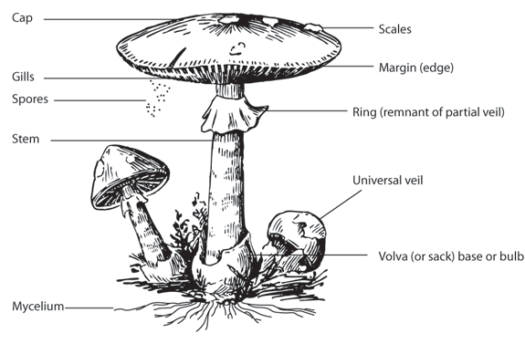
Figure 1: The structure of mushrooms
The term stipe is referring to the mushroom’s stem like structure. The stipe may have a variety of characteristics depending on the mushrooms species. The stipe of some mushroom hasannulus, or ring, which is a remnant of the partial veil that covered the cap underside, gills as the mushroom developed. At the lower surface the cap numerous plate like radiating structures which extend from the stipe are present (Liang et al. 2011).
Since mushrooms are not plants, they do not have roots. Their tissue is made of extensive networks of fine threads called hyphae, with a single thread being a hypha. Mycologists use the term mycelium to describe an entire network of hyphae (Kuo, 2006). Mycelia threads or hyphae extending from the mushroom’s base, anchor the mushroom and to connect it to its nutrient and water supplies. An individual mycelium can grow quite large, with at least one well-documented case covering more than 1,500 acres in Oregon (Volk, 2002).
A volva is a ruptured, sack-like covering at the base of the mushroom’s stem. The volva results from the mushroom pushing through the universal veil, which covers young buttons to protect them. Many species of Amanitaincluding some of the deadliest mushrooms on the earth have volvas, as do mushrooms in Volvariella and some other mushrooms. Because the deadly Amanitas have vulvas, it is essential for beginning mushrooms to learn how to recognize this feature. Sometimes, vulva is buried and they are not always as prominent as they are in a typical Amanita phalloidesorVolvariella speciosaso and someone should be sure to dig out the base of the mushrooms (Kuo, 2006).
A “universal veil” is a tissue enclosing the entire button mushroom. It serves to protect the immature mushroom, and makes it look rather like an egg. When sliced in cross section, button mushrooms encased in universal veils reveal the mushroom to be inside (which is why those who eat Puffballs should always slice them open to make sure they are not poisonous Amanitas).Many mushrooms display a universal veil, including Amanita species like Amanita muscaria, Volvariella species.
Rings are extremely variable, ranging from ephemeral and quickly disintegrating to sturdy and prominent. The type of ring a mushroom has frequently a key determiner of its identity. Some mushrooms, like the parasol mushroom, have rings that are separable from the stem and can make to slide up and down(Kuo, 2006).The shape of a ring can also help identify some mushrooms; rings may be sheath like, skirt like, or intermediate. Additionally, the position of the ring can be important.
Gills, known as lamellae are plate like structures arranged on the underside of mushroom’s cap. The common button mushroom sold in grocery stores is a gilled mushroom, through it is usually sold in the button stage when the partial veil is still covering the gills. Gills are covered with microscopic basidia, which hold the mushroom’s spores. Close observation of the gills is one of the most important steps in identifying gilled mushroom. Their colors are important, and may change as the mushroom matures (Kuo, 2006).
Spore characteristics are among the macroscopic key feature that mycologist’s observe when identifying mushrooms (Arora, 1986). Their color, shape, size, attachment, ornamentation, and reaction to chemical tests often can be the crux of identification. A spore often has a protrusion at one end, called an apiculus, which is the point of attachment to the basidia, termed the apical germ pore, from which the hyphae emerges when the spore germinates(Ammirats et al., 1985).
At the microscopic level, the basidiospores are shot off basidia and then fall between the gills in the dead air space. As a result, for most mushrooms, if the cap is cutoff and placed gill-side-down overnight, a powdery impression reflecting the shape of the gills (or pores, or spines) formed (when the fruit body is sporulating). The color of the powdery print, called a spore print, is used to help classifying mushrooms, and can help to identify them. Spore print colors include white (most common), brown, black, purple brown, pink, yellow, and creamy, but almost never blue, green, or red (Dickinson and Lucas, 1982).
While modern identification of mushroom is quickly becoming molecular, the standard methods for identification are still used by most and have developed in to a fine art harking back to medieval times and the Victorian era, combined with microscopic examination. The presence of juices up on breaking, bruising reactions, odors, tastes, both amateur and professional mycologists consider all shades of color, habitats, habit, and season. Tasting and smelling mushrooms carries their own hazards because of poisons and allergens (Kilvikko, 1988).
Chemical tests are also used for some genera (Ammirati et al., 1985).In general, identification to genus can often be accomplished in the field using a local mushroom guide. Identification to species, however, requires more effort; one must remember that a mushroom develops from a button stage in to a mature structure, and only the later can provide certain characteristics needed for the identification of the species. However, over mature specimens lose features and cease producing spores.

2.2. Ecology of mushrooms
A mushroom grows on a vast number of substrates and environmental conditions. It includes terrestrial (e.g., Agaricus, Amanita, Russula, Tricholoma, Boletes, and Cantharellus), cattle dung (Coprinus, Paneolus, Psathyrella, Stropharia), below ground (Truffles), on insects (Cordyceps), on tree trunks (Ganoderma, Pluteus, Volvariella, Pleurotus, Bolbitous, Pholiota), even on mushroom fruit body (Asterophora)(Mike, 1999). Since mushrooms lack the vascular system of plants to transport water and nutrients, they must grow in damp environments.
Mushrooms are the visible, above the ground extensions of much larger underground network of fungal tissue that absorbs nutrients directly from the surrounding soil. The exterior surface of fungus or hyphae is analogous to the interior surface of an animal stomach. It secretes digestive enzymes and absorbs the resulting chemical soup directly. It decomposes leaf litter, dead wood and ally of more than 85% plants as they form mycorrhizal association with tree roots (Kirk et al., 2008). In this, symbiotic relationships both are mutually benefited.
Mushrooms are parasitic; consume the living tissues of other organisms, sometimes killing them in the process. Parasitism is common among mushrooms, and most famously demonstrated in Boletus parasiticus that attacks the fungus Scleroderma citrinum. Other parasites include species of Hypomyces, which parasitize mushrooms, and the Honey mushroom, which attacks trees and is a constant concern in forest management (Kuo, 2006).

2.3.Reproduction and growth

Just as flowering plants produce pollen or seeds, mushrooms generate spores. A single mature mushroom can create up to trillions of individual spores, which manifests as the fine dark dust coating the gills or emanating from puffballs. Most mushrooms come from one of two phyla, Basidiomycetes or Ascomycota which are producing two types of spore called basidiaand asci, respectively (Mike, 1999).The main distinction between these is the manner in which their respective spores develop. In asci, the spores are fully contained within the outer covering. When the spores mature, the tip of the ascus breaks open and the spores are released. In basidia, the spores are produced externally. The spores are released when they break off.
A mushroom’s life cycle consists of sporulation, mycelium growth, mushroom primordial and growth into a mature mushroom (Figure 2) (Johnson, 1995). Adult mushrooms produce spores and release them into the air. This is known as sporulation. The spore is carried by the wind and land on a hospitable growing environment. The environment can be soil, manure, or even debris from other plants. They germinate and start to produce mycelium in the soil. The mycelia grow toward the surface and form the mushroom primordial. At this stage, it resembles a small mushroom with a casing called the universal veil. The mushroom grows, breaks the universal veil and becomes a mature mushroom. The mature mushroom produces its own spores, and the process repeats itself.
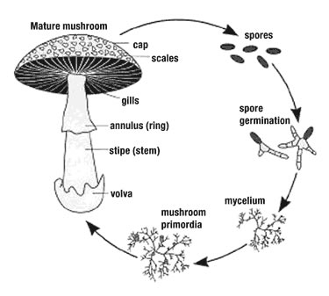
Figure 2: The life cycle of mushrooms

Many species of mushrooms seemingly appear overnight, growing, or expanding rapidly (Venturella, et al. 2016). This phenomenon is the source of several common expressions in the English language including ‘mushrooming’ (expanding rapidly in size or scope) and ‘to pop up like a mushroom’ (to appear unexpectedly and quickly). In reality, all species of mushrooms take several days to form primordial mushroom fruit bodies, though they do expand rapidly by the absorption of fluids.
Though mushroom fruiting bodies are short lived, the underlying mycelium can itself be long-lived and massive. A colony of Armillaria solidipes (formerly known as Armillariaostoyae) in Malheur National Forest in the United States is estimated to be 2,400 years old, possibly older, and spans an estimated 2,200 acres (8.9 km). It has been suggested thatthe electrical stimulus of a lightning bolt striking mycelia in logs accelerates the production of mushroom (Lee, 2005).

2.4. Important uses of mushrooms
Mushrooms have long been used as a valuable food source and as traditional medicines around the world, especially in Japan and China. Records of health promoting properties such as antioxidant, antimicrobial, anticancer, cholesterol lowering, and immune-stimulatory effects have been reported for some species of mushrooms (Anderson and Stasovsk, 1992; Mau et al., 2004; Soylu et al., 2010).

2.4.1. Nutritional uses of mushrooms
Mushrooms have been used extensively in cooking, in some countries including China, Korea, some European, and Japan. They areknown as the ‘meat’ of the vegetable world (Caglarirmak, 2011; Heas and James, 2009). People who collect mushrooms for consumption are known as mycophagists (Metzler and Metzler, 1992), and the act of collecting them for such purpose is known as mushroom hunting or simply ‘mushrooming’.
Mushrooms with their flavor, texture, nutritional value, and high productivity per unit area have been identified as an excellent food source to alleviate malnutrition in developing countries (Eswaran and Ramabadran, 2000).Mushrooms are low in calorific value but rank very high for their vitamins, minerals, and protein contents (Beetz and Greer, 1999).As shown in Table 1, in a 100gram serving food, mushrooms are an excellent source (higher than 20% of the daily value, DV) of B vitamins, such as riboflavin and pantothenic acid, an excellent source of the essential minerals, selenium (37% DV) and copper (25% DV), and a good source (10-19% DV) of phosphorous and potassium.
Table 1: Nutritional values of mushroom per 100g
Nutrients | Unites |  | Content per 100g
Carbohydrates | gram |  | 4.3
Fats | gram |  | 0.1
Proteins | gram |  | 2.5
Thiamine (B1) | mg |  | 0.1
Riboflavin (B2) | mg |  | 0.5
Niacin (B3) | mg |  | 3.8
Pantothenic acid | mg |  | 1.5
Calcium | mg |  | 18.0
Phosphorous | mg |  | 120.0
Potassium | mg |  | 448.0
Zinc | mg |  | 1.1

Some mushroom contains a number of valuable nutrients including proteins, enzymes, B-vitamins (especially niacin), and vitamin D2. When exposed to ultraviolet (UV) light even after harvesting (Kalama et al., 2012) natural ergosterolin mushrooms produce vitamin D (Koyyalamudiet al., 2009), a process now used to supply fresh vitamin D mushrooms for the functional food grocery market. In a comprehensive safety assessment of producing vitamin D in fresh mushrooms, researcher showed that artificial UV light technologies were equally effective for vitamin D production as in mushrooms exposed to natural sunlight and that UV light as a long record of safe use for production of vitamin D in food (Simon et al., 2013).
Edible mushrooms, like Pleurotusare known to be among the largest of fungus (Onuoha, 2007).Pleurotus ostreatus (Figure 3) is an edible mushroom having excellent flavor and taste (Shah et al., 2004). This fungus is appreciated because of its delicious taste, it has high quantities of proteins, carbohydrates, minerals (calcium, phosphorous), and vitamins (thiamin, riboflavin and niacin) as well as low fat (Justo et al., 1998; Manziet al., 1999).
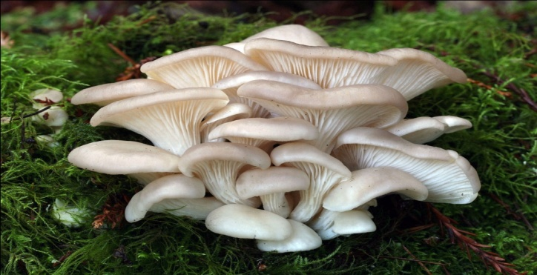
Figure 3: Edible mushroom, Pleurotus ostreatus (Oyster mushroom)
In general, mushrooms are highly nutritious, their taste and delightful aroma makes them one of the delicious preferred foods in restaurants throughout the world (Chang and Mshigneic, 2000). The high nutritional value of mushroom is due to the presence of eight essential amino acids, polyunsaturated fatty acids (linoleic and arachidonic acids) and reduced quantities of saturated fatty acids (Fortes et al., 2006). Hence, eating mushroom is recommended for diabetics and high cholesterol patients (Mshigneic and Chang, 2000). Edible mushrooms are also highly recommended by the FAO as food, contributing to the protein nutrition of developing countries who are dependent largely on cereals.
As do edible mushroom have many important advantages, there are also mushrooms that are toxic when eaten (Turhan et al., 2007). A number of species of mushrooms are poisonous; although some resemble certain edible species, consuming them could be fatal. Eating mushrooms gathered in the wild is risk and should be only undertaken by individuals knowledgeable in mushroom identification. Common best practice is for wild mushroom pickers to focus on collecting a small number of visually distinctive, edible mushroom species that cannot be easily confused with poisonous varieties. Agaricus bisporus contains carcinogens called hydrazine, the most abundant of which is agaritine. However, the carcinogens are destroyed by moderate heat when heating (Sieger, 1998).
The deadly poisonous mushrooms belongs to genus Amanita particularly Amanita muscaria and Amanita phalloides (Figure 4). These contain endotoxins (toxic substance found inside the mushroom) i.e., phallotoxins and Amatoxins. Phallotoxins causes abdominal pain, muscular cramping, and renal failure followed by death (Mike, 1999). Amatoxins has also same effects with failure of lever damage in kidney, irritation in respiratory tract followed by shortness of breath and dizziness (Wasson, 1968). Some other species viz. Galerina autumnalis, Conocybe filaris also produce same deadly toxins.
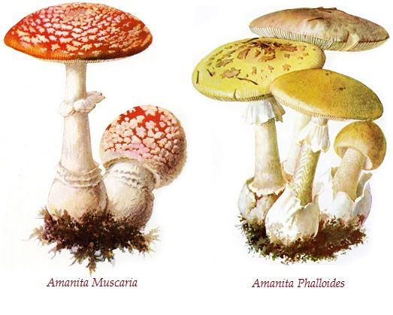
Figure 4: Toxic mushroom (Amanita muscaria and Amanita phalloides)

2.4.2Medicinal uses of mushrooms
Many mushrooms have been used as medicine in different ethnic cultures of the world. Some of the medicinal use of mushroom includes prevention of heart attacks, cancers and tumors (Chang, 1995; Liu and Chang, 1995). Mushrooms contain chemical compounds that are responsible to cure viral infections, bacterial diseases and fungal diseases. It also decreases blood cholesterol and high blood sugar (Mshigenic and Chang, 2000).For instance, Ganoderma (Figure 5a), known as a magic herbal medicine in traditional Chinese medicinewith no side effect, even after consuming for a long time. It increases body healing ability, and provide a long life (anti-aging and vitality). It also has different bioactive molecules that have Anti-cancer activity (Cheung, 1996; Lo et al., 2005). Lentinus edodes (shiitake), Inonotus obliquus (chaga) also have been collected and used for hundreds of years in Korea, China, Japan and eastern Russia (Wasser and Weis, 2009; Ying et al., 1987).
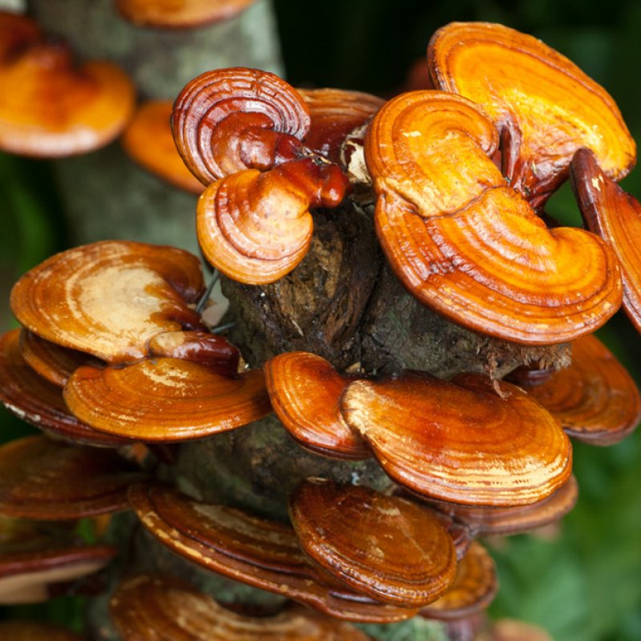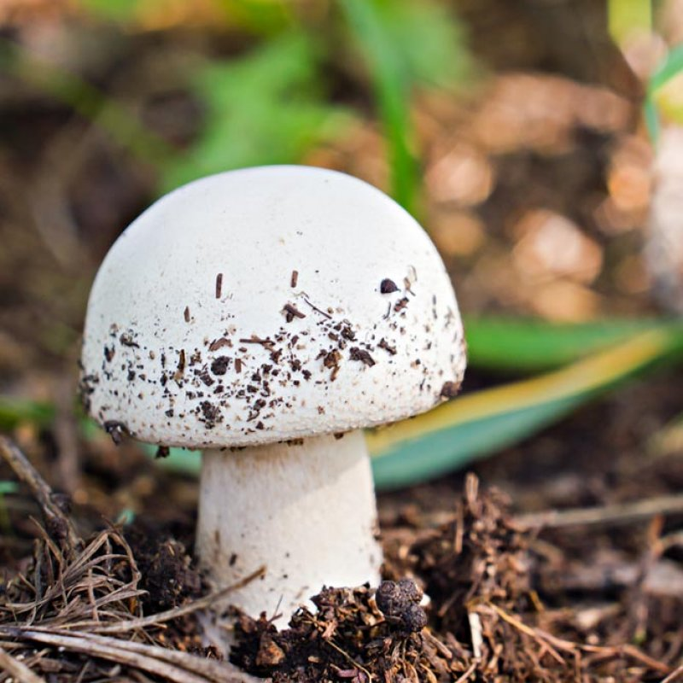
b
a
Figure 5: Medicinal mushrooms (a) Ganoderma lucidum and (b) Agaricus bisporus

Agaricus bisporus (Figure 5b) mushroom research has suggested that it has anti-carcinogenic effects for breast and prostate cancer (Caglarirmak, 2005). It has been found to restrain the activity of aromataste, an enzyme involved in estrogen production and 5-alpha-reductase, an enzyme that converts testosterone to dihydrotestosterone (Cheung, 1996; Lo et al., 2005).
Shiitake mushroom contains lentinan, B-glucan which stimulethe immune system and can fight against AIDS and exhibits anti-tumor activity. It has anti-carcinogenic effects because of B-glucan, selenium, or medicinal compounds. Shiitake mushroom also have cardiovascular protective effects. Pleurotussp also contain bioactive compounds that can affect vein system in human body (Caglarirmak, 2005).
Russula spp. (gilled mushroom) and Pycnoporus cinnabarinus are wild mushrooms. Their fruit bodies were screened and possess antibacterial properties in previous work (Fajana et al., 1999). As mushrooms are widely distributed all over the world, some of them have been used in traditional medicine as anti-inflammatory, anti-allergies, hemostatic, diuretic, nourishment, and anti-tumor agents (Koyama et al., 1997). Most of the medicinal extracts from mushrooms are different forms of polysaccharides and all of them are strengtheners of the immune system with little or no side effects (Gaoet al., 1997; Oei, 1996). Another highly prized medicinal mushroom is Caterpillar fungus, which helps in improving body immunity; reduce stress, helps in relieving nervous tension and mild anxiety (Jiang and Gao, 1995).
Briefly, mushroom intake is a promise to human body to keep in healthier and live longer. Some mushroom materials, including polysaccharides, and proteoglycans are under basic research for their potential to modulate immune system responses and inhibit tumor growth (Borchers et al., 2008). Whereas other isolates show potential antiviral, antibacterial, anti-parasitic, anti-inflammatory, and anti-diabetic properties in preliminary studies (Lull et al., 2005).
There are various chemical compounds found in mushrooms that reportedly have medicinal uses and benefits. Some of the chemical compounds extracted from mushrooms are summarizedin Table 2.The liquid component of Agaricus contains a compound with anti-tumor activity thatwas later identified as Ergosterol (Takaku et al., 2001).Similarly, the liquid fraction of Grifola exhibits anti-oxidant activity and inhibits enzymes that cause many chronic diseases including cancer (Inoue et al., 2002).The mushroom constituents not only inhibit progression of the disease by exerting direct cytotoxicity against tumor cells (Chang, 1996), but also unregulated other non-immune suppressing mechanisms.
These constituents are beneficial even in some established tumors (Bener et al., 2003) and isolates from mushroom cells have cytostatic compounds that induce apoptosis in leukemia cells.The chemicals produced by species of Ganoderma have antibacterial properties ((El-Mekkawy et al., 1998; Smania et al., 1999; Tchimura et al., 1998) and have been shown to inhibit the growth of bacteria such as Staphylococcus (Mothana et al., 2000). Steroids isolated from them are active against numerous Gram-negative and Gram-positive microorganisms (Kuznetsov et al., 2005). The mycelia extracts from Lentinula produce anti-protozoan activities against paramecium (Badalyan, 2004).

Table 2: Some chemical compounds extracted from mushroom

Chemical compounds | Extracted from | Properties
Peptide glycans | Lentinus,Schizophyllum,Grifola,Sclerotinia | Anti-tumor
Ergosterol | Agaricusblazei | Anti-tumor
Lipid fraction | Grifolas | Anti-oxidant
Steroids, hydroquinone | Ganodermaprfifferi | Anti-bacterial
Oxalic acid | Lentinula edodes | Anti-protozoan
Schizophyllan | Schizophyllan commune | Anti-tumor
Epicorazin | Podaxispistillaris | Anti-microbial
Ganodric acid | Ganoderma lucidum | Anti-viral (HIV)
Ganodricacid, lucidadiol | Ganoderma sp. | Anti-viral(influ)
Polysaccharides | Trametes versicolor | Anti-viral (HIV)
Velutin | Flammulinavelutipes | Anti-viral (HIV)
Illudins | Ompphalotusolearis | Cytotoxicity
Trierpenes | Ganoderma concinnum | Apoptosis
Polysaccharides | Phellinuslinteus | Anti-angiogenic
Hispolon,hispidin | Indocalamushispidin | Anti-allergic
Ergosterol peroxide | Tricholomapopulinum | Anti-allergic

2.4.3. Economic importance of mushrooms
Mushrooms sold in supermarkets have been commercially grown mushroom in farms. The most popular of these Agaricus bisporusis considered as safe for most people to eat, because it is grown in controlled and sterilized environments. Several varieties of A. bisporu are grown commercially, including white, crimini, and Portobello.
In recent years, increasing affluence in developing countries has led to a considerable growth in interest in mushroom cultivation, which now seen as a potentially important economic activity for small farmers. In some studies, the reported amount of total cultivated mushroom is 40,000-50,000 tones (Anon, 1889). In rural areas, the public collects wild edible mushrooms that contribute to their economy and nutritional levels.

2.5. Distribution of mushrooms

2.5.1. Mushroom status in the world
Mushrooms are known to human beings since immemorialtime and its use as food is as old as civilization. Their references are reported in various ancient treatises including Indian literature Vedas (Wassan, 1968). In China, the civilization of black ear mushroom (Auricularia) was started about one thousand years ago (Chang, 1993).More than 2,000 species composed of 31 genera are identified to be edible from all over the world (Moore, 2005).According to Boa (2004), 1000 species are edible worldwide and in 80 countries fungi are collected for food necessities and sold to economic upliftment.
World production of edible mushrooms is estimated at 14 million tones and their cultivation is centuries old not only for food but has always been used for its medicinal nature or contents (Abate, 1998). Total global production of mushrooms has increased more than tenfold in the past 25 years and the market for mushrooms is growing. The production of mushrooms, therefore, has the potential to generate a significant cash income (Abate, 1998). The common mushrooms collected from nature are species of Astraeus, Auricularia, Calvatia, Cantharellus, Lycoperdon, Morchella, Schizophyllum, Termitomyces andTubers (Purkayastha and Aindrila, 1985).
Globally, mushrooms are traded mostly in processed form. However, lately fresh mushrooms are being preferred over preserved ones in European Union and American countries. Major exporting countries of fresh mushrooms are Netherlands, Poland, Ireland, and Belgium. China is the largest exporter of preserved mushrooms with a market share of 41.82%. Netherlands (25.11%) and Spain (7.37%) are the other major countries. India ranks sixth with a market share of 4.44% (Change and Miles, 2004).The major importing countries of prepared and preserved mushrooms are Germany, UK, USA, and France. Although China (47%) is the major producer of mushrooms, nevertheless maximum portion is consumed by USA (30%) followed by Germany (17%). The market for edible and medicinal mushrooms has been growing over the years especially in Asia, Europe, and North America. The market value of mushroom at USA was $15 billion, which represented 10% of the general market of dietary supplements (Wasser, 2009).

2.5.2. Mushroom status in Africa
In Africa, the knowledge of historical uses of mushroom as food, source of income and small-scale businesses, and the sociological impacts (myth, culture and spiritually) are apparently threatened due to slow ethno-mycological research drive. The poor identification and documentation of edible and medicinal species of mushrooms in many developing nations have created some degrees of inconsistencies in their usages relative to folk medicine practice, food and mythological beliefs (Kesel and Degreef, 2007).
While mushrooms are popular as nutritious food and are becoming an important source of income especially in Africa, their mythological and mystical uses as well as associated knowledge base was increased by civilization. Boa (2004) who reported over 1200 species of macro-fungi used in about 85 different countries of the world for food and medicinal purposes only corroborates this.
Mushrooms have been a well-known and traditional delicacy in the Africa setting. It is a very good dish for nutritious value as well as medicinal functions. They are more nutritious and yet cheaper alternative of meat. For instance, Oyster mushroom has been noted as the most common grown species of mushrooms in Uganda but some farmers have also been exploring the tasty wild species of mushrooms. Most available data are on the nutritional compositions of mushrooms obtained from the wild (Aletor, 1993; Alofeet al., 1996).
Nigeria with unique climatic conditions of tropical rain forest in the south and sub- Saharan condition in the north is a home to diverse species of mushrooms. Those that are common belong to the following species;Termitomyces, Pleurotus, Lentinus, Lenzites, Trameters, Coriolopsis, Ganoderma and Pycnoporus.Presently, in most parts of sub-Saharan Africa, mushrooms provide a low cost alternative source of high quality protein. Ethno-mycological survey of utilization of mushrooms in North Central Nigeria is reveals that most people consume mushroom based on their nutritional (81.7%) and palatability (93.5%) characteristics while only 15.1% utilize mushroom based on their medicinal properties (Ayodeleet al,. 2009).
Nigeria utilizes mushrooms, farming fungi only for food and folk medicine for many decades. Auricularia auricular, Lenthus squarrosulus, Pleurotus tuberregium, and Volvariella volvaceawas some of the common edible mushroom that were successfully cultivated in Nigeria on small-scale basis.In Kenya, the cultivation of mushrooms is still in its infancy stage and the growth rate has been very slow. There was little awareness of mushroom production and utilization and the market prices where high and out of reach for most Ethiopians and other African countries. However, all that has changed since now both the rich and the poor people have turned to mushroom cultivation for food security, income generation, nutrition, and medicinal factors.

2.5.3. Mushroom status in Ethiopia
The mushroom consumption habit and cultivation practice of people in Ethiopia has not been well documented so far though it is believed that many part of the country is suitable for mushroom cultivation (Moore, 2005). Many agricultural and industrial byproducts can find uses in mushroom production.
In Ethiopia, wild mushroom eating habit is variable among the various ethnic groups of the country (Abate, 1998). The use of mushrooms as food is probably as old as civilization and mushrooms currently have greater importance in the diet of humankind. The increased nutritional importance is due to the nutritive value of high-grade mushrooms, which almost equals that of milk (Shu et al., 2007).
Mushrooms have been evaluated for their nutritional statusbased on their chemical composition. Cultivated and wild mushrooms contain reasonable amounts of proteins, carbohydrates, minerals, fibers, and vitamins (Aida et al., 2009). Furthermore, mushrooms share low in calories, sodium, fats and cholesterol (Barros et al., 2007).Mushroom cultivation is a new activity in Ethiopia. While wild mushrooms harvested in forests in Ethiopia during the rainy season, they are not a staple part of the diet and were not cultivated previously (Abate, 1998).
Research on mushroom cultivation in Ethiopia started in 1993 at the Department of Biology, Addis Ababa University (Abate, 1998). Agricultural and agro-industrial waste and other cellulose-rich materials available in the country were investigated for production of the three most commonly cultivated mushrooms: Agaricus bisporus (button mushroom), Pleurotus ostreatus (oyster mushroom) and Lentinula edodes (shiitake mushroom).

3. MATERIALS AND METHODS

3.1. Description of the study area
South Omo Zone is located at the Southwestern part of the country, as well at the southern tip of the South Nation Nationalities and People’s Region (Figure 6). It lies between 4 43’N to 6 46’N latitude and 35’ 75 E to 37 07’ E longitude. The altitude of the study area is ranging between 376m to 3,418m above sea levels. It is bordered with Keffa Zone and Konta Special District in the North, GamoGofa Zone and Basketo Special District in the Northeast; Kenya in the South, SegenZuria People’s Zone in the East, Oromiya Region (Borena Zone) in the Southeast, and Bench Magi Zone in the West and Northwest direction.
The total area of the zone estimated to be 22,835.80 square kilometer, which share 20.94% of the total area of the region(CSA, 2007). The population size of the zone in 2016 was estimated to be 745,717 and the average population density of the zone is 32.7 persons per square km (Central Statistical Agency (CSA, 2007).The study covered two Districts and rural areas of Jinka city administration with different geographical areas of South Omo Zone,Jinka. It includes Benatsemay District, which is located Kim South of Jinka Town, Debub Ari District, which is located 17 km North of Jinka Town and Jinka City Administration.
The zone has a diverse agro-ecological zones ranging from hot arid to tropical humid. Each agro-ecological zone constitutes the following percentage of the total area of the zone. Dega /Extreme highlands, WeynaDega /Tropical highlands, Semi Kola/Semi-desert and Kola/Desert consist of 0.5, 5.1, 60 and 34.4%, respectively. The mean annual temperature of the zone in 2014 varies from 10.1$℃$ in extreme highlands/parts of Debub Ari and Semen Ari District/ to 27.5 $℃$in lowlands, parts of Nyangatom, Dassenech, Salamago and Hammer District. The amount, duration and intensity of the rainfall in the zone vary considerably. The mean annual rainfall of the zone is ranged from 400 mm to 1,600mm (South Omo zone DOFED Annual Statistical Abstract, 2013, (Unpublished)
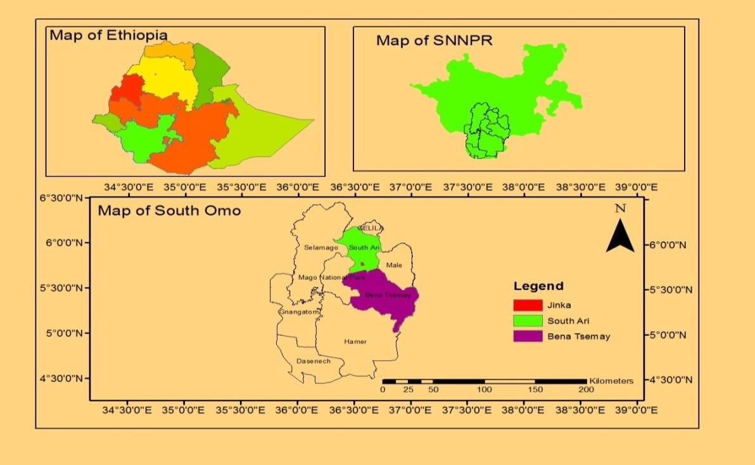
Figure 6: Map of the study area

3.2.Data Collection Techniques
After a reconnaissance survey, the study sites were selected. Figure 7 shows the overall technical route of this study. In order to collect appropriate data, primary and secondary data have been collected from three sites in South Omo Zone namely Arri District, Benatsemay District and Jinka Town area. Interview, questionnaire and field observation were used as a primary data collection technique.

3.2.1. Sample size determination
In this study, the respondents for questionnaires were determined by computing the minimum sample size required for accuracy in estimating proportions by considering the standard normal deviation set at 95% confidence interval for Z statistics (1.96), percentage picking a choice or response (50%=0.5) and the confidence level (0.05).

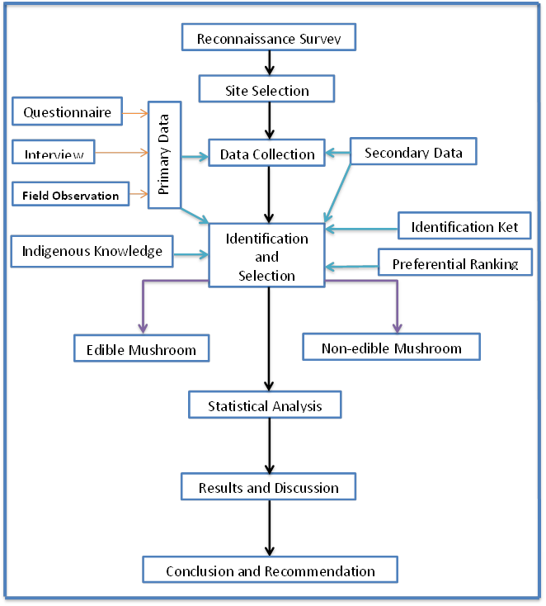
Figure 7: Overall route of this study

The sample size was calculated by using the formula (Daniel, 1999)
$$n=\frac{Z^{2}P\left(1-P\right)}{d^{2}}$$
Where: n= sample size, Z = Z statistics, P = the percentage picking choice or responses, d = confidence interval.
Based on the formula, 384 total respondents were randomly selected with equal proportion of male and females (Table 3). From Ari District (Senmamer, Kaysa, Baptismal and around Gazer area), BenatsemayDistrict (Challi, Kako, and Goldiya) and around Jinka Town area (Alga, Burkamer, Bazet andArkisha area), all together 11 sites respondents used for the assessment of wild mushrooms.
Table 3: Sex and age distribution of the study participants
Woreda | Kebele | Participants
Woreda | Kebele | < 40 years |  |  | $≥$40 years |  |  | Total
Woreda | Kebele | Male | Female |  | Male | Female |  | Male | Female
Debub Ari | Gazer area | 7 | 8 |  | 8 | 12 |  | 15 | 20
Debub Ari | Senmamer Keble | 8 | 7 |  | 10 | 8 |  | 18 | 15
Debub Ari | Kaysa Keble | 8 | 7 |  | 10 | 9 |  | 18 | 16
Debub Ari | Baytsemal Keble | 9 | 7 |  | 11 | 10 |  | 20 | 17
Jinka | Alga Keble | 7 | 6 |  | 7 | 12 |  | 14 | 18
Jinka | Burkamer Keble | 7 | 7 |  | 8 | 11 |  | 15 | 18
Jinka | Bazet Keble | 7 | 8 |  | 11 | 14 |  | 18 | 22
Jinka | Arkisha Keble | 7 | 8 |  | 11 | 8 |  | 18 | 16
Benatsemay | Challi Keble | 7 | 7 |  | 11 | 10 |  | 18 | 17
Benatsemay | Kako Keble | 7 | 7 |  | 11 | 8 |  | 18 | 15
Benatsemay | Goldiya Keble | 9 | 8 |  | 11 | 10 |  | 20 | 18
Total |  | 83 | 80 |  | 109 | 112 |  | 192 | 192

3.2.2. Primary and secondary data collection methods
For data collection purpose, primary and secondary data collection techniques were employed. Secondary data collected from recent publications, journals, books, magazines, unpublished research works, government report etc. It helps to assess the general characteristics of mushrooms (morphology, ecology, nutrition, reproduction and growth), identification of mushroom (edible and non-edible) and uses of mushroom (nutritional, medicinal, economical and other uses). As a result, sufficient and relevant data were obtained from secondary information.
To collect primary data, field observation, questionnaires andinterviews wereemployed. Mushroom collection has been primarily done during rainy(March-September) seasons. Primary data were collected by using household questionnaire, focus group discussion, key informant interviews and field observations. During field survey, special notes (distribution, growth, ecology) were recorded and photo has been taken (Figure 8, Appendix-2).
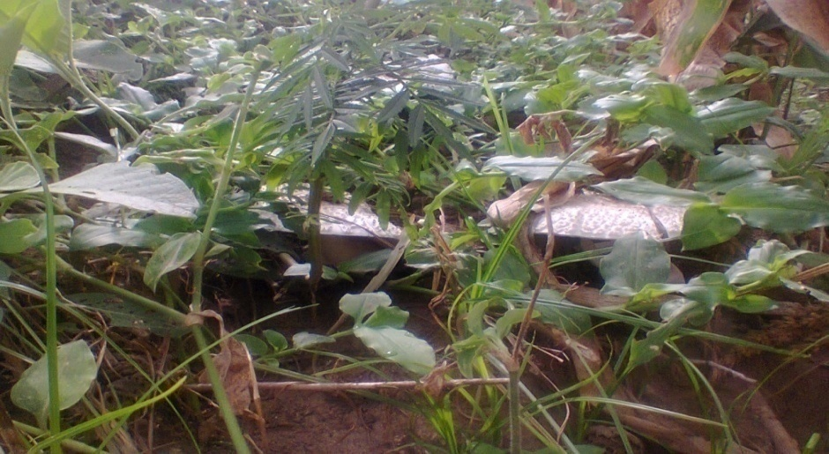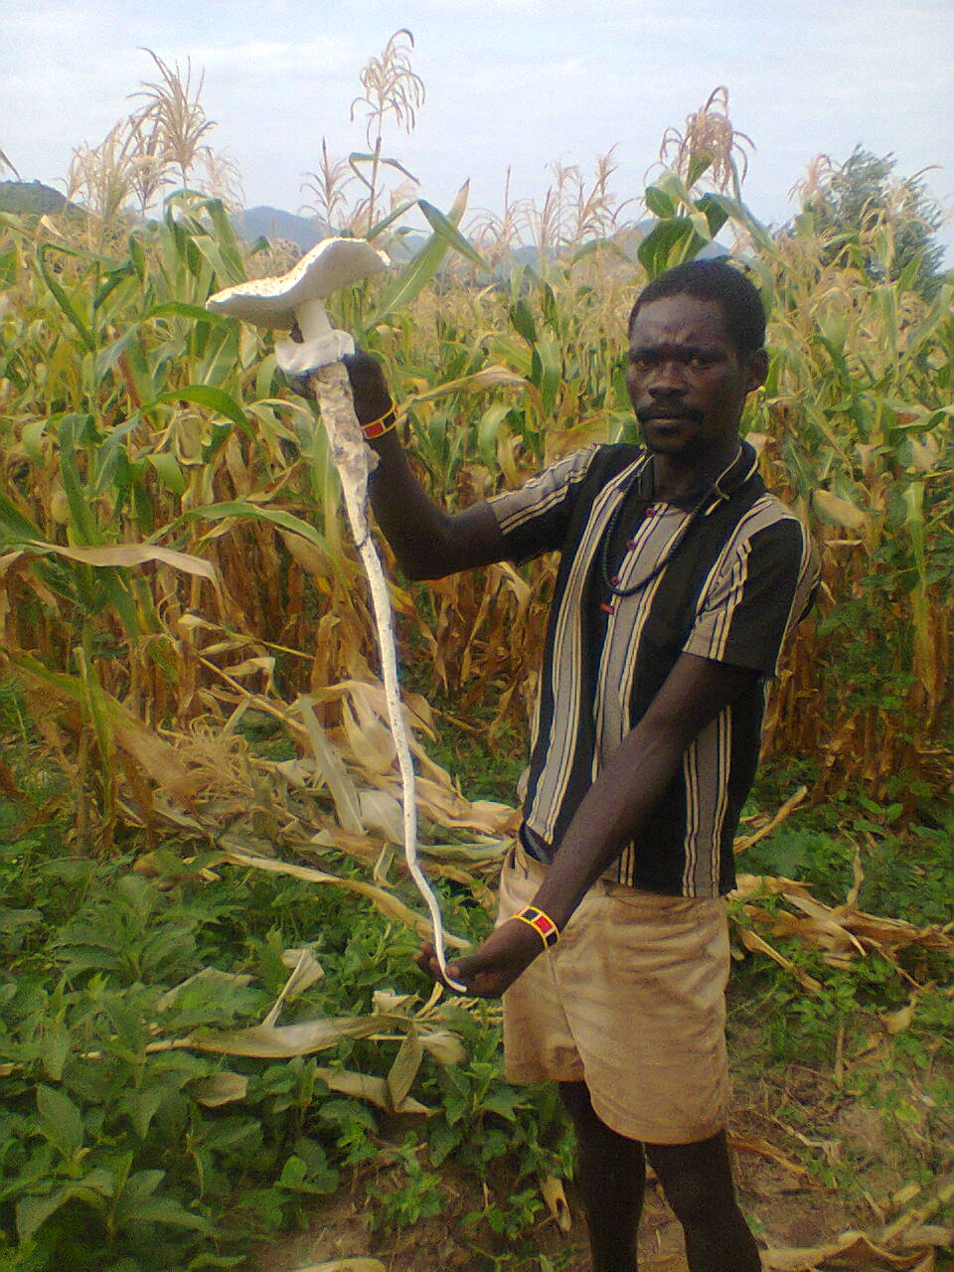
Figure 8: Photos taken during field observation
Structured questionnaires were used to collect information from 384 respondents about wild mushroom grown in their area (Appendix-1). A total of 39 questions concerning availability and distribution, growth and ecology, and indigenous knowledge of the local community about uses (such as nutritional, medicinal, economical and other uses), toxic effects on human healthy, production and cultivation of mushrooms in the study area were assessed. The questions were distributed to 384 respondents on face to face based with the help of assistants (which know the local language) and properly filled and returned. The close- and open-ended questions were prepared aiming respondents to express their ideas and opinions about the edible and non-edible mushroom.
There are eleven interview questions prepared and asked to 89 key respondents to obtain more information about mushroom distribution, growth, ecology, collection, identification, their names, uses, marketing value and toxicity effect on human healthy. The key informants were purposefully selected from the community 68 and office 21 that have more information about mushroom (Appendix- 3)

3.3. Identification and selection techniques
Mushroom samples were collected from the 11 study sites to identify whether they are edible or non-edible. During sample collection, important data such as habitat/ecology, substratum they grow, structure, color, size, shape and growing seasons carefully considered to assess further identification. Wild mushrooms were carefully collected with the help oflocal knowledgeable assistants in the community. Local practices and preferences had been alsoused to reveal useful information and local names such as Ariegna language used for the identification of both wild edible and non-edible mushrooms in the study area. The diameter of the mushroom’s stem/stalk and the cap of the mushrooms were measured following standard protocol (Hand, 2004)).
Specimens were identified based on identification keys such as color, shape, size, and the presence or absence of caporgills (Kuo, 2006). Close observation of the gill is one of the most important steps in identifying gilled mushroom that we collected. Their colors are important, and may change as the mushroom matures.
Preferential rankingwas made to identify which mushroom is most liked by the local community. Twelvekey informants were selected for preferential ranking among the edible wild mushrooms. The one who is selected best by the local community is ranked first.

3.4. Ethical Consideration
At the beginning of the study, the objectives and the purpose of the study was explained to all the participants that were involved in the study. Informed consent was obtained before data collection. The scientific advisors approved data collection procedures.

3.5. Statistical data analysis
The information gathered from this study was analyzed using appropriate techniques. Data collected from questioners were coded and categorized into a suitable data entry format using statistical package for social scientists (SPSS) window version 20.0 software. The P-value < 0.05was consideredstatistically significant.

4. RESULTS AND DISCUSSION

4.1. Socio-demographic characteristics of the study participants
The socio-demographic characteristics of the study participant summarized and presented in Table 4. The numbers of male and female participants were made (50%). The proportion of male in the study Districts were also almost the same. For instance, the number of male participants in Arri and Benatsemaye Districts were found to be 71 (18.5%) and 65 (17.0%), respectively (Table 3). However, the number of females showed a bit variation (n=50-74) especially least for Jinka (13.0%)and highest for Benatsemaye (19.3%).
The age range of the study participants were between 20 and 60 years. As shown in Table 4, 42.4 and 57.6% of the participants were in the age groups of<40 (20-39) and ≥ 40 (40-60) years old.With regard to respondentseducational level most were unable to read and write (37.8%) and primary and secondary school level (35.1%). Relatively, certificate (16.7%) and diplomaand above (10.4%) respondents were proportionally low (Table 4).Most (78.6%) of the respondent ethnic group were found to be Arri who speaks Arri language (74.0%) followed by Bena (14.6%) and Amhara (6.8%).Bena and Amharic languages were also spoken proportionally low (17.7 and 8.3%, respectively) in the study area.
Most (82%) of the respondents included in this study were found to be married and least proportion (18.0%) unmarried (Table 4). Family size of the respondents in the study area was also found to be 56.8%for those who have less than 5 children and 43.2% for those who have ≥5 children. Although the family size of the study area have comparable results to the national level of family size for rural area (4.8), the income levels were fund to be least (<1000 birr) for most (55.7%) respondents. Very few respondents (6.0%) has income level (>2000 birr) per month which indicates that forced them to find natural available source like wild edible mushroom. Moreover, the land size of the study participants indicated that 31.8, 38.0 and 30.2% have <0.4, 0.4-1.0 and >1.0 hectare of land, respectively which is almost the same (Table 4).

Table 4: Socio demographic characteristics of the study participants
Variable | Alternatives | Frequency | Percentage
Sex | Male | 192 | 50.0
Sex | Female | 192 | 50.0
Age (years) | <40 | 163 | 42.4
Age (years) | ≥40 | 221 | 57.6
Ethnic group | Arri | 302 | 78.6
Ethnic group | Bena | 56 | 14.6
Ethnic group | Amhara | 26 | 6.8
Language | Arri language | 284 | 74.0
Language | Bena language | 68 | 17.7
Language | Amharic | 32 | 8.3
Education status | Unable to read and write | 145 | 37.8
Education status | Primary and secondary school | 139 | 35.1
Education status | Certificate level | 64 | 16.7
Education status | Diploma and above | 40 | 10.4
Marital status | Single | 69 | 18.0
Marital status | Married | 315 | 82.0
Family size | <5 | 218 | 56.8
Family size | ≥5 | 166 | 43.2
Family income per month (in birr) | < 1000 | 214 | 55.7
Family income per month (in birr) | 1000-2000 | 147 | 38.3
Family income per month (in birr) | >2000 | 23 | 6.0
Land size  (hectare) | <0.4 | 122 | 31.8
Land size  (hectare) | 0.4-1.0 | 146 | 38.0
Land size  (hectare) | >1.0 | 116 | 30.2

4.2. The growth season and ecology of wild mushroom
The ecology and climate of the study area were favorable for wild mushrooms to grow on. As shown in Table 5, common wild mushrooms were found to grow seasonal during the rainy season (March-September). Warez and Bista grew very well during summer (July, August and September) and winter (May). Morri also grow very well in March, April, May, July and August. During February, almost none of the edible mushrooms had detected in the study area
Table 5: Seasonal growth of different mushroom
Mushroom type | Local Name | Summer |  |  |  |  | Winter
Mushroom type | Local Name | Jun | Jul | Agu | Sep |  | Feb | Mar | Apr | May
Type 1 | Warez | + | +++ | +++ | +++ |  | - | - | - | ++
Type 2 | Maa | + | ++ | ++ | ++ |  | - | + | +++ | +++
Type 3 | Bista | + | +++ | +++ | + |  | - | + | +++ | +++
Type 4 | Pella | + | ++ | ++ | - |  | - | ++ | +++ | +++
Type 5 | Morri | + | +++ | +++ | ++ |  | _ | +++ | +++ | +++
+= Small, ++= moderate, +++= high, -=not observed
Respondents said that many (58%) of the wild mushrooms collected in the study area were associated with termite mound (Figure 9). Warez, Maa and Bista were classified under the genus Termitomyces (Table 6). They are an important group of edible mushroom in the study area.
They are obligatory associated with termites. Many species of mushrooms seemingly appear overnight, growing, or expanding rapidly. This finding was consistent with Pegler and Van heacke(1994) that stated Termitomyces are fungi found and growing on or near termite mounds. They have a large white cap reaching up to 12cm radius across depending on the species of mushrooms, a large stalk, and a long root (Table 6).The data obtained from respondents also showed that edible mushroom grow in farmland (13%), tree logs (11%), grazing land (10%) and animal dung (8%). This result is different from those reported by Radiet Sitotaw (2017),

Figure 9: The ecology of mushroom distribution recognized by respondents in (percentage)

4.3. Sample collection and identification

The samples of most commonly grown wild mushroom in the study area were collected during March to September (2018) and identification was carried out. Five mushroom types (Types- 1 to 5) were collected and characterized based on their cap color, gill number, stipe length, root length, stipe diameter and cap diameter (Table 6, Appendix-4). The cap color of the mushrooms were found to be white (Types-1, 3 and 5), black (Type-2) and pale red (Type-4). The largest number of gills was identified for Type-1 (500-600) mushroom followed by Type-2 (400-480), Type-4 (250-300), Type-5 (200-250) and Type-3 (90-120). The stipe lengths of the mushroom collected varied from least for Type-3 (3.0-3.5 cm) and maximum for Type-1 (12-15 cm). Mycelia lengths also varied from 2.5-3.0 cm (least) for Type-3 and 80-84 cm (maximum) for Type-1. The same least and maximum value of stipe and cap diameters were recorded for Type-3 and Type-1 mushroom, respectively. With local names, Types-1, 2, 3, 4 and 5 were known as Warez, Maa, Bista, Pella and Morri, respectively.
Although taxonomic identification without molecular technique is difficult, classification of the collected mushroom, types were done based on macroscopic structure. The collected samples were taxonomicallyclassified at family and genus level. At family level, Types-1, 2 and 3 were identified as Lyophyllaceae. At genus level, the three types of mushroom were also classified under Termitomyces. Type-4 and Type-5 were also identified at family level as Russulaceae and Amanitaceae, respectively. At genus level, Type-4 and Type-5 were categorized under Lactarius and Amanita, respectively.

Table 6: Some of the descriptive characteristics of mushrooms
Mushroom type | Cap  color | Gill (number) | Measurement in centimeters (cm) |  |  |  | Vernacular names | Taxonomic classification
Mushroom type | Cap  color | Gill (number) | Stipe length | Root length | Stipe diameter | Cap diameter | Vernacular names | Family | Genus
Type-1 | White | 500-600 | 12.0-15.0 | 80.0-84.0 | 10.0-12.0 | 22.0-24.0 | Warez | Lyophyllaceae | Termitomyces
Type-2 | Black | 400-480 | 8.0-10.0 | 6.0-8.0 | 5.0-6.0 | 12.0-15.0 | Maa | Lyophyllaceae | Termitomyces
Type-3 | White | 90-120 | 3.0-3.5 | 2.5-3.0 | 1.8-2.0 | 1.5-2.0 | Bista | Lyophyllaceae | Termitomyces
Type-4 | Pale red | 250-300 | 6.0-8.0 | 3.8-5.0 | 4.0-4.5 | 7.0-8.0 | Pella | Russulaceae | Lactarius
Type-5 | White | 200-250 | 5.0-12.0 | 4.5-5.0 | 1.5-2.5 | 6.0-10.0 | Morri | Amanitaceae | Amanita

Accurate determination and proper identification of a species is the only safe way to ensure edibility. Local people with similar skills acquired from personal experience of what is safe to eat and with knowledge of local traditions were used for this study. Based on the knowledge and experience of the local community both edible and non-edible wild mushrooms were identified (Figure 10). According to the respondents, habits, morphology, color, odor, and taste are the common parameters used to distinguish edible mushrooms from non-edible mushrooms. When most respondents (66-77%) identified the mushroom samples provided to the respondents, Types-1 to 4 as edible and few (23-34%) respondents said non-edible. Among the mushroom types (Type-5) which is locally known as Morri has been said non-edible by most respondents (92%) (Figure 10). Beliefs of the community about the edibility of wild mushrooms found in the study area as follows:
- Mushrooms found on termite mounds and rotting woods are collected for consumption.
- Mushrooms found on animal dung are not safe for consumption or poisonous.
- Mushroom which give burning sensations on tongue when tasted raw are unsafe.
- Mushroom with mild taste and thick flesh are safe for consumption.
- Mushrooms with black stipe and cap considered as unsafe for consumption.
Figure 10: Edible and non-edible mushroom recognized by respondents
According to Kirk et al. (2008), edible fungi occur in the family Lyophyllaceae that have stalk, cap and gills. Termitomyces, which is classified under Lyophyllaceae, is the most common mushroom type in the study area that people likes to eat. Termitomyceshas been identified as an obligate symbiosis with termite in the termite mound. Termites provide shelter and food for the Termitomyces. Using roughly chewed and only slightly digested plant material, they make a small ventilated structure, the fungus comb or garden which serve as shelter, on which the mycelium of a Termitomyces well grow. In turn, the fungus (Termitomyces) provide enzyme that digest wood for termites that naturally lack. Termites have no enzymes to digest cellulose or lignin, basic constituents of their food plants, and therefore call on the services of a symbiotic relationship with a higher fungus.

4.4. Ethnomycological dataof wild mushroom
A totally 384 participants were selected for this study from two Woreda and one Administrative city (Tables 3 and 7) to assess indigenous knowledge of the community about important uses (food and medicine) of wild edible mushroom, type of mushroom found in the area, distribution of mushroom, growth season of mushroom and ability to identify the poisonous and non-poisonous type of mushroom. Fromtotal respondents, 248 (64.6%) have indigenous knowledge about mushroom use. This finding showed that there was statistical significant difference between ethnomycological data of wild mushroom and different informant groups (X²=32.667) (P<0.05) obtained from the 11 sampling sites (Table 7). Most respondents (n=242, 63%) said that wild mushroom are available in the study area. Both wild edible and non-edible mushrooms were widely available and readily distributed in the study area during rainy or summer seasons (71.1%) which has been significantly (p<0.05) differ among respondents and ethnomycological data of wild mushrooms(X²=26.042) There was also significant difference observed in distribution and growing season of wild mushroom between different informant groups (X²=68.484) (P<0.05) (Table 7).
Based on the interview of respondents and observation of researchers, all the wild mushrooms found in the study area were appearing above the ground or epigenous. This finding was consistent with studies reported by Chang et al. 1989. Mushrooms are fruiting body of higher fungi. Diversity and distribution of wild mushrooms are dependent on variety of substrates, rainfall, and temperature. Due to variations in vegetation, geography, etc., Ethiopian’s mushroom diversity presumed to be high.

Table 7: Statistical test significance of study participant with ethnomycological uses of mushroom
Item | Variables | Total  (n=384) |  | DebubArri  (n=139) |  | Jinka  (n=139) |  | Benatsemaye (n=106) |  | Confidence interval (95%) | X² | p-value
Item | Variables | Number | % | Number | % | Number | % | Number | % | Confidence interval (95%) | X² | p-value
Indigenous knowledge to mushroom use | Yes | 248 | 64.6 | 97 | 39.1 | 83 | 33.5 | 68 | 27.4 | 0.1354(1.3431-1.3653) | 32.667 | 0.000**
Indigenous knowledge to mushroom use | No | 136 | 35.4 | 42 | 30.9 | 56 | 41.2 | 38 | 27.9 | 0.1354(1.3431-1.3653) | 32.667 | 0.000**
Mushroom availability | Yes | 242 | 63.0 | 87 | 36.0 | 88 | 36.3 | 67 | 27.7 | 0.1399(1.3581-1.3815) | 26.042 | 0.000**
Mushroom availability | No | 142 | 37.0 | 52 | 36.6 | 51 | 35.9 | 39 | 27.5 | 0.1399(1.3581-1.3815) | 26.042 | 0.000**
Distribution of mushroom | High | 167 | 43.5 | 59 | 35.3 | 56 | 33.53 | 52 | 31.14 | 0.1831(1.4408-2.2205) | 18.484 | 0.000**
Distribution of mushroom | Moderate | 115 | 29.9 | 41 | 35.7 | 39 | 33.9 | 35 | 30.4 | 0.1831(1.4408-2.2205) | 18.484 | 0.000**
Distribution of mushroom | Low | 102 | 26.6 | 39 | 38.2 | 44 | 43.14 | 19 | 18.62 | 0.1831(1.4408-2.2205) | 18.484 | 0.000**
Growth season of mushroom | Summer | 273 | 71.1 | 98 | 35.9 | 99 | 36.3 | 76 | 27.8 | 0.1289(1.278-1.3001) | 68.344 | 0.000**
Growth season of mushroom | Winter | 111 | 28.9 | 41 | 36.94 | 40 | 36.04 | 30 | 27.02 | 0.1289(1.278-1.3001) | 68.344 | 0.000**
Mushroom type available | Edible | 91 | 23.7 | 31 | 34.0 | 33 | 36.3 | 27 | 29.7 | 0.2233(1.8412-2.6358) | 1.028 | 0.000**
Mushroom type available | Non-edible | 72 | 18.8 | 33 | 45.8 | 27 | 37.5 | 12 | 16.7 | 0.2233(1.8412-2.6358) | 1.028 | 0.000**
Mushroom type available | Both | 221 | 57.5 | 75 | 33.9 | 79 | 35.75 | 67 | 30.31 | 0.2233(1.8412-2.6358) | 1.028 | 0.000**
Eating mushrooms | Yes | 228 | 59.4 | 85 | 37.3 | 81 | 35.5 | 62 | 27.2 | 0.1407(1.3943-1.4181 | 13.500 | 0.000**
Eating mushrooms | No | 156 | 40.6 | 54 | 34.6 | 58 | 37.2 | 44 | 28.2 | 0.1407(1.3943-1.4181 | 13.500 | 0.000**
Habits of eating mushrooms | High | 129 | 33.6 | 49 | 38.0 | 45 | 34.9 | 35 | 27.1 | 0.1888 (1.5361-2329) | 26.922 | 0.000**
Habits of eating mushrooms | Moderate | 169 | 44.0 | 62 | 36.7 | 52 | 30.8 | 55 | 32.5 | 0.1888 (1.5361-2329) | 26.922 | 0.000**
Habits of eating mushrooms | Low | 86 | 22.4 | 28 | 32.6 | 42 | 48.8 | 16 | 18.6 | 0.1888 (1.5361-2329) | 26.922 | 0.000**
Mushroom used as food | Yes | 217 | 56.5 | 83 | 38.2 | 75 | 34.6 | 59 | 27.2 | 0.1435(1.4229-1.4469) | 6.510 | 0.011**
Mushroom used as food | No | 167 | 43.5 | 56 | 33.5 | 64 | 38.32 | 47 | 28.14 | 0.1435(1.4229-1.4469) | 6.510 | 0.011**
Mushroom used as medicine | Yes | 204 | 53.1 | 75 | 36.8 | 73 | 35.8 | 56 | 27.4 | 0.1469(1.4567-1.4809) | 1.500 | 0.221
Mushroom used as medicine | No | 180 | 46.9 | 64 | 35.5 | 66 | 36.7 | 50 | 27.8 | 0.1469(1.4567-1.4809) | 1.500 | 0.221
Mushroom poisoning | Yes | 276 | 71.9 | 99 | 35.9 | 101 | 36.6 | 76 | 27.5 | 0.1281(1.2703-1.2921) | 73.500 | 0.000**
Mushroom poisoning | No | 108 | 28.1 | 40 | 37.0 | 38 | 35.2 | 30 | 27.8 | 0.1281(1.2703-1.2921) | 73.500 | 0.000**
Mushroom that cause poisoning | Edible | 122 | 31.8 | 42 | 34.4 | 46 | 37.7 | 34 | 27.9 | 0.2088(1.7560-1.7802) | 79.362 | 0.000**
Mushroom that cause poisoning | Non-edible | 262 | 68.2 | 97 | 37.0 | 93 | 35.5 | 72 | 27.5 | 0.2088(1.7560-1.7802) | 79.362 | 0.000**

As the result shown in Table 7, most (59.4%) respondents said that the communities eat wild mushrooms. The result of this finding showed that there was statistically significant difference between eating mushroom and different informant groups (X²=13.500) (p<0.05) that said community eating and not eating wild mushroom in the study area. Of course, previous reports said that peoples in rural areas of Ethiopia collect and consume wild mushroom traditionally (Birhanu and Zerihun, 2012; Teferi et al., 2013; Tumo, 2001). According to Abate (2014), mushroom consumption is a common practice among many ethnic groups of South and Southwest Ethiopia. Rural people appreciate mushrooms more than urban dwellers. Moreover, older consumers’ value mushrooms more than the young do. Thus, reliable information on traditional use of wild mushrooms in Ethiopia can be obtained from rural senior citizens. Women who sell vegetables, mushrooms and elderly people are usually most helpful in supplying information about ethno mycological uses of mushrooms in south west Nigeria (Oso, 1975). The same observations were made in the current study that more aged women give more information about wild mushroom.
Questions raised about the wild mushroom type availability showed that statistically significant difference between different informant groups(X²=26.042) (p<0.05). Most (57.5%)of the respondents recognized that the wild mushroom type available in the study area as both edible and non-edible type. However, about 23.7% respondents said that mushroom grow in the study are only edible and 18.8% said non-edible type. According to Arora (1986) and Mattila et al. (2000) edibility of mushrooms maybe defined by criteria that include absence of poisonous effects on humans and desirable taste and aroma.

From 384 respondents, 129 (33.6%), 169 (44.0%) and 86 (22.4%) said that the community consumes mushrooms high, moderate and low respectively (Table 87). The result of this finding showed that there was statistically significant difference between mushroom eating habits and different informant groups(X²=13.500) (p<0.05) (Table 7). However, the eating habit of mushroom by the community is moderate (44.0%) and not developed compared with other cereal crops. This is due to lack of awareness concerning ethnomycological uses of mushroom and the development of modernization. In other countries like China, wild mushroom are given high value in terms of medicinal and nutritional advantages (Boa, 2004).Ancient Romans and Greeks, particularly the upper classes, used mushrooms for culinary purposes.
In the current study, 217(56.5%) and 167(43.5%) respondents said that mushrooms are used as a source of food and not used as source of food by the community, respectively (Table 7). The result of this finding showed that there was statistically significant difference between mushroom used s a source of food and different informant groups(X²=6.510) (p<0.05) (Table 87).Grangeia et al. (2011) reported that most people eat mushrooms mostly because of its flavors, meaty taste and medicinal values. According to Getachew et al. (2016), mushroom is a delicious food consumed throughout the world. Others also mentioned that mushroom traditionally collected from the wild have been widely used as food source (Gilbert and Robinson, 1957;Vincetiet al., 2013). According to Jordan (2006), the practice of eating mushroom as food source probably began during the hunting and gathering periods.It has been considered that mushroom is the future vegetable, which is a guarantee for food insecurity, malnutrition problem and medicinal value.
From 384 respondents, 204(53.1) and 180(46.9%) said that mushrooms are used as medicine and not used as medicine, respectively (Table 7). This finding showed that there was no statistical significant difference between the medicinal uses of mushroom and different informant groups.(X²=1.500)(P=0.221). However, the medicinal benefits of edible mushrooms in the study area have not been scientifically identified and well documented. Those who said mushroom used as medicinal value mentioned that people use wild edible mushroom to treat some viral diseases such as common cold in traditional way. In fact, little traditional or indigenous knowledge exists on utilization of mushrooms for medicinal purposes in Ethiopia (Fikadu, 2015). In some part of the country like Keffa region, the use of Laetiporus sufureusfor easing childbirth (Woldegiorgis et al, .2015). However, according to Birhanu and Zerihun (2012), mushroom consumption habits in other parts of African countries arewell documented.
Mushrooms, especially non-edible mushrooms have negative impact on human healthy (Chang, 2008).In the current study, most (71.9%) respondents said that there is mushroom poisoning in the study area resulted from misidentification of edible fromnon-edible mushroom types (Table 7). The result of this finding showed that there was statistically significant difference between mushroom poisoning and different informant groups(X²=73.500) (P<0.05). Most (68%) respondents said that non-edible mushroomwhich causes poisoning and affect human healthy. This finding showed that there was statistically significant(X²=79.362) (p<0.05) difference between mushroom type that cause poisoning and different informant groups.

4.5. Wild mushroom collection and utilization practice in the study area
Mushroom collection is one of the most widespread activities in a movement to discover local sources for food that is growing in popularity nationwide. It is apparent that wild mushroom consumption supplements the nutritional needs of local people. The main system of obtaining wild edible mushroom in the community is through direct searching and collection.In the study area, mushroom are not found in the local market, but male and females deliberately go for searching mushrooms used for food during rainy seasons (Figure 11).It was identified that women in the study area played a vital role in gathering wild mushrooms deliberately than do males. Males are collecting mushroom more randomly than females. In addition, men collect mushroom when they walk to or from their farmland or farming activity. Children are also involved in the collection of edible wild mushroom such as Termitomyces around termite mound when they are keeping sheep or cattle
Figure 11: Gender difference in mushroom collection and utilization
The result obtained from the study area (Table 8) indicated that there is a relationship between respondents age, education status, informant groups, family income, land size and involvement in wild edible mushroom collection (p<0.05). However, there is no statistical deference between male and female in collecting wild edible mushroom.
The indigenous knowledge of the community is very important in revealing identification, classification and ethnomycological uses of wild mushrooms. There is significance (p=0.03) difference in wild edible mushroom collection practice between senior groups (≥40 years) and young (<40 years) members of the community in the study area where older people (78.7%) are involved in wild edible mushroom collection when compared to young members (57.1%) (Table 8). This indicated that if the individual gets older the knowledge increases. There are more information obtained from key (knowledgeable) informants than general informants and there was statistically significant difference observed (p<0.05). In the case of education status, the study participants categorized as illiterate were found to be involved more (77.2%) in wild edible mushroom collection compared to literate (64.9%) groups (Table 8).
There is a significant relationship between family income, land size and involvement in wild edible mushroom collection (p<0.05), but there is no significant between distance from the source where wild edible mushroom available and involvement in wild edible mushroom collection (p=0.759) (Table 8). Family income is one of the determining factors in wild edible mushroom collection. Families from low-income collects mushroom from the wild and sold for members of middle or high income families as a source of money. Land size also one of the determining factors and there is a significant relationship with involvement of wild edible mushroom collection (p<0.05). Families with small land size (79.8%) are actively involved in wild edible mushroom collection in order to get their nutrition or to replace meat.

Table 8: Proportion of informant groups that involve in wild edible mushroom collection
Parameters | Informant groups | Frequency | Respondents |  |  |  |  | p-value
Parameters | Informant groups | Frequency | Yes |  |  | No |  | p-value
Parameters | Informant groups | Frequency | Fr. | % |  | Fr. | %
Sex | Male | 192 | 103 | 53.6 |  | 89 | 46.4 | 1.000
Sex | Female | 192 | 141 | 73.4 |  | 51 | 26.6 | 1.000
Age (year) | <40 | 163 | 93 | 57.1 |  | 70 | 42.9 | 0.03**
Age (year) | 40 | 221 | 174 | 78.7 |  | 47 | 21.3 | 0.03**
Literacy level | Illiterate | 145 | 112 | 77.2 |  | 33 | 22.8 | 0.000**
Literacy level | Literate | 239 | 155 | 64.9 |  | 84 | 35.1 | 0.000**
Informant experience | Key informant | 89 | 83 | 93.3 |  | 6 | 6.7 | 0.000**
Informant experience | General informant | 295 | 184 | 62.4 |  | 111 | 37.6 | 0.000**
Family income per month (birr) | <1000) | 214 | 143 | 66.8 |  | 71 | 33.2 | 0.000**
Family income per month (birr) | 1000-2000 | 147 | 104 | 70.7 |  | 43 | 29.3 | 0.000**
Family income per month (birr) | >2000 | 23 | 20 | 87.0 |  | 3 | 13.0 | 0.000**
Land size (hectare) | <0.4 | 84 | 67 | 79.8 |  | 17 | 20.2 | 0.000**
Land size (hectare) | 0.4-1.0 | 164 | 112 | 68.3 |  | 52 | 31.7 | 0.000**
Land size (hectare) | >1.0 | 136 | 88 | 64.7 |  | 48 | 35.3 | 0.000**
Distance from source  (km) | <3 | 195 | 135 | 69.8 |  | 60 | 30.2 | 0.759
Distance from source  (km) | >3 | 189 | 132 | 69.2 |  | 57 | 30.8 | 0.759

4.6. Preparing wild mushrooms for meal
Identifying and collecting wild mushroom is boring and not easily identified especially the largest and widely consumed mushroom, Termitomyces sp. Because of their growth and the need of the community for consumption was very high. Every member of the communities in the rural areas is well experienced about growing season, appearing time and the ecology of this wild edible mushroom. There are four wild edible mushrooms types identified and collected from the study area and Termitomyces (Type-1) species of wild mushroom was selected (Figure 12) for preparation and consumption based on their preferential levels of the mushrooms. Mushrooms associated with termites, Termitomyces sp. are diverse and they are collected by all ethnic groups are considered to have the best aroma and taste among edible mushrooms (Abate, 2014).
The communities in the study area have been consuming mushrooms both as raw and cooked. However, consuming raw is not recommended because of the toxic of mushrooms on human health.Therefore, proper preparation (boiling, draining and cooking) of wild edible mushrooms before eating or consuming is the best practice for preparing wild mushrooms for humanconsumption.Besides, the firmness and freshness of the mushrooms must be inspected before consumption.
For preparing, mushrooms for human consumption the necessary material such as onion bulb, garlic, green pepper, oil or butter and salt are needed. Firstly, the mushrooms are cut into small pieces by using knife. Then, put into the dish, and small amount of water is added into the dish, and the dish is placed on the heat and boiled. After boiling the mushroom, the water drained and the mushroom is placed in another container.
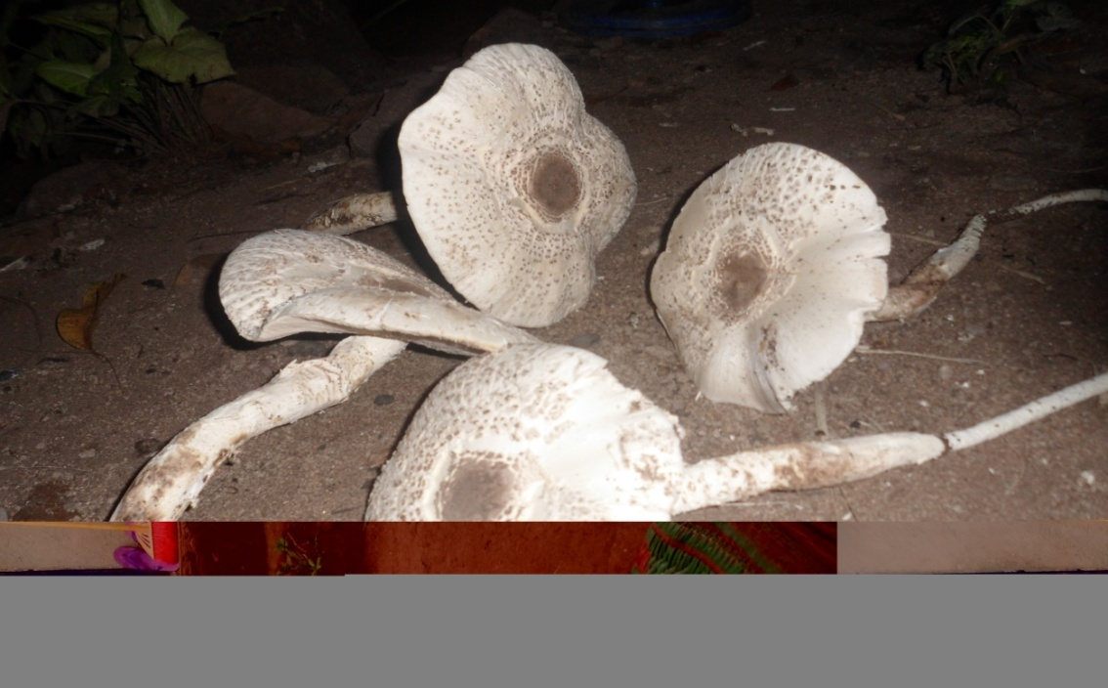
Figure 12: Termitomyces collected for cooking
Secondly, the onion bulb and garlicare cut into smaller pieces by using knife and making it ready forpreparation. These prepared onions and garlic are put into the dish and then placed on heat supplier again. After a few minutes, oil or butter is added into the dish and the mixture is stirred. Then boiled and drained mushrooms is added in to the dish and the mixture stirred again. Finally, the green pepper cut into small pieces and salt is added into the dish containing the mixture and stirred again. After a minute the dish containing the cooked mushroom was took away from the heat supplier and make it ready for consumption (Appendix-5).

4.7. Preferential ranking
Preference ranking is a participatory technique that allows analyzing and identifying problems of preference. It describes certain voting systems in which voters rank outcomes in a hierarchy on the ordinal scales when choosing between more than two options. Preferential voting system provides a number of advantages over first-past-the-post voting (also called plurality voting). This does not mean that preferential voting is always the best system (Mankiw, 2012).
Borda count system used in preferential ranking of wild edible mushrooms in the study area(Frankel et al., 2014). Every person has different preferences and tastes, and this is especially true when it comes to wild edible mushrooms. Wild edible fungi have been collected and consumed by people for thousands of years.
The values were counted by assigning a point value to assigned each wild edible mushroom then each informant is ranking the mushroom and the choice with the smallest number of overall points was taken best preferred than higher number. The 12 key informants were taken and assigned by letters from A to L(Table 9). Informant’spreference levels were assigned by values 1 to 4. Finally, the total values were assigned for each wild edible mushroom by each key informant and each wild edible mushroom was ranked based on the total sum of the values (Table 9).
Table 9: The preference rank of wild edible mushroom
Mushroom type | Key informants (A-L)
Mushroom type | A | B | C | D | E | F | G | H | I | J | K | L | Total |  | Rank
Type-1 (Warez) | 1 | 1 | 2 | 1 | 1 | 2 | 2 | 1 | 1 | 1 | 1 | 2 |  | 16 |  | 1
Type-2 (Bista) | 3 | 3 | 3 | 2 | 3 | 3 | 4 | 3 | 3 | 3 | 2 | 1 |  | 33 |  | 3
Type-3 (Maa) | 2 | 2 | 1 | 4 | 2 | 1 | 1 | 2 | 2 | 2 | 4 | 3 |  | 26 |  | 2
Type-4 (Pella) | 4 | 4 | 4 | 3 | 4 | 4 | 3 | 4 | 4 | 4 | 3 | 4 |  | 45 |  | 4

As a result, mushroom Type- locally known as Warez (Termitomyces sp.)had the total scoredleast (16) which is the best choice of key informants followed by Type-3 (Maa) which scored (26) and Type-2 (Bista). This findings was consistent with those reported by Abate (2014) suggested that mushrooms associated with termites, Termitomyces sp. are diverse and collected by all ethnic groups and are considered to have the best aroma and taste among edible mushrooms. Among the most commonly available wild edible mushroom types, Type-4 (Pella) ranked last and described as poor and the least preferable wild edible mushroom consumed by the local community.

4.8. Indigenous knowledge transfer and conservation practice
The data obtained from respondents indicated that the main system of mycological knowledge transfer on ecology and growing season, methods of collection, identification, namingand grouping, methods of preparation for food and medicine in the study area was from elder to younger people in their family through word of mouth. The contribution of other sectors such as local school, agricultural experts and religious organization has been found to be insignificant (Figure 13).
Figure 13: Source of ethnomycological knowledge in the community

All the wild edible mushroom species collected and utilized by the community in the study area are available in their natural environments. There are poor efforts to conserve wild edible mushroom in their natural habitat (in-situ conservation), lack of knowledge to cultivate mushrooms artificially which puts mushrooms under threat due to over harvest and an ever-increasing of human influences on natural habitat. The main factors affecting the availability and distribution of wild edible mushroom obtained from the respondents include deforestation, agricultural expansion due to rapid population growth, urbanization and uses of agro- chemicals (Figure 14). This finding was consistent those reported by kik et al. (2013)
Figure 14: Factors affecting the availability and distribution of wild edible mushroom reported by respondents

4.9. Marketability of wild edible mushroom
During market survey in the study area, we found that from the 192 male and192 female respondents 73% women and77% male said that they are not involved in selling mushroom. However, the marketability of wild edible mushroom in the study areawasn’t known in the local market. Only 27%% of women and 23 % of male respondents said that they are involved in selling mushrooms (Figure 15).Study on the selling price in each study area is slightly different dependingon the type of mushrooms. For instance, the selling price of the largest edible mushroom Termitomycesranged from 5 to 10 Ethiopian birr per mushroom.

5. CONCLUSION AND RECOMMENDATIONS

5.1. Conclusion
In the present study, four edible and one non-edible or toxic wild mushroom types were collected and identified based on standard protocol.Identifying wild mushrooms requires awareness and understanding of their parts, colors, size or texture, their habitat or ecology and important and beneficial role in the environment. In addition, local experiences and knowledge of the community, different publications on mushrooms and mushroom’s guide also very important for identification of wild mushrooms. Wild mushrooms such as Termitomyces(Types-1 to 3), and Lactarius(Type- 4) were used as a source of food in traditional way. Among the Types, Type-1 which is locally known as Warez has been found the most fluently used mushrooms by the community. The community also used wild edible mushroom as medicine in traditional way to treat viral diseases, such as common cold. However, still mushroom consumption habits of the community are not enough (54.2%).This is because of lack of awareness of the community about the important benefits of the mushrooms and lack of the development of modernization. In addition, some non-edible mushrooms or toxic mushrooms have negative impact on human health due to misidentification of wild edible mushrooms.
Although the climate and weather conditions, availability of vegetation cover and agricultural wastes in the study area are very good for mushroom cultivation, mushroom cultivation practices are generally poor and unknown. This is because of lack of awareness on important benefits of mushrooms and lack of skills on mushroom cultivation by farmers and agricultural extension workers. In general, the present study has provided strong evidence on mushroom assessment and identification, their important benefits, and negative impacts on human health, and can serve as baseline information and indicator for further mycological studies in the study areas.

5.2. Recommendations
Based on the findings of the present study, the following recommendations have been made:
The study area needs creating awareness about importance of mushroom consumption as source of food and medicine
It needs creating awareness by experts to harvest most commonly used wild edible mushroom in their home garden
Further investigation and examination of the mushroom is very important in order to identify the nutrient available, the chemical substances that have medicinal properties, and the toxic substance present in the mushroom
Molecular characterization is very important to classify the mushroom as species level.

REFERENCE

Abate, D. (1995). Cultivations of the oyster mushrooms in tradition brick pots. Mycologists
9:179-181
Abate, D. (1998). Cultivation of oyster mushroom. TheInternational Journal ofSmall-Scale Food
Processing 23:20-21
Abate, D. (2014). Wild mushrooms and mushroom cultivation efforts in Ethiopia. Addis Ababa
University, Ethiopia. World Society for Mushroom Biology and Mushroom Products,
Bulletin 11, July 31, 2014
Aida, F. M. N., Shuhaimi, M., Yazid, M. and Maaruf, A. G. (2009). Mushroom as a potential
source of Prebiotics: A review. Trends Food Science Technology 20:567-575
Akapaja, E.O., Isikhuemhen, O. S. and Okhuoya, J. A. (2003). Ethno mycology and usage
edible and medicinal mushrooms among the Igbo people of Nigeria. International
Journalof Medicinal mushroom 3:313-319
Akinyele, J.B., Fakoya, S. and Adetuyi (2012). Anti-growth factors associated with pleurous in
submerge liquid fermentation.Malaysian Journal of Microbiology volume8:135-140
Aletor, V.A. (1993). Allelo chemicals in plant foods and feeding stuffs: 1.Nutritional,
Biochemicaland Physiopathological aspects in animalproduction35:57-67
Alofe, F.V., Odeyemi, A.O. and Oke, O.L. (1996). Three wild mushrooms from Nigeria: Their
proximate and mineral composition. Plant Food for Human Nutrition 49:63-67
Alonson, J.,Lamata,T., Kumar and Vaidya, Omkarprasa and Sushil, Teknomo and Kardi (2006).
Analytical Hierarchy Process 169:1-29
Ammirati,J.F., Traquair, J.A. and Horgen, P.A. (1985). Poisonous mushroom of Canadainclude
the inedible fungi markham, ontario: fitzhenry and Whiteside in cooperation with
agricultural. Canada and Canada Government Publishing Center Supply and Service
Canada 25-83
Anderson, J.B. and Stasovsk, E. (1992). Molecular phylogeny of northern hemisphere species of
Armillaria.Mycologica 84:505-516
Anon (1889). Edible mushrooms of the United States Science 13:453-455
Antonella, A. and Giovanna, C.V. (2013). The bioremediation potential of different
ecophysiological group of fungi. In: EM Goltapeh, YRDaneshandAVerma (eds.).Fungi
asBioremediators Soil Biology 32, Springer-VerlagBerlHeidberg 29-49
Arora, D. (1986). Mushrooms demystified: A Comprehensive Guide to the Fleshy Fungi (@nd
edition).Berkeley:Ten Speed Press.ISBN 0-89815-169-4
Ayodele ,S. M., Akpaja, E. O. and Adama, Y. (2009). Some edible and medicinal mushrooms
found in Igala land in Nigeria and their sociocultural and ethnomycological uses.African
Journal of Traditional, Complementary andAlternative Medicines526-531
Badalyan, S. M. (2004). Antiprotozoal activity and mitogenic effect of mycelium of culinary
Medicinal Shiitak mushroom Lentinus edodes (Berk)(Agaricomycetidae). International
Journalof Medicinal Mushroom 6:131-138
Barros,L., Ferreira, M., Queirós, B., Ferreira, I. C. F. and Baptista, P. (2007). Total phenols,
ascorbic acid, β-carotene and lycopene in Portuguese wild edible mushrooms and their
antioxidant activities. Food Chemistry 103:413–419
Beelman,R.D., Royse, D. and Chikthiramash, N. (2003). Bio-reactive components in Agaricus
Bisporus mach of nutritional, medicinal, or biological importance. International Journal of
MedicinalMushroom 5:321-337
Beetz, A. andLane, G. (1999). Mushroom cultivation and marketing horticulture reproduction
guide for appropriate technology transfer for rural areas, Fayetteville 24
Bender, S., Dumitrache, C. N., Backhuas, J., Christie, G., Cross, R. F. and Lonergan, G. T. (2003).
A case for caution in assessing the antibioticactivity of extracts of culinary medicinal Shiitak
Mushroom (Lentinus edodes (Berk). Singer (Agaricomycetidae). International
Journal of Medicinal Mushroom 5:31-35
Birhanu, G. and Zerihun, T. (2012). Mushroom cultivation for sustainable food security Abiyot
Berhanu and Genene Tefera (Eds.) Institute of Biodiversity Conservation: Biodiversity
Newsletter 1:14-17
Boa, E.(2004). Wild edible fungi: A global overview of their use and importance to people non-
woody forest product, No.17, Wild edible fungi FAO, Forestry Department, Rome, Italy 148
Borchers, A. T., Krishnamurthy, A., Keen, C. L., Mayers, F. J. and Gershwin, M. E. (2008). The
immunobiology of mushrooms. Experimental Biology andMedicine 233:259-76
Buller,A. H. R. (1914).The fungus lore of the Greeks and Romans Trans Br Mycology
Society5:21-66
Buswell, J. A., Cal, Y.J. and Chang, S.T. (1996). Lignocellyulolytic enzyme profiles of edible
mushroom fungi. World Microbiology Biotechnology 12:537-542
Caglarirmak, N. (2008). Nutritional evaluation of wild edible mushrooms grown in Turkey.
Journal Food Science Technology 3:11-15
Caglarirmak, N. (2009). Determination of nutrients and volatile constituent of Agaricus bisporus
(Brown) at different stages. Journal Food Science 89:634-638
Central statistical agency (CSA) of Ethiopia, population, and housing census of Ethiopia: statistical
of South omo zone, 2000, Ethiopia.
Chang, S. T. and Miles, P. G. (2004). Mushroom cultivation, nutritional value, medicinal effects
and environmental effects, Second edition, CRCP press 451
Chang, S.T., Lau, O. W. and Choky (1998).The cultivation and nutritive value of Pleurotus sajor-
Caju European Journal Applied Microbiology Biotechnology 12:58-62
Change, S.T. (2006).The world mushroom industry: trends and technologicaldevelopment
International Journal of Medicinal Mushroom 8:297-314
Cheung. P. C. K. (1996). The hypocholesterolemic effects of two edible mushrooms: Auriculari
auricular (tree ear) and Tremella fuciformis (white jelly-leaf) in hypocholesterolemic rats.
Nutrition Research 16:1721-1725
Dijk, H., Onguene, N. A. and Kuyper, T. W. (2003). Knowledge and utilization of edible
mushrooms by local population of the rainforest of South Cameron. Ambio, 32:19-23
El-Mekkawy, S., Meselhy, M. R., Nakamura, N., Tezuka, Y., Hattori, M. and Kakuiuchi, N.
(1998). Anti-HIV-1 and anti- HIV-1 protease substances from Ganoderma lucidum.
Phytochemical 49:1651-1657
Eswaran, A. and Ramabadran, R. (2000). Studies on some physiological, cultural and post-harvest
aspects of oyster mushroom, Pleurotus ostreatus.Tropical Agriculture Research, 12:360-

Fajana,O. B., Alote, F. V., Dnawunmi, G. O., Ogundaini, A. O. and Tiwalade, T. A. (199).
Antimicrobial studies on Nigerian higher fungi Nigerian. Journal of Natural Products and
Medicines 3:64-65
Fikadu, A. (2015). Cultivation of Shitake mushroom (Lentinus endodes) on coffee husk at Dilla
University, Ethiopia. Ethiopia Journal of Food and NutritionScience3:63-70.
Fortes, R. C., Taveira, V.C., Rita , M. and Novaes , C.G. (2006). The immunomodulator role of B-
Glucansas Co-adjuvant for cancer therapy. Journal of Biotechnology 21:163-168
Frankel, J. and Grofman, B. (2014-04-03). The Borda count and its real-world alternatives;
comparing scoring rules in Nauru and Solvenia. Australia Journal of Political Science
49:186-205
Gao, Q., Killie, M. K., Chen , H., Jiang, R. and Seljelid, R. (1997). Characterization and cytokine
stimulating activities of acidic heteroglycans fromTremella fuciformis. PlantaMedica
63:457-460
Getachew, D., Woldemedhin ,Zemedu, L., Seifu , Eshete, A. and Wassie (2010). Mushroom
value Chain Analysis in Addis Ababa, Ethiopia
Griffiths, R., Richards, W., Johnson, M., McCann, U. and Jesse, R. (2008). Mystical type
experiences occasioned by Psilocybin mediates the attribution of personal meaning and
spiritual significance 14 months later.Journal of Psychopharmacology 22:621-632
Hand, D. J. (2004). Measurement Theory and Peactice: The World through Quantification
Chichester: Wiley
Hjortstam,K. and Ryvarden, L.(1996). New and interesting wood inhabiting fung
(Basiidiomycotina- Aphyllophorales) from Ethiopia.Mycotaxonomy60:181-190
Hudler, G. W. (2000). Magical mushrooms, mischievous molds. Princeton, New Jessey: Princeton
University Press 175
Inoue, A., Kodama, N. and Nanba, H. (2002). Effects of mitake (Grifolafrondosa) D-fraction on
the control of the T-lymph node Th-1/Th- proportion. Biological andPharmaceutical Bull
25:536-540
Jiang, J. C. andGao, Y. F. (1995). Summary of the treatment of 37 chronic renaldysfunction
Patients with JinShuiBao. Journal of Admin Trad. Chin. Med.5:23-24
Jordan, P. (2006). Field guide to edible mushrooms. Journal of Clinical and Pharmaceutical
Research 7:286-245
Justo, M. B., Guzman, G. A., Mejia, E. G., Diaz, C. L. G., Martinez, G. and Corona, E. B. (1998).
Composition quimicadetrescepas Mexicans deset as (Pleurotus ostreatus). DeNutrition
48:359-363
Kesel, A. D. E. and Degreef, J. (2007). Ethno mycological research and literature surveys from
Africa. Mycology Africa 2:4-5
Kik, A., Jeyarathan, P. and Debritto, S. (2013). Ethnomycological documentation of mushroom
diversity of Wopkola in Mul District of Western highlands province papua new Guinea and
investigation of antimicrobial properties of selected species. Economic Botany 12:111-120
Kirk, P. M., Cannon, P. F., Minter, D. V. and Stalpers, J. A. (2008). Ainsworth and Bisby’s
Dictionary ofthe fungi(10thEd) CABI Europe, UK 1-77
Koyama, K., Imaizumi, T., Akiba, M., Kinoshita, K., Suzuki, A., Yano, S., Watanabe, K. and
Naoi,Y. (1997). Antinoceptive component of Ganoderma lucidum. Planta Medica 63:224-
227
Koyyalamudi, S. R., Jeong, S. C., Song, C. H, Cho, K.Y. and Pang, G. (2009). Vitamin D2
formation and bioavailability from Agaricus bisporus button mushrooms treated with UV-
irradiations. Journal of Agricultural and Food Chemistry 57:3351-3355
Kuo, M. (2006), Glossary retrieved from the mushroom expert.com.web site:
http://www.mushroomexpert.com.
Kuznetsov, O. I., Milkova, E. V., Sosnia, A. E. and Sotnikova, N. I. (2005). Antimicrobial action
Of Lentinus edodes juice on human micro flora Microbial Epidemiology and
Imimmunobiology 1:80-82
Lee, H. Y.,Kim, W. R. andMin, B. H. (2005). Automation of solid-state bioreactor for oyster
mushroom composting. Mycology 30:228-232
Liu, F. and Chang, S. T. (1995).Anti-tumor component of the culture filtrates from Tricholoma
spp. World Journal Microbial Biotechnology 11:489-490
Lo, H. C., Tsai, F. A., Wasser, S. P., Yang, J. G. and Huang, B. M. (2005). Effectsof ingested
fruiting bodies, submerged culture biomass and acidic polysaccharide glucuronoxylomannal
of tremelmesentericretz: Fr on glycemic response in normal and diabetic rats. Life Science
78:1957-1966
Lull, C., Wichers, J. and Savelkoul, F. (2005). Anti-inflammatory immunomodulatingproperties
of fungal metabolites.Mediators of Inflammation2005:63-80
Mankiw G. (2012).Principles of microeconomics (6thEd) Southwestern Cengage Learning478-
479
Manzi, P., Gambelli, L., Marconi, S., Vivanti, V. and Pizzoferrato, L. (1999). Nutrients in edible
mushroom: inter-species comparative study. Food Chemistry 65:477-482
Mattila, P.,Suoripaa, K. and Piironen, V. (2000). Functional properties of edible mushrooms.
Nutrition 16:694-696
Metzler, V. and Metzler, S. (1992). Taxas mushrooms: a field guide: Universisty of Texas press.
Austin, Texas p298.
Moore, D. (2005).Principlesof mushroom development biology. International Journal of
MedicinalMushrooms 7:79-101
Mothana, R. A.,Jansen,R., Julich, W. D. and Lindequist, H. (2000). Ganomycinaand new
Antimicrobialfarnesyl hydroquinone from the basidiomycetes Ganoderma prfifferi. Journal
of Natural Products 63:416-418
Mshigneic,K. E. and Chang, S.T.(2000). A guide to successful mushroom farming with emphasis
on technologies appropriate and accessible to Africa’s rural and peri-urbancommunities.
University of Namibia Windhoek Namibia 34
Oei, P. (1996). Mushroom cultivation with special emphasis on appropriate techniques for
developing countries Tool Publications, Leiden, and Netherland 256
Onuoha, C. L. (2007). Cultivation of the mushroom (Pleurotus tuberregium)using some local
substrates. Life Science Journal 4:58-61
Oso, B. A. (1975). Mushrooms and Yoruba people of Nigeria. Mycologia67:311-319
Pegler, D. N. and Van haecke, M. (1994). Termitomyces of Southeast Asia. Kew Bulletin 49:717-
736
Purkayastha, R. P. and Aindrila, C. (1985).Manual of Indian edible mushrooms. International
Bioscience Monographs.
Sadler, M. (2003). Nutritional properties of edible fungi.BritishNutritionBulletin 28:305-308
Shu, Y. T., Tsai, P. W., Shih, J. H. and Jeng, L. M. (2007). Agaricus bisporus harvested at
different stages of maturity. Food Chemistry 103:1457-1464
Sieger, A. A. (1998). Spore prints Bulletin of the Puget Sound microbiology society.
Simon, R. R., Borzelleca, J. F., Deluca,H. F. and weaver, C. M. (2013). Safetyassessment of the
post-harvest treatment of button mushrooms (Agaricus bisporus) using UV-light. Food
and Chemical Toxicology 56:278-289
Smania, J. A., Monache, D.F., Smania, E. F. and Cuneo, R. S. (1999). Antibacterial activity of
steroidal compounds isolated from Ganoderma applanatum(Aphyliophoromycetidae)
body. International Journal of Medicinal Mushrooms1:325-330
South omo zone DOFED annual statistical abstract 2013-2014 (Unpublished)
Soylu, M. K., Nur, Z., Ustuner, B., Dogan, L., Sagirkaya, H., Gunay, U. and Kemal, A. K. (2010).
The commercial importance of edible wild and cultivated mushrooms in TurkeyIn:
Proceedings of the eighthTurkishVegetable Agriculture Symposium 22-256
Takaku, T., Kimura, Y. and Okuda, H. (2001). Isolation of an antitumor compound fromAgaricus
blazeimurill and its mechanism of action. Journal of Nutrition131:1409-1413
Teferi,Y., Muleta, D. and Woyessa, D. (2013). Mushroom consumption habits of WachaKebele
resident southwestern Ethiopia. Global Research Journal of Agricultural and Biological
Science4:6-66
Tuno, N. (2001). Mushroom utilization by the Majangir, an Ethiopian tribe.Mycologis15:78-79
Turhan, S. and Varinlioglu A. (2007). Radioactivity levels in some wild edible mushroom species
in Turkey.Environmental and Health Studies43:249-256
Venturella, G. Zerakis, G. I., Polemic, E. and Garganis , M. L. (2016). Taxonomic identity,
geographic distribution and commercial exploration of the culinary-medical mushroom P.
nebrodensis. International Journal of Medical Mushroom 18: 59-65
Volk, T. (2001).Hypomyceslactifluorum, the lobster mushroom fungus of the month, University
of Wisconsin-La Crosse, Department of Biology
Wasser, S. P. (2009). Medicinal mushroom science: history, current status, futuretrends and
unsolved problems. International Journal of Medicinal Mushroom 12:1-16.
Wasson, R.G. (1968). Soma: divine mushroom of immortality. New York: Harcourt, Braceand
World. Ethno mycological Studies no.1
Woldegeorgis, A. Z., Abate, D., Haki, G.P.,Ziegler, G.R. and Harvatine (2015). Fatty acid profile
of wild and cultivated edible mushrooms collected from Ethiopia. Journal of Nutrition
Food Science 5:360.
Ying, J., Maox, Q., Zong, Y. and Wen, H. (1987). Icons of medicinal fungi from China
Beijing,China: Science press p575.

Appendix I- Research questionnaires and interviews

Dear respondents, these questionnaires are used to conduct research activities on mushroom assessment and their importance for the course of MSc thesis in biology.
Objectives: The main aim of these questionnaires are used to collect sufficient and relevant data from respondents on the issues about the assessment of mushroom and their importance, negative impacts of wild mushrooms, cultivation and conservation status of mushrooms and methods used to improve the consumption and cultivation of mushrooms in South omo zone, Southern Ethiopia. This study covers two districts of South Omo zone including Benatsemay, and Debub Ari districts and Jinka city administration were included in the study area. I hope that different levels of the community in the study area will be actively and cooperatively participate in responding possible answers for the close-ended and open-ended questions based on their previous knowledge and experience about wild mushrooms.
Thank you very much for your fully participation and cooperation to respond possible answers for the questions!
Instructions to answer questionnaires: These questionnaires consist of close-ended and open-ended questions. Therefore, read the following instructions to answer the questions.
1. Circle the number to answer alternative questions.
2. Write possible answers for the open-ended questions on the space provided.
3. It is possible to write your answers by using one of the language given below which is easier to answer questions (Amharic, English,Benegna, Ariegna).
1. Respondents personal information
1.1. Name_________________
1.1. Age______________
1.2. Sex____________________
1.3. Name of Keble_____________
1.4. District___________________ Zone______________________
1.5. Occupation_______________________
1.6. Ethnic group____________________ Language_____________
1.7. Education status
. Unable to read and write__________Primary and secondary education level (1-12) ______________
Certificate level____________ Diploma and above level ________________
2. Mushroom assessment related questions
2.1 Do you have indigenous knowledge about mushrooms? Yes_____ No_____
2.2 How do you get the knowledge regarding mushroom? From family_____ Agricultural expert______ Local school_____ Religious________ Traditional medicinal experts_________ Others________
2.3 Do you think that wild mushrooms available in your locality? Yes_____ No______
2.4 Which types of wild mushrooms are available? Edible_____ Non-edible____ Both______
2.5 Do you have habits of collecting wild mushrooms? Yes______ No_______
2.6 How often do you collect WEM? Never__________ Sometimes_________ Always__________
2.7 Who collect wild mushrooms from your locality?
Children___ Women_____ Men_____ Elder groups______ Others______
2.8 Why you are collecting wild mushrooms from your locality? For food____ Medicine_____ Religious purpose_______ Others______
2.9 From where do you collect wild mushrooms? Termite mounds___ near road sides_____ open grassy area_____
Near or in the houses______ near the forest ______Decaying organic matter ______ Farm land________
2.10 When people go for searching wild mushrooms? When deliberately searching_____ keeping cattle______
Collecting fire wood_______ by chance______ others________
2.11 At what time wild mushrooms grow in your locality. Summer_______ winter________
2.12 Write the name of months wild mushrooms can grow________________________________
2.13 List which wild mushroom is available in which months of the year_________
2.14 Which mushroom type is/are the most abundant?
2.15Do you have the habits of eating mushroom? Yes________ No_______
2.16 If your answer for the question No.2.12 is yeshow do you differentiate the edible mushrooms from non-edible mushrooms?____________________________________________________________
2.17 How is your eating habit of WEM? High_____ moderate______ low_______
2.18 List the name of wild mushrooms available in your locality you know by local language?__________
2.19 Do you think that mushroomis used as a source of food in your locality? Yes_____ No______
2.20 What benefits do you obtain from eating mushrooms? ____________________________?
2.21 Which type of wild mushrooms is used as a source food? __________________________?
2.22 Are mushroom used for medicine? Yes______ No__________
2.23 If your answer for the above question No. 2.21 is yes, which mushroom for what disease?
2.24 Which mushroom type is/are the most preferable for consumption?__________________________
2.25 Why this mushroom is the most prepared one______________________________________?
2.26 How is the mushroom prepared for food? Explain the local recipes or procedures.
2.27 Are mushroom sold in the local market to increase their income? Yes______ No________
2.28If the community uses the mushroom for marketing, what is the selling price?
2.29 Which mushroom type is/are the most expensive?________________________
2.30 Did any mushroom poisoning occur in your locality? Yes______ No_______
2.31 Which mushroom type causes mushroom poisoning?
2.32 What is the impact of mushroom poisoning on human healthy?

II/ Interview questions
1. Do you preserve wild mushroom for future use? Yes______ No________
2. If your answer for the above question No. 1 is yes, how do you preserve?
3. What is the current status of wild edible mushroom distribution in your locality? Decreasing_____ Increasing___
4. If decreasing what do you think will be the main reason(s) Deforestation______ Habitat destruction________
Population pressure_______ Urbanization_______ Agro-chemicals (fungicides, herbicides, etc) Others______
5. Are there wild mushrooms, which totally disappeared at present?
6. Do you know that mushroom could be cultivated artificially?
7. Do you want to adopt mushroom cultivation in your locality? Yes______ No________
If your answer is yes, which type of mushroom do you prefer to cultivate?
8. Are there any folklore and traditional beliefs in your community concerning mushroom appearance and consumption?
9. Which social groups consume mushrooms more frequently? People from rural areas_______ People from urban areas_______ educated people_________. Why do you think the reason?
10. What factors determine the growth of wild mushroom in your locality? Rain and soil type______ Heavy thunder rain_______ Soil type coupled with heavy thunder rain_______ Others_________
11. How to improve the indigenous knowledge of the community to conserve wild edible mushroom

Thank you once for again!!!

Appendix 2- Photographs illustrating study sites and field observation
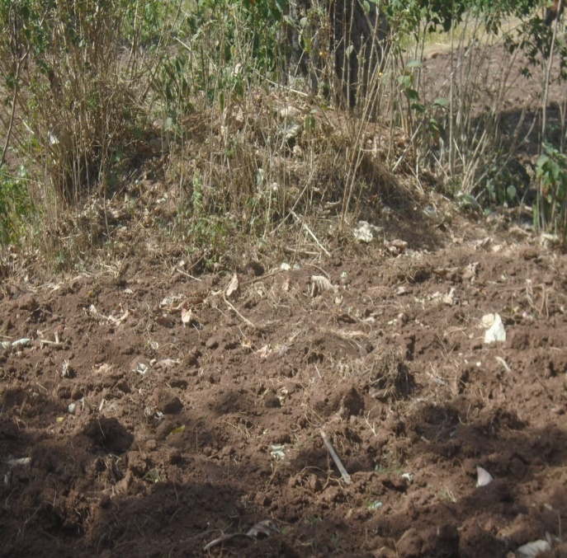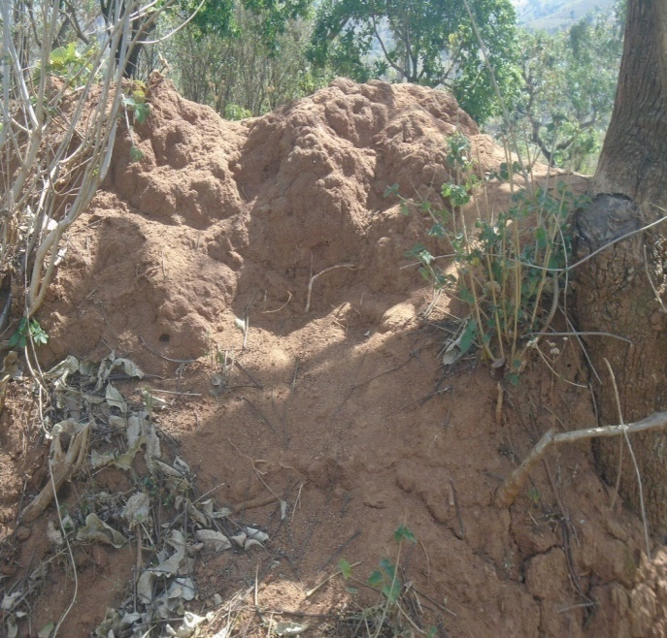
Termite mound
Farmland
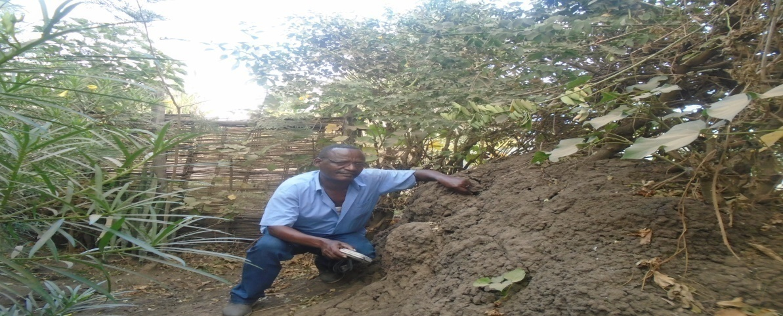
Researcher at termite mound site

Appendix 3-Photographs illustrating interview of key informants during data collection
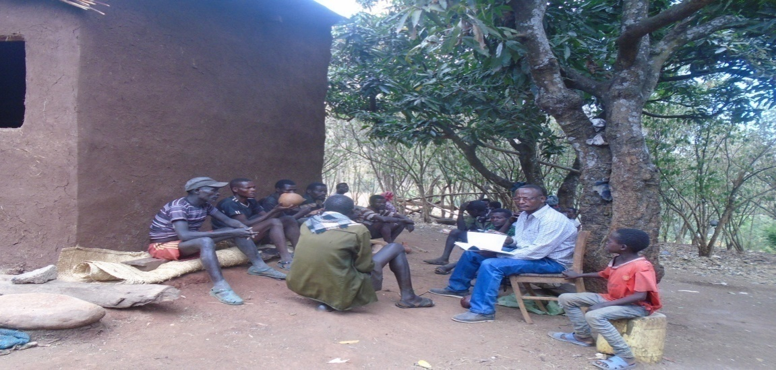
Key informants

Appendix 4- Photographs illustrating some common mushroom collected
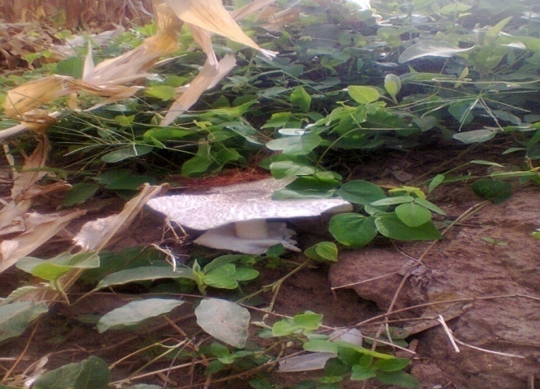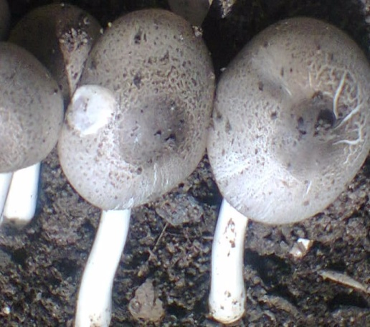
Type1 (Warez)-1 (Warez)
Type-2 (Maa)
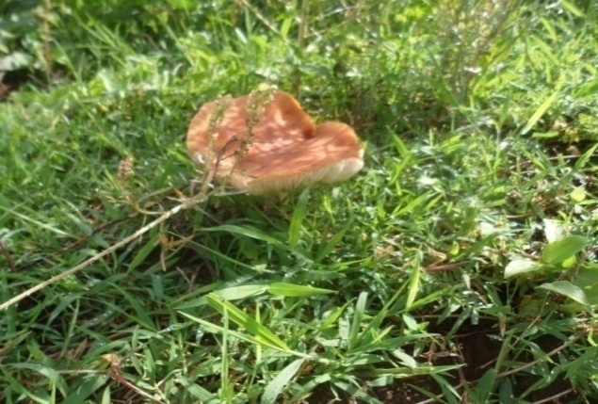
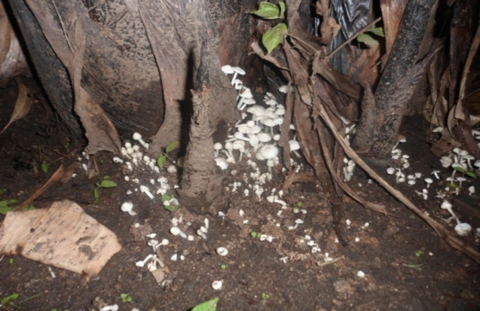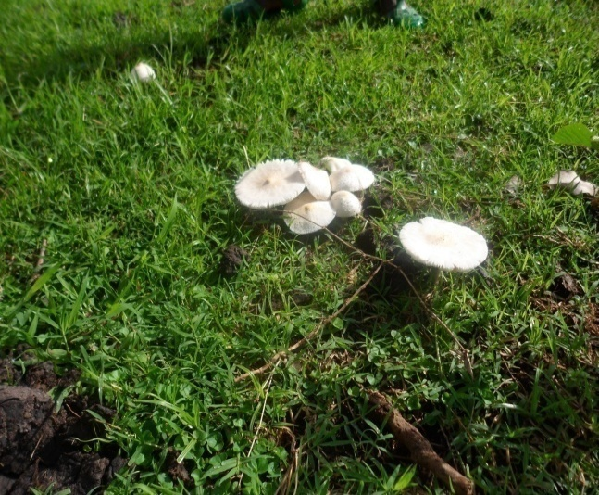
Type 3 (Bista)
Type 5 (Morri)
Type 4(Pella)

Appendix 5- Photographs illustrating mushroom preparation
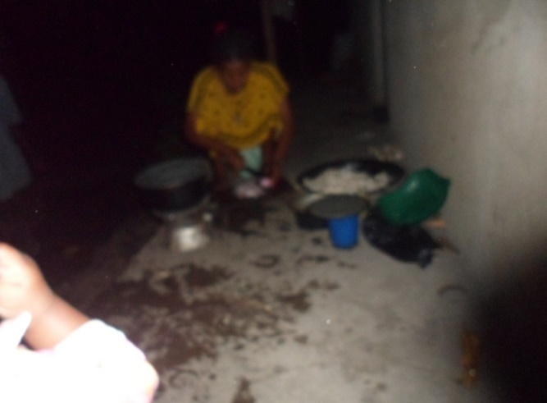
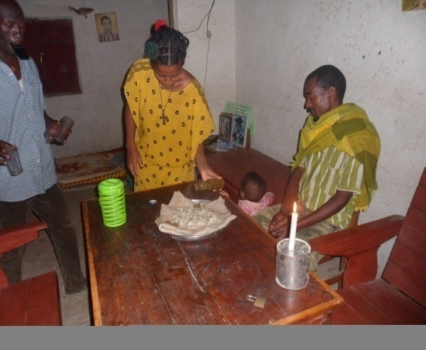
Cooking mushroom
Cooked mushroom ready for a meal
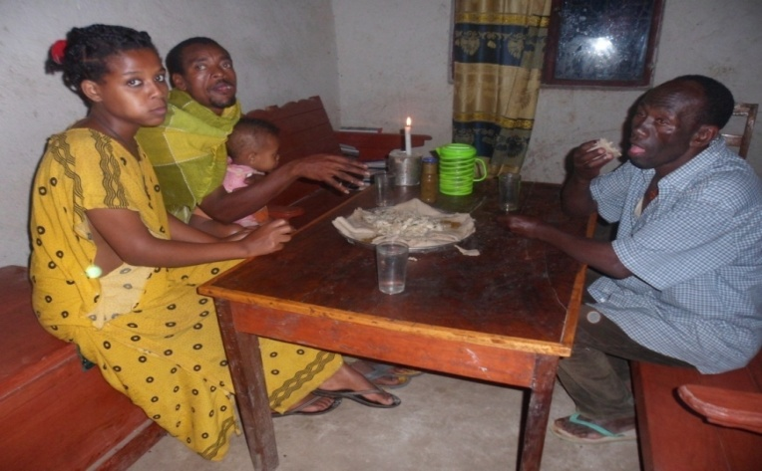
Eating mushroom

