LAND USE/LAND COVER DYNAMICS AND ASSESSMENT OF SOIL EROSION USING REMOTE SENSING AND GIS TECHNIQUES: A CASE OF SILE WATERSHED, GAMO ZONE, SNNPR, ETHIOPIA

MSc. THESIS
BY

LISAN BERHANU BONKA

AUGUST, 2019
ARBA MINCH, ETHIOPIA

LAND USE/LAND COVER DYNAMICS AND ASSESSMENT OF SOIL EROSION USING REMOTE SENSING AND GIS TECHNIQUES: A CASE OF SILE WATERSHED, GAMO ZONE, SNNPR, ETHIOPIA

LISAN BERHANU BONKA

ADVISOR: VANUM GOVINDU (PhD)
CO-ADVISOR: ALEMU ASSELE (MA)

A THESIS SUBMITTED TO THE SCHOOL OF GRADUATE STUDIES OF ARBA MINCH UNIVERSITY IN PARTIAL FULFILLMENT OF THE REQUIREMENTS FOR THE DEGREE OF MASTER OF SCIENCE IN GEO-INFORMATICS

SCHOOL OF GRADUATE STUDIES
COLLEGE OF SOCIAL SCIENCE AND HUMANITIES
DEPARTMENT OF GEOGRAPHY AND ENVIRONMENTAL STUDIES
ARBA MINCH UNIVERSITY

AUGUST, 2019
ARBA MINCH UNIVERSITY

DECLARATION
I hereby declare that this MSc thesis is my original work and has not been presented for a diploma or degree in any other university, and all sources of material used for this thesis have been duly acknowledged.
Name: Lisan Berhanu Bonka
Signature: _______________
Date: ___________________

ARBA MINCH UNIVERSITY
SCHOOL OF GRADUATE STUDIES
APPROVAL PAGE
This thesis entitled " Land use/land cover dynamics and assessment of soil erosion using Remote Sensing and GIS techniques: A case of Sile watershed, Gamo Zone, SNNPR, Ethiopia " has been approved by the board of examiners for the partial fulfillment of the requirements for MSc degree in Geo-informatics, the Graduate program of the department of Geography and Environmental studies. The examiners' board approve that this thesis has passed through the defense and review process.

Dr. Vanum Govindu | ____________ | ____________
Principal advisor | Signature | Date
Mr. Alemu Assele | ____________ | ____________
Co-advisor | Signature | Date
Dr. Abera Uncha | ____________ | ____________
Internal Examiner | Signature | Date
Dr. | ____________ | ____________
External Examiner | Signature | Date
Mr. Afera Azmera | ____________ | ____________
Chairman | Signature | Date

ACKNOWLEDGEMENT
First of all I would like to express my soul gratitude to Almighty God that has been the way and wisdom in all the shacking pressures that I have encountered in my life and research endeavor and finally brought me to this end.
Next my heartfelt acknowledgement goes to my principal advisor Dr. Vanum Govindu and Co-advisor Mr. Alemu Assele for their genuine academic and professional guidance and support they provided till the completion of the research work.
I am also thankful to the Ministry of Water, Irrigation and Energy, National Meteorological Service Agency (NMSA), Arba Minch University (department of Geography and Environmental Studies), Arba Minch Zuria and Bonke Wereda Agricultural and Rural Development for making available relevant data, instrument and documentation.
I would like to extend my special thanks to my father Berhanu Bonka, my younger brother Nafkot Berhanu (Msc) and my beloved families, and to all of my colleagues for their interruptive moral, material, financial and other supports forwarded from the beginning to the end of the research work in one or another way.

TABLE OF CONTENTS
Contents | Page
DECLARATION ii
ACKNOWLEDGEMENT iv
TABLE OF CONTENTS v
LIST OF TABLES viii
LIST OF FIGURES ix
ACRONYMS x
ABSTRACT xi
CHAPTER ONE 1
INTRODUCTION 1
1.1 Back Ground of Study 1
1.2 Statement of the Problem 2
1.3 Research Objectives 3
1.3.1 General Objectives 3
1.3.2 Specific Objectives 4
1.4 Research Questions 4
1.5 Significance of the Study 4
1.6 Scope of the Study 4
1.7 Limitation of the Study 4
1.8 Organization of the Research 5
CHAPTER TWO 6
LITERATURE REVIEW 6
2.1 Definition of LULC and Soil Erosion 6
2.2 LULC Dynamics 7
2.3 Application of GIS and RS for LULC Analysis 8
2.4 Landsat Images 9
2.5 Watershed 9
2.5.1 Sub-Watersheds Vulnerability 10
2.6 Soil Erosion Types by Water 10
2.6.1 Rain Splash Erosion/Splash Erosion 10
2.6.2 Sheet Erosion 10
2.6.3 Rill Erosion 10
2.6.4 Gully Erosion 11
2.6.5 Bank Erosion 11
2.7 Factors Affecting Soil Erosion 12
2.7.1 Soil 12
2.7.2 Topography 12
2.7.3 Climate 12
2.7.4 Conservation Practice 13
2.7.5 LULC Changes 13
2.8 Impact of Soil Erosion 13
2.8.1 Reduction of Productivity 14
2.8.2 Waterbodies Sedimentation 14
2.9 Soil Erosion Models 15
2.9.1 Conceptual Model 15
2.9.2 Empirical Model 15
2.9.3 Physically Model 16
2.10 Revised Universal Soil Loss Equation for Soil Loss Estimation 16
2.11 Application of RS and GIS for Assessment of Soil Erosion Modeling 17
2.11.1 RS for Soil Erosion Assessment 18
2.11.2 GIS for Soil Erosion Assessment 18
CHAPTER THREE 19
DESCRIPTION OF STUDY AREA AND METHODS 19
3.1 Description of Study Area 19
3.1.1 Location 19
3.1.2 Topography 19
3.1.3 Climate 20
3.2 Research Methodology 20
3.2.1 Research Design 20
3.2.2 Data Sources 20
3.2.2.1 Rainfall Data 20
3.2.2.2 Soil Data 21
3.2.2.3 The Digital Elevation Model 21
3.2.2.4 LULC Data 21
3.2.3 Data Collection Method and Instruments 22
3.2.3.1 Field Observation 22
3.2.3.2 Tools and Software 22
3.2.4 Data Analysis 23
3.2.4.1 Method of Quantify LULC Dynamics Analyses 23
3.2.4.2 Method of Estimate the Amount of Soil Loss Analyses 25
CHAPTER FOUR 29
RESULT AND DISCUSSION 29
4.1 LULC Dynamics Analysis 29
4.1.1 Quantify LULC Dynamics Over the Past Thirty Years 29
4.1.2 LULC Change Detection 31
4.1.3 Accuracy Assessment 32
4.2 Estimated Amount of Soil Loss from the Watershed 34
4.2.1 Rainfall Erosivity Factor 34
4.2.2 Soil Erodibility Factor 35
4.2.3 Slope Length Factor 37
4.2.4 Land Use/Cover Factor 38
4.2.5 Management Practice Factor 39
4.2.6 Amount of Soil Loss Per Unit Area Per Year 41
4.3 Prioritization of Sub-watersheds 42
4.3.1 Sub-Watershed Pattern and Erosion Rate 42
4.3.2 Prioritization of Sub-Watersheds Based on Erosion Risk 43
CHAPTER FIVE 45
CONCLUSION AND RECOMMENDATION 45
5.1 Conclusion 45
5.2 Recommendation 45
REFERENCES 47
APPENDIX I 56
APPENDIX II 59
APPENDIX III 64

LIST OF TABLES
Tables | Page
Table 3.1: Tools and software used 22
Table 4.1: LULC share of each class 29
Table 4.2: LULC change detection share of each class 32
Table 4.4: Error matrix of classification for 2018 images 33
Table 4.4: MAP and the corresponding R-factor value 34
Table 4.5: Seven soil types and five colors in Sile watershed and their erodibility value 36
Table 4.6: LULC and the corresponding value of C-factor 38
Table 4.7: LULC type, slope and P-factor value 40
Table 4.8: Area coverage and proportion of soil erosion risk classes 42
Table 4.9: Soil loss from sub-watershed 43
Table 4.10: Severity classes and Prioritization of sub-watersheds 43

LIST OF FIGURES
Figures | Page

Figure 3.1: Location map of study area 19
Figure 3.2: Metrological station map of study area 21
Figure 3.3: Image classification process 24
Figure 3.4: Methodology of flowchart diagram 28
Figure 4.1: Landsat image TM of 1989 Showing LULC of the study area 30
Figure 4.2: Landsat image ETM+ of 2003 showing LULC of the study area 30
Figure 4.3: Landsat 8 image of 2018 showing LULC map of the study area 31
Figure 4.4: Map showing change detection of LULC classes 32
Figure 4.5: R-factor map of the watershed 35
Figure 4.6: Soil map of the watershed 35
Figure 4.7: K-factor value map of the watershed 37
Figure 4.8: LS-factor value map of the watershed 37
Figure 4.9: C-factor map of the watershed 39
Figure 4.10: P-factor map of the watershed 40
Figure 4.11: Soil loss rate map of the watershed 41
Figure 4.12: Sub-watersheds map of the sile watershed 42
Figure 4.13: Sub-watershed erosion level of the study area 44

ACRONYMS
DEM | Digital Elevation Model
ELUC | Environmental Land Use Conﬂicts
EPIC | Erosion Productivity Impact Calculator
ERDAS | Earth Resources Data Analysis System
ETM+ | Enhanced Thematic Mapper Plus
FAO | Food and Agricultural Organization
GCP | Ground Control Points
GIS | Geographic Information System
GPS | Global Positioning System
K_{hat} | Kappa Coefficient
LULC | Land Use Land Cover
MAP | Mean Annual Precipitation
MAR | Mean Annual Rainfall
MMF | Morgan-Morgan and Finney
MUSLE | Modified Universal Soil Loss Equation
NMA | National Meteorological Agency
PESERA | Pan European Soil Erosion Risk Assessment
RS | Remote Sensing
RUSLE | Revised Universal Soil Loss Equation
SWAT | Soil and Water Assessment Tool
TM | Thematic Mapper
UNEP | United Nations Environment Program
USGS | United States Geological Survey’s
USLE | Universal Soil Loss Equation
WEPP | Water Erosion Prediction Project

ABSTRACT
Soil erosion is wide spread and serious throughout the Ethiopian highlands. It is also a major watershed problem in many developing countries causing significant loss of soil fertility, loss of productivity and environmental degradation. This research has, therefore, been carried out to quantify the major land use/land cover dynamics over the past thirty years and assessment of soil erosion using remote sensing and geography information system techniques in the Sile watershed. For the land use/land cover dynamics calculation three satellite images such as Landsat Thematic Mapper 1989, Landsat Enhanced Thematic Mapper Plus 2003 and Landsat8 2018 has been utilized. As a result the rate soil erosion risk and land use land cover map of 1989, 2003 and 2018 of the study area was generated. Rainfall data, soil data, Digital Elevation Model data and satellite image were used as input data sets to generate revised universal soil loss equation factor values. Raster calculator was used to interactively calculated soil loss rate and prepare soil erosion risk map. The result showed that extent in the classification, the plantation land use/land cover type was generalized to other classes, but, as evident in the field observation, forest is highly diminished due to cultivation. The forest cover has been declining since the year 1989 in the order of 14.2% for 2003 and 12.5% for 2018 and the annual soil loss of the watershed ranges from 0.00 to 393.49 ton per hector per year and the mean annual soil loss rate is 55.7 ton per hector per year. Among the six sub-watersheds, three such as SWS1, SWS3 and SWS5 were predicted to experience annual soil loss of more than the watershed’s average 55.7 ton per hector per year; whereas three sub-watersheds SWS2, SWS4 and SWS6 were estimated annual soil losses were less than the average.
Key Words: GIS, Land Use/Land Cover, Remote Sensing, RUSLE, Soil Erosion, Watershed

CHAPTER ONE

INTRODUCTION

1.1 Back Ground of Study
Soil provides food, clean water and air and is a major carrier for biodiversity (Katsuyuki, 2009; Keesstra et al., 2016). Nowadays, most of the people in the world remain heavily dependent on soil resources as their main livelihood source, what leads to soil degradation. LULC dynamics and soil erosion are a worldwide environmental problem that reduces the productivity of all natural ecosystems and agriculture, which threatens the lives of most smallholder farmers (Dai et al, 2015; Gessesse et al, 2017). Soil erosion by water is the greatest factor limiting agricultural productivity in the humid tropical regions (Sunday et al., 2012). The high erosion rates are mainly affecting the developing countries due to intensive cultivation, deforestation, plowing of marginal lands and extreme climate hazards (Biswas et al, 2015; Colazo and Buschiazzo, 2015; Ligonja and Shrestha, 2015). Soil erosion is further aggravated by environmental land use conﬂicts (ELUCs), as recently recognized by Pacheco et al. (2014). ELUCs in developing countries have been reported to cause a decline in soil fertility (Valle et al., 2014). Soil erosion rates beyond the tolerable limits cause changes in the hydrological, biological and geomorphic processes and geochemical cycles, which reduces services that the soil offers to the human beings (Berendse et al., 2015; Brevik et al., 2015; Decock et al., 2015). On cultivated lands, appropriate soil conservation mechanisms supported with vegetation are efﬁcient strategies to control soil loss (Cerdà et al., 2016; Zhao et al., 2015). About 80% of the current agricultural land degradation is caused by soil erosion globally (Angassa, 2014; Rodrigo et al., 2015). In most developing countries, including Ethiopia, anthropogenic activities trigger soil erosion (Belyaev et al., 2004; Hurni, 2005).
With the present Ethiopian estimated population of 110.14 million and a growth rate of 2.42% (UNP, 2019), about 80% of the population depends on agricultural practices, leading to very high population pressure on the land. Studies conducted in Ethiopian highlands show that soil erosion is seen as a direct result of the historical human settlement in the highlands because of its favorable climatic conditions, political factors and soil fertility (Keesstra et al., 2016). Inappropriate land use, poor farming practices and removal of the natural vegetation aggravate soil erosion and so productivity declines, resulting in food insecurity for smallholding farmers (Adimassu et al, 2014; Angassa, 2014). Soil erosion is one of the biggest problems resulting in both on-site and off-site effects. The direct on-site effect is related to farming practices which is often linked to loss of agricultural soil by runoff (Hurni, 1993). Annually, Ethiopia loses over 1493 million tons of topsoil from the highlands due to erosion, which could add about 1.5 million tons of grain to the country’s harvest (Hurni, 1993; Erkossa et al., 2015). Further, about 43% (537 000 km²) of the total highland areas of Ethiopia are highly affected by soil erosion with an estimated average of 20 ton ha ⁻¹ y⁻¹ and measured amounts of more than 300 ton ha⁻¹ y⁻¹ on speciﬁc plots (Paulos, 2001; CRSPT, 2000). As a consequence of soil erosion, it is estimated that more than 30000ha of the country’s cropland will be out of production annually (Erkossa et al., 2015).
Quantifying the effects of the LULC dynamics and soil loss helps to substantiate investment in sustainable land management for the beneﬁts to land users. Appropriate soil conservation measures bring economic advantages to the land users, but farmers resist adopting improved erosion control measures due to lack of awareness on the immediate impacts of soil loss for livelihood, and low skills for construction of soil conservation structures (Telles et al., 2013). The LULC dynamics and amount of soil loss and the status of the existing soil conservation measures can be realistic for farmers and policy makers if expressed in terms of understandable value. The main objective of this study was LULC dynamics and assessment of soil erosion risk area using Remote sensing (RS) and Geographic Information System (GIS) techniques in case of Sile watershed. Speciﬁcally, the study was designed to model soil erosion with the revised universal soil loss equation (RUSLE) structure according to the national guidelines. The adapted RUSLE model was therefore selected for its low number of required data and for its ease as a tool for ﬁeld application by technicians.

1.2 Statement of the Problem
LULC dynamics and human or natural modifications have largely resulted in deforestation, biodiversity loss, global warming and increase of natural flooding. Thus environmental problems are often related to LULC dynamics. The LULC pattern of a region is an outcome of natural and socio economic factors and their utilization by man in time and space. Land is becoming a scarce resource due to immense agricultural and demographic pressure. Hence, information on LULC and possibilities for their optimal use is essential for the selection, planning and implementation of land use schemes to meet the increasing demands for basic human needs and welfare. This information also assists in monitoring the dynamics of land use resulting out of changing demands of increasing population (Abera, 2013).

Erosion removes organic and mineral materials from the soil and contributes to the breakdown of the soil structure that will, in turn, affect soil fertility and crop yields. The situation is more serious in developing countries like Ethiopia and creates severe constraints to sustainable agricultural land use, as it reduces on farm soil productivity and causes food insecurity (Moges and Holden, 2006). Several studies reported about land degradation due to soil erosion in Ethiopia. According to Tulu, (2002) almost all agricultural lands on sloppy areas in Ethiopia are endangered by intensive erosion processes. Soil erosion is more severe in the highlands (Kidane, and Alemu, 2015). Annually, Ethiopia loses over 1493 million tons of topsoil from the highlands due to erosion, which could add about 1.5 million tons of grain to the country’s harvest (Hurni, 1993; Erkossa et al., 2015). Further, about 43% (537 000 km²) of the total highland areas of Ethiopia are highly affected by soil erosion with an estimated average of 20 ton ha⁻¹ y⁻¹ and measured amounts of more than 300 ton ha⁻¹ y⁻¹ on speciﬁc plots (Paulos, 2001; CRSPT, 2000). The large amount of soil loss made Ethiopia one of the most seriously erosion affected country in the world (Hurni, 2005).
Sile watershed, located in the Southern rift valley of Ethiopia, is characterized by sever soil erosion, flooding, sediment and nutrient intrusion to the lake Chamo due to the expansion of crop farms with inappropriate practices. It seems obvious that large amount of soil has been lost to the lake Chamo but there is no scientific research conducted yet to clearly know how much amount of soil is eroded per year and which sub-watersheds are more vulnerable in the watershed. Also the significant erosion factors are not identified yet in any previous studies. The local government has no appropriate statistical information to know the dynamics of LULC over the past years. So far, there was no scientific study has been conducted to establish the current position regarding the problem. Therefore, this situation is encouraged to assess LULC dynamics and soil erosion rate using GIS and RS in case of Sile watershed.

1.3 Research Objectives

1.3.1 General Objectives
The general objective of the study is land use/land cover dynamics and assessment of soil erosion risk area using RS and GIS techniques in case of Sile watershed.

1.3.2 Specific Objectives
- To quantify the LULC dynamics over the past thirty years;
- To estimate the amount of soil loss per year of the watershed;
- To develop a soil loss rate map of the study area;
- To prioritize sub-watersheds for intervention on the basis of erosion risk;

1.4 Research Questions
- How GIS and RS techniques can be applied to quantify LULC dynamics for the thirty years?
- How RUSLE equation is appropriate to assess the amount of soil loss in ton per hector per year?
- How can be developed soil loss rate map using GIS?
- How can be assessed that which sub-watersheds are more vulnerable of soil erosion using GIS and RS?

1.5 Significance of the Study
To secure life and property of local community needs to obtain future information on LULC dynamics, soil erosion and its effect. The output will be used as input for decision makers (higher government bodies), Land use Planning Agricultural Offices, Soil management bodies, Disaster Management and Food security sectors for Bonke and Arba Minch Zuria Woreda, and for Researchers on modeling soil loss so far. To be effective over the long term, the adaptation process should lay the groundwork for similar efforts in the future in ways that support over reaching national development objectives. This research will minimize or avoid loss of life and property due LULC dynamics and soil loss in the watershed and assure community sustainability.

1.6 Scope of the Study
The research is emphasized on analyzes LULC dynamics over the past thirty years and assess the status of soil erosion in the Sile watershed, Gamo Zone, Ethiopia.

1.7 Limitation of the Study
The study has some limitations encountered from different angles these include shortage of time, financial constraints, and the lack of recorded data with regard to soil erosion and the land management practices being practiced in the study area. The other limitation was the data sources that were Landsat imageries used for LULC analysis. The Landsat imageries of 30m resolution were incurred to LULC classification errors that were indicated in error matrixes of accuracy assessment. High resolution satellite imageries such as IKONOS and Quick Bird are highly recommended to have more accurate dynamics detection studies but it was not possible to obtain those sensor data according budget limitations.

1.8 Organization of the Research
The thesis is organized into five chapters. Chapter one deals with the background, statement of the problem, objectives, significance, scope, and limitation of the study and organization of the research. Chapter two reviews related literature. Description of study area and methods issues including the study area description was presented in chapter three. Chapter four related to result and discussion of the study. The final chapter includes conclusion and recommendations.

CHAPTER TWO

LITERATURE REVIEW

2.1 Definition of LULC and Soil Erosion
Land cover provides information on the physical coverage of the earth surface. Land use also shows the activities of human beings on the landscape, revealing the degree to which humans exploit their environment. LULC dynamics are very important factors that affect ecosystem structure and function (Mary et al., 2013). Recently LULC dynamics have been considerably altering the biophysical cycle of the earth leading to dynamics in surface atmospheric energy fluxes, alteration of carbon and water cycles, decline in soil quantity and quality, loss of biodiversity, and diminishing the capacity of ecosystems in fulfilling human needs. Therefore, recognizing LULC dynamics; analyzing the subsequent trends of dynamics; and understanding the complex dynamics of a social ecological system are necessary for planning, implementation of natural resource management policies and decision making (Mary et al., 2013).
Soil erosion is the process of washing away of the top part of the soil by runoff water. Water action during soil erosion comprise the following processes; (1) splash erosion, which occurs when soil particles are detached and transported as a result of the impact of falling raindrops; (2) sheet erosion, which removes soil in thin layers and is caused by the combined effects of splash erosion and surfaces runoff; (3) rill erosion, which is the transport or detachments of soil particles caused by concentrations of flowing water; and (4) gully erosion, which occurs when flow concentration increases and the incision becomes deeper and wider than rills (Balasubramanian, 2017).
Soil erosion refers to the wearing a way of a field's topsoil by the natural physical forces of water and wind. It can be a slow process. It is relatively unnoticed or can occur at an alarming rate, causing serious loss of topsoil. Soil compaction, low organic matter, loss of soil structure, poor internal drainage, salinization and soil acidity problems are other serious soil degradation conditions that can accelerate the soil erosion process. Soil Erosion, whether it is by water, wind, involves three distinct actions soil detachment, movement and deposition. Accelerated erosion is largely the consequence of human activity. The primary causes are tillage, grazing, and cutting of timber. The rate of erosion can be increased by activities other than those of humans. Land degradation due to soil erosion is one of the most serious problems in the world. There are different definitions about soil erosion, but the most common is, the “wearing away of the land surface by running water, wind, ice, or other geological agents” (Adediji et al., 2010).

2.2 LULC Dynamics
Land cover provides information on the physical and biological coverage of the earth surface. Land cover also shows the activities of human beings on the landscape, revealing the degree to which humans exploit their environment. LULC dynamics are very important factors that affect ecosystem structure and function (Mary et al., 2013). Some people use the terms land cover and land use interchangeably, but there are actually clear distinctions between them. Land cover is defined as a physical description of space or the observed physical cover of the earth's surface (European, 2001). Land use is more complex than land cover because sometimes it coincides with certain land covers. For example, when the land is covered by buildings we can say that land use and land cover are the same. However, land use is usually more complex. The European Commission defines land use by considering two schools of thought; functional basis of land and socio-economic basis of the land. By this definition, land use is a series of operations on the land, carried out by humans, with the intention to obtain products and/or benefits through using land resources (European, 2001).
Changes in land cover driven by land use can be categorized into two types: modification and conversion. Modification is a dynamics of condition within a cover type; for example, unmanaged forest modified to a forest managed by selective cutting. Conversion is a dynamics from one cover type to another, such as deforestation to create cropland or pasture (Abiy, 2010).
The impacts of these changes on climate have been found in local, regional, and global trends in modern atmospheric temperature records and other relevant climatic dynamics indicators (Rezaul et al., 2010). Large scale environmental phenomena such as land degradation and desertification, biodiversity loss, habitat fragmentation and species migration are consequences of land use changes by converting natural land covers into other land use types (Amare, 2014). Understanding the cause and effects of LULC dynamics is very important for good planning, especially for Ethiopia, where the resource base is rapidly declining and there is a need to be improving LULC dynamics in order to feed Ethiopia’s rapidly growing population (Abera, 2013).
Since the early 19th century, there has been rapid increase in the area of crop lands in the southern parts of the Ethiopian high lands. The resultant land cover dynamics has led to a number of variability in the local and regional climate system by changing surface temperature and thermal radiation, evaporation transpiration, wind direction, increasing flood hazards (Rezaul et al., 2010).

2.3 Application of GIS and RS for LULC Analysis
The image processing can broadly be categorized into: pre-processing, image classification or segmentation, post processing and evaluation (Jensen, 2014). The most common pre-processing techniques in RS data include radiometric and geometric correction, radiometric enhancement, spatial enhancement, spectral enhancement, and Fourier analysis (Jensen, 2014; Lillesand et al., 2013). Radiometric correction addresses variations in the pixel intensities that are not caused by the object or scene being scanned. This correction aimed to minimize variation due to varying solar zenith angles and incident solar radiation. Several algorithms have been developed to radiometric correction (Jensen, 2014). LULC mapping and subsequent quantitative dynamics detection required geometric registration between Thematic Map (TM) and Enhanced Thematic Mapper plus (ETM+) scenes, and radiometric rectification to adjust for differences in atmospheric conditions, viewing geometry and sensor noise and response (Lillesand et al., 2013). One of the pre-processing of satellite image is making geometric corrections before data base creation. Geometric correction addresses errors in the relative positions of pixels. It is undertaken to avoid geometric distortions from a distorted image.
According to European Commission (2001), there are many different approaches to classifying remotely sensed data. Image classification is the process of categorizing the pixels of an image into a specific number of individual classes based on set criteria. Categorization is primarily based on the spectral patterns and radiance measurements obtained in the various bands of the individual pixels in an image (Lillesand et al., 2013). However, in common image classification, there are two main classification namely unsupervised and supervised classification (Jensen, 2014). In unsupervised classification, an algorithm is chosen that will take a remotely sensed data set and find a pre-specified number of statistical clusters in multi spectral or hyper-spectral space (Ismail et al., 2009). The main purposed of unsupervised classification is to produce spectral groupings based on certain spectral similarities.
Accuracy assessment is an essential and most crucial part of studying image classification and thus LULC dynamics detection in order to understand and estimate the changes accurately. It is important to be able to derive accuracy for individual classification if the resulting data are to be useful in dynamics detection analysis (Ismail et al., 2009; Shewangizaw et al., 2010). This need for accessing accuracy of spatial data derived from RS techniques and used in GIS analysis has been recognized as a critical component of many projects. If information derived from RS data is to be used in some decision making process, then it is critical that some measure of its quality be known. The most common accuracy assessment elements include overall accuracy, producer‘s accuracy, user‘s accuracy and kappa coefficient (Jensen, 2014).

2.4 Landsat Images
The Landsat Program has provided over 40 years of calibrated high spatial resolution data of the Earth's surface to a broad and varied user community. This user community includes agribusiness, global change researchers, academia, state and local governments, commercial users, national security agencies, the international community, decision-makers, and the public. Landsat images provide information that meets the broad and diverse needs of business, science, education, government, and national security (EROS, 2016).
The mission of the Landsat Program is to provide repetitive acquisition of moderate resolution multispectral data of the Earth's surface on a global basis. Landsat represents the only source of global, calibrated, moderate spatial resolution measurements of the Earth's surface that are preserved in a national archive and freely available to the public. The data from the Landsat spacecraft constitute the longest record of the Earth's continental surfaces as seen from space. It is a record unmatched in quality, detail, coverage, and value (NASA, 2016).
The United States Geological Survey (USGS) has a long history as a national leader in land cover and land use mapping and monitoring. Landsat data, including 4-5, 7 and Landsat 8 are essential for USGS efforts to document the rates and causes of land cover and land use change, and to address the linkages between land cover and use dynamics on water quality and quantity, biodiversity, energy development, and many other environmental topics. In addition, the USGS is working toward the provision of long-term environmental records that describe ecosystem disturbances and conditions (NASA, 2016).

2.5 Watershed
A watershed is a surface area from which runoff which is resulting from rainfall is collected and drained through a common outlet. Most of the time the term are similar with a drainage basin and catchment area. Hydrological, it is an area from which the runoff drains through a particular point in the drainage system. It is made up of the natural resources in a basin, especially water, soil, and vegetative factors. Socioeconomically a watershed includes people, their farming system and interactions with land resources, cropping strategies, social and economic activities and cultural aspects (Cerdà et al., 2016).

2.5.1 Sub-Watersheds Vulnerability
All parts of the sub-watershed cannot be eroded at the same extent because of their differences in environmental attributes across land (Ligonja and Shrestha, 2015). Those it is very important to identify the most erosion vulnerable sub-watershed and give priority for soil and water conservation activities. Based the on that it is possible to implement effective and efficient of watershed management programs.
It is important to consider various factors to identify the most erosion vulnerable area because in the watershed there is an integration of different variables such as precipitation, runoff, erosion and sediment discharge as they relate to input and output in an open hydrological system (Panagos et al., 2015).

2.6 Soil Erosion Types by Water

2.6.1 Rain Splash Erosion/Splash Erosion
Rain splash is the first stage of erosion process and it occurs when rain drops hit bare soils/soil surface. As a result of this the soil particles can detach and splashed on to the soil surface. The splashed particles can rise as high 60cm above the ground and move up to 1.5m from the point of impact of detachment. The detached particles block the spaces between soils aggregate and create crust that increases runoff and reduces infiltration (Muhammad, 2018).

2.6.2 Sheet Erosion
Sheet erosion removes the thin layer of soil by raindrops and shallow surface flow. Due to sheet erosion, loss of finest particles of soil and available nutrients and organic matter is lost. Soil loss is so gradual that it goes unnoticed while cumulative loss accounts large soil losses. Soil is more vulnerable to sheet erosion when overgrazed and less or no vegetation on arable soils. Early signs of sheet erosion are bare area, water pudding as soon as rainfall, visible roots of grasses and trees. Vegetation cover protects the soil particles to move and increase infiltration into the soil (Muhammad, 2018).

2.6.3 Rill Erosion
Rill erosion about 30cm deep shallow drainage lines is called rills. When surface water concentrates in depressions through paddocks and erodes the soil then these rill are developed. Detachment in a rill occurs if the sediment in the flow is below the amount the load can transport and if the flow exceeds the soil's resistance to detachment. As detachment continues or flow increases, rills will become wider and deeper. Rill erosion mainly occurs as a result of concentrated overland flow of water leading to the development of small well-defined channels. These channels act as sediment sources and transport passages, leading to soil loss. Rill erosion is most common where bare agricultural land, overgrazing and loosen soil. Rill erosion can be reduced when grassed waterways, mulching and contour drains are developed. It is the intermediate stage between sheet erosion and gully erosion (Muhammad, 2018).

2.6.4 Gully Erosion
Gully erosion is “the removal of soil or soft rock material by water, forming distinct narrow channels, larger than rills, which usually carry water only during and immediately after rains”. Gully erosion is an advanced stage of rill erosion. A gully is a distinct channel, carved into a hill slope or valley bottom by intermittent or ephemeral runoff. Such channels are carved where the force exerted by flowing water a function of its mass and velocity exceeds the subsoil’s resistance. Gully erosion results in significant amounts of land being taken out of production and creates hazardous conditions for the operators of farm machinery (Balasubramanian, 2017).

2.6.5 Bank Erosion
Bank erosion is the wearing away of the banks of a stream or river. This is distinguished from erosion of the bed of the watercourse, which is referred to as scour. Natural streams and constructed drainage channels act as outlets for surface water runoff and subsurface drainage systems. Bank erosion is the progressive undercutting, scouring and slumping of these drainage ways (Muhammad, 2018).
There are three main processes that cause bank erosion (scour, mass failure and slumping), and it is essential to determine which are operating at any particular site because the management required to slow or prevent them may differ. Bank scour is the direct removal of bank materials by the physical action of flowing water and is often dominant in smaller streams and the upper reaches of larger streams and rivers. Mass failure, which includes bank collapse and slumping, is where large chunks of bank material become unstable and topple into the stream or river in single events. Mass failure is often dominant in the lower reaches of large streams and often occurs in association with scouring of the lower banks (Balasubramanian, 2017).

2.7 Factors Affecting Soil Erosion
The rate of soil erosion is controlled by different factors which are both biophysical and socioeconomic. The main factors include the rainfall/runoff, wind, soil characteristics, topographic features, plant cover and conservation practice (Yyldyrym, 2011; Zhang et al., 2008; Yuksel et al., 2008). As cited in Sharma et al., (2011), the two important factors affecting soil erosion and sediment delivery to river channels are changes in land use and climate but the whole factors are considered into three groups. The energy group consist the rate ability of the rainfall/runoff and wind to cause erosion. The resistance group consist the mechanical and chemical ability of the soil to resist the erosion. The plant cover and the conservation practice are considered as protection group (Morgan, 2005).

2.7.1 Soil
Soil erodibility defines the resistance of the soil to both detachment and transport. The different soil properties such as soil texture, soil organic matter, soil structure, depth and moisture determine the erodibility (Mitiku et al., 2006). Soil erodibility increase with an increase in silt, due to their weak structural stability comparing to clay and sand soils with coarse texture high organic matter content and strong structural development are less susceptible to soil erosion. Soil organic matter content decrease with linearly increase in soil erosion (Biswas et al., 2015). On the other hand shallow soils with less fertility and vegetative cover are more susceptible to erosion, their water retention and holding capacity decreasing with decreasing soil depth (Pimentel, 2006).

2.7.2 Topography
Topographic features include the slope steepness; slope length and slope shape (Yuksel et al., 2008). Erosion would normally be expected to increase in slope steepness and slope length as a result of respective increase in velocity and volume of surface runoff (Morgan, 2005). Soil loss is also influenced by the shape of the slope. The convex slope is the place where the maximum gradient (down slope) coincides with a large runoff. On the other hand on concave slope the maximum gradient is (up slope) where runoff is still smaller (Dai et al., 2015).

2.7.3 Climate
The different climatic variables include rainfall, wind and temperature. From these variables rainfall (amount and intensity) is one of the driving forces for water erosion. The rain drops which pound on the soil surface both infiltrate into the soil or detaching the soil particles and leave the field as a surface runoff with carrying the detached particles. Also wind speed and temperature determine the detachment of soil particles and the soil moisture content respectively (Abiy, 2010).

2.7.4 Conservation Practice
Conservation practice which increase water infiltration or reduce runoff velocity also decrease soil loss. The practices include reduced tillage/no tillage, contouring, soil cover by inorganic and organic mulch and surface forming practice (ridging, tied-ridging, and bedding). Due to these methods runoff will be slowdown, the water stay longer on the field and gets more time to infiltrate. On the other hand hillsides ditch filter-strips with grasses, hedges or tree rows, earthen and stone bunds and terraces used to reduce the slope length, as a result of this the runoff producing upslope area and runoff volume are reduced (Nill et al., 1996; Wischmeier and Smith, 1978).

2.7.5 LULC Changes
Land use refers to the human employment of the land while land cover denotes the physical and biotic character of the land surface (Mary et al., 2013). The most spatially and economically important human uses of land globally include cultivation in various forms, livestock grazing, settlement and construction, reserves and protected lands, and timber extraction. These and other land uses have cumulatively transformed land cover at a global scale (Shewangizaw and Michael, 2010). The factor that significantly affects the soil displacement by rain is land cover or vegetation cover (Wijitkosum, 2012). Land areas covered by plant biomass, living or dead are more protected and experience relatively little soil erosion. Vegetation acts as a protective layer or buffer between the atmosphere and the soil. The above ground components such as leaves and stems protect the soil from raindrops impact, running water and wind. On the other hand the below ground components consists the root system, which contribute to the mechanical strength of the soil, increase water holding capacity and generally soil covered by vegetation infiltrates more water than uncovered soil in which decrease the rate of runoff (Morgan, 2005; Yuksel et al., 2008). As cited in Dai et al., (2015) many authors have demonstrated that in a wide range of environments both runoff and sediment loss decrease exponentially as the percentage of vegetation cover increase.

2.8 Impact of Soil Erosion
Soil erosion has different effects on the environment. Some of the effects are; water resource disturbance, flood risk, river sedimentation, siltation of water storage structures and soil loss (topsoil) as a result of this the nutrients will gone and this lead to loss of productivity (Ivan and Stanimir, 2010). The following are the major onsite and offsite effects of soil erosion and they are interrelated.

2.8.1 Reduction of Productivity
Land degradation, in the form of soil erosion and nutrient depletion, threatens food security and the sustainability of agricultural production in Sub-Saharan Africa (Sunday et al., 2012). The net effect of soil erosion is loss of productivity; this is caused by two limiting factors; by the profile of the soil (type, structure, organic matter) and available moisture (water). Nutrients such as Nitrogen, Phosphorus, Potassium and Calcium and organic matter are vital for plant growth. When the top soil is removed crop roots are exposed to soil with high clay content, pH, and lower organic matter, phosphorous, and nitrogen. On the other hand soil moisture (water) is crucial for plant growth and if the top soil is eroded the infiltration rate will decrease (Pal and Samanta, 2011). Consequently the plant struggle to obtain required water and nutrients in soils with high clay content, low nitrogen and phosphorous availability and all this leads to stunted plant growth and overall productivity declines. Soil erosion productivity interrelationships are cyclic in nature. Maintenance of soil productivity is essential for supporting healthy stands of vegetation and this in turn used to reduce or eliminate soil loss (Louis, 2011).

2.8.2 Waterbodies Sedimentation
Sedimentation is the end product of soil erosion and becoming an intensified case (Pal and Samanta, 2011). It is caused by the flowing water, wind, gravity driven processes (mass movements and bank collapse), flowing glaciers and ice, animal and human and machinery (Philip, 2008). The soil particles can be eroded by these erosive agents and transported through the processes of sheet, rill, and gully erosion. Once eroded, sediment particles are transported through a river system and are eventually deposited in (water bodies) reservoirs, in lakes, or at sea. This portion of the eroded material that transported through the stream network to some point of interest is referred to as the sediment yield and subsequent sedimentation decrease the carrying capacity of water bodies (Sheikh et al., 2011). Hydrologists estimated that one fourth of the soil lost through erosion in a watershed actually makes it to the ocean as sediment (FAO/UNEP, 2009). The remaining three fourths are deposited on foothill slopes, in reservoirs, in river plains and other low lying areas or in the river bed itself, which often causes channel shifts (Gebreyesus, 2011). Also sediment transport degrades soil productivity and a pollutant with attached chemicals such as nutrients, pesticides, and toxic metals can negatively impact water quality, aquatic habitat, and hydrologic system which and collectively result in eutrophication (Zhang et al., 2008).

2.9 Soil Erosion Models
Every soil erosion model tries to simplify and represent the complexity of natural processes. Model building is based on defining the essential factors relating to erosion and soil loss through obtaining from methodology of field observation, measurement, experiment and statistical analysis. With increasing computation power of computers, several models were developed. However, only one model cannot cater and solves diverse problems. This is the reason why many models are available. Users need to understand the concepts behind the models before applying them. Some models are developed for particular conditions that cannot be directly applied to other locations (Abdul et al., 2015).
Modeling in soil erosion is the process of mathematically describing soil particle detachment, transport and deposition on land surfaces. Erosion models allow users to ascertain temporal trends, examine spatial variations, identify critical processes and explore the possible impacts of remedial measures and the relative effectiveness of implementation strategies for erosion and sedimentation control (Brevik et al., 2015). The objective of soil erosion models is either predictability or explanatory. Usually, erosion models can be categorized into three groups: conceptual, empirical and physically based models.

2.9.1 Conceptual Model
Conceptual models lie somewhere between physically based models and empirical models, and are based on spatially lumped forms of water and sediment continuity equation. The focus of the conceptual models has been to predict sediment yields. Such models incorporate the underlying transfer mechanisms of sediment and runoff generation in their structure, and are formulated to mimic the functional flow paths in the catchment as a series of storages, each requiring some characterization of its dynamic behavior. Agricultural Non-Point Source is one of the conceptual models (Gebreyesus, 2011).

2.9.2 Empirical Model
Empirical models are the simplest of the three model types. They are based primarily on observation and are usually statistical in nature. These models are based on mathematical calculations which consists relatively simple responses functions calibrated to fit limited numbers of statistical observations (Abate, 2011). These models require less data and thus that best fit with available resource and if they integrated with GIS environment conveniently be used to estimate soil loss and stimulate conservation options. The most widely applicable ones are universal soil loss equation (USLE) (Wischmeier, and Smith, 1978) and its variants; RUSLE (Renard et al., 1996) and Modified Universal Soil Loss Equation (MUSLE), Sediment yield prediction with universal equation using runoff energy factor. In Present and prospective technology for predicting sediment yield and sources Pan European Soil Erosion Risk Assessment (PESERA) approach (Gobin et al., 2003) and Erosion Productivity Impact Calculator (EPIC) (Williams, 1995).

2.9.3 Physically Model
Physically based models are based on an understanding of the physics of the erosion and sediment transport processes (Deore, 2015). In principle, they can be applied outside the range of conditions used for calibration and, as their parameters have a physical meaning, they can be evaluated from direct measurements and without the need for long hydro meteorological records (Saavedra, 2015). Examples of physically based models are the Morgan-Morgan and Finney (MMF), Water Erosion Prediction Project (WEPP) and the Soil and Water Assessment Tool (SWAT).

2.10 Revised Universal Soil Loss Equation for Soil Loss Estimation
Research on soil erosion and its effect on agricultural productivity started in 1930s. During 1940 and 1956, research scientists began to develop a quantitative procedure for estimating soil loss in the Corn Belt in the United States. Several factors were introduced to an early soil loss equation, in which slope and practice were primarily considered. It was recognized that a soil loss equation could have a great value for farm planning and the Corn Belt equation could be adapted for other regions (Wischmeier and Smith, 1978). Based on the data, assembled at the data center and previous studies, Wischmeier and Smith, and others developed the USLE. Describing USLE was published in 1965 and revised in 1978. With a widespread acceptance, USLE has become the major conservation planning tool which is used in the United States and other countries in the world. With additional research, experiments, data and resources, research scientists continued to improve USLE, which led to the development of RUSLE (Renard et al., 1996).
The principal equation for the RUSLE model family is below:
𝐴 = 𝑅 × 𝐾 × 𝐿 × 𝑆 × 𝐶 × 𝑃 …………Equation 1
Where:
A = Mean annual soil loss (metric tons ha⁻¹ y⁻¹)
R = Rainfall and runoff factor or rainfall erosivity factor (mm)
K = Soil erodibility factor (unit less)
L = Slope-length factor (m)
S = Slope-steepness factor (degree)
C = Cover and management factor (unit less)
P = Support practice factor (unit less)
The USLE was originally developed for the United States of America, but has seen use in many other countries since then. Work by Renard et al., (1996) has applied a form of RUSLE to the geographic area of the European Union. The uncertainties from soil erosion modeling also stem from the availability of long term reliable data for modeling, which is a problem not unique to RUSLE applications and is more pressing for more complex models that have high data inputs (De Vente, and Poesen, 2005; Hernandez et al., 2012). Hence, the ubiquitous usage of the RUSLE can be attributed to its relatively lower data requirements compared to more complex soil loss models, making it lately easier to apply in areas with scarce data.
To identify the spatial pattern of rate soil erosion in the study area, all the considered erosion factors (R, K, LS, C and P) had been surveyed and calculated depending on the recommendations of Hurni (1985) to Ethiopian context and other related studies. Individual GIS files were built for each factor in the RUSLE and combined by cell grid modeling procedures in GIS software to predict soil loss in a spatial domain.

2.11 Application of RS and GIS for Assessment of Soil Erosion Modeling
The advancements in RS and GIS technology provide an effective analytical tool in the modeling of soil erosion, mapping and assessing landscape attributes controlling soil erosion (Krishna, 2009). RS provides imagery data for identifying and analyzing necessary data layers.
In a GIS environment, it is possible to link data generated from RS with their spatial location (Krishna, 2009). In general, the uses of geo-information techniques offer the following advantages in erosion modeling: fast and cost effective estimates, possibilities to investigate larger areas, greater possibilities of continuous monitoring of these areas and possibilities to refine the soil erosion model depending on the required output scale, i.e. rough global to more precise local scale (Biswas et al, 2015).

2.11.1 RS for Soil Erosion Assessment
The basic fundamentals in RS are the properties of electromagnetic radiation and their interaction with matter. RS has opened a new era in the planning and development of watershed management, as satellites imagery provides a fast and economic way to analyze large watersheds by virtue of their synoptic and repetitive coverage (Jain and Goel, 2012). Thus, by using multispectral data appropriately, different ground features can be differentiated from each other and a thematic map depicting LULC can be prepared. Satellite imagery has been well utilized in different studies for watershed characterization and management aims (Saxena et al., 2000).
For soil erosion assessment in a watershed, RS has been used for both detecting erosion features and obtaining erosion model input data (Dai et al, 2015). RS can facilitate studying the factors enhancing the process, such as soil type, slope gradient, drainage, geology and land cover. Multi temporal satellite images provide valuable information related to seasonal land use dynamics. Digital Elevation Model (DEM) one of the vital inputs required for soil erosion modeling can be created by analysis of stereoscopic optical and microwave RS data (Pande et al., 1992).

2.11.2 GIS for Soil Erosion Assessment
GIS is characterized by its capability to integrate layers of spatially oriented information. The number and type of applications and analysis that can be performed by GIS in a watershed are as large and diverse as the available geographic datasets (Deore, 2015). GIS has been widely used in characterization and assessment studies of soil erosion which require a watershed based approach (Khan et al., 2011). In addition, the modeling and visualization capabilities of modern GIS offer fundamentally new tools to understand the processes and dynamics that shapes the physical, biological and chemical environment of watersheds (Jain and Goel, 2012). Mapping soil erosion using GIS can easily identify areas that are at rate risk of extensive soil erosion and provide information on the estimated value of soil loss at various locations in the watershed (Shi et al., 2003).

CHAPTER THREE

DESCRIPTION OF STUDY AREA AND METHODS

3.1 Description of Study Area

3.1.1 Location
The study area, Sile watershed, is located in the Gamo Zone, SNNPR, Ethiopia. The watershed located about 24km in the west of Arba Minch town of Gamo Zone, on the road that joins Arba Minch and Jinka towns on the Addis Ababa to Jinka main road. According to the current structure, it has 24 Kebeles from these 14 Kebeles in Arba Minch Zuria Woreda and others in Bonke Woreda. It is located between 5°52ʹ47ʹʹ N to 6°4ʹ34ʹʹ N latitude and 37°19´22ʹʹ E to 37°31ʹ21ʹʹ E longitude as shown in Figure.3.1. This area is a flood plain land bounded by Lake Chamo in the southern directions, while its northern and western directions are bounded by Mano Mountain. The area is drained by Sile Rivers, which drains into Lake Chamo (Bisrat et al., 2015).
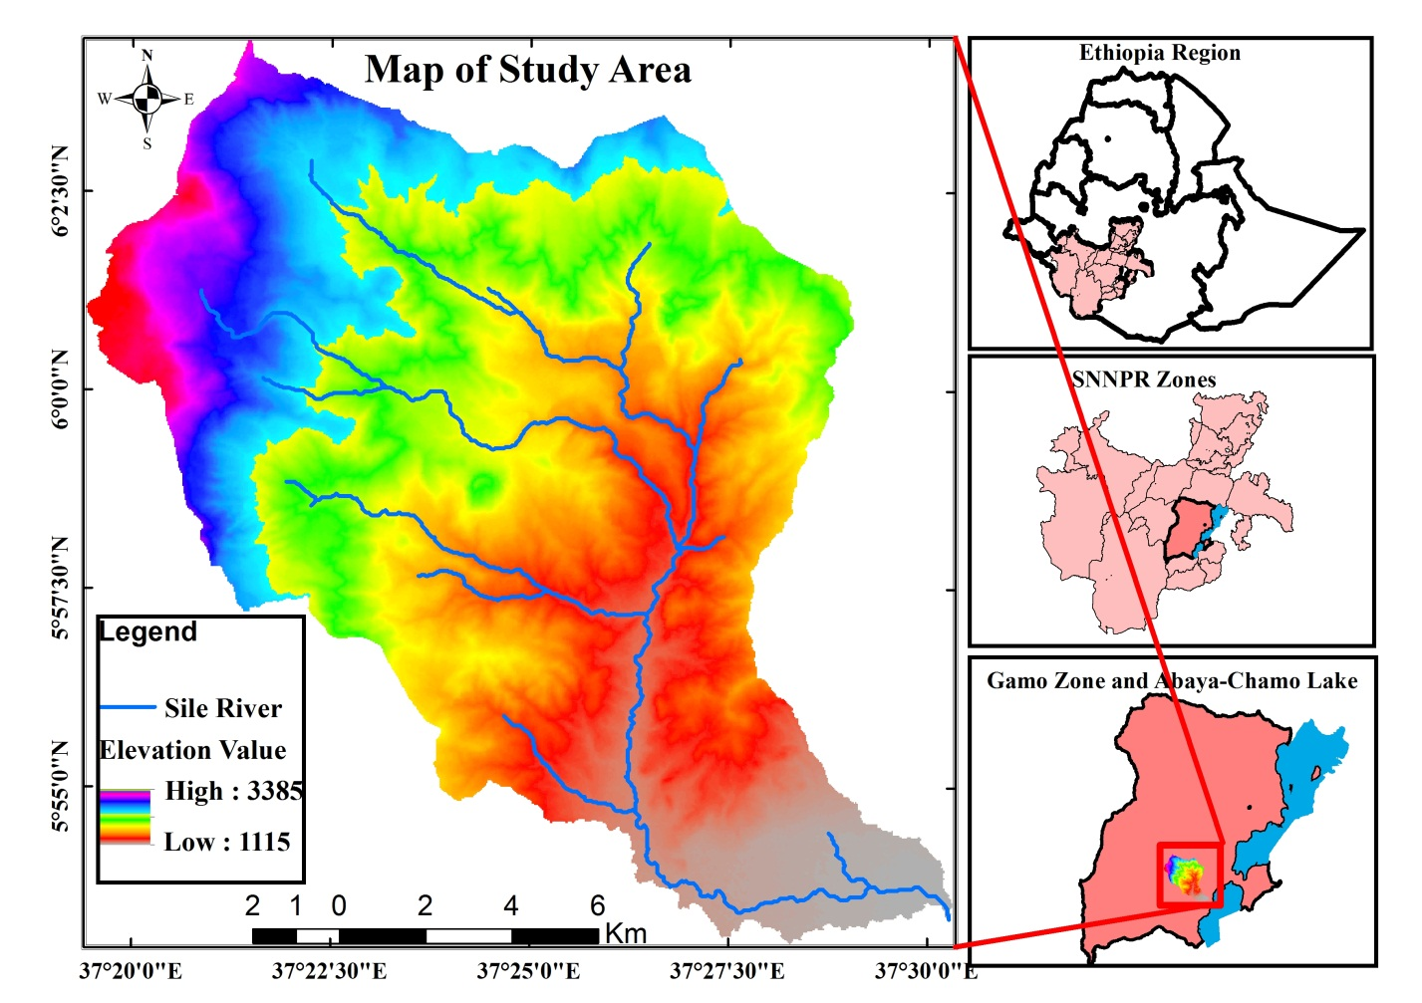
Figure.3.1: Location map of study area (Author, 2019)

3.1.2 Topography
Regionally the watershed is located in part of the South refit valley of Ethiopia and is characterized by highly to moderately rugged topography with a general decreasing trend of elevation from northwest towards southeast direction. The maximum elevation is 3385m.a.s.l at the Mano Mountain in northwest of watershed and the minimum elevation is 1115m.a.s.l at the outlet of the watershed near the Lake Chamo. There is an abrupt change of topography where Sile River emerged into a plain in bordering Lake Chamo see above Figure.3.1.

3.1.3 Climate
The highlands of study area are characterized all year round, the maximum rainfall is in summer and minimum is in winter. Receives a mean annual rain fall it varies from 1000-2500 mm. The average maximum temperature is 22.5°C, which occur in the months of December to January. The lowest minimum temperature is 10.1°C which occurs in the months of June to August.
The maximum and the minimum average monthly rainfall at the lowlands of the watershed are 15mm in the January and 295mm in the May. The rain over the watershed is with 80% of annual rain falling during March to October. The semi-arid climate with an average annual minimum and maximum temperature of 17°C and 32°C and dry season occurs from November to April (Bisrat et al., 2015).

3.2 Research Methodology

3.2.1 Research Design
In this research mixed approach was used to collect and analyses data. The data was collected from different sources whether primary or secondary. The data was analyzed respect to objectives concurrently. Similarity, the collected data analysis was involved both qualitative and quantitative techniques (Cresswell, 1999).

3.2.2 Data Sources
The required data for this study was generated from both primary and secondary sources. Primary data such as ground truth data were collected from field using Global positioning system (GPS) instruments and field observation was carried out. Secondary data such as rainfall data, DEM, satellite image and digital soil map were collected from different governmental, non-governmental organizations, published and unpublished materials such as research reports and journal paper obtain from different sources were used.

3.2.2.1 Rainfall Data
There is no any metrological station within the watershed. As a result, six stations were used in this study, which are located around the study watershed as shown in Figure.3.2. The monthly amounts of precipitation for these stations (Arba Minch, Dorze, Zigiti, Kemba, Gerese and Arguba) were last 15 years from the years 2004 to 2018 data obtained from National Metrological Agency (NMA) of Ethiopia.
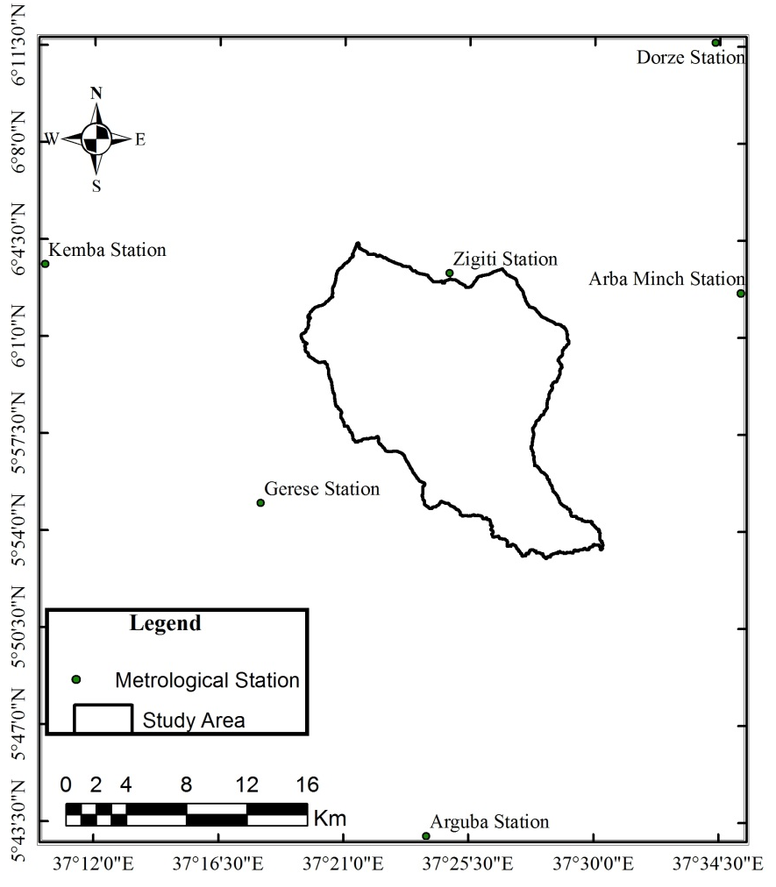
Figure.3.2: Metrological station map of study area (Author, 2019)

3.2.2.2 Soil Data
Digital soil map was obtained from the Ministry of Water, Irrigation and Energy used for this study in order to develop soil map in the analysis of soil erosion. The soil map has a polygon shape format. The soil feature map of the study area is obtained by clipping the soil map of Ethiopia with the study watershed in the GIS environment. Then, erodibility value (K-factor) is assigned for each of the soil types based on their colors as indicated by (Hurni H, 1985).

3.2.2.3 The Digital Elevation Model
The DEM for this study is extracted from USGS Earth Explorer website (eartexplorer.usgs.gov) with 30m resolution and used to develop topographic parameters such as slope gradient, elevation and slope length.

3.2.2.4 LULC Data
The 1989 Landsat TM, 2003 ETM+ and 2018 Landsat 8 satellite images which have a Path-169 and Row-056, acquired 15/01/1989, 28/01/2003 and 20/01/2018, from USGS Earth Explorer website (eartexplorer.usgs.gov) images month January during the dry season were used to classify the current and thirty years back LULC map of the study watershed. The image has 30*30m resolutions.
In addition, ground truth data were used, which is a vital reference for supervised classification, accuracy assessment and validation of the result. The field data collection was done to verify the classified image and to collect the necessary LULC data for training area delineation and accuracy assessment. The selection of appropriate time for ground data collection is one fundamental issue. Ground truth data were collected during similar season of image acquisition.

3.2.3 Data Collection Method and Instruments

3.2.3.1 Field Observation
At the beginning, based on the nature of data require a general personal field survey of the area was carried out by the researcher to have a general view of the study area. Later, with help of local guard, the researcher has conducted intensive field visit to observe topography, vegetation cover, settlement pattern and overall aspects of soil management practices of the study area.
The field trip was conducted for a month. The trip covered main parts of the study area extends from near Lake Chamo of lower shed to Mano Mountain of upper shed. During the field trip, ground control points were collected using GPS and climate stations were also recorded and registered. Climatic situation of the study area and LULC patterns were also partially identified.

3.2.3.2 Tools and Software
Table 3.1: Tools and software used
No | Name of tools and software | Purpose and description
1 | ArcGIS 10.5 | Spatial analysis and soil erosion rate map.
2 | ERDAS IMAGE 2014 | Image classification and LULC dynamics cover map.
3 | Google Earth | Study area interpretation and background for digitization
4 | Garmin GPS | Control points, ground truth verification and accuracy assessment
5 | Digital camera | LULC patterns and dynamics
Source; Author, 2019

3.2.4 Data Analysis
Both primary and secondary data was analyzed, summarized and presented via quantitative and qualitative methods. Regarding to the quantitative data, field survey was conducted, collected required information and analyzed to predict soil loss sites along the river. After collecting all necessary qualitative data, spatial data analysis and processing were done using ERDAS IMGINE 2014 and ArcGIS 10.5 software.

3.2.4.1 Method of Quantify LULC Dynamics Analyses
Multi temporal satellite imageries of the study area were imported to ERDAS IMAGINE 2014 image processing software. Image preprocessing, enhancement, classifications techniques were applied on the raw image. The classified images were used to extract information on land cover condition and quantification for the last three decades.
3.2.4.1.1 Image Preprocessing
Before LULC classification, RS data preprocessing techniques were employed using ERDAS IMAGINE 2014 software. Image enhancement is concerned with the modification of images to optimize their appearance of the visual system. Various false color composite raster band combinations in Red-Green-Blue order, noise reduction, haze reduction, histogram equalization, convolution, environmental correction, brightness adjustment and principal component analysis image enhancement techniques were employed.
3.2.4.1.2 Image Classification
As presented in Figure.3.3, satellite imageries were classified and analyzed using the basic photogrammetric elements (color, ton, texture, size, shape, structure, association, and shadow); the prior knowledge of the area and field observation.
LULC map for 1989, 2003, and 2018 were produced by supervised classification using the maximum likelihood classifier algorithms of ERDAS IMAGINE 2014 software. In supervised classification, three activities were done such as collecting spectral signature, evaluating signature and classified images. The images were interpreted or classified into six LULC classes, namely bare land, bush land, cultivation land, forest land, grass land and settlement.

Figure.3.3: Image classification process (Author, 2019)
3.2.4.1.3 Accuracy Assessment
Accuracy assessment was employed for determining whether the output map meets or does not meet level of acceptance. Error matrices are a common method of expressing classification accuracy, and were created to compare category by category basis, the reference data (ground truth) and the corresponding results of classification (Lillesand et al., 2013). The study assessed the accuracy of the classification results for each classified image.
After creating the error matrix for each classification, user accuracy, producer accuracy, overall accuracy and Kappa coefficient were computed. According to Lillesand et al., (2013) user’s accuracies are computed by dividing the number of correctly classified pixels in each category by the total number of pixels that were classified in that category (the row total). Producer's accuracies result from dividing the number of correctly classified pixels in each category (on the major diagonal) by the number of training set pixels used for that category (the column total). The Kappa coefficient (K_{hat}) of agreement was used for multivariate statistical measure that can be used to test LULC classification accuracy. Computing K_{hat} is the ability to use this value as a basis for determining the statistical significance of any given matrix or the differences among matrices.
$K=\frac{N\sum_{i=1}^{r}{x_{ii}-\sum_{i=1}^{r}{(x_{i+}*x_{+i})}}}{N^{2}-\sum_{i=1}^{r}{(x_{i+}*x_{+i}})}$------------------------Equation 2
Where r = number of rows in the error matrix; X_{ii} = number of observations in row i and column i (on the major diagonal); X_{i+} = total of observations in row i (shown as marginal total to right of the matrix); X_{+i} = total of observations in column i (shown as marginal total at bottom of the matrix) and N = total number of observations included in matrix.

3.2.4.2 Method of Estimate the Amount of Soil Loss Analyses
Both primary and secondary data were analyzed the use of the RUSLE in a GIS environment, with factors obtain from meteorological stations, Ministry of Water, Irrigation and Energy, USGS, and results of other relevant studies. Individual GIS layers were built for each factor in the RUSLE and combine by cell grid modeling procedures in ArcGIS 10.5 to predict soil loss in a spatial domain (Stanimir, 2010).
The expected soil loss rate express as ton ha⁻¹ y⁻¹ for the study area was determined using the RUSLE model in a GIS environment. The control factors of soil erosion, namely: climate, soils, vegetation cover, topography and Support practice/management are combined in the empirical RUSLE (Renard et al., 1996).
3.3.4.2.1 Rainfall Erosivity Factor
Erosivity can be predicted by a suitable regression equation in a case of insufﬁcient rainfall records (FES, 2009). Hence, since the rainfall kinetic energy and intensity data were not available in Sile watershed, the erosivity factor was calculated according to the equation given by Hurni (1985), derived from a spatial regression analysis for Ethiopian conditions. The model adapted by Hurni (1985) for Ethiopian condition is based on the available mean annual rainfall (MAR) data in mm.
R = -8.12 + 0.562P-------------------------Equation 3
Where R is rainfall erosivity (mm ha ⁻¹ y⁻¹) and P is mean annual rainfall (mm).
The MAR of the six stations generated from the monthly rainfall and interpolated by inverse distance weighted method to produce uninterrupted rain fall data for each grid cell in ArcGIS 10.5 environment. From this continuous rainfall data, the Rainfall erosivity (R) factor of each grid cell was calculated using Equation 3 and raster calculator geo-processing tool.
3.3.4.2.2 Soil Erodibility Factor
Soil erodibility is the manifestation of the inherent resistance of soil particles for the detaching and transporting power of rain fall (Wischmeier and Smith, 1978). This factor quantiﬁes the cohesive character of a soil type and its resistance to dislodging and transport due to raindrop impact and overland ﬂow shear forces. The Soil erodibility (K) factor is empirically determined for a particular soil type and reﬂects the physical and chemical properties of the soil, which contribute to its erodibility rate, recommended the K-values based on easily observable soil color as an indicator for the erodibility of the soil in the highlands of Ethiopia (Animka et al., 2013; Hurni, 1985; Helden, 1997). Thus, the soil types of Sile watershed were classiﬁed based on their color that was adapted to Ethiopia by (Hurni, 1985). Thus, the vector format of Sile watershed soil map was dissolved with vector format soil type map. The original vector format soil map was converted into raster format. The raster format was then reclassiﬁed based on K-factor value for each soil class in ArcGIS 10.5 using reclassiﬁcation geo-processing tools. Provided that the reclassiﬁcation of the raster soil map was done according to the soil color class given by (Hurni, 1985; Helden, 1997).
3.3.4.2.3 Topographic Factor
Slope length (L) and slope gradient (S) are factors representing the topography of the land and they define the effects of slope length and slope angle respectively on sheet and rill erosion. Slope length is defined as the horizontal distance from the origin of overland flow to the point where deposition begins or where runoff flows into a defined channel (Renard et al., 1999).
LS-factor are usually considered together to combine the effect of slope and slope length, which basically reflects the terrain on a given site. In this study, an approach developed by Moore and Burch (1985) is used to compute LS-factor.
The DEM was used to determine which cells flow into other cells flow direction. However, if there are errors in the elevation model there may be some cell locations that are lower than the surrounding cells. If this is the case, all water traveling into the cell will not travel out. These depressions are called sinks. The hydrologic analysis functions allow identifying the sinks and giving tools to fill them. This creates a raster of flow direction from each cell to its steepest down slope neighbor. It creates a raster of accumulated flow to each cell. The result of flow accumulation is a raster of accumulated flow to each cell, as determined by accumulating the weight for all cells that flow into each downslope cell. Calculate slope of watershed in degree using DEM as the input layer in Arcmap 10.5 by spatial analyst tools and wrote the LS-factor formula below in Arcmap 10.5 using map algebra tool in spatial analyses of the raster calculation. This study therefore employed the following advanced LS-factor computation method based on up slope contributing area suggested by (Desmet and Govers, 1996; Moore and Burch, 1986; Mitasova, and Mitas, 1999; Simms et al., 2003).
Power (“flow accumulation”*”cell resolution”/22.13, 0.4) * power (sin (“slope in degree” *0.01745)/0.0896,1.4)*1.4
LS = Power (“flow accumulation”*30/22.13, 0.4) * power (sin (“slope in degree”)* 0.01745/0.0896,1.4)*1.4-----------------Equation 4
3.3.4.2.4 Cover Management Factor
Assessment of the type of LULC was made separately for each land classes and the corresponding value for LULC were obtained from Hurni (1985) which was adapted to Ethiopian condition. LULC data were generated by ERDAS IMAGINE 2014 software from the satellite image using supervised classification. The 2018 Landsat 8 satellite image was used to classify the current LULC of the watershed. The image has 30*30m resolution. Ground truth data 35-50 pontes ware used for the supervised image classification. Accuracy assessment and validation of the result the selection of appropriate time for ground truth data collection were fundamental issue. In order to determine C-factor, Sile watershed was classified into six LULC classes generated from Landsat 8 images of 2018, Path-169 and Row-056 by applying maximum likelihood of supervised classification. After getting the classified image, thematic LULC raster map of Sile watershed was then converted to vector format to assign the corresponding cover and management factor value obtained from different studies. Finally, raster map of C-factor was produced.
3.3.4.2.5 Support Practice Factor
The P-factor map generated is used for understanding the conservation practices being taken up in the study area. This factor considers the control practices which reduce the eroding power of rainfall and runoff by their impact on drainage patterns, runoff concentration, and runoff velocity. The supporting mechanical practices include the effects of contouring, strip cropping, or terracing (Hyeon and Pierre, 2006). Wischmeier and Smith (1978) assigned the P-factor value by categorizing the land into agricultural and other land major kinds of LULC types. They then subdivided the agricultural land in to six slope classes and assigned P-value for each respective slope class as many management activities are highly dependent on slope of the area. In this study, this method of combining general LULC type and slope was therefore adopted. Values for this factor were therefore assigned considering local management practices along with values suggested in Wischmeier and Smith (1978).
Hence, in this study the lands with bare land, bush land, forest land, grass land and settlement were classiﬁed as other lands given the P-value regardless of the slope class they have, whereas the cultivation land was classiﬁed into six slope classes and given P-values as discussed by Wischmeier and Smith (1978). Finally, the classiﬁed LULC and slope thematic map format has been changed to vector format and the corresponding P-values were assigned to the combination of each LULC and slope classes, and raster map of P-factor was produced.
DEM (30m*30m)

Rainfall data
Soil map
Land sat image
Field data
Management practice map
P-factor
Image classification
C-factor
K-factor
R-factor
LS-factor
K*R*LS*C*P
Soil erosion risk map
LULC map
Flow length
Slope
Figure.3.4: Methodology of flowchart diagram
Figure.3.4: Methodology of flowchart diagram (Author, 2019)
To identify the spatial pattern of rate soil erosion in the study area, all the considered erosion factors (R, K, LS, C and P-factor) had been surveyed and calculated de pending on the recommendations of Hurni ( 1985) to Ethiopian context and other related studies. RUSLE doesn’t estimate de position, sediment yield at a downstream location and ephemeral gully erosion and doesn’t represent fundamental erosion processes and interactions. It is however, found to an adequately represent the first order effect of the factors that affect sheet and rill erosion. Individual GIS files were built for each factor in the RUSLE and combined by cell-grid modeling procedures in GIS software to predict soil loss in a spatial domain. The flow chart of erosion risk mapping is presented above in Figure.3.4.

CHAPTER FOUR

RESULT AND DISCUSSION
In this chapter, results of the data analysis are interpreted and a discussion is made considering existing realities of the study site and also in comparison with the findings of other studies conducted on issues related to this research work. Besides, in the chapter, the findings of the study are presented and reported in different ways below.

4.1 LULC Dynamics Analysis

4.1.1 Quantify LULC Dynamics Over the Past Thirty Years
The LULC dynamics maps were correctly classified independently according to the selected land use classes including bare land, bush land, cultivation land, forest land, grass land and settlement for each period (1989, 2003 and 2018). The LULC classification maps for the study site are depicted in Figure.4.1 and spatial temporal LULC dynamic process was analyzed (Table 4.1).
Table 4.1: LULC share of each class
LULC classes |  | 1989 |  | 2003 |  | 2018
LULC classes |  | Area (ha) | Area (%) | Area (ha) | Area (%) | Area (ha) | Area (%)
Cultivation land |  | 5764 | 25.8 | 6847 | 30.7 | 7601 | 34
Settlement |  | 904 | 4.2 | 1549 | 6.9 | 2101 | 9.4
Grass land |  | 2756 | 12.3 | 3189 | 14.3 | 3107 | 13.9
Bare land |  | 638 | 2.8 | 843 | 3.8 | 964 | 4.3
Bush land |  | 6618 | 29.6 | 6387 | 28.6 | 5263 | 23.6
Forest land |  | 5647 | 25.3 | 3512 | 15.7 | 3291 | 14.8
Total |  | 22327 | 100 | 22327 | 100 | 22327 | 100
Source: Own survey, 2019
Based on the LULC classification, the major part of the area was covered by bush land in 1989. In 1989 bush land, cultivation land and forest land covered 29.6%, 25.8 % and 25.3% of the total area respectively. The remaining parts of the area were covered with grass land (12.3%), settlement (4.2%) and bare lands (2.8%) respectively see (Table 4.1 and Figure.4.2).
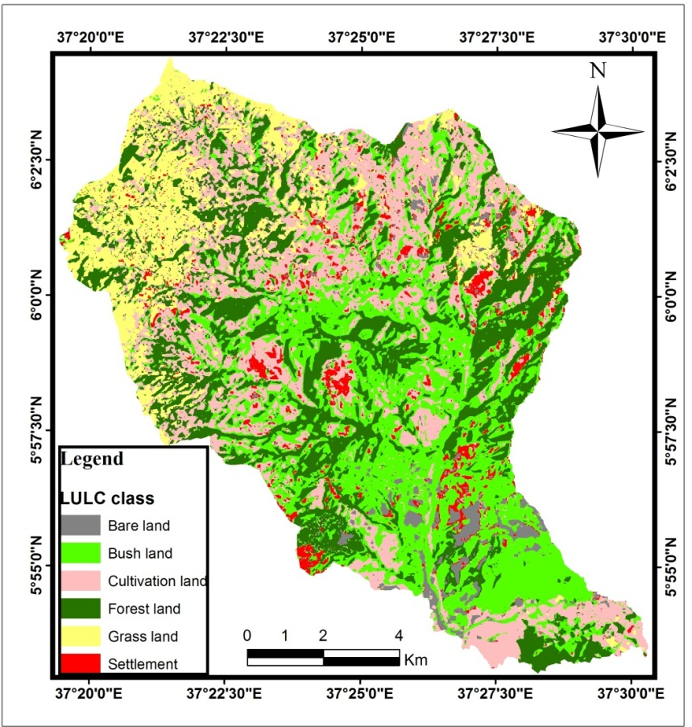
Figure.4.1: Landsat image TM of 1989 Showing LULC of the study area (Author, 2019)
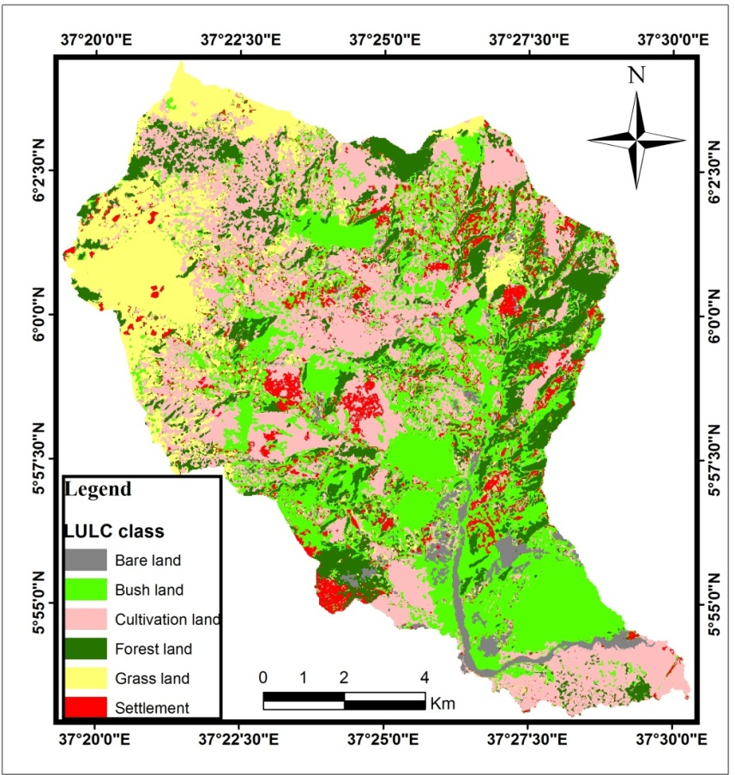
Figure.4.2: Landsat image ETM+ of 2003 showing LULC of the study area (Author, 2019)
In 2003 cultivation land, bush land and forest land covered 30.7%, 28.6% and 15.7% of the total area respectively. The rest of the areas were covered with grass land (14.3%), settlement (6.9%) and bare land (3.8%) respectively see (Table 4.1 and Figure.4.3).
In 2018 cultivation land had the largest areal coverage (34%) and the remaining (66%) was the share of other LULC classes (Table 4.1, and Figure.4.4). To some extent in the classification, the plantation LULC type was generalized to other classes, but, as evident in the field observation, forest is highly diminished due to cultivation. The forest cover has been declining since the year 1989 in the order of 15.7% for 2003 and 14.8% for 2018.
In the period 1989 to 2018, cultivated land was highly changed as compared to settlement with spread to 6847ha (30.7%) in 2003 and with expansion of 7601ha (34%) from some forest and grass land LULC classes. However, bush land compared less area change. On the other hand, forest land and bush land lost large areas (5647 and 6618 ha respectively).
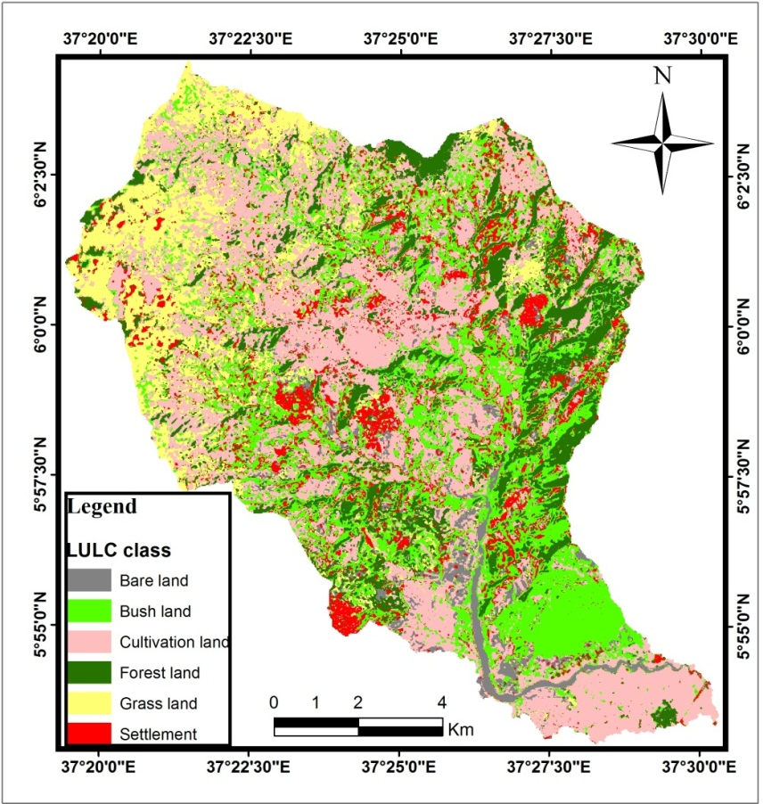
Figure.4.3: Landsat 8 image of 2018 showing LULC map of the study area (Author, 2019)

4.1.2 LULC Change Detection
The LULCC of 1989, 2003 and 2018 is summarized in Table 4.1 and 4.2. In 1989, cultivation land accounts for 25.8%, settlement (4.2%), grass land (12.3%), bare land (2.8%), bush land (29.6%) and forest land (25.3%). In 2003 LULC map cultivation land, grassland, settlement and bare lad change rate in coverage to 4.8%, 1.9%, 2.9% and 1% respectively, while forest and bush land decreased -9.6% and -1%.
Table 4.2: LULC change detection share of each class (1989-2018)
LULC classes | Periods
LULC classes | 1989-2003 |  | 2003-2018 |  | 1989-2018
LULC classes | Area (ha) | Area (%) | Area (ha) | Area (%) | Area (ha) | Area (%)
Cultivation land | 1083 | 4.8 | 754 | 3.4 | 1837 | 8
Settlement | 645 | 2.9 | 552 | 2.5 | 1197 | 5.4
Grass land | 433 | 1.9 | -82 | -0.4 | 351 | 1.6
Bare land | 205 | 1 | 121 | 0.5 | 326 | 1.5
Bush land | -231 | -1 | -1124 | -5 | -1355 | -6
Forest land | -2135 | -9.6 | -221 | -1 | -2356 | -10.5
Source: Own survey, 2019
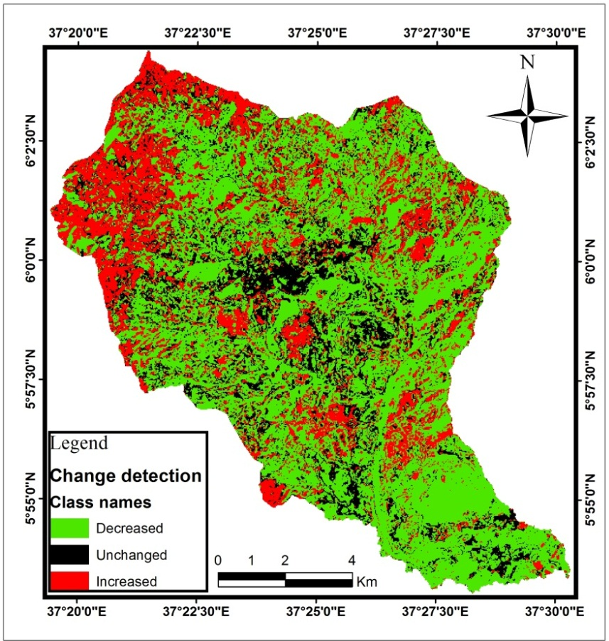
Figure.4.4: Map showing change detection of LULC classes which increases by 10%, decreases by 10% and unchanged LULC classes from 1989 to 2018 image (30 years change detection)
In 2018 LULC, cultivation accounted for about 34%, followed by bush land (23.6%), forest land (14.8%), grass land (13.9%) settlement (9.4) and bare land also accounted for about 4.3%. From 2004 to 2018 indicated that cultivation, settlement, and bare land increased by +3.4, +2.5, and +0.5 percent respectively. When the change analysis for the last 30 years is observed, cultivation land showed an increase of 8% followed by settlement, grass land and bare land showing an increase of 5.4%, 1.6% and 1.4% and forest and bush land decreased by -10.5% and -6% respectively see Figure.4.4 .

4.1.3 Accuracy Assessment
Classified LULC dynamics maps from RS imageries may contain some errors. Therefore, accuracy assessment was employed to find out those errors so as ensure reliability of the produced LULC dynamics maps. The classified maps were assessed and compared with a referenced data and ground truth using an error matrix. The ground truth data were utilized in the classification report as the independent data set from which the classification accuracy was compared. An error report containing the error matrix and accuracy report summarizing the agreement and disagreement are produced (Appendix II).
Table 4.4: Error matrix of classification for 2018 images
Classified Samples |  | Ground Truth
 |  | Cultivation | Settlement | Bare | Forest | Bush/Shrub | Grass | Row Total | UA (100%)
Cultivation |  | 47 | 0 | 3 | 0 | 0 | 0 | 50 | 94
Settlement |  | 1 | 44 | 2 | 0 | 0 | 1 | 48 | 91.6
Bare |  | 1 | 0 | 41 | 0 | 0 | 1 | 43 | 95.3
Forest |  | 0 | 0 | 0 | 45 | 0 | 0 | 45 | 100
Bush/Shrub |  | 0 | 0 | 0 | 0 | 34 | 1 | 35 | 97.2
Grass |  | 2 | 1 | 1 | 0 | 0 | 28 | 32 | 87.5
Total Column |  | 51 | 45 | 47 | 45 | 34 | 31 | 253
PA (100%) |  | 94 | 91.6 | 95.3 | 100 | 97.2 | 87.5
Over all accrues = 0.944664032
K= 0.933259219
Where UA=user accuracy PA= producer accuracy K=Kappa statistics
Source: Own survey, 2019
The overall accuracies are 94% with the Kappa statistics of 0.933 respectively (Table 4.4). The Kappa statistics value greater than 0.80 (i.e., 80%) represents a strong agreement and a value between 0.60 and 0.80 represents a substantial agreement (Landis and Koch, 1977). Hence, the maps met the accuracy requirements for change detection analysis and there is a positive correlation between the RS classified samples and the reference data.
Results of user’s accuracy in this study showed that the maximum class accuracy was for forest land (100%) and the minimum was for grassland (87.5%). Results of producer’s accuracy showed that forest land relatively correctly classified and lowest accuracy was grass land 87.5% respectively (Table 4.4).

4.2 Estimated Amount of Soil Loss from the Watershed

4.2.1 Rainfall Erosivity Factor
The Mean annual precipitation (MAP) ranges from 798.17mm (Arguba station) to 1514.24mm (Gerese station). The MAP of Zigit station which is quite close to the study watershed is 1219.53mm; this value has great weight to the R-value of the watershed see below Table 4.4.
Table 4.4: MAP and the corresponding R-factor value
Station Name | MAP (mm) | R-factor (mm ha⁻¹ y⁻¹)
Arba Minch | 817.177 | 451.13
Dorze | 1331.89 | 740.4
Zigit | 1219.53 | 677.25
Kemba | 1379.56 | 767.19
Gerese | 1514.24 | 842.88
Arguba | 798.17 | 440.45
Source: National Meteorological Agency (Computed, 2019)
Considering topographic variation, the R-factor was determined from average long term rainfall data interpolated from six stations. The R-factor value ranges between 600.17 and 767 mm ha⁻¹ y⁻¹ in the study area. The effect of rainfall on soil erosion is high at the northwest part of the watershed, with a mean erosivity value of 662.58 mm ha⁻¹ y⁻¹. On the other hand, the erosion rate of rainfall gradually decreases from the northwest to the southeast part of the watershed see Figure.4.5.
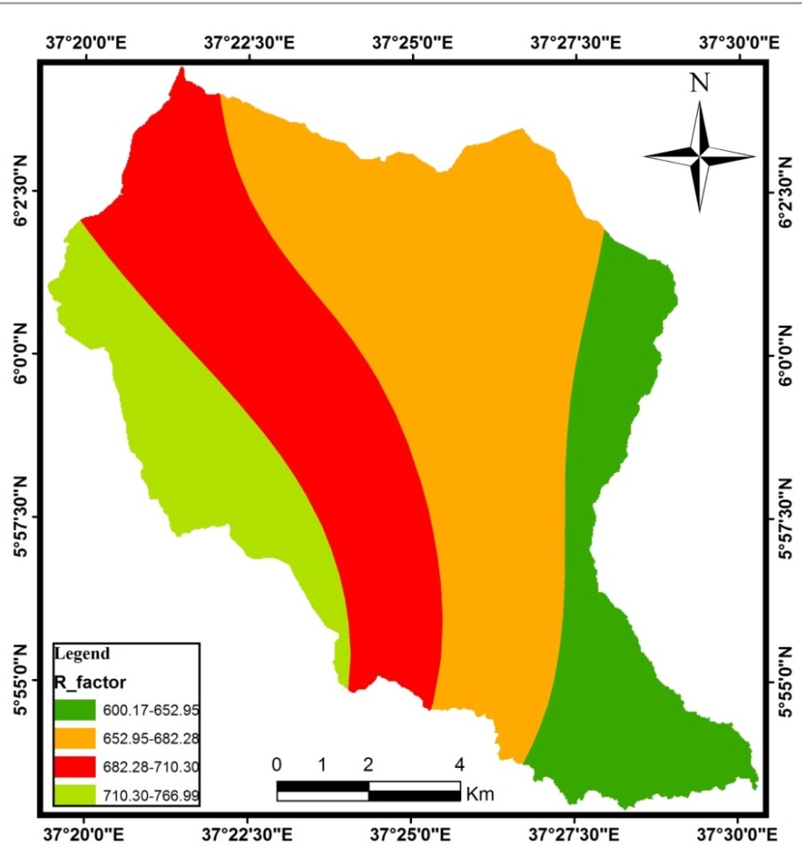
Figure .4.5: R-factor map of the watershed (Author, 2019)

4.2.2 Soil Erodibility Factor
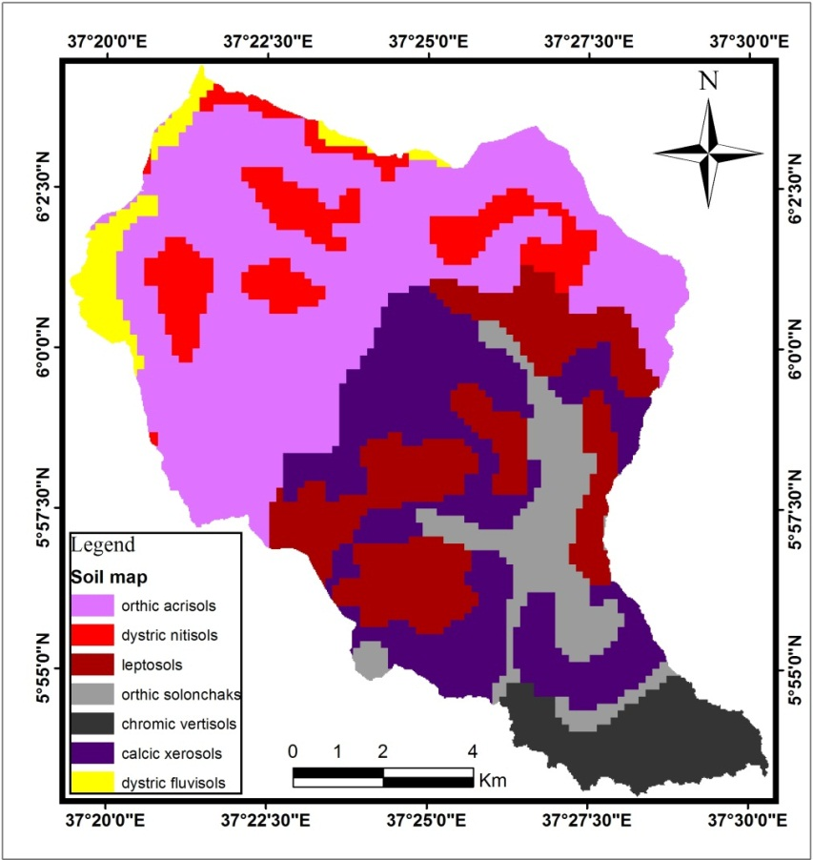
Figure.4.6: Soil map of the watershed (MWIE, 2019)
The K-factor value of Sile watershed comprises five dissimilar soil color types, but seven soil class. Calcic xerosols and orthic acrisols (brown), dystric nitisols and leptosols (red), chromic vertisols (black), dystric fluvisols (yellow) and orthic solonchaks (gray) were the dominant soil class in Sile watershed. Thus, the K-factor value was assigned for each soil class with special reference to their color as recommended by Hurni (1985). Accordingly, the K-value of 0.2, 0.15, 0.3, 0.25 and 0.32 were assigned for calcic xerosols and orthic acrisols, chromic vertisols, dystric fluvisols, dystric nitisols and leptosols and orthic solonchaks respectively see Table 4.5.
Table 4.5: Seven soil types and five colors in Sile watershed and their erodibility value
No | Soil type | Soil color | Erodibility factor (K-factor) | Area (ha) | Area (%)
1 | Calcic xerosols | brown | 0.2 | 4586 | 20.6
2 | Chromic vertisols | black | 0.15 | 1480 | 6.7
3 | Dystric fluvisols | yellow | 0.3 | 675 | 3
4 | Dystric nitisols | red | 0.25 | 1947 | 8.7
5 | Leptosols | red | 0.25 | 3618 | 16.2
6 | Orthic acrisols | brown | 0.2 | 8068 | 36.1
7 | Orthic solonchaks | gray | 0.32 | 1953 | 8.7
Source: FAO soil classification
Therefore, we can understand that orthic solonchaks have high K-value (0.32); hence these soils are highly affected by erosion followed by dystric fluvisols with K-value of 0.3. On the contrary, chromic vertisols has low soil erodibility factor (0.15); it is therefore less susceptible to the detaching power of rain drop. Most of the upper and midel part of Sile watershed is dominated by calcic xerosols and orthic acrisols which are intrinsically moderately resistant to the eroding power of rain fall. Whereas, chromic vertisols with high-resistance to rain fall force is situated in the outlet of the watershed see above Figure.4.6.

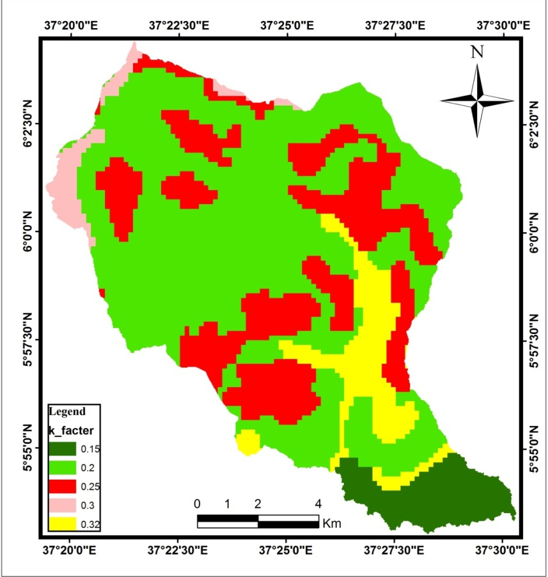
Figure.4.7: K-factor value map of the watershed (Author, 2019)

4.2.3 Slope Length Factor
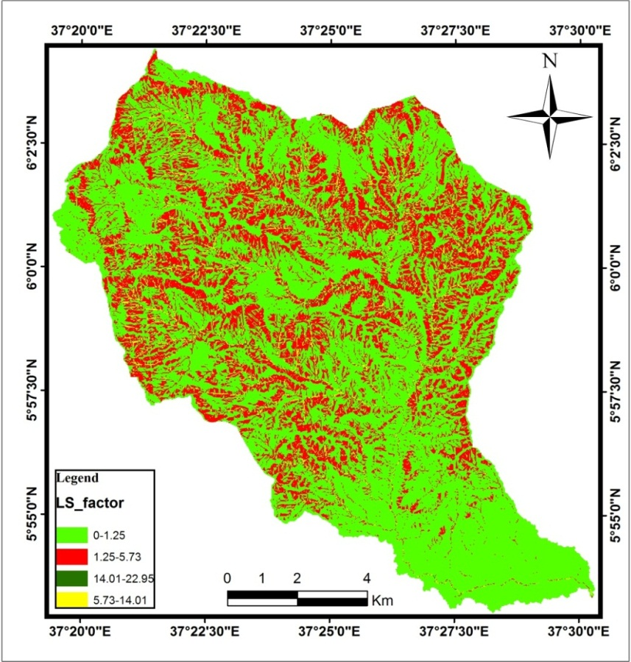
Figure.4.8: LS-factor value map of the watershed (Author, 2019)
The topographic component of RUSLE model was computed using (Equation 4) suggested by (Moore and Burch, 1986; Mitasova and Mitas, 1999; Simms et al., 2003). As shown in the figure below. in the lower part of the watershed the slope length is high due to high flow accumulation. On the other hand slope inclination is high in the middle parts of the watershed. Hence the combined LS-factor ranges from 0 to 22.95 on the upper and middle part of watershed respectively. This implies that the influence of the combined LS-factor for soil erosion is significant in the upper parts of watershed.
As a result, the LS-factor of extends from 0 in the lower part of the watershed to 22.95 in the steepest slope upper part of the watershed. This implies that the inﬂuence of the combined LS-factor for soil loss is signiﬁcant in the upper and middle part of the watershed. On the contrary, the LS-factor contributes insignificantly for soil erosion in the lower part of the watershed (Figure.4.8).

4.2.4 Land Use/Cover Factor
The supervised image classification of the study area, six LULC classes were identified (bare land, bush land, cultivation land, forest land, grass land and settlement). By the image classification has showed that large portion of the watershed (39.4%) is covered by cultivation land see Table 4.6.
Table 4.6: LULC and the corresponding value of C-factor
No | LULC type | Area (ha) | Area (%) | C-factor
1 | Bare land | 2662 | 12.4 | 0.05
2 | Bush land | 1193 | 5.3 | 0.014
3 | Cultivation land | 8803 | 39.4 | 0.18
4 | Forest land | 2970 | 13.3 | 0.001
5 | Grass land | 1093 | 4.5 | 0.01
6 | Settlement | 5606 | 25.1 | 0.05
Source: Own survey, 2019
Therefore these cultivation lands have higher value of C-factor and are susceptible to erosion. Whereas most of the middle catchment of the watershed is dominated by bush land and assigned the C-value of 0.014 which has less C-factor value next to forest and grass land. The magnitude and spatial pattern of C-factor show values between 0.001 to 0.18 in (Table 4.6). The C-factor values were assigned to be 0.001 for the areas representing well protected forest land where less erosion process occurs and high value 0.18 for the cultivation land. Therefore we conclude that the contribution of C-factor for soil erosion model is higher in case of cultivation land followed by settlement and bare land (Figure.4.9).
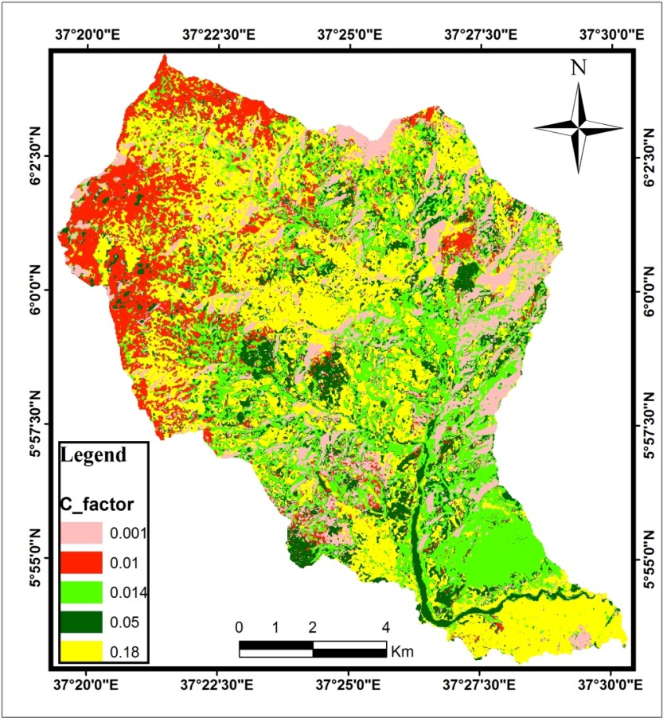
Figure.4.9: C-factor map of the watershed (Author, 2019)

4.2.5 Management Practice Factor
The field observation and report of Gamo Zone Ofﬁce of Agriculture conﬁrmed that different supporting cropland and other land practices in the study area were conducted around the reservoir in the middle and lower part of the watershed. These are contour tillage, area closure, terrace, stream bank stabilization, forest development, and grass strip development. Stabilized water ways for the disposal of excess rainfall are also a necessary part of each of this practice.
As explained in detail, Wischmeier and Smith (1978) method of calculating the P-value was used. As illustrated in Figure.4.9 below, most of the center upper catchment and some of the eastern middle part of the watershed exhibits P-value of 1. On the contrary, most of the lower part of the watershed has the P-value of nearly 0.1. This implies that the upper catchment of the watershed where erosion management practice were not yet conducted, shrub and grass lands are dominated as well the highest slope classes are dominant have a signiﬁcant contribution for erosion.
Table 4.7: LULC type, slope and P-factor value
LULC type | Slope (%) | P-factor
Cultivation land | 0-5 | 0.11
Cultivation land | 5-10 | 0.12
Cultivation land | 10-20 | 0.14
Cultivation land | 20-30 | 0.22
Cultivation land | 30-50 | 0.31
Cultivation land | 50-100 | 0.43
Other land | all | 1
Source: Own survey, 2019
As explained in detail, Wischmeier and Smith (1978) method of calculating the P-value was used. As illustrated in Figure.4.9 below, most of the center upper catchment and some of the eastern middle part of the watershed exhibits P-value of 1. On the contrary, most of the lower part of the watershed has the P-value of nearly 0.1. This implies that the upper catchment of the watershed where erosion management practice were not yet conducted, shrub and grass lands are dominated as well the highest slope classes are dominant have a signiﬁcant contribution for erosion.
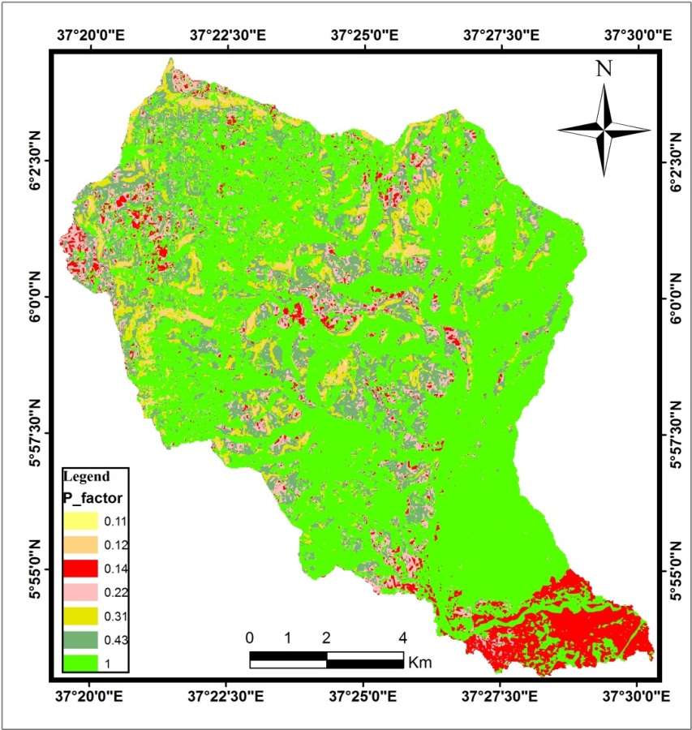
Figure 4.10: P-factor map of the watershed (Author, 2019)
The P-factor values decrease by adopting the conservation practice. In the study area the support practice factor applied on the upper and middle parts of the watershed. These indicates that the lower P-factor value have better practice for controlling soil erosion. The P-factor value of the watershed ranged from 0.11 to 1.

4.2.6 Amount of Soil Loss Per Unit Area Per Year
The ﬁnal map that shows the rate annual soil loss of the watershed was produced by overlaying the above ﬁve parameters (R, K, LS, C, and P-factor) using (Equation 1) and raster calculator geo-processing tools in ArcGIS 10.5 environment (Figure.4.10). Each layer was organized in a grid format with a resampled cell size (30*30m) of the DEM. Furthermore, the statistical tool has been used to estimate the amount of soil loss rate and to classify the level of the soil loss risk in the study watershed. For the matter of management prioritization, soil erosion map of the watershed was classiﬁed in to fore classes as shown in Table 4.8 and Figure.4.11 below.
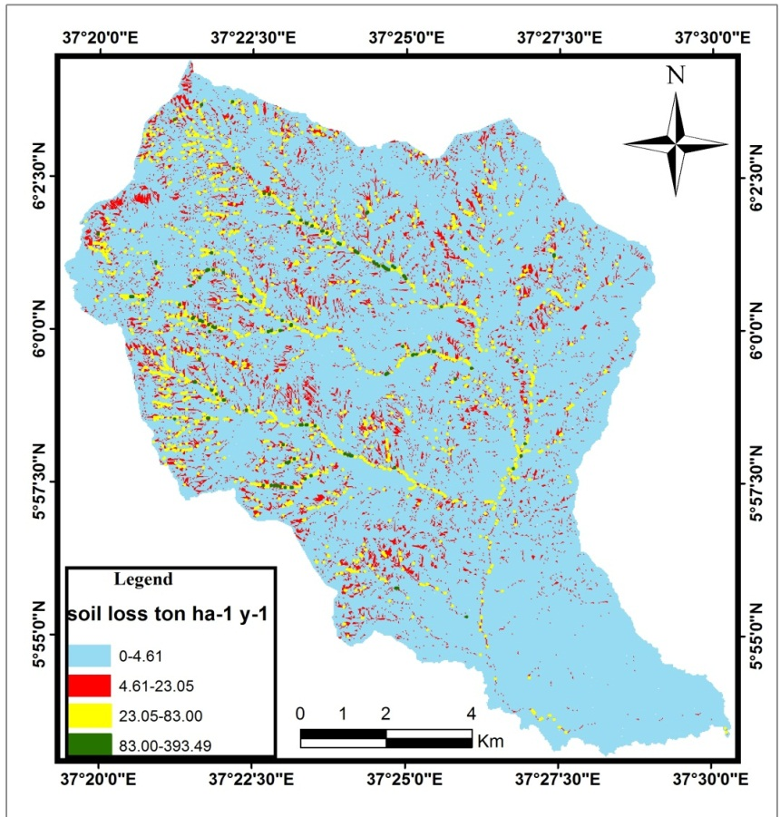
Figure 4.11: Soil loss rate map of the watershed (Author, 2019)
As shown in Figure.4.10, the annual soil loss of Sile watershed extends from 0 (the lower, middle and upper part) to 393.49 metric ton ha⁻¹ y⁻¹ (the narrow steep slope lower, middle and upper watershed) with a mean annual soil loss rate of 55.7 ton ha⁻¹ y⁻¹.

Table 4.8: Area coverage and proportion of soil erosion risk classes
No | Numerical range of soil loss rate (ton ha⁻¹ y⁻¹) | Area (ha) | Area (%)
1 | 0-4.61 | 20294 | 90.9
2 | 4.61-23.05 | 1843 | 8.2
3 | 23.05-83.00 | 178 | 0.8
4 | 83.00-393.49 | 12 | 0.06
Source: Own survey, 2019
The rate soil erosion map of the study watershed have been divided in to four classes, therefore soil loss less than 4.61 ton ha⁻¹y⁻¹ which is described as low soil erosion risk class; between 4.61 and 23.05 ton ha⁻¹y⁻¹ described as moderate soil erosion risk class; between 23.05 and 83 ton ha⁻¹ y⁻¹ described as high soil erosion risk class; and above 83 ton ha⁻¹ y⁻¹ described as very high soil erosion risk class. The area coverage and relative per cent of each class has been derived from the soil erosion rate map of the study watershed. The spatial locations of the high spot area for soil erosion in the study revealed that the rate soil loss is typically greater along the steeper slope banks of tributaries. Other high soil erosion areas are dispersed throughout the watershed and are typically associated with high erosion rate land uses.

4.3 Prioritization of Sub-watersheds

4.3.1 Sub-Watershed Pattern and Erosion Rate
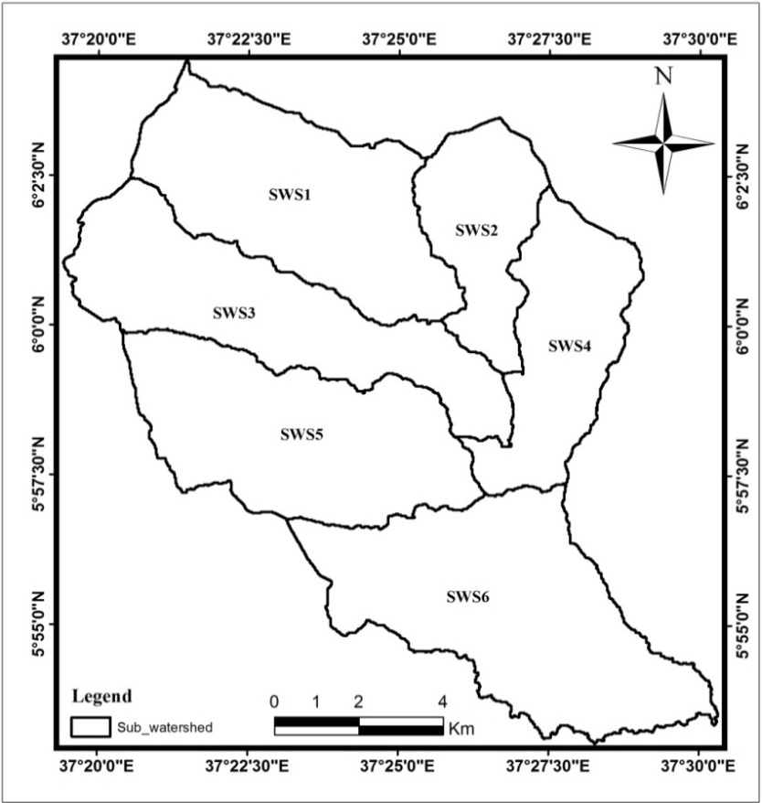
Figure.4.12: Sub-watersheds map of the Sile watershed (Author, 2019)
The study watershed is classified into six sub-watershed based on their drainage pattern (Figure.4.11). The sub-watershed generated by ArcGIS 10.5. The area of the sub-watersheds ranges between 1958 ha (sub-watershed SWS2) and 5250 ha (sub-watershed SWS6). The soil loss values for each of the sub-watershed were extracted from the soil loss rate map of the watershed and mean soil loss value for each sub-watershed is recorded as shown in Table 4.9 below.
Table 4.9: Soil loss from sub-watershed
Rank | Sub-watershed | Area (ha) | Area (%) | Mean soil loss (ton ha⁻¹ y⁻¹) | Ranges of soil lose (ton ha⁻¹ y⁻¹)
1 | SWS3 | 3936 | 17.6 | 75.5 | 0-294.4
2 | SWS1 | 4269 | 19.1 | 70.1 | 0-393.4
3 | SWS5 | 4295 | 19.2 | 59.6 | 0-188.5
4 | SWS4 | 2619 | 11.7 | 36.6 | 0-123.7
5 | SWS2 | 1958 | 8.7 | 35.7 | 0-128.2
6 | SWS6 | 5250 | 23.5 | 31.2 | 0-110.8
Source: Own survey, 2019
Of the six sub-watersheds, three (SWS1, SWS3 and SWS5) were predicted to experience annual soil loss of more than the watershed’s average (55.7 ton ha⁻¹y⁻¹), whereas three sub-watersheds (SWS2, SWS4 and SWS6) estimated annual soil losses were less than the average (Table 4.9).

4.3.2 Prioritization of Sub-Watersheds Based on Erosion Risk
Table 4.10: Severity classes and Prioritization of sub-watersheds
Priority classes | Severity classes | Sub-watersheds | Mean soil loss (ton ha⁻¹ y⁻¹) | Area (ha) | Area (%)
I | very high | SWS3, SWS1 | >70 | 8205 | 36.7
II | High | SWS5 | 50-70 | 4295 | 19.2
III | Moderate | SWS4, SWS2 | 35-50 | 4577 | 20.5
IV | Low | SWS6 | 30-35 | 5250 | 23.5
Source: Own survey, 2019
Prioritization of sub-watershed was done on the basis of average annual soil loss. Prioritization of different erosion classes followed the FAO basic classification of desertification FAO (1986) with some modification to suit the features of the study area (Table 4.10). Soil loss tolerance denotes the maximum allowable soil loss that will sustain an economic and a high level of productivity (Wischmeier and Smith,1978; Gebreyesus and Kirubel, 2009). The assignment of a range depended on the judgment of how much erosion would be harmful to the soil. Figure.4.13 shows areas with higher soil loss rate than the soil loss tolerance.
The result showed that very high soil loses (>75 ton ha⁻¹ y⁻¹) is observed in the north western part of the watershed. Out of the six sub-watersheds, two sub-watersheds (SWS3, SWS1) covering an area of 8205 ha and which accounts 36.7% of the total area. Sub-watershed SWS5 covering an area of 4295 ha and accounts 19.2 % fell under high soil loss classes (50-75 ton ha⁻¹ y⁻¹). The sub-watersheds SWS4, SWS2 and SWS6 that are predicted to experience low to moderate soil loss together cover about 44% of the watershed area. Generally, the result showed that the upper northwest part of the watershed is characterized by high generation of soil loss.
On the basis of annual soil losses, those sub-watersheds fell on high and very high erosion classes were found to be critical. After ranking the critical sub-watersheds in ascending order, considering the annual soil losses from each sub-watershed, priorities were fixed (Table 4.10). The sub-watershed that comes first is given the top priority for developing the management plan to reduce the soil and nutrient losses.
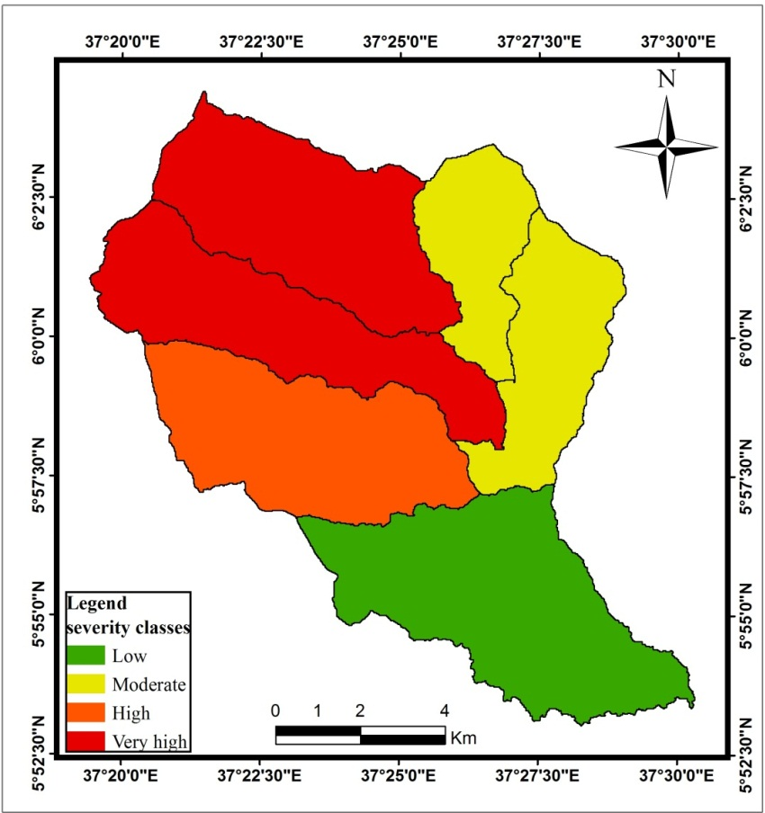
Figure.4.13: Sub-watershed erosion level of the study area (Author, 2019)

CHAPTER FIVE

CONCLUSION AND RECOMMENDATION

5.1 Conclusion
Land use/land cover is one of the important factors that used to minimize soil erosion. Based on this having knowledge about changes occurs on land use/land cover a feature is effective for soil conservation and protection. In this area are unsustainable land use/land cover practices aggravated by continuous settlement and deforestation.
Soil erosion is a serious problem in the highlands of Ethiopia and attempting different methods to evaluate soil loss at the watershed scale is necessary for planning of soil erosion protection and conservation measures, which are necessary for sustainable land use and development. Revised universal soil loss equation is often used to estimate average annual soil loss from study area. GIS is valuable tool for soil erosion risk estimation and prediction. With proper selection of Digital Elevation Model, satellite imagery indices and appropriate methodology, very objective results can be achieved. GIS based soil erosion risk assessment, minimizes subjective errors of the traditional estimations, and maximizes the possibilities for different uses and spatial computation. To adopt the revised universal soil loss equation, large sets of data starting from rainfall, soil, slope, land use/land cover class, and land management are needed in detail. This paper attempts to analyses land use/land cover, evaluate soil losses and map the area susceptible to the soil erosion in Sile watershed by means of satellite images, remote sensing and GIS tools. The average annual soil loss in the Sile watershed area was computed by overlaying the five factor maps using Revised Universal Soil Loss Equation with spatial analyst extension. The annual soil loss ranged from 0-393.49 tons ha⁻¹ y⁻¹ the mean value is 55.7 ton ha⁻¹ y⁻¹.
Prioritization of sub-watershed was done on the basis of average annual soil loss. Out of the six sub-watersheds, two sub-watersheds (SWS3, SWS1) covering an area of 8205 ha and which accounts 36.7% of the total area. Sub-watershed SWS5 covering an area of 4295 ha and accounts 19.2% fell under high soil loss classes (50-75 ton ha⁻¹ y⁻¹). The sub-watersheds SWS4, SWS2 and SWS6 that are predicted to experience low to moderate soil loss together cover about 44% of the watershed area.

5.2 Recommendation
The primary focuses of this study was to land use/land cover dynamics and assessment soil erosion of the study watershed based on the land use/cover dynamics and amount of soil loss using selected factors. So, any strategy which will be used for soil conservation must focus upon the changes of the values of the factors that are taken into consideration in soil loss evaluation. In addition, the following points are forwarded as a recommendation:
- This study also recommends that education and creating awareness to communities on the need of sustainable utilization of land resources in order to minimize land use/cover change that are detrimental to the environment and soil loss.
- Further studies will be recommended to determine what conservation structure will be required for each severity classes to halt the situation. .
- Based on the result of the study, the sub-watersheds which have fallen under high severity classes need immediate attention of local communities in their order of soil erosion severity classes.
- For the better estimation of rainfall erosivity dense rainfall station needed in the watershed.

REFERENCES
Abate Seifu. (2011). Estimating soil loss rates for soil conservation planning in the Borenaworeda of south Wollo highlands, Ethiopia. Journal of Sustainable Development in Africa, 3.
Abdul, R., Aruchamy, S., Jegankumar, S., and Abdul, A. (2015). Estimation of annual average soil loss based on rusle model in kallar watershed. ISPRS Annals of the Photogrammetry. Kuala Lumpur, Malaysia.
Abebe Shiferaw, Hurni, H., Gete Zeleke, Berhanu Debele. (2010). Review on soil carbon sequestration in Ethiopia to mitigate climate change. Solid earth, 34-35.
Abera Lamnewu. (2013). Assessing the Impacts of Land Use and Land Cover Change on Ground Water Recharge Using Remote Sensing and Geographic Information System. Case of Awassa Catchment, Southern Ethiopia, 60-71.
Abiy Debay. (2010). Land use/Land cover Dynamics and Soil Erosion Risk Analysis, for Sustainable Land Management in North Central Ethiopia. The Case of Antsokia-GemzaWoreda, 120-131.
Adediji A., Tukur A., and Adepoju K. (2010). Assessment of Revised Universal Soil Loss Equation (RUSLE) in Katsina Area, Katsina. Iranica Journal of Energy and Environment, 255-264.
Adimassu Zenebe., Mekonnen Kifle., Yirga Cario., and Kessler, A. (2014). Effect of soil bunds on runoff, soil and nutrient losses, and crop yield in the central highlands of Ethiopia. Land Degrad, 54-56.
Amare Sewnet. (2014). Land use/cover change at Infraz Watershed, Northern Ethiopia. Journal of Landscape Ecology, 57-69.
Anderson, R., Hardy, E., Roach, T., and Witmer, E. (1976). A Land Use And Land Cover Classification System For Use With Remote Sensor Data. Washington: United States Government Printing Office.
Angassa, A. (2014). Effects of grazing intensity and bush encroachment onherbaceous species and rangeland condition in southern Ethiopia. Land Degrad, 66-75.
Animka, S., Tirkey, P., and Nathawat, S. (2013). Use of satellite data, GIS and RUSLE forestimation of average annual soil loss in Daltonganj watershed of Jharkhand. Journal of Remote Sensing Technology, 43-47.
Bahrami, H. A. , Vaghei, H. G. , Vaghei, B. G., Tahmasbipour, N., and Taliey-Tabaria,F. (2005). New method for determining the soil erodibility factor based on fuzzy systems. Journal of Agriculture Scince and Technology, 115-123.
Balasubramanian, A. (2017). Soil Erosion causes and effects. Advanced studies in earth science, 1-2.
Belyaev, V. R., Wallbrink, P. J., Golosov, V. N., Murray, A. S., and Sidorchuk, A. (2004). A comparison of methods for evaluating soil redistribution in the severely eroded Stavropol region, southern European Russia. Moscow: Moscow State University.
Berendse, F., van Ruijven, J., Jongejans, E., and Keesstra, S. (2015). Loss of plant species diversity reduces soil erosion resistance. Ecosys tems, 18-22.
Bisrat Temesgen, Bogale G/mariam, Gebiaw Ayele, Solomon Demissie, Mengistu Jemberie. (2015). Investigating Highway Drainage Problems in the Sile River Bridge, South, Ethiopia. Multidisciplinary Engineering Science and Technology, 56-69.
Biswas, H., Raizada, A., Mandal, D., Kumar, S., Srinivas, S., and Mishra, P. (2015). Identiﬁcation of areas vulnerable to soil erosion risk in India using GIS methods. Solid Earth, 1247-1257.
Brevik, E. C., Cerdà, A.,Mataix-Solera, J., Pereg, L., Quinton, J. N.,Six, J., and Van Oost, K. (2015). The interdisciplinary nature of SOIL. SOIL, 117-129.
Cerdà, A., González-Pelayo, O., Giménez-Morera, A., Jordán, A., Pereira, P., Novara, A., Brevik, E. C., Prosdocimi, M., Mahmoodabadi, M., Keesstra, S., García Orenes, F., and Ritsema, C. (2016). The use of barley straw residues to avoid high erosion and runoff rates on persimmon plantations in Eastern Spain under low frequency-high magnitude simulated rainfall events. Soil Research, 154-165.
Colazo, J. C. and Buschiazzo, D. (2015). The impact of agriculture on soil texture due to wind erosion. Dev, 62-70.
Cresswell, J. (1999). Research Design: Qualitative, Quantitative and mixedmethods Approaches, 2nd Edition. London: SAGE publication.
CRSPT, U. (2000). Amhara National Regional State food security research assessment report. Hawai’i, USA: University of Hawai’i.
Da Silva, A.M. (2008). Regional scale modeling of erosion related to land cover evolution: a case study in Brazilian southeastern region. CI. Suelo, 153-160.
Dai, Q., Liu, Z., Shao, H., and Yang, Z. (2015). Karst bare slope soil erosion and soil quality: a simulation case study. Solid earth, 85-92.
De Vente, J., and Poesen, J. (2005). Predicting soil erosion and sediment yield at the basin scale. Earth Sci. Rev, 95-125.
Decock, C., Lee, J., Necpalova, M., Pereira, E. I. P., Tendall,D. M., and Six, J. (2015). Mitigating N2O emissions from soil: from patching leaks to transformative action. SOIL, 687-694.
Deore, J. (2015). Rioritization of Micro-watersheds of Upper Bhama Basin on the Basis of Soil Erosion Risk Using Remote Sensing and GIS Technology. Pune: University of Pune.
Desmet, P. J., and Govers, G. (1996). A GIS procedure for automatically calculating the USLE LS factor on topographically complex landscape units. Journal of Soiland Water Conservation,, 427-433.
Erkossa, T., Wudneh Ayle., Desalegn Birhanu., and Taye Gizachewu. (2015). Linking soil erosion to on-site ﬁnancial cost: lessons from watersheds in the Blue Nile basin. Solid Earth,, 41-43.
EROS (Earth Resources Observation and Science). (2016). Data users handbook. South Dakota: USGS.
European Comssion. (2001). Manual of Concepts on Land cover and Land Use Information System. Printed in Luxembourg: European Commission.
FAO (Food and Agricultural Organization). (1986). Ethiopia, Highland Reclamation study final report. 1-334.
FAO/UNEP (Food and Agricultural Organization/ United Nations Enviromental Programme). (2009). Methodology for Assessing Soil Degradation. New York: FAO/UNEP.
FES (Friedrich Ebert Stiftung). (2009). Assessment of soil erosion in selected micro-watersheds in Koraput district, Orissa. Anand, India. Foundation for Ecological Security Report.
Gebreyesus Birhane Tesfahunegn. (2011). Soil erosion modeling and soil quality evaluation for catchment management strategies in northern Ethiopia. Land Degrand, 603-609.
Gessesse Beyene., Bewket Wubalem., and Bräuning, A. (2017). Model-based characterization and monitoring of runoff and soil erosion in response to land use/land cover changes in theModjo watershed, Ethiopia. Land Degrad, 7-14.
Gobin, A., Govers, G., Jones, R., Kirkby, M., and Kosmas. (2003). Assessment and reporting on soil erosion. Background and workshop report. European Environment Agency.
Helden, U. (1997). An assessment of woody biomass, community forests, land use and soil erosion in Ethiopia. Lund: Lund University Press.
Hernandez, E. C., Henderson, A., and Oliver, D. P. (2012). Effects of changing land use in the Pagsanjan–Lumban catchment on suspended sediment loads to Laguna de Bay, Philippines. Agric. Water Manag, 119-120.
Hurni, H. (1985). Soil Conservation Manual for Ethiopia. Addis Ababa: Ministry of Agriculture.
Hurni, H. (1993). Land degradation, famine, and land resource scenarios in Ethiopia. Cambridge, UK: Cambridge University Press.
Hurni, H. (2005). Degradation and Conservation of the Soil Resources in the Ethiopian. 51-64.
Hyeon, K., and Pierre, J. (2006). Soil erosion modeling using RUSLE and GIS on the IMHA watershed. Water Engineering Research, 1797-1807.
Ismail, M., Pakhriazad, H., and Shahrin, M. (2009). Evaluating supervised and unsupervised techniques for land cover mapping using remote sensing data. . Journal of Society and Space, 1-15.
Ivan, B., and Stanimir, K. (2010). Applicability of various erosion risk assessment methods for engineering purposes. BALWOIS-Ohrid, Republic of Macedonia, 2556-2560.
Jain. S.K. and Goel. M.K. (2012). Assessing the vulnerability to soil erosion of the Ukai Dam catchments using remote sensing and GIS. Hydrological Sciences, 310-320.
Jensen, J. (2014). Introductory digital image processing: a remote sensing perspective. New Jersey: Prentice-Hall.
Katsuyuki, M. (2009). Soil and humanity: Culture, civilization, livelihood and health. Plant Nutr, 60-65.
Keesstra, S., Pereira, P., Novara, A., Brevik, E. C., AzorinMolina, C., Parras-Alcántara, L., Jordán, A., and Cerdà, A. (2016). Effects of soil management techniques on soil water erosionapricot orchards, Sci. Total Environ, 3457-3466.
Khan. M.A. Gupta. V.P. and Moharana. P.C. (2011). Watershed prioritization using remote sensing and geographical information system: a case study from Guhiya. Journal of Arid Environments, 465-475.
Kidane Desita. and Alemu Biranu. (2015). A critical review of Integrated River Basin Management in the. International Journal of River, 1390-1397.
Krishna, B. (2009). Mapping soil erosion susceptibility using remote sensing and GIS: a case of the Upper Nam Wa Watershed, Nan Province, Thailand. Environ Geol, 695-705.
Ligonja, P. J. and Shrestha, R. P. (2015). Soil erosion assessment in kondoa eroded area in Tanzania using universal soil loss equation, geographic information systems and socioeconomic approach. Land Degrad, 367-370.
Lillesand, M., Kiefer, W., and Chipman, W. (2013). Remote Sensing and Image Interpretation. New York: Wiley.
Louis, P. (2011). Erosion Impacts on Soil and Environmental Quality: Vertisols in the Highlands Region of Ethiopia.
Mahmud Yesuf, Alemu Mekonnen, Menale Kassie, and Pender,J. (2005). Cost of Land Degradation in Ethiopia. A Critical Review of Past Studies. Environmental Economics Policy Forum for Ethiopia (EEPFE).
Mary, T., Ekwal, I., and Tahir, H. (2013). Evaluation of land use/land cover changes in Mekelle City, Ethiopia using Remote Sensing and GIS. Computational Ecology, 9-16.
Mitasova, H., and Mitas, Z. (1999). Modeling soil detachment with RUSLE 3D using GIS. IL, USA: University of Illinois at Urbana-Champaign.
Mitiku Haile, Karl, H.,and Brigitta, S. (2006). Sustainable Land Management-A New Approach to Soil and Water Conservation in Ethiopia.Mekelle, Ethiopia. Land Resources Management and Environmental Protection Department, Mekelle University, 53-60.
Moges, A. and Holden, M. (2006). Farmers’ perceptions of soil erosion and soil fertility. Land Degradation and Development, 543-554.
Moore, I. D., and Burch, G. J. (1986). Physical basis of the length-slope factor in the universal soil loss equation. Soil Science Society of America Journal, 1294-1298.
Morgan, R. (2005). Soil erosion and conservation.Third edition.Blackwell. Malden.
Muhammad, Y. (2018). Soil Erosion its types and their control. information insight, 1116-1120.
NASA (National Aeronautics and Space Administration). (2016). Landsat 8 Science Data Users Handbook . Sioux Falls: National Aeronautics and Space Administration.
Nill, D., Schwertmann, U., Sabel-Koschella, U., Bernhard, M., and Breuer, J.,. (1996). Soil erosion by water in Africa principles, prediction and protection.DeutscheGesellschaft fur TechnischeZusammenarbeit (GTZ) GmbH-Rossdorf. TZ-verl-Ges.
Pacheco, F. L., Varandas, S. P., Sanches Fernandes, L. F. (2014). Soil losses in rural watersheds with environmenta land use conﬂict. Total Environ, 110-115.
Pal, B., and Samanta, S. (2011). Estimation of soil loss using remote sensing and geographic information system techniques. Indian journal of Science and technology, 1093-1098.
Panagos, P., Borrelli, P., Poesen, J., Ballabio, C., Lugato, E., Meusburger, K., and Alewell, C. (2015). The new assessment of soil loss by water erosion in Europe. Environ. Sci. Policy, 438-447.
Pande, L.M., Prasad, J., Saha, S.K. and Subramanyam, C. (1992). Review of Remote Sensing applications to soils and agriculture. Dehra Dun.: Silver Jubilee Seminar.
Paulos, D. (2001). Soil and water resources and degradation factors affecting their productivity in the Ethiopian highland agro-ecosystems. Michigan State University Press, 1956-1962.
Philip, N. (2008). Sediment Behavior, function and management in River Basins.Sustainable management of sediment resources.
Pimentel, D. (2006). Soil erosion: a food and environmental threat. Environment, Development and Sustainability, 119-137.
Renard, K., Foster, G., Weesies, G., McCool, D., and Yoder, D. (1999). Predicting Soil Erosion by Water: A Guide to Conservation Planning with the Revised Universal Soil Loss Equation (RUSLE). Washington, DC.: USDA.
Rezaul, M., Roger, A. Pielke, Sr., Kenneth, G. H, Dev, N., Gordon, B., Peter, L., Richard,M., Clive, M., Andres, E., Samuel Gameda, Budong, Q., Andrew, C., Adriana, B. (2010). Impacts of Land use/Land Lover Change on Climate and Future Research Priorities, Papers in natural resources, University of Nebraska-Lincoln. 1227-1243.
Rodrigo C, J., Brings, C., Lassu, T., Iserloh, T., Senciales, J.M., Martínez, J. F., Ruiz, J. D., Seeger, M., and Ries, J. B. (2015). Rainfall and human activity impacts on soil losses and rill erosion in vineyard. Solid Earth, 823-837.
Saavedra, C. (2015). Estimating spatial patterns of soil erosion and deposition in the Andean region using geo-information techniques: a case study in Cochabamba, Bolivia. Wageningen University.
Saxena, R. K., Verma, K. S., Chary, G. R., Srivastava, R. and Barthwal, A. K. (2000). IRS-1C data application in watershed characterization and Management. J. remote sensing, 3197-3208.
Sharma, A., Tiwari, K.N. and Bhadoria, P. S. (2011). Integration of GIS and Universal Soil Loss Equation (USLE) for soil loss estimation in a Himalayan watershed. Recent Research in Science and Technology, 351-367.
Sheikh, A.H., Palria, S., and Alam, A. (2011). Integration of GIS and Universal Soil Loss Equation (USLE) for soil loss estimation in a Himalayan watershed. Recent Research in Science and Technology, 51-57.
Shewangizaw, D., and Michael, Y. (2010). Assessing the effect of land use change on the hydraulic regime of Lake Awassa. Nile Basin Water Science and Engineerin, 110-120.
Shi, H., Cai, F., Ding, W., Wang, W., and Chow, L., (2003). Soil conservation planning at the small watershed level using RUSLE with GIS: a case study in the three Gorge Area of China. Journal of Catena, 33-48.
Simms, A. D., Woodroffe, D., and Jones, B. G. (2003). Application of RUSLE for erosion management in a coastal catchment, Southern NSW. In Proceedings of the in-ternational congress on modeling and simulation: integrative modeling of bio-physical, social and economic systems for resource management solutions. 14-17.
Sonneveld, S and Keyzer, A. (2003). Land under pressure: Soil conservation concerns and opportunities for Ethiopia. Land Degrad amd Develop., 5-23.
Stanimir, K. (2010). Applicability of various erosion risk assessment methods for engineering purposes. BALWOIS-Ohrid, Republic of Macedonia., 1525-1534.
Sunday, E. O., Mohammed, M. B., John, C. N., Hermansah,Y. W., Charles, A., and Toshiyuki, W. (2012). Soil degradation induced decline in productivity of sub-Saharan African soils: the prospects of looking downwards the lowlands with the Sawah ecotechnology. Soil Sci., 5901-5910.
Telles, T. S., Dechen, S. C. F., Souza, L. A., and Guimarães,M.F. (2013). Valuation and assessment of soil erosion costs. Sci., 70-78.
Tulu, T. (2002). Soil and water conservation for development. Technical center for agriculture and rural cooperation. Addis Ababa, Ethiopia.
UN (United Nations projections). (2019). Population Projection for Population Projection for Ethiopia.
Valle Jr., R. F., Varandas, S. P., Sanches L. F. (2014). Environmental land use conﬂicts: A threat to soil conservation. Land Use Policy, 172-185.
Wijitkosum, S. (2012). Impacts of Land Use Changes on Soil Erosion in Pa Deng Sub-district, Adjacent Area of KaengKrachan National Park. Soil and Water Res, 10-17.
Williams, R. (1975). Sediment yield prediction with universal equation using runoff energy factor. In Present and prospective technology for predicting sediment yield and sources. Oxford, USA: USDA Sedimentation Lab.
Williams, R. (1995). The EPIC model In Computer models of watershed hydrology. Highlands Ranch: Water resources Publications.
Wischmeier, W.H.,and Smith, D.D. (1978). Predicting rainfall erosion losses, a guide to conservation planning.Agricultural Hand Book. Washington, DC: US Department of Agriculture.
Yuksel, A., Gundogan,R., and Akay, A.E. (2008). Using the Remote Sensing and GIS Technology for Erosion Risk Mapping of Kartalkaya Dam Watershed in Kahramanmaras,Turkey. Sensors, 4851-4865.
Yyldyrym, U. (2011). Assessment of Soil Erosion at the Degirmen Creek Watershed Area, Afyonkarahisar, Turkey. International Symposium on Environmental Protection and Planning: GIS and RS Applications.
Zhang, Y., Degroote, J., Wolter, C., and Sugumaran, R. (2008). Integration of Modified Universal Soil Loss Equation (MUSLE) into a GIS framework to assess soil erosion risk. Land degradation and development, 84-90.
Zhao, C., Gao, J., Huang, Y., Wang, G., and Zhang, M. (2015). Effects of vegetation stems on hydraulics of overland ﬂow uner varying water discharges. Land Degrad, 75-83.

APPENDIX I
Appendix Table 1: Monthly Rainfall Data of the Six Stations
Element: | Monthly Rainfall in mm
Station: | Arba Minch
Year | Jan | Feb | Mar | Apr | May | Jun | Jul | Aug | Sep | Oct | Nov | Dec
2004 | 41.7 | 31.2 | 17.5 | 164.8 | 58.7 | 34.8 | 22.2 | 69.9 | 81.6 | 60.9 | 143 | 32
2005 | 29 | 1.4 | 67.1 | 311.1 | 221.4 | 16.3 | 28.8 | 22.3 | 77.4 | 120.6 | 33.4 | 4.3
2006 | 12.8 | 83.9 | 137.4 | 115.4 | 129.7 | 126.2 | 24.4 | 75.2 | 42.8 | 158.7 | 103.3 | 118.6
2007 | 63.4 | 35.5 | 16.9 | 129.4 | 193.4 | 107.2 | 111.8 | 99.3 | 246.4 | 76.3 | 61.5 | 0
2008 | 0.6 | 9 | 60.1 | 135.1 | 48.4 | 76 | 33.8 | 56 | 200.8 | 149 | 81.7 | 0
2009 | 45.1 | 3.1 | 28.5 | 98.5 | 109.4 | 14.9 | 1.4 | 16.2 | 41.3 | 162.2 | 14.1 | 104
2010 | 19.2 | 49.7 | 191 | 177.9 | 222.2 | 80.7 | 39.7 | 33.7 | 146.1 | 95.1 | 4.5 | 8.3
2011 | 0 | 28.6 | 18.9 | 30.7 | 258 | 60.8 | 28.1 | 84.7 | 154.8 | 73.8 | 256.8 | 11.6
2012 | 0 | 2.2 | 30.5 | 319.7 | 67.9 | 72.3 | 28.2 | 57 | 193 | 129.7 | 79.3 | 33.6
2013 | 27.4 | 6.9 | 87.7 | 240.9 | 111.1 | 87.8 | 48.6 | 33 | 78.4 | 245 | 86.6 | 7.7
2014 | 8.7 | 44.3 | 71.2 | 70.3 | 208.4 | 73.1 | 15.1 | 77 | 105.2 | 132.2 | 59.3 | 1.4
2015 | 0 | 2.7 | 57.1 | 122.4 | 177.5 | 131.7 | 19.4 | 18.8 | 64.6 | 202.4 | 209.4 | 115.3
2016 | 3.4 | 9.4 | 39.1 | 272.5 | 66.3 | 96.4 | 45.8 | 7.4 | 25.2 | 118.1 | 95.6 | 34.5
2017 | 0.6 | 28.5 | 18.6 | 91.2 | 188.3 | 2.7 | 27.4 | 120.8 | 92.6 | 111.6 | 70.3 | 0
2018 | 0 | 47.6 | 88.3 | 220 | 135.6 | 75.3 | 4 | 36.1 | 60.6 | 78 | 30.8 | 15.7
Element: | Monthly Rainfall in mm
Station: | Dorze
Year | Jan | Feb | Mar | Apr | May | Jun | Jul | Aug | Sep | Oct | Nov | Dec
2004 | 11 | 1.2 | 2.2 | 110.8 | 19.7 | 24.1 | 73.7 | 373.5 | 300.5 | 307.8 | 287.2 | 6.4
2005 | 28 | 20.1 | 227.5 | 241.2 | 322.1 | 59.8 | 63.4 | 29.4 | 117.3 | 140.5 | 71.7 | 102.4
2006 | 15 | 48.1 | 230.3 | 193.7 | 130.1 | 43 | 24.7 | 43.6 | 21.2 | 66.1 | 237.7 | 1.8
2007 | 160 | 35.9 | 60.2 | 328.4 | 340 | 366.8 | 234 | 560.8 | 464.2 | 323.6 | 97.4 | 217.4
2008 | 0.3 | 0 | 70 | 185.8 | 289.4 | 99 | 219 | 93.8 | 63.3 | 467.2 | 202.6 | 0
2009 | 126 | 12.3 | 61.4 | 159.7 | 137.3 | 107.9 | 30.2 | 30.3 | 137.6 | 243.1 | 71.6 | 0
2010 | 48 | 133 | 230.7 | 254.2 | 361.9 | 232.1 | 111 | 80.4 | 154.3 | 126.4 | 25.5 | 140.9
2011 | 5.6 | 36.6 | 57.7 | 68.2 | 393.8 | 175.6 | 108 | 175.8 | 255.1 | 92.2 | 222.8 | 28.2
2012 | 2.1 | 0.8 | 45.1 | 196.5 | 230.2 | 149.3 | 154 | 149.4 | 256.6 | 116 | 139.1 | 4.3
2013 | 66 | 14.6 | 86.8 | 388.4 | 160.6 | 51.6 | 116 | 146 | 215.1 | 227.3 | 135 | 74.3
2014 | 6.3 | 83.8 | 123.3 | 112.4 | 343.7 | 187.9 | 51.1 | 155.9 | 199.8 | 239.3 | 123.7 | 8.3
2015 | 1.3 | 5 | 52.6 | 61.6 | 90.1 | 180.9 | 85.3 | 47.4 | 77.2 | 304.8 | 247.1 | 22.5
2016 | 8.6 | 34.1 | 86.6 | 193.2 | 201.3 | 89 | 119 | 83.8 | 43.3 | 437.2 | 102.5 | 106
2017 | 0 | 47 | 26.9 | 99.5 | 166.3 | 11.2 | 81.9 | 50 | 51.2 | 320.8 | 21.4 | 30.1
2018 | 0.5 | 33 | 91.2 | 106.3 | 66.8 | 54.3 | 54.6 | 59.7 | 37.5 | 40.1 | 31.8 | 0
Element: | Monthly Rainfall in mm
Station: | Zigiti
Year | Jan | Feb | Mar | Apr | May | Jun | Jul | Aug | Sep | Oct | Nov | Dec
2004 | 65 | 39.1 | 1.7 | 212 | 91.2 | 49.2 | 32.6 | 90.6 | 133 | 77.2 | 22 | 55
2005 | 37.5 | 4 | 4.6 | 323 | 26 | 22 | 36 | 33.2 | 93 | 135 | 43 | 7.3
2006 | 1.7 | 104 | 154 | 15 | 155.2 | 116.3 | 45.5 | 77.9 | 65 | 132 | 129 | 53
2007 | 77 | 43 | 20.7 | 160 | 21.1 | 134.9 | 113 | 131 | 299 | 94.6 | 7 | 0
2008 | 9.7 | 4.6 | 114 | 156 | 45.3 | 86.3 | 31.5 | 65.8 | 206 | 178.2 | 61 | 0.2
2009 | 1113 | 7.5 | 0 | 57.8 | 152.7 | 63.1 | 104 | 22.2 | 102 | 91.9 | 123 | 0
2010 | 52.6 | 75.1 | 280 | 227 | 558.2 | 79.2 | 61.8 | 90.9 | 159 | 100.2 | 9.4 | 9
2011 | 1.8 | 64.8 | 68.3 | 111 | 512.5 | 99 | 66.5 | 135 | 175 | 66.1 | 186 | 13
2012 | 0.3 | 1.9 | 26.3 | 324 | 142.2 | 125.3 | 147 | 116 | 148 | 161.8 | 77 | 21.4
2013 | 27.5 | 11.4 | 86.7 | 273 | 96.7 | 47.2 | 92.5 | 163 | 134 | 361.5 | 148 | 2.2
2014 | 8.9 | 57.4 | 93.9 | 77.7 | 246.1 | 106.8 | 40.3 | 92.8 | 121 | 175.3 | 82 | 10.4
2015 | 0.4 | 194 | 200 | 139 | 188.3 | 153.9 | 50.5 | 33.8 | 69 | 238.8 | 220 | 104.5
2016 | 15.4 | 16.4 | 57.6 | 478.3 | 398 | 120.5 | 56.4 | 91.5 | 66.4 | 160.2 | 255.1 | 11.3
2017 | 15.4 | 44.4 | 65 | 97.6 | 242.0 | 24.8 | 47.4 | 150 | 79.4 | 74.4 | 29.2 | 0.0
2018 | 2.0 | 3.4 | 54.8 | 151.6 | 247.2 | 88.2 | 72.2 | 12.6 | 42.2 | 112.8 | 138.0 | 55.6
Element: | Monthly Rainfall in mm
Station: | Gerese
Year | Jan | Feb | Mar | Apr | May | Jun | Jul | Aug | Sep | Oct | Nov | Dec
2004 | 110.7 | 25 | 98.8 | 512.7 | 268.9 | 145.6 | 86.8 | 39.1 | 242 | 227.3 | 212.1 | 56.6
2005 | 31.5 | 6.1 | 117 | 288.1 | 576.9 | 71.7 | 200.7 | 130 | 318.8 | 193.4 | 37.2 | 0
2006 | 3.5 | 77.4 | 228.2 | 383.5 | 515.3 | 117.9 | 45.7 | 436.9 | 38.8 | 243.4 | 169.3 | 197.6
2007 | 161.4 | 45.1 | 114.8 | 396.4 | 416.5 | 210 | 209.6 | 235 | 417.4 | 158.6 | 70.9 | 0
2008 | 3.4 | 6.1 | 189.1 | 198.6 | 233.4 | 127.6 | 142.7 | 149.8 | 302 | 489.7 | 147.3 | 4.7
2009 | 53.7 | 9.5 | 83 | 288.3 | 259.2 | 136.7 | 44.4 | 73.6 | 90.9 | 339.9 | 70.2 | 40.4
2010 | 55.3 | 96.2 | 275.8 | 451 | 148.1 | 22 | 53.4 | 129.1 | 68.6 | 64.2 | 41.5 | 39.9
2011 | 0 | 0 | 62.9 | 133.4 | 460.9 | 160.9 | 79.3 | 204.9 | 197.1 | 188.5 | 124.9 | 35
2013 | 31.8 | 8.2 | 87.1 | 302.6 | 122.8 | 0 | 195.5 | 477.3 | 149.1 | 221.8 | 351.5 | 0
2014 | 0 | 77.8 | 519.1 | 209.7 | 215 | 146.7 | 51.1 | 109.9 | 66.5 | 0 | 91 | 5
2015 | 0 | 766.3 | 638.9 | 290.4 | 349.7 | 139.6 | 47.7 | 39.3 | 98.9 | 258.3 | 206.9 | 65.3
2016 | 15.4 | 16.4 | 57.6 | 478.3 | 398 | 120.5 | 56.4 | 91.5 | 66.4 | 160.2 | 255.1 | 11.3
2017 | 3.3 | 22.2 | 64 | 177.9 | 345.8 | 61.5 | 102.2 | 209.8 | 218.8 | 275.1 | 138.2 | 0
2018 | 0.2 | 43.1 | 136.8 | 335.9 | 285.3 | 73.5 | 36.6 | 107.2 | 49.1 | 59.1 | 30.8 | 16

Element: | Monthly Rainfall in mm
Station: | Kemba
Year | Jan | Feb | Mar | Apr | May | Jun | Jul | Aug | Sep | Oct | Nov | Dec
2004 | 101.1 | 36.6 | 57.7 | 300.8 | 104.3 | 20.1 | 122.2 | 105.1 | 96.2 | 96.2 | 138 | 54.7
2005 | 74.8 | 13.1 | 95.2 | 175.1 | 346.3 | 97.7 | 90.1 | 55.5 | 135.3 | 97.6 | 54.3 | 0
2006 | 0 | 51.9 | 83.5 | 225.8 | 185.2 | 35.8 | 88.3 | 155.2 | 26 | 150 | 107 | 136.2
2007 | 54.5 | 13.4 | 54.3 | 253.5 | 242.75 | 149.3 | 104.9 | 103.9 | 114.9 | 104.7 | 55.9 | 0
2008 | 2.2 | 21.5 | 68.9 | 179.1 | 153.1 | 132.3 | 96.6 | 181.9 | 163.1 | 106.2 | 56.7 | 8.5
2009 | 0 | 3.1 | 105 | 164.4 | 119.7 | 71 | 76 | 82.1 | 114.8 | 177.9 | 66.6 | 180.5
2010 | 43 | 95.7 | 210.3 | 329.1 | 322.6 | 107 | 66.4 | 113.8 | 77.3 | 78.8 | 0 | 9
2011 | 10.5 | 0 | 62.9 | 122.6 | 144 | 112.5 | 91.9 | 74.7 | 148.4 | 72.2 | 153.2 | 12.3
2012 | 0 | 0 | 33.9 | 205.7 | 146.7 | 105.6 | 203 | 84.9 | 201 | 57.8 | 98.4 | 18.3
2013 | 20 | 10.2 | 87 | 183.4 | 122.8 | 46.6 | 68.7 | 204.8 | 123.2 | 193.2 | 50.4 | 0
2014 | 2 | 49 | 90.1 | 81.3 | 166 | 141.3 | 97.9 | 113.9 | 64.5 | 88.4 | 99 | 0
2015 | 0 | 0 | 61.5 | 121.5 | 113.6 | 91.9 | 35.2 | 57.2 | 184.9 | 154.9 | 151.3 | 19
2016 | 34.2 | 19.9 | 68.5 | 240.5 | 152.3 | 93.2 | 62.5 | 67.4 | 10.3 | 175.4 | 70.4 | 21
2017 | 0 | 26.2 | 45.5 | 116.1 | 136.9 | 51.1 | 70.5 | 139.5 | 185 | 171.3 | 20.8 | 10
2018 | 0.2 | 43.1 | 26.4 | 252.5 | 143.8 | 91 | 27.5 | 40.5 | 49 | 59 | 30.8 | 10.5
Element: | Monthly Rainfall in mm
Station: | Arguba
Year | Jan | Feb | Mar | Apr | May | Jun | Jul | Aug | Sep | Oct | Nov | Dec
2004 | 37 | 28 | 15.7 | 183 | 79.9 | 46 | 32 | 24.7 | 102 | 23 | 68.2 | 26.7
2005 | 8 | 4.1 | 106 | 66 | 61.8 | 36 | 21 | 53.4 | 46.7 | 46.8 | 108 | 118
2006 | 4.6 | 48 | 106 | 76 | 36 | 21 | 53.4 | 46.8 | 148 | 138.4 | 60 | 118
2007 | 36.7 | 26.8 | 49.2 | 146.1 | 205.4 | 147.3 | 62.8 | 76.7 | 318.1 | 65.3 | 69.2 | 1.2
2008 | 0 | 4.3 | 64.3 | 184 | 82.9 | 68.1 | 73.8 | 54.3 | 117.6 | 157.9 | 224.4 | 1.5
2009 | 47.7 | 2.1 | 60.5 | 138 | 130.9 | 36.4 | 13.6 | 30.6 | 58.8 | 135.4 | 11.5 | 57.7
2010 | 32.7 | 83.7 | 294.7 | 301 | 236.8 | 50 | 54.9 | 64.2 | 55.7 | 103.4 | 0.6 | 32.3
2011 | 9.1 | 20.7 | 41.7 | 36.3 | 243.8 | 59.7 | 44.5 | 99.9 | 74.5 | 85.4 | 231 | 17.1
2012 | 3.2 | 9.7 | 13.6 | 107.3 | 134.8 | 80.2 | 49.6 | 68.4 | 152.5 | 115.3 | 78.9 | 57.6
2013 | 18 | 0 | 87 | 308 | 122.8 | 62.5 | 45.9 | 97.6 | 195 | 82.2 | 120.5 | 16.8
2014 | 5.1 | 62.4 | 84 | 111.3 | 182 | 85.3 | 44.9 | 109 | 71.9 | 73.5 | 55.9 | 5
2015 | 0 | 8.6 | 252.5 | 116 | 111.2 | 129.1 | 38.6 | 53.3 | 42.6 | 185.9 | 173.4 | 66.5
2016 | 3.3 | 5.7 | 55 | 268.8 | 69.8 | 81.3 | 54.9 | 42.1 | 37.1 | 151.2 | 140.3 | 0
2017 | 0 | 45 | 52.8 | 87.8 | 276.8 | 8.5 | 100.7 | 47 | 99.5 | 116.6 | 71.6 | 0
2018 | 0.2 | 48.7 | 98.9 | 288.2 | 126.4 | 66.5 | 7.2 | 73.3 | 52.9 | 65.3 | 30 | 14

APPENDIX II
Co-Ordinate of Control Point
Appendix Table 2.1: Co-ordinate of control point
No | X | Y | LULC class | X | Y | LULC class
1 | 328075 | 668951 | Cultivation land | 334337 | 653281 | Settlement
2 | 328064 | 669022 | Cultivation land | 334398 | 653391 | Settlement
3 | 328069 | 669127 | Cultivation land | 334648 | 653317 | Settlement
4 | 328043 | 669241 | Cultivation land | 334525 | 653296 | Settlement
5 | 328008 | 669326 | Cultivation land | 334503 | 653233 | Settlement
6 | 328069 | 669339 | Cultivation land | 334319 | 653224 | Settlement
7 | 328199 | 669342 | Cultivation land | 324891 | 668088 | Settlement
8 | 328287 | 669317 | Cultivation land | 324827 | 668081 | Settlement
9 | 328392 | 669229 | Cultivation land | 324795 | 668099 | Settlement
10 | 328453 | 669200 | Cultivation land | 324765 | 668109 | Settlement
11 | 328525 | 669194 | Cultivation land | 324717 | 668097 | Settlement
12 | 328519 | 669071 | Cultivation land | 324698 | 668056 | Settlement
13 | 328578 | 668987 | Cultivation land | 324697 | 668105 | Settlement
14 | 328570 | 668936 | Cultivation land | 324699 | 668158 | Settlement
15 | 328554 | 668886 | Cultivation land | 324659 | 668195 | Settlement
16 | 328536 | 668838 | Cultivation land | 324607 | 668253 | Settlement
17 | 328454 | 668875 | Cultivation land | 324308 | 668137 | Settlement
18 | 328322 | 668913 | Cultivation land | 324299 | 668146 | Settlement
19 | 328127 | 668925 | Cultivation land | 324295 | 668161 | Settlement
20 | 328118 | 66888 | Cultivation land | 324278 | 668230 | Settlement
21 | 328202 | 668795 | Cultivation land | 324264 | 668230 | Settlement
22 | 328254 | 668735 | Cultivation land | 324248 | 668240 | Settlement
23 | 328281 | 668707 | Cultivation land | 330034 | 667264 | Settlement
24 | 328290 | 668699 | Cultivation land | 329948 | 667287 | Settlement
25 | 328357 | 668357 | Cultivation land | 329800 | 667251 | Settlement
26 | 328427 | 668735 | Cultivation land | 329744 | 667195 | Settlement
27 | 328499 | 668753 | Cultivation land | 329739 | 329739 | Settlement
28 | 330106 | 650379 | Cultivation land | 329722 | 667095 | Settlement
29 | 330146 | 650566 | Cultivation land | 329737 | 667057 | Settlement
30 | 330175 | 650726 | Cultivation land | 329718 | 666996 | Settlement
31 | 330218 | 650951 | Cultivation land | 329691 | 667043 | Settlement
32 | 330244 | 6511133 | Cultivation land | 329697 | 667096 | Settlement
33 | 329717 | 651168 | Cultivation land | 329666 | 667157 | Settlement
34 | 329708 | 651164 | Cultivation land | 329599 | 667246 | Settlement
35 | 329263 | 651223 | Cultivation land | 329604 | 667332 | Settlement
36 | 329156 | 650984 | Cultivation land | 329602 | 667376 | Settlement
37 | 328849 | 651224 | Cultivation land | 329615 | 667405 | Settlement
38 | 328695 | 651282 | Cultivation land | 329756 | 667320 | Settlement
39 | 328546 | 651320 | Cultivation land | 329804 | 667263 | Settlement
40 | 328520 | 651326 | Cultivation land | 324453 | 669274 | Forest cover
41 | 328374 | 651361 | Cultivation land | 324479 | 669244 | Forest cover
42 | 328274 | 651404 | Cultivation land | 324480 | 669218 | Forest cover
43 | 328220 | 651255 | Cultivation land | 324474 | 669200 | Forest cover
44 | 328381 | 651216 | Cultivation land | 324453 | 669187 | Forest cover
45 | 328402 | 651063 | Cultivation land | 324414 | 669188 | Forest cover
46 | 328378 | 650965 | Cultivation land | 324391 | 669204 | Forest cover
47 | 328318 | 650924 | Cultivation land | 324356 | 669210 | Forest cover
48 | 328312 | 650861 | Cultivation land | 324314 | 669220 | Forest cover
49 | 328353 | 650828 | Cultivation land | 324285 | 669227 | Forest cover
50 | 328449 | 650761 | Cultivation land | 324248 | 669204 | Forest cover
51 | 325517 | 668438 | Cultivation land | 324206 | 669206 | Forest cover
52 | 325678 | 668543 | Bare land | 324174 | 669211 | Forest cover
53 | 325746 | 668527 | Bare land | 324135 | 669220 | Forest cover
54 | 325892 | 668677 | Bare land | 324085 | 669212 | Forest cover
55 | 326021 | 668923 | Bare land | 324046 | 669217 | Forest cover
56 | 326097 | 669052 | Bare land | 324019 | 669237 | Forest cover
57 | 326209 | 669238 | Bare land | 323950 | 669257 | Forest cover
58 | 326280 | 669330 | Bare land | 323941 | 66928 | Forest cover
59 | 326386 | 669355 | Bare land | 324001 | 669288 | Forest cover
60 | 326588 | 669361 | Bare land | 324049 | 669303 | Forest cover
61 | 326724 | 669288 | Bare land | 324157 | 669314 | Forest cover
62 | 326576 | 669261 | Bare land | 324276 | 66933 | Forest cover
63 | 326436 | 669211 | Bare land | 324325 | 669312 | Forest cover
64 | 326336 | 669139 | Bare land | 324460 | 669293 | Forest cover
65 | 326270 | 669035 | Bare land | 323287 | 659964 | Forest cover
66 | 326199 | 668926 | Bare land | 323337 | 660022 | Forest cover
67 | 326213 | 668848 | Bare land | 323308 | 660103 | Forest cover
68 | 326220 | 668754 | Bare land | 323306 | 660124 | Forest cover
69 | 326157 | 668537 | Bare land | 323271 | 660196 | Forest cover
70 | 326122 | 668372 | Bare land | 323252 | 660252 | Forest cover
71 | 326109 | 668242 | Bare land | 323225 | 660323 | Forest cover
72 | 326082 | 668143 | Bare land | 323197 | 660359 | Forest cover
73 | 326067 | 668081 | Bare land | 323113 | 660425 | Forest cover
74 | 325966 | 667993 | Bare land | 323133 | 660480 | Forest cover
75 | 325892 | 667841 | Bare land | 323143 | 660701 | Forest cover
76 | 325812 | 667874 | Bare land | 323106 | 660687 | Forest cover
77 | 323116 | 667073 | Bare land | 323076 | 660649 | Forest cover
78 | 323080 | 667075 | Bare land | 323002 | 660596 | Forest cover
79 | 323063 | 667081 | Bare land | 322976 | 660569 | Forest cover
80 | 323051 | 667104 | Bare land | 322940 | 660564 | Forest cover
81 | 323048 | 667139 | Bare land | 322876 | 660558 | Forest cover
82 | 323057 | 667165 | Bare land | 322842 | 660561 | Forest cover
83 | 323061 | 667197 | Bare land | 322841 | 660541 | Forest cover
84 | 323103 | 667206 | Bare land | 322838 | 660442 | Forest cover
85 | 323137 | 667189 | Bare land | 329116 | 668336 | Grass land
86 | 323139 | 667154 | Bare land | 329139 | 668301 | Grass land
87 | 323149 | 667124 | Bare land | 329177 | 668266 | Grass land
88 | 323173 | 667096 | Bare land | 329212 | 668218 | Grass land
89 | 323188 | 667084 | Bare land | 329214 | 668164 | Grass land
90 | 323178 | 667070 | Bare land | 329154 | 668139 | Grass land
91 | 323163 | 667065 | Bare land | 329116 | 668158 | Grass land
92 | 323140 | 667074 | Bare land | 329086 | 668182 | Grass land
93 | 323127 | 667072 | Bare land | 329052 | 668200 | Grass land
94 | 328190 | 653583 | Bush land | 329002 | 668203 | Grass land
95 | 328205 | 653654 | Bush land | 329013 | 668223 | Grass land
96 | 328187 | 653723 | Bush land | 329041 | 668262 | Grass land
97 | 328185 | 653795 | Bush land | 329073 | 668310 | Grass land
98 | 328253 | 653768 | Bush land | 329098 | 668350 | Grass land
99 | 328290 | 653695 | Bush land | 329118 | 668336 | Grass land
100 | 328323 | 653623 | Bush land | 327892 | 669834 | Grass land
101 | 328379 | 653585 | Bush land | 327883 | 669742 | Grass land
102 | 328403 | 653674 | Bush land | 327825 | 669779 | Grass land
103 | 328463 | 653752 | Bush land | 327773 | 669790 | Grass land
104 | 328539 | 653880 | Bush land | 327723 | 669774 | Grass land
105 | 328608 | 653841 | Bush land | 327709 | 669815 | Grass land
106 | 328630 | 653747 | Bush land | 323220 | 668604 | Grass land
107 | 328667 | 653666 | Bush land | 323216 | 668689 | Grass land
108 | 328683 | 653574 | Bush land | 323198 | 668672 | Grass land
109 | 328734 | 653631 | Bush land | 323192 | 668623 | Grass land
110 | 328792 | 653701 | Bush land | 323188 | 668555 | Grass land
111 | 328869 | 653741 | Bush land | 323188 | 668525 | Grass land
112 | 328956 | 653795 | Bush land | 323156 | 668511 | Grass land
113 | 328975 | 653704 | Bush land | 323229 | 668505 | Grass land
114 | 329009 | 653621 | Bush land | 323270 | 668476 | Grass land
115 | 329002 | 653487 | Bush land | 323252 | 668407 | Grass land
116 | 328192 | 653852 | Bush land | 323226 | 668428 | Grass land
117 | 328211 | 654030 | Bush land | 328592 | 654648 | Bush land
118 | 328079 | 654172 | Bush land | 328451 | 654682 | Bush land
119 | 328011 | 654370 | Bush land | 328289 | 654788 | Bush land
120 | 328138 | 654467 | Bush land | 328181 | 654856 | Bush land
121 | 328267 | 654435 | Bush land | 328386 | 654952 | Bush land
122 | 328429 | 654486 | Bush land

APPENDIX III
Appendix Table 3.1: FAO (1985) K factor value of the soil class
FAO soil unit | K-factor | FAO soil unit | K-factor
Eutric Fluvisol | 0.15 | Luvic Phaeozem | 0.1
Calcaric Fluvisol | 0.1 | Gleyic Phyaeozem | 0.1
Dystric Fluvisol | 0.3 | Eutric Cambisol | 0.15
Eutric Gleysol | 0.15 | Dystric Cambisol | 0.15
Calcaric Gleysol | 0.1 | Humic Cambisol | 0.1
Dystric Gleysol | 0.15 | Gleyic Cambisol | 0.15
Mollic Gleysol | 0.1 | Calcaric Cambisol | 0.15
Humic Gleysol | 0.1 | Chromic Cambiso | 0.15
Plinthic Gleysol | 0.1 | Vertic Cambisol | 0.2
Eutric Regosol | 0.15 | Orthic Luvisol | 0.15
Dystric Regosol | 0.15 | Chromic Luvisol | 0.15
Leptosol | 0.25 | Calcic Luvisol | 0.15
Cambic Arinosol | 0.1 | Vertic Luvisol | 0.2
Luvic Arinosol | 0.1 | Ferralic Luvisol | 0.15
Feralic Arinosol | 0.1 | Albic Luvisol | 0.2
Albic Arinosol | 0.1 | Plinthic Luvisol | 0.2
Rendzina | 0.1 | Gleyic Luvisol | 0.15
Ranker | 0.1 | Eutric planosol | 0.2
Gypsic yermosols | 0.2 | Luvic yermosols | 0.2
Haplic Phaeozem | 0.1 | Orthic Acrisol | 0.2
Calcaric phaeozem | 0.1 | FerricAcrisol | 0.15
Humic Planosol | 0.15 | HumicAcrisol | 0.1
Solodic Planosol | 0.2 | Plinthic Acrisol | 0.2
Ochric Andosol | 0.15 | Gleyic Acrisol | 0.15
Molic Andosol | 0.1 | Eutric Nitosol | 0.15
Molic Andosol | 0.1 | Dystric Nitosol | 0.25
Vertic Andosol | 0.15 | Humic Nitosol | 0.1
Chromic Vertisol | 0.2 | Dystric Planosol | 0.2
Orthic solonchak | 0.32 | Mollic Planosol | 0.15

FAO soil unit | K-factor | FAO soil unit | K-factor
Molic solonchak | 0.1 | Calcic Xerosols | 0.25
Takyric solonchak | 0.2 | Gypsic Xerosol | 0.2
Gleyic solonchak | 0.15 | Orthic Ferralosol | 0.15
Orthic solonetz | 0.2 | Xanthic Ferralosol | 0.15
Mollic solonetz | 0.15 | Rhodic Ferralosol | 0.15
Gleyic solonetz | 0.2 | Humic Ferralosol | 0.1
Haplic yermosols | 0.2 | Acric Ferralosol | 0.15
Calcic yermosols | 0.2 | Plinthic Ferralosol | 0.15
Dystric Histosol | 0.1 | Eutric Histosol | 0.1

